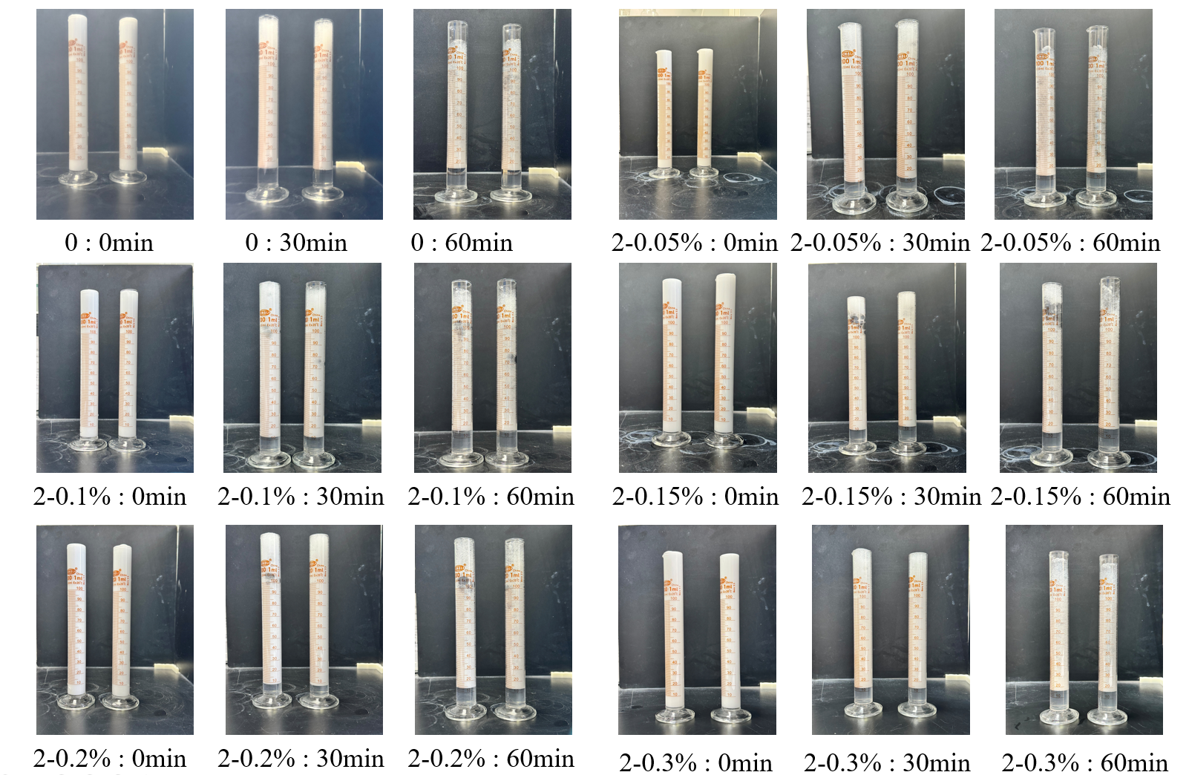
Fig.S1 Temporal Variation of Foam Height

