Supporting information
A selenamorpholine and pyrimidine-based redox-responsive fluorescent probe and its response mechanism
Tao Ma¹, Yiyun Li¹, Ling Ma^{*, 2}, Zhichun Li¹, Wenbing Ma¹, Changchun Yuan^{*,1}
School of Chemical Engineering and Technology, North University of China,Taiyuan 030051, PR China
Department of Chemistry and Chemical, Jinzhong University, Jinzhong 030606, PR China
*Corresponding author: maling@jzxy.edu.cn (Ling Ma), Changchun Yuan ycc543700483@nuc.edu.cn(CC.Yuan)
Figure S1. MS spectrum of Pyrimidine-Se after adding H₂O₂ in methanol
Figure S2. The ¹H NMR spectra of compound 1 in DMSO-d₆
Figure S3. The ¹H NMR spectra of Pyrimidine-Se in CDCl₃
Figure S4. The ¹³C NMR spectra of compound 1 in DMSO-d₆
Figure S5. The ¹³C NMR spectra of Pyrimidine-Se in CDCl₃
Figure S6. The HR-EMI-MS spectrum of compound 1 in DMSO-d₆
Figure S7. The HR-EMI-MS spectrum of Pyrimidine-Se in CDCl₃

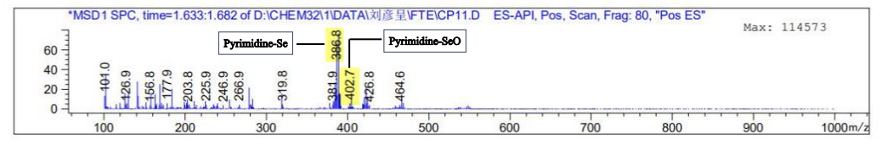
Figure S1. MS spectrum of Pyrimidine-Se after adding H₂O₂ in methanol

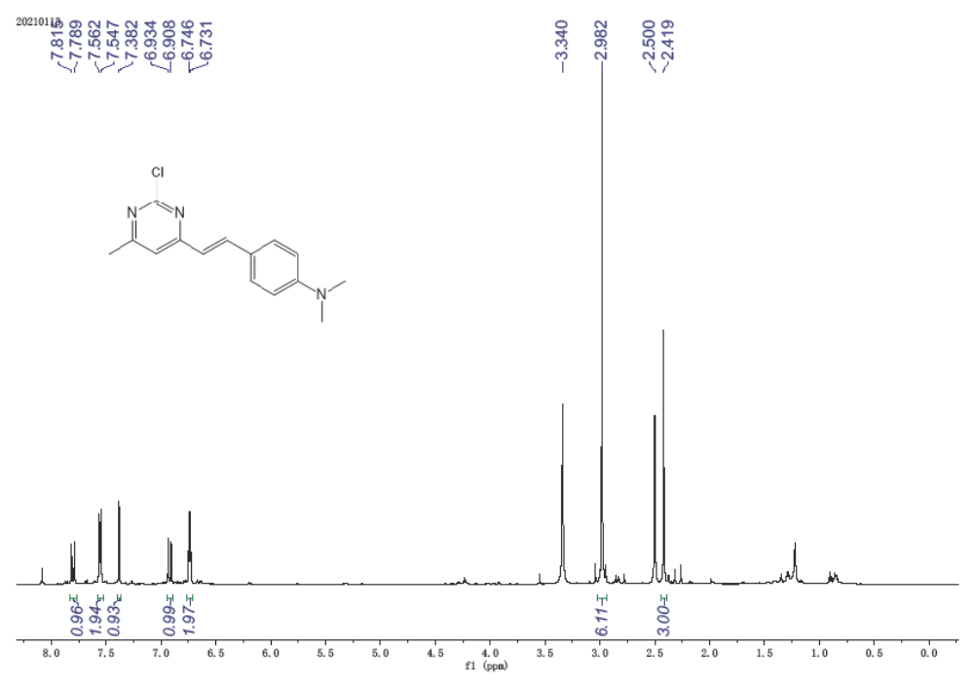
Figure S2. The ¹H NMR spectra of compound 1 in DMSO-d₆

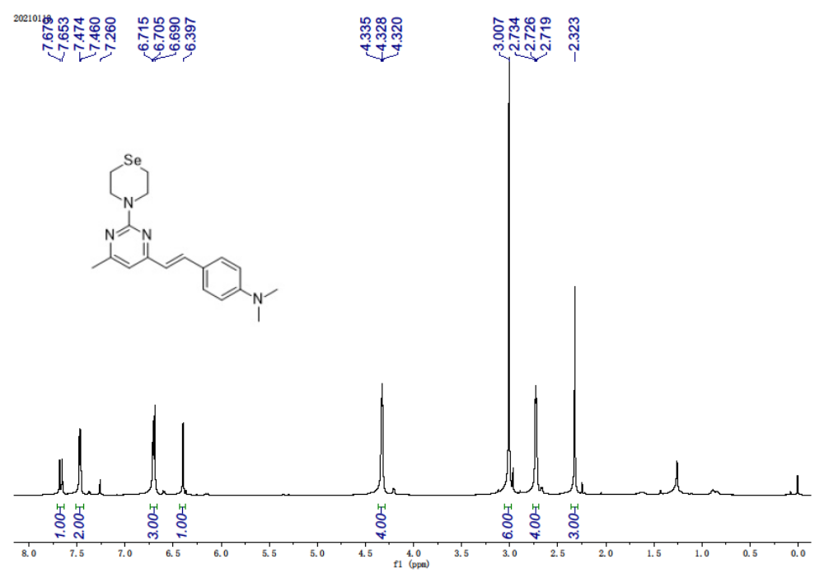
Figure S3. The ¹H NMR spectra of Pyrimidine-Se in CDCl₃

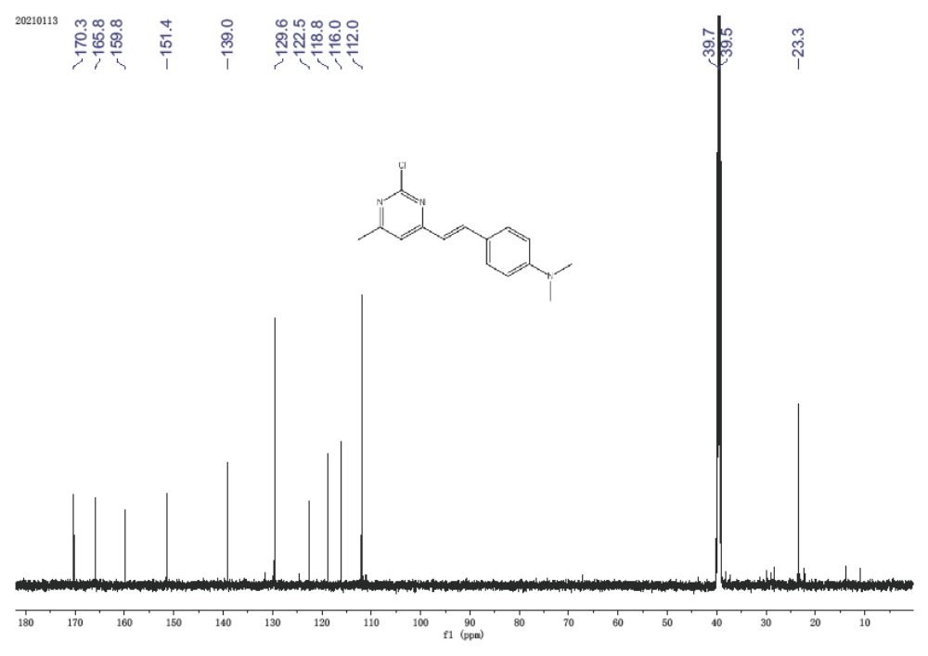
Figure S4. The ¹³C NMR spectra of compound 1 in DMSO-d₆

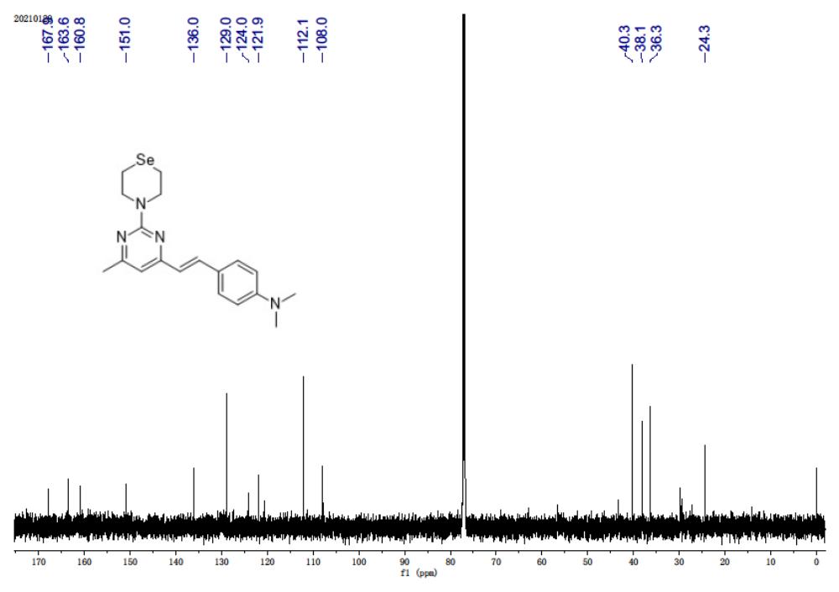
Figure S5. The ¹³C NMR spectra of Pyrimidine-Se in CDCl₃

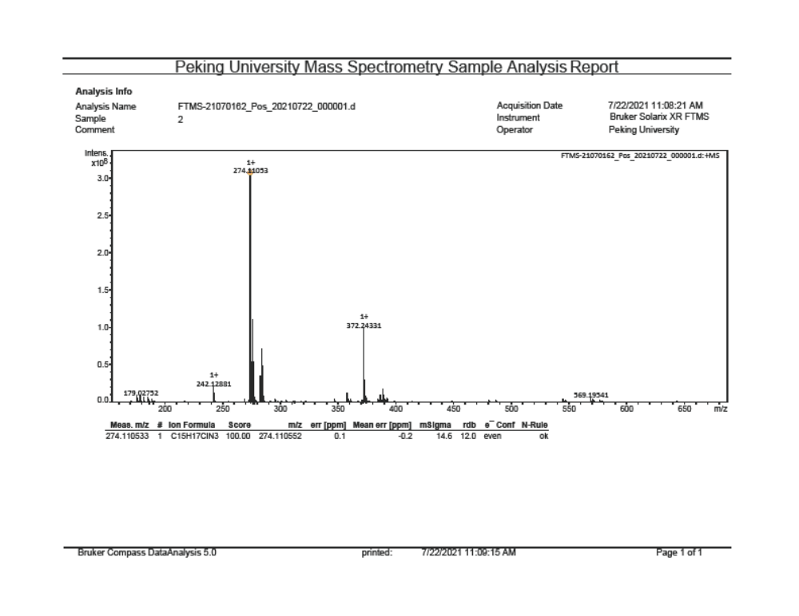
Figure S6. The HR-EMI-MS spectrum of compound 1 in DMSO-d₆
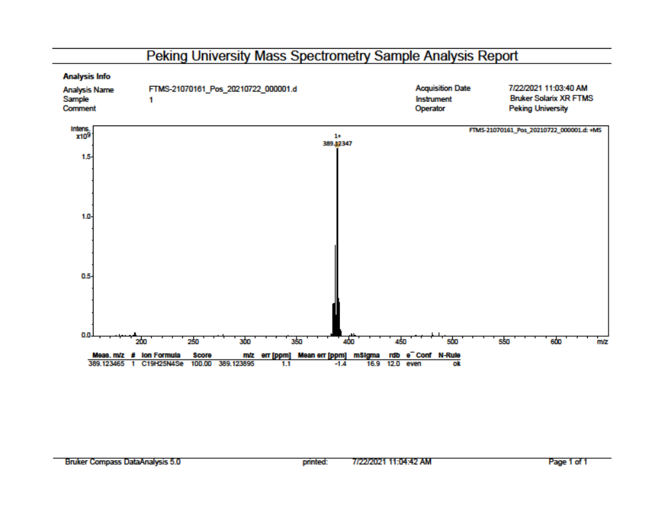Figure S7. The HR-EMI-MS spectrum of Pyrimidine-Se in CDCl₃

