Assessing Genotypic Differences in Nitrogen Response and Emission Intensity between Linseed Varieties and Oilseed Rape
Supplementary Figures
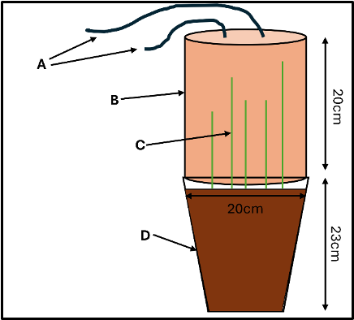
Supplementary Figure 1: The chamber design and setup for taking GHG measurements showing (A) inlet and outlet tubes for the Gasmet portable gas analyzer / Picarro G2508 gas concentration analyzer, (B) the closed static chamber (C) linseed / OSR growth within the chamber and (D) the pot.
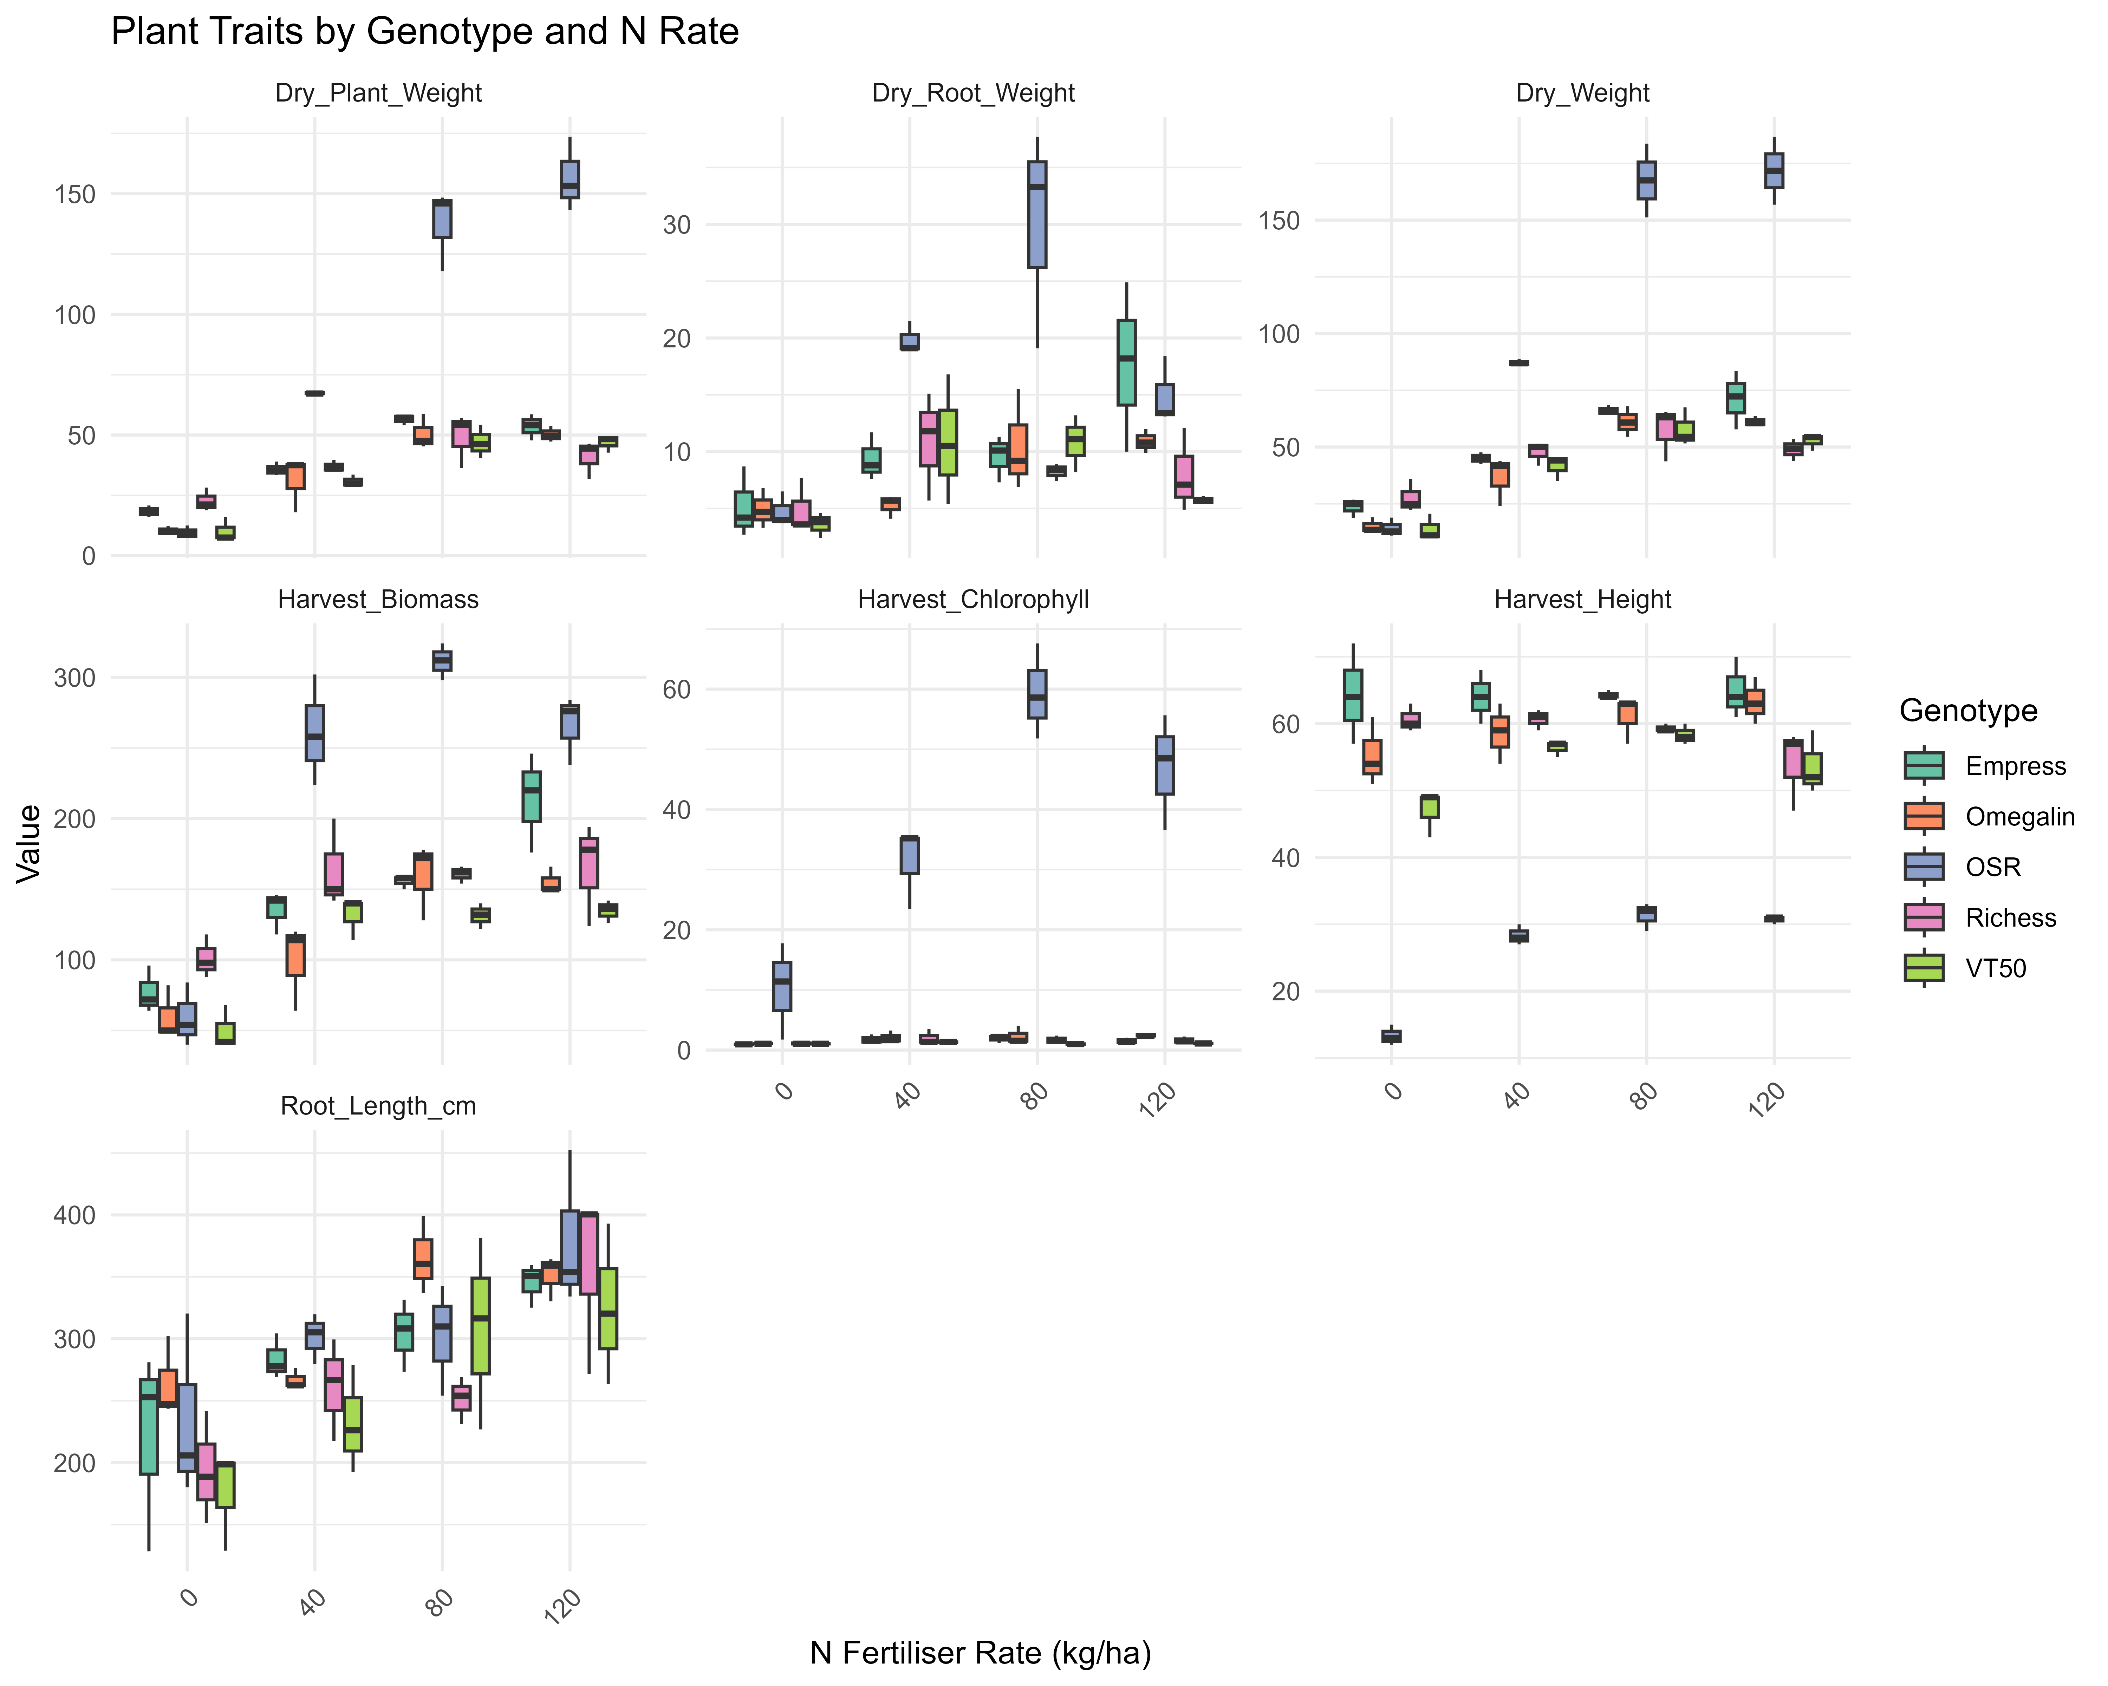
Supplementary Figure 2: Mean values (± standard error) of key plant traits (harvest biomass, height, chlorophyll content, dry root weight, dry plant weight, total dry weight and root length) for four linseed genotypes and one OSR genotype across N fertiliser rates in a controlled glasshouse experiment. Traits are presented in faceted panels for clarity. Boxplots represent data from three replicates per genotype-treatment combination. Colours denote genotypes.

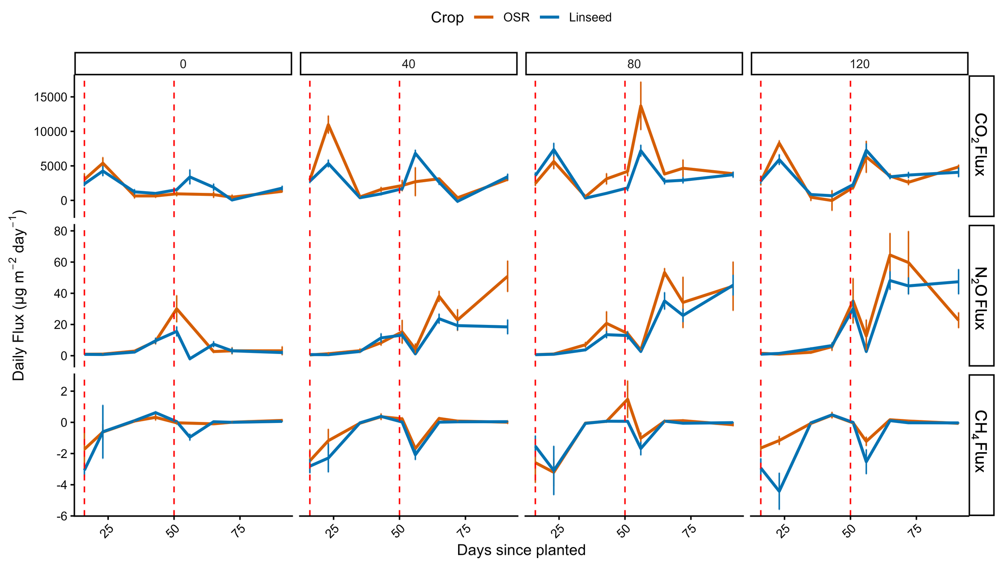
Supplementary figure 3: Daily mean (± SE) GHG fluxes over the experiment duration for OSR and linseed across N fertiliser rates (kg per ha⁻¹). Fluxes are shown for CO₂, N₂O and CH₄, aggregated from respective linseed (n=12) and OSR (n=3) replicates per crop-treatment combination. Red dashed lines indicate fertiliser application dates.

Supplementary Tables
Supplementary Table 1: Two-way ANOVA results for seven plant growth traits (dry plant weight, dry root weight, total dry weight, harvest biomass, harvest chlorophyll content, harvest height and root length) across four linseed genotypes and one OSR genotype under variable nitrogen fertiliser rates in a controlled glasshouse experiment. The table includes degrees of freedom (Df), sum of squares (Sum Sq), mean squares (Mean Sq), F-values and p-values (Pr(<F)) for the main effects of genotype, fertiliser rate and their interaction along with residuals. Only significant results are shown. Significance codes: *** p < 0.001, ** p < 0.01, * p < 0.05.
Trait | Source | Df | Sum Sq | Mean Sq | F value | Pr(>F)
Dry_Plant_Weight | Genotype | 4 | 30286.70067 | 7571.675167 | 139.0880482 | 6.68E-23***
Dry_Plant_Weight | Fertiliser | 3 | 31071.07 | 10357.02333 | 190.2535606 | 1.05E-23***
Dry_Plant_Weight | Genotype:Fertiliser | 12 | 19839.72333 | 1653.310278 | 30.37051835 | 2.60E-16***
Dry_Plant_Weight | Residuals | 40 | 2177.52 | 54.438 | NA | NA
Dry_Root_Weight | Genotype | 4 | 812.9743333 | 203.2435833 | 14.03034539 | 3.07E-07***
Dry_Root_Weight | Fertiliser | 3 | 694.6578333 | 231.5526111 | 15.98457898 | 5.54E-07***
Dry_Root_Weight | Genotype:Fertiliser | 12 | 817.3096667 | 68.10913889 | 4.701721586 | 9.91E-05***
Dry_Root_Weight | Residuals | 40 | 579.44 | 14.486 | NA | NA
Dry_Weight | Genotype | 4 | 40849.321 | 10212.33025 | 159.8699142 | 4.95E-24***
Dry_Weight | Fertiliser | 3 | 40164.40583 | 13388.13528 | 209.585862 | 1.71E-24***
Dry_Weight | Genotype:Fertiliser | 12 | 23822.36167 | 1985.196806 | 31.0774559 | 1.73E-16***
Dry_Weight | Residuals | 40 | 2555.16 | 63.879 | NA | NA
Harvest_Biomass | Genotype | 4 | 96281.6 | 24070.4 | 48.39244069 | 8.27E-15***
Harvest_Biomass | Fertiliser | 3 | 135522.8667 | 45174.28889 | 90.82084618 | 6.73E-18***
Harvest_Biomass | Genotype:Fertiliser | 12 | 51231.46667 | 4269.288889 | 8.583210472 | 9.74E-08***
Harvest_Biomass | Residuals | 40 | 19896 | 497.4 | NA | NA
Harvest_Chlorophyll | Genotype | 4 | 12038.6635 | 3009.665875 | 220.4486402 | 1.13E-26***
Harvest_Chlorophyll | Fertiliser | 3 | 891.653125 | 297.2177083 | 21.77027031 | 1.60E-08***
Harvest_Chlorophyll | Genotype:Fertiliser | 12 | 3141.964167 | 261.8303472 | 19.17825646 | 6.38E-13***
Harvest_Chlorophyll | Residuals | 40 | 546.0983333 | 13.65245833 | NA | NA
Harvest_Height | Genotype | 4 | 11263.9 | 2815.975 | 219.9980469 | 1.17E-26***
Harvest_Height | Fertiliser | 3 | 398.5833333 | 132.8611111 | 10.37977431 | 3.49E-05***
Harvest_Height | Genotype:Fertiliser | 12 | 666.5 | 55.54166667 | 4.339192708 | 0.000213653***
Harvest_Height | Residuals | 40 | 512 | 12.8 | NA | NA
Root_Length_cm | Genotype | 4 | 24959.80998 | 6239.952495 | 2.712266624 | 0.04336277*
Root_Length_cm | Fertiliser | 3 | 144834.4381 | 48278.14605 | 20.98464761 | 2.51E-08***
Root_Length_cm | Residuals | 40 | 92025.65027 | 2300.641257 | NA | NA

Supplementary Table 2: Nested ANOVA results for seven plant growth traits (dry plant weight, dry root weight, total dry weight, harvest biomass, harvest chlorophyll content, harvest height and root length) under variable N fertiliser rates in a controlled glasshouse experiment. Models were fitted as trait ~ Fertiliser * Crop + Fertiliser:Genotype, with OSR as a single genotype and linseed aggregated from four genotypes.
Fertiliser (kg N ha‚Åª¬π) | Group1 | Group2 | Mean Difference | p-adj | Lower CI | Upper CI
0 | Linseed | OSR | -40.183 | <0.001 | -50.272 | -30.095
40 | Linseed | OSR | -55.517 | <0.001 | -65.605 | -45.428
80 | Linseed | OSR | -70.85 | <0.001 | -80.938 | -60.762
120 | Linseed | OSR | -86.183 | <0.001 | -96.272 | -76.095

Supplementary Table 3: Tukey HSD post-hoc pairwise comparisons for cumulative GHG emissions (CO₂ and N₂O, kg ha⁻¹) across fertiliser rates, aggregated across crops. Significant differences indicate rate-specific escalations, with no crop effects from the main ANOVA (p > 0.05).
CO₂ (kg ha⁻¹)
group1 | group2 | meandiff | p-adj | lower | upper | reject
0 | 120 | 33.1451 | 0 | 24.0512 | 42.2389 | TRUE
0 | 40 | 18.0273 | 0 | 8.9335 | 27.1211 | TRUE
0 | 80 | 33.8812 | 0 | 24.7874 | 42.9751 | TRUE
120 | 40 | -15.1177 | 0.0003 | -24.2116 | -6.0239 | TRUE
120 | 80 | 0.7362 | 0.9965 | -8.3577 | 9.83 | FALSE
40 | 80 | 15.8539 | 0.0001 | 6.7601 | 24.9478 | TRUE
N₂O (kg ha⁻¹)
group1 | group2 | meandiff | p-adj | lower | upper | reject
0 | 120 | 0.3628 | 0 | 0.2538 | 0.4718 | TRUE
0 | 40 | 0.1595 | 0.0016 | 0.0505 | 0.2685 | TRUE
0 | 80 | 0.2941 | 0 | 0.1851 | 0.4031 | TRUE
120 | 40 | -0.2033 | 0 | -0.3123 | -0.0943 | TRUE
120 | 80 | -0.0687 | 0.3494 | -0.1777 | 0.0403 | FALSE
40 | 80 | 0.1346 | 0.0097 | 0.0256 | 0.2436 | TRUE

Supplementary Table 4: Summary of p-values from Type III ANOVA in linear mixed models (LMMs) analysing daily GHG fluxes across four linseed genotypes and one OSR genotype under variable N fertiliser rates in a controlled glasshouse experiment. The table specifies model type (Original for untransformed fluxes; Log for log-transformed fluxes were applied to address non-normality), p-values for main effects (Genotype, Fertiliser) and their interaction, and Shapiro-Wilk test results for residual normality (with notes on non-normality where P < 0.05). Models used the formula Flux ~ Genotype * Fertiliser + (1|Date), with data from 527 observations over 9 measurement dates and 3 replicates per genotype-treatment combination. Significance codes: *** p < 0.001, ** p < 0.01, * p < 0.05. For gases with persistent non-normality, results were robust to model choice, emphasising fertiliser-driven increases in emissions.
GHG | Model Type | Genotype p | Fertiliser p | Interaction p | Normality p (Shapiro)
CO2 | Original | 0.643 | 4.9e-14 *** | 0.518 | 7.6e-16 (non-normal)
N2O | Log | 0.178 | <2e-16 *** | 0.367 | 1.1e-06 (marginal)
CH4 | Original | 0.187 | 0.054 | 0.602 | <2e-16 (non-normal)
CO2e | Original | 0.231 | <2e-16 *** | 0.817 | <2e-16 (non-normal)

Supplementary Table 5: Post-hock Tukey HSD pairwise contrasts for estimated marginal means of daily GHG fluxes by genotype within each N fertiliser rate from LMMs. The table summarises selected representative comparisons with adjusted p-values (p adj). All contrasts were non-significant (p adj > 0.05), confirming no genotypic differences in flux responses. Data from 527 observations over 9 measurement dates and 3 replicates per genotype-treatment combination. Models used the formula Flux ~ Genotype * Fertiliser + (1|Date); log-transformed were noted for improved normality. Significance codes: *** p < 0.001, ** p < 0.01, * p < 0.05.
GHG | Model Type | Fertiliser (kg ha⁻¹) | Comparison (Genotype Pair) | p adj
CO2_flux | Original | 0 | Empress - Omegalin | 1
CO2_flux | Original | 0 | Empress - OSR | 0.889
CO2_flux | Original | 0 | OSR - VT50 | 1
CO2_flux | Original | 40 | Omegalin - OSR | 0.997
CO2_flux | Original | 40 | Empress - Richess | 0.999
CO2_flux | Original | 80 | OSR - Richess | 0.471
CO2_flux | Original | 80 | Empress - VT50 | 0.696
CO2_flux | Original | 120 | Omegalin - Richess | 0.771
CO2_flux | Original | 120 | OSR - VT50 | 0.944
N2O_flux | Log | 0 | Omegalin - Richess | 0.995
N2O_flux | Log | 0 | Empress - VT50 | 0.998
N2O_flux | Log | 40 | OSR - Richess | 0.389
N2O_flux | Log | 40 | Omegalin - VT50 | 0.682
N2O_flux | Log | 80 | Empress - Omegalin | 0.964
N2O_flux | Log | 80 | Richess - VT50 | 0.996
N2O_flux | Log | 120 | Omegalin - OSR | 0.305
N2O_flux | Log | 120 | Richess - VT50 | 0.224
CH4_flux | Original | 0 | Empress - OSR | 0.976
CH4_flux | Original | 0 | Omegalin - VT50 | 0.639
CH4_flux | Original | 40 | Empress - Richess | 0.997
CH4_flux | Original | 40 | OSR - VT50 | 0.997
CH4_flux | Original | 80 | Omegalin - Richess | 0.922
CH4_flux | Original | 80 | Empress - VT50 | 0.91
CH4_flux | Original | 120 | Richess - VT50 | 0.188
CH4_flux | Original | 120 | Omegalin - OSR | 0.306
CO2e_flux | Original | 0 | Empress - Omegalin | 0.965
CO2e_flux | Original | 0 | OSR - Richess | 0.99
CO2e_flux | Original | 40 | Omegalin - OSR | 0.201
CO2e_flux | Original | 40 | Empress - VT50 | 0.992
CO2e_flux | Original | 80 | Richess - VT50 | 0.996
CO2e_flux | Original | 80 | Empress - Omegalin | 0.997
CO2e_flux | Original | 120 | OSR - Richess | 0.986
CO2e_flux | Original | 120 | Omegalin - VT50 | 0.306

Supplementary Table 6: Two-way ANOVA results for cumulative GHG emissions at the end of the glasshouse experiment across four linseed genotypes and one OSR genotype under variable N fertiliser rates. The table includes degrees of freedom (df), sum of squares (sumsq), mean squares (meansq), F-statistics (statistic) and p-values (p.value). Genotype, fertiliser rate and their interaction were tested but only significant effects were kept within the table. Analyses used the formula Cumulative_Flux ~ Genotype * Fertiliser, with data from three replicates per genotype-treatment combination (n=60 total). Significance codes: *** p < 0.001, ** p < 0.01, * p < 0.05.
Gas | term | df | sumsq | meansq | statistic | p.value
CO2 | Fertiliser | 3 | 11444.81824 | 3814.939414 | 51.545669 | 8.32E-14***
CO2 | Residuals | 40 | 2960.434495 | 74.01086237 | NA | NA
N2O | Fertiliser | 3 | 1.153846698 | 0.384615566 | 29.29491766 | 3.46E-10***
N2O | Residuals | 40 | 0.525163539 | 0.013129088 | NA | NA
CH4 | Fertiliser | 3 | 0.000439191 | 0.000146397 | 4.187246367 | 0.011424743*
CH4 | Residuals | 40 | 0.001398503 | 3.50E-05 | NA | NA
CO2e | Fertiliser | 3 | 94843.84537 | 31614.61512 | 31.20018262 | 1.46E-10***
CO2e | Residuals | 40 | 40531.32062 | 1013.283015 | NA | NA

Supplementary Table 7: Two-way ANOVA results for NUE and emission intensity across four linseed genotypes and one OSR genotype under variable N fertiliser rates in a controlled glasshouse experiment. NUE was calculated as (harvest biomass at N rate - harvest biomass at 0 N) / N applied (g biomass/kg N) (n=45 for N>0). Emission intensity was calculated as cumulative flux (kg ha⁻¹) / harvest biomass (g) per GHG (n=60 total). The table includes degrees of freedom (Df), sum of squares (Sum Sq), mean squares (Mean Sq), F-values and p-values (Pr(>F)) for the main effects of genotype, fertiliser rate and their interaction, along with residuals. Only significant terms are highlighted. Analyses used the formula metric ~ Genotype * Fertiliser, with data from three replicates per genotype-treatment combination. Significance codes: *** p < 0.001, ** p < 0.01, * p < 0.05.
NUE ANOVA
Term | Df | Sum Sq | Mean Sq | F value | Pr(>F)
Genotype | 4 | 35.7004414 | 8.92511034 | 47.0418934 | 1.66E-12***
Fertiliser | 2 | 11.7892253 | 5.89461265 | 31.0689425 | 4.90E-08***
Genotype:Fertiliser | 8 | 10.2703272 | 1.2837909 | 6.76652188 | 4.63E-05***
Residual | 30 | 5.69180556 | 0.18972685 | NA | NA
Emission Intensity ANOVA
GHG | Term | Df | Sum Sq | Mean Sq | F value | Pr(>F)
CO2 | Genotype | 4 | 0.32047527 | 0.08011882 | 7.88664168 | 8.74E-05***
CO2 | Fertiliser | 3 | 0.10959798 | 0.03653266 | 3.59615888 | 0.02161565*
CO2 | Residual | 40 | 0.40635201 | 0.0101588 | NA | NA
N2O | Fertiliser | 3 | 1.16E-05 | 3.86E-06 | 6.97264778 | 0.00069785***
N2O | Residual | 40 | 2.22E-05 | 5.54E-07 | NA | NA
CH4 | Genotype | 4 | 2.75E-08 | 6.88E-09 | 2.89437286 | 0.03400299*
CH4 | Residual | 40 | 9.51E-08 | 2.38E-09 | NA | NA
CO2e | Fertiliser | 3 | 0.87745411 | 0.29248471 | 6.95736655 | 0.00070799*
CO2e | Residual | 40 | 1.68158284 | 0.04203957 | NA | NA

Supplementary Table 8: Post-hoc Tukey HSD test results for pairwise comparisons of NUE and emission intensity across four linseed genotypes and one OSR genotype under variable N fertiliser rates in a controlled glasshouse experiment. NUE was calculated as (harvest biomass at N rate - harvest biomass at 0 N) / N applied (g biomass/kg N) (n=45 for N>0). Emission intensity was calculated as cumulative flux (kg ha⁻¹) / harvest biomass (g) per GHG (n=60 total). The table includes comparisons for NUE and emission intensity by Fertiliser, Genotype and Genotype:Fertiliser interaction. Table includes mean differences (diff), lower and upper 95% confidence intervals (lwr, upr), and adjusted p-values (p adj). Only significant pairs are shown. Data based on three replicates per genotype-treatment combination. Significance codes: *** p < 0.001, ** p < 0.01, * p < 0.05.
NUE Post-hoc
Comparison | Term | diff | lwr | upr | p adj
120-80 | Fertiliser | -0.4461111 | -0.8382126 | -0.0540096 | 0.023110347*
80-40 | Fertiliser | -0.7916667 | -1.1837681 | -0.3995652 | 7.20E-05***
120-40 | Fertiliser | -1.2377778 | -1.6298793 | -0.8456763 | 3.27E-08***
VT50-OSR | Genotype | -2.0555556 | -2.6511452 | -1.4599659 | 4.36E-10***
OSR-Empress | Genotype | 2.11944444 | 1.52385476 | 2.71503413 | 2.13E-10***
OSR-Omegalin | Genotype | 2.30092593 | 1.70533624 | 2.89651561 | 2.97E-11***
Richess-OSR | Genotype | -2.3601852 | -2.9557749 | -1.7645955 | 1.60E-11***
VT50:120-VT50:40 | Genotype:Fertiliser | -1.3277778 | -2.638339 | -0.0172165 | 0.044688097*
OSR:120-OSR:80 | Genotype:Fertiliser | -1.4277778 | -2.738339 | -0.1172165 | 0.02279315*
Richess:120-VT50:40 | Genotype:Fertiliser | -1.5 | -2.8105613 | -0.1894387 | 0.01375499*
OSR:80-Richess:40 | Genotype:Fertiliser | 1.58333333 | 0.27277207 | 2.8938946 | 0.007562141**
OSR:80-Empress:40 | Genotype:Fertiliser | 1.7 | 0.38943873 | 3.01056127 | 0.003203969**
OSR:80-OSR:40 | Genotype:Fertiliser | -1.9 | -3.2105613 | -0.5894387 | 0.000708909***
OSR:80-Omegalin:80 | Genotype:Fertiliser | 1.90833333 | 0.59777207 | 3.2188946 | 0.000665323***
Empress:120-OSR:80 | Genotype:Fertiliser | -2.0111111 | -3.3216724 | -0.7005498 | 0.000303601***
VT50:80-OSR:80 | Genotype:Fertiliser | -2.1333333 | -3.4438946 | -0.8227721 | 0.000119215***
OSR:80-Omegalin:40 | Genotype:Fertiliser | 2.16666667 | 0.8561054 | 3.47722793 | 9.24E-05***
OSR:80-Empress:80 | Genotype:Fertiliser | 2.175 | 0.86443873 | 3.48556127 | 8.67E-05***
Omegalin:120-OSR:80 | Genotype:Fertiliser | -2.3555556 | -3.6661168 | -1.0449943 | 2.20E-05***
Richess:80-OSR:80 | Genotype:Fertiliser | -2.4083333 | -3.7188946 | -1.0977721 | 1.47E-05***
VT50:120-OSR:80 | Genotype:Fertiliser | -2.4444444 | -3.7550057 | -1.1338832 | 1.12E-05***
Richess:120-OSR:80 | Genotype:Fertiliser | -2.6166667 | -3.9272279 | -1.3061054 | 3.11E-06***
VT50:40-OSR:40 | Genotype:Fertiliser | -3.0166667 | -4.3272279 | -1.7061054 | 1.72E-07***
OSR:120-OSR:40 | Genotype:Fertiliser | -3.3277778 | -4.638339 | -2.0172165 | 2.02E-08***
Richess:40-OSR:40 | Genotype:Fertiliser | -3.4833333 | -4.7938946 | -2.1727721 | 7.15E-09***
OSR:40-Empress:40 | Genotype:Fertiliser | 3.6 | 2.28943873 | 4.91056127 | 3.34E-09***
Omegalin:80-OSR:40 | Genotype:Fertiliser | -3.8083333 | -5.1188946 | -2.4977721 | 8.85E-10***
Empress:120-OSR:40 | Genotype:Fertiliser | -3.9111111 | -5.2216724 | -2.6005498 | 4.67E-10***
VT50:80-OSR:40 | Genotype:Fertiliser | -4.0333333 | -5.3438946 | -2.7227721 | 2.21E-10***
OSR:40-Omegalin:40 | Genotype:Fertiliser | 4.06666667 | 2.7561054 | 5.37722793 | 1.81E-10***
Empress:80-OSR:40 | Genotype:Fertiliser | -4.075 | -5.3855613 | -2.7644387 | 1.72E-10***
Omegalin:120-OSR:40 | Genotype:Fertiliser | -4.2555556 | -5.5661168 | -2.9449943 | 5.89E-11***
Richess:80-OSR:40 | Genotype:Fertiliser | -4.3083333 | -5.6188946 | -2.9977721 | 4.34E-11***
VT50:120-OSR:40 | Genotype:Fertiliser | -4.3444444 | -5.6550057 | -3.0338832 | 3.52E-11***
Richess:120-OSR:40 | Genotype:Fertiliser | -4.5166667 | -5.8272279 | -3.2061054 | 1.33E-11***
Emissions Intensity Post-hoc
Gas | Comparison | Term | diff | lwr | upr | p adj
CO2 | OSR-Omegalin | Genotype | -0.2076931 | -0.3252147 | -0.09017 | 9.56E-05***
CO2 | VT50-OSR | Genotype | 0.18287592 | 0.06535432 | 0.300397 | 0.00062156***
CO2 | OSR:40-VT50:0 | Genotype:Fertiliser | -0.3581162 | -0.6698785 | -0.04635 | 0.01113845*
CO2 | 40-0 | Fertiliser | -0.1150536 | -0.2137027 | -0.01640 | 0.01667884*
CO2 | OSR:120-VT50:0 | Genotype:Fertiliser | -0.3359253 | -0.6476877 | -0.02416 | 0.0233442*
CO2 | OSR-Empress | Genotype | -0.120719 | -0.2382406 | -0.00319 | 0.0415249*
CO2 | Omegalin:120-OSR:40 | Genotype:Fertiliser | 0.31744449 | 0.00568211 | 0.629206 | 0.04199683*
CO2 | OSR:80-VT50:0 | Genotype:Fertiliser | -0.3167952 | -0.6285576 | -0.00503 | 0.04284888*
N2O | 120-0 | Fertiliser | 0.00109135 | 0.00036294 | 0.001819 | 0.00139485**
N2O | 120-40 | Fertiliser | 0.00092745 | 0.00019904 | 0.001658 | 0.00777582**
N2O | 80-0 | Fertiliser | 0.00074439 | 1.60E-05 | 0.001472 | 0.0435578*
CH4 | VT50-OSR | Genotype | -6.53E-05 | -0.0001222 | -8.49E-06 | 0.01723424*
CO2e | 120-0 | Fertiliser | 0.2964232 | 0.09574452 | 0.497101 | 0.00164848**
CO2e | 120-40 | Fertiliser | 0.26049923 | 0.05982054 | 0.461177 | 0.00647732**
CO2e | 80-0 | Fertiliser | 0.20139445 | 0.00071577 | 0.402073 | 0.04889904*

Supplementary Table 9: Results of PERMANOVA for multivariate patterns in plant growth traits (harvest biomass, height, chlorophyll content, dry root weight, dry plant weight, total dry weight and root length) and cumulative GHG emissions across four linseed genotypes and one OSR genotype under variable N fertiliser rates in a controlled glasshouse experiment. The table includes degrees of freedom (Df), sum of squares (Sum Sq), mean squares (Mean Sq), F-values, R-squared (R²) and p-values (Pr(>F)) for the main effects of genotype, fertiliser rate and their interaction along with residuals. Data based on three replicates per genotype-treatment combination (n=60 total). Significance codes: *** p < 0.001, ** p < 0.01, * p < 0.05.
Source | Df | Sum Sq | Mean Sq | F value | R² | Pr(>F)
Genotype | 4 | 187.89 | 46.9725 | 15.474 | 0.28951 | 0.001 ***
Fertiliser | 3 | 245.95 | 81.9833 | 27.007 | 0.37896 | 0.001 ***
Genotype:Fertiliser | 12 | 93.74 | 7.8117 | 2.5733 | 0.14443 | 0.001 ***
Residuals | 40 | 121.42 | 3.0355 | NA | 0.18709 | NA
Total | 59 | 649 | NA | NA | 1 | NA

Supplementary Table 10: Post-hoc pairwise comparisons from PERMANOVA for multivariate patterns in plant growth traits (harvest biomass, height, chlorophyll content, dry root weight, dry plant weight, total dry weight and root length) and cumulative GHG emissions across four linseed genotypes and one OSR genotype under variable N fertiliser rates in a controlled glasshouse experiment. Tables include overall pairwise comparisons for genotypes, fertiliser rates and their combined interaction. The table includes the compared pair, F-values, R-squared (R²), raw p-values and Bonferroni-adjusted p-values (p adj). Data based on three replicates per genotype-treatment combination (n=60 total). Significance codes: *** p < 0.001, ** p < 0.01, * p < 0.05.
Pairwise Comparison for Genotypes
Pair | F.Model | R² | p.value | p.adj
Omegalin vs Empress | 0.5908 | 0.0262 | 0.552 | 1
Omegalin vs Richess | 0.5987 | 0.0265 | 0.602 | 1
Omegalin vs VT50 | 0.9662 | 0.0421 | 0.361 | 1
Omegalin vs OSR | 9.8118 | 0.3084 | 0.001 | 0.01 **
Empress vs Richess | 0.3872 | 0.0173 | 0.82 | 1
Empress vs VT50 | 1.7189 | 0.0725 | 0.164 | 1
Empress vs OSR | 9.649 | 0.3049 | 0.002 | 0.02 *
Richess vs VT50 | 0.8514 | 0.0373 | 0.438 | 1
Richess vs OSR | 9.226 | 0.2955 | 0.002 | 0.02 *
VT50 vs OSR | 10.5177 | 0.3234 | 0.001 | 0.01 **
Pairwise Comparisons for Fertiliser Rates
Pair | F.Model | R² | p.value | p.adj
0 vs 40 | 12.3254 | 0.3056 | 0.001 | 0.006 ***
0 vs 80 | 21.9874 | 0.4399 | 0.001 | 0.006 ***
0 vs 120 | 27.4402 | 0.495 | 0.001 | 0.006 ***
40 vs 80 | 3.8978 | 0.1222 | 0.014 | 0.084
40 vs 120 | 6.6553 | 0.192 | 0.001 | 0.006 ***
80 vs 120 | 1.1847 | 0.0406 | 0.266 | 1
Pairwise Comparisons for Genotypes Within Each Fertiliser Rate
Within 0kg N ha⁻¹
Pair | F.Model | R² | p.value | p.adj
Omegalin vs Empress | 0.8841 | 0.181 | 0.5 | 1
Omegalin vs Richess | 0.9958 | 0.1993 | 0.5 | 1
Omegalin vs VT50 | 3.6047 | 0.474 | 0.1 | 1
Omegalin vs OSR | 8.0509 | 0.6681 | 0.1 | 1
Empress vs Richess | 0.38 | 0.0868 | 0.9 | 1
Empress vs VT50 | 2.2594 | 0.361 | 0.2 | 1
Empress vs OSR | 8.6953 | 0.6849 | 0.1 | 1
Richess vs VT50 | 1.9261 | 0.325 | 0.2 | 1
Richess vs OSR | 5.6137 | 0.5839 | 0.1 | 1
VT50 vs OSR | 6.533 | 0.6202 | 0.1 | 1
Within 40kg N ha⁻¹
Pair | F.Model | R² | p.value | p.adj
Omegalin vs Empress | 2.9935 | 0.428 | 0.1 | 1
Omegalin vs Richess | 2.6684 | 0.4002 | 0.1 | 1
Omegalin vs VT50 | 1.4943 | 0.272 | 0.2 | 1
Omegalin vs OSR | 26.2642 | 0.8678 | 0.1 | 1
Empress vs Richess | 0.571 | 0.1249 | 0.9 | 1
Empress vs VT50 | 0.6651 | 0.1426 | 0.8 | 1
Empress vs OSR | 17.8048 | 0.8166 | 0.1 | 1
Richess vs VT50 | 0.3647 | 0.0836 | 0.8 | 1
Richess vs OSR | 15.2217 | 0.7919 | 0.1 | 1
VT50 vs OSR | 10.7321 | 0.7285 | 0.1 | 1
Within 80kg N ha⁻¹
Pair | F.Model | R² | p.value | p.adj
Omegalin vs Empress | 0.6695 | 0.1434 | 0.7 | 1
Omegalin vs Richess | 1.4858 | 0.2708 | 0.3 | 1
Omegalin vs VT50 | 0.9163 | 0.1864 | 0.4 | 1
Omegalin vs OSR | 12.2157 | 0.7533 | 0.1 | 1
Empress vs Richess | 2.2876 | 0.3638 | 0.1 | 1
Empress vs VT50 | 2.3285 | 0.3679 | 0.1 | 1
Empress vs OSR | 19.8664 | 0.8324 | 0.1 | 1
Richess vs VT50 | 1.4963 | 0.2722 | 0.3 | 1
Richess vs OSR | 18.6794 | 0.8236 | 0.1 | 1
VT50 vs OSR | 16.8032 | 0.8077 | 0.1 | 1
Within 120kg N ha⁻¹
Pair | F.Model | R² | p.value | p.adj
Omegalin vs Empress | 1.3426 | 0.2513 | 0.3 | 1
Omegalin vs Richess | 0.4673 | 0.1046 | 0.9 | 1
Omegalin vs VT50 | 1.2253 | 0.2345 | 0.5 | 1
Omegalin vs OSR | 17.2134 | 0.8114 | 0.1 | 1
Empress vs Richess | 0.8389 | 0.1734 | 0.7 | 1
Empress vs VT50 | 2.606 | 0.3945 | 0.2 | 1
Empress vs OSR | 14.6182 | 0.7852 | 0.1 | 1
Richess vs VT50 | 0.1584 | 0.0381 | 1 | 1
Richess vs OSR | 7.4392 | 0.6503 | 0.1 | 1
VT50 vs OSR | 16.5991 | 0.8058 | 0.1 | 1

