Supplementary file 1
Association between ambient temperature and first-time hospitalizations for acute kidney injury in Taiwan: A nationwide case-crossover study

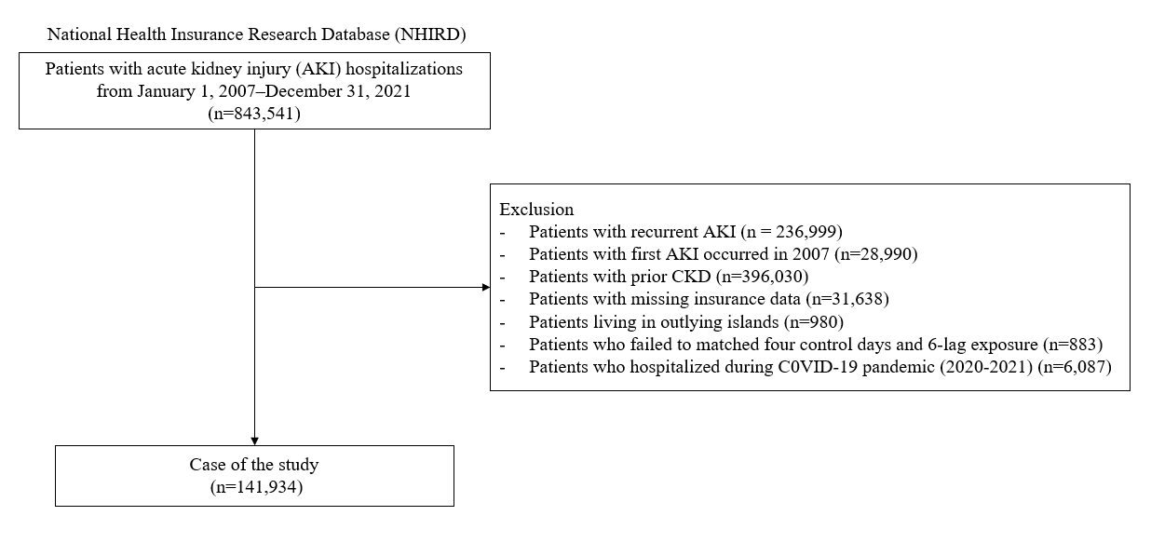
Figure S1. Study population selection process

Table S1. Demographic characteristics of hospitalized patients with acute kidney injury (AKI) in Taiwan (2008–2019)
Cases hospitalized for acute kidney injury
(n =141,934)
 | n | %
Age (year)
0-44 | 9,331 | 6.57
45-64 | 36,574 | 25.77
≥ 65 | 96,029 | 67.66
Gender
Male | 79,862 | 56.27
Female | 62,072 | 43.73
Hypertension
Yes | 102,655 | 72.33
No | 39,279 | 27.67
Diabetes
Yes | 72,408 | 51.02
No | 69,526 | 48.98
Farmer
Yes | 33,932 | 23.91
No | 108,002 | 76.09
Fisherman
Yes | 2,342 | 1.65
No | 139,592 | 98.35
Low income
Yes | 1,976 | 1.39
No | 139,958 | 98.61
Study areas
Yilan County | 4,577 | 3.22
Hualien County | 3,832 | 2.70
Nantou County | 3,431 | 2.42
Pingtung County | 4,433 | 3.12
Miaoli County | 2,268 | 1.60
Taoyuan City | 14,844 | 10.46
Kaohsiung City | 13,514 | 9.52
Keelung City | 3,423 | 2.41
Yunlin County | 4,872 | 3.43
New Taipei City | 12,053 | 8.49
Hsinchu City | 3,480 | 2.45
Hsinchu County | 1,430 | 1.01
Chiayi City | 4,231 | 2.98
Chiayi County | 4,646 | 3.27
Changhua County | 8,233 | 5.80
Taichung City | 14,437 | 10.17
Taipei City | 24,825 | 17.49
Taitung County | 1,606 | 1.13
Tainan City | 11,799 | 8.31
Years
2008 | 7,499 | 5.07%
2009 | 8,654 | 5.85%
2010 | 10,849 | 7.33%
2011 | 11,396 | 7.7%
2012 | 12,105 | 8.18%
2013 | 12,470 | 8.42%
2014 | 13,516 | 9.13%
2015 | 15,169 | 10.25%
2016 | 15,893 | 10.74%
2017 | 14,677 | 9.92%
2018 | 10,448 | 7.06%
2019 | 9,258 | 6.25%
Months
January | 11,997 | 8.45%
February | 11,725 | 8.26%
March | 12,177 | 8.58%
April | 11,763 | 8.29%
May | 12,239 | 8.62%
June | 12,287 | 8.66%
July | 12,275 | 8.65%
August | 12,047 | 8.49%
September | 11,285 | 7.95%
October | 11,332 | 7.98%
November | 11,000 | 7.75%
December | 11,807 | 8.32%
Day of week
Sunday | 14,672 | 10.34%
Monday | 22,816 | 16.08%
Tuesday | 21,421 | 15.09%
Wednesday | 21,151 | 14.90%
Thursday | 21,341 | 15.04%
Friday | 21,817 | 15.37%
Saturday | 18,716 | 13.19%

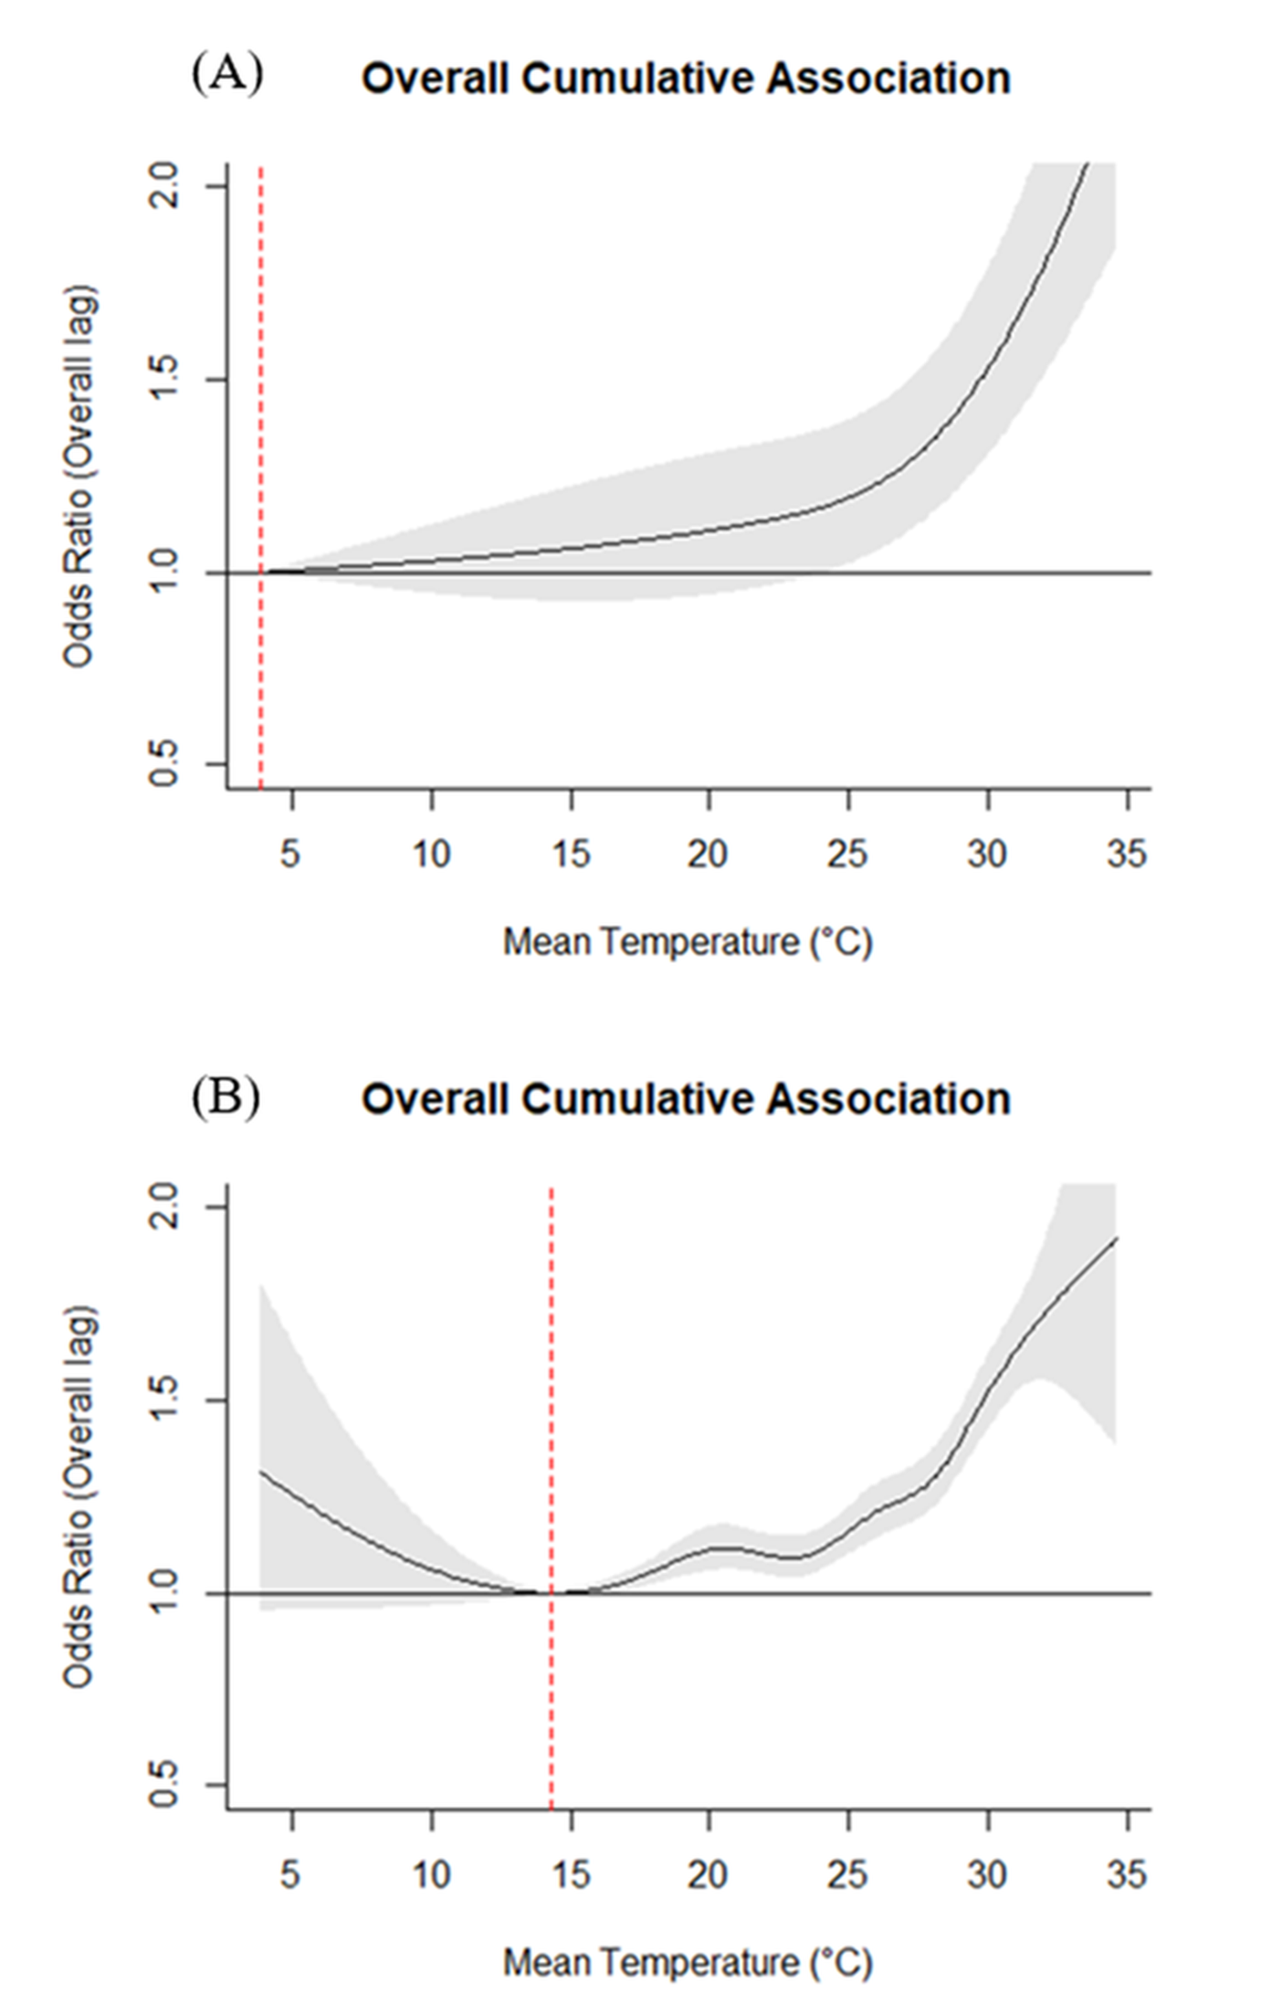
Figure S2. Sensitivity analysis of the overall cumulative temperature–AKI association using alternative degrees of freedom (df) for the temperature–response spline. (A) Model using 3 degrees of freedom, showing a slightly smoother temperature–response curve. (B) Model using 7 degrees of freedom, yielding a more flexible curve to capture potential nonlinearities. These analyses assess the robustness of the main specification (df = 5) to different spline smoothness choices in the cross-basis function.

Table S2. Overall cumulative main effect estimates for AKI hospitalized by mean temperature and maximum temperature (2008-2019)
 | Mean temperature |  |  |  | Maximum temperature
 | OR ª | Lower CI | Upper CI | OR ª |  | Lower CI | Upper CI
4°C | 1.010 | 0.867 | 1.176 | – |  | – | –
5°C | 1.007 | 0.889 | 1.141 | – |  | – | –
6°C | 1.005 | 0.911 | 1.109 | 1.078 |  | 0.887 | 1.309
7°C | 1.003 | 0.933 | 1.078 | 1.065 |  | 0.898 | 1.264
8°C | 1.000 | 0.956 | 1.049 | 1.054 |  | 0.908 | 1.222
9°C | 1.000 | 0.978 | 1.023 | 1.043 |  | 0.919 | 1.183
10°C | 1.000 | (reference) | – | 1.033 |  | 0.931 | 1.147
11°C | 1.000 | 0.980 | 1.022 | 1.024 |  | 0.942 | 1.114
12°C | 1.002 | 0.962 | 1.043 | 1.016 |  | 0.953 | 1.184
13°C | 1.004 | 0.950 | 1.063 | 1.010 |  | 0.964 | 1.058
14°C | 1.008 | 0.940 | 1.082 | 1.005 |  | 0.975 | 1.035
15°C | 1.013 | 0.933 | 1.099 | 1.001 |  | 0.986 | 1.017
16°C | 1.019 | 0.931 | 1.116 | 1.000 |  | (reference) | –
17°C | 1.027 | 0.933 | 1.130 | 1.000 |  | 0.992 | 1.010
18°C | 1.037 | 0.940 | 1.144 | 1.003 |  | 0.986 | 1.021
19°C | 1.049 | 0.952 | 1.156 | 1.009 |  | 0.985 | 1.033
20°C | 1.063 | 0.967 | 1.168 | 1.017 |  | 0.988 | 1.046
21°C | 1.077 | 0.984 | 1.180 | 1.027 |  | 0.995 | 1.060
22°C | 1.092 | 0.999 | 1.194 | 1.041 |  | 1.007 | 1.077
23°C | 1.107 | 1.013 | 1.208 | 1.058 |  | 1.020 | 1.099
24°C | 1.121 | 1.024 | 1.227 | 1.078 |  | 1.033 | 1.124
25°C | 1.140 | 1.037 | 1.254 | 1.096 |  | 1.047 | 1.148
26°C | 1.172 | 1.061 | 1.294 | 1.112 |  | 1.060 | 1.168
27°C | 1.222 | 1.106 | 1.351 | 1.124 |  | 1.072 | 1.179
28°C | 1.294 | 1.172 | 1.428 | 1.136 |  | 1.083 | 1.191
29°C | 1.383 | 1.153 | 1.527 | 1.154 |  | 1.098 | 1.212
30°C | 1.488 | 1.347 | 1.644 | 1.186 |  | 1.127 | 1.247
31°C | 1.607 | 1.446 | 1.786 | 1.238 |  | 1.176 | 1.303
32°C | 1.741 | 1.537 | 1.971 | 1.308 |  | 1.240 | 1.381
33°C | 1.892 | 1.615 | 2.215 | 1.392 |  | 1.315 | 1.474
34°C | 2.058 | 1.681 | 2.520 | 1.486 |  | 1.401 | 1.575
35°C | – | – | – | 1.589 |  | 1.486 | 1.699
36°C | – | – | – | 1.704 |  | 1.557 | 1.863
37°C | – | – | – | 1.829 |  | 1.613 | 2.074
38°C | – | – | – | 1.965 |  | 1.657 | 2.330
39°C | – | – | – | 2.113 |  | 1.696 | 2.631
ª Adjusted for PM_{2.5}, O₃, NO₂, and relative humidity

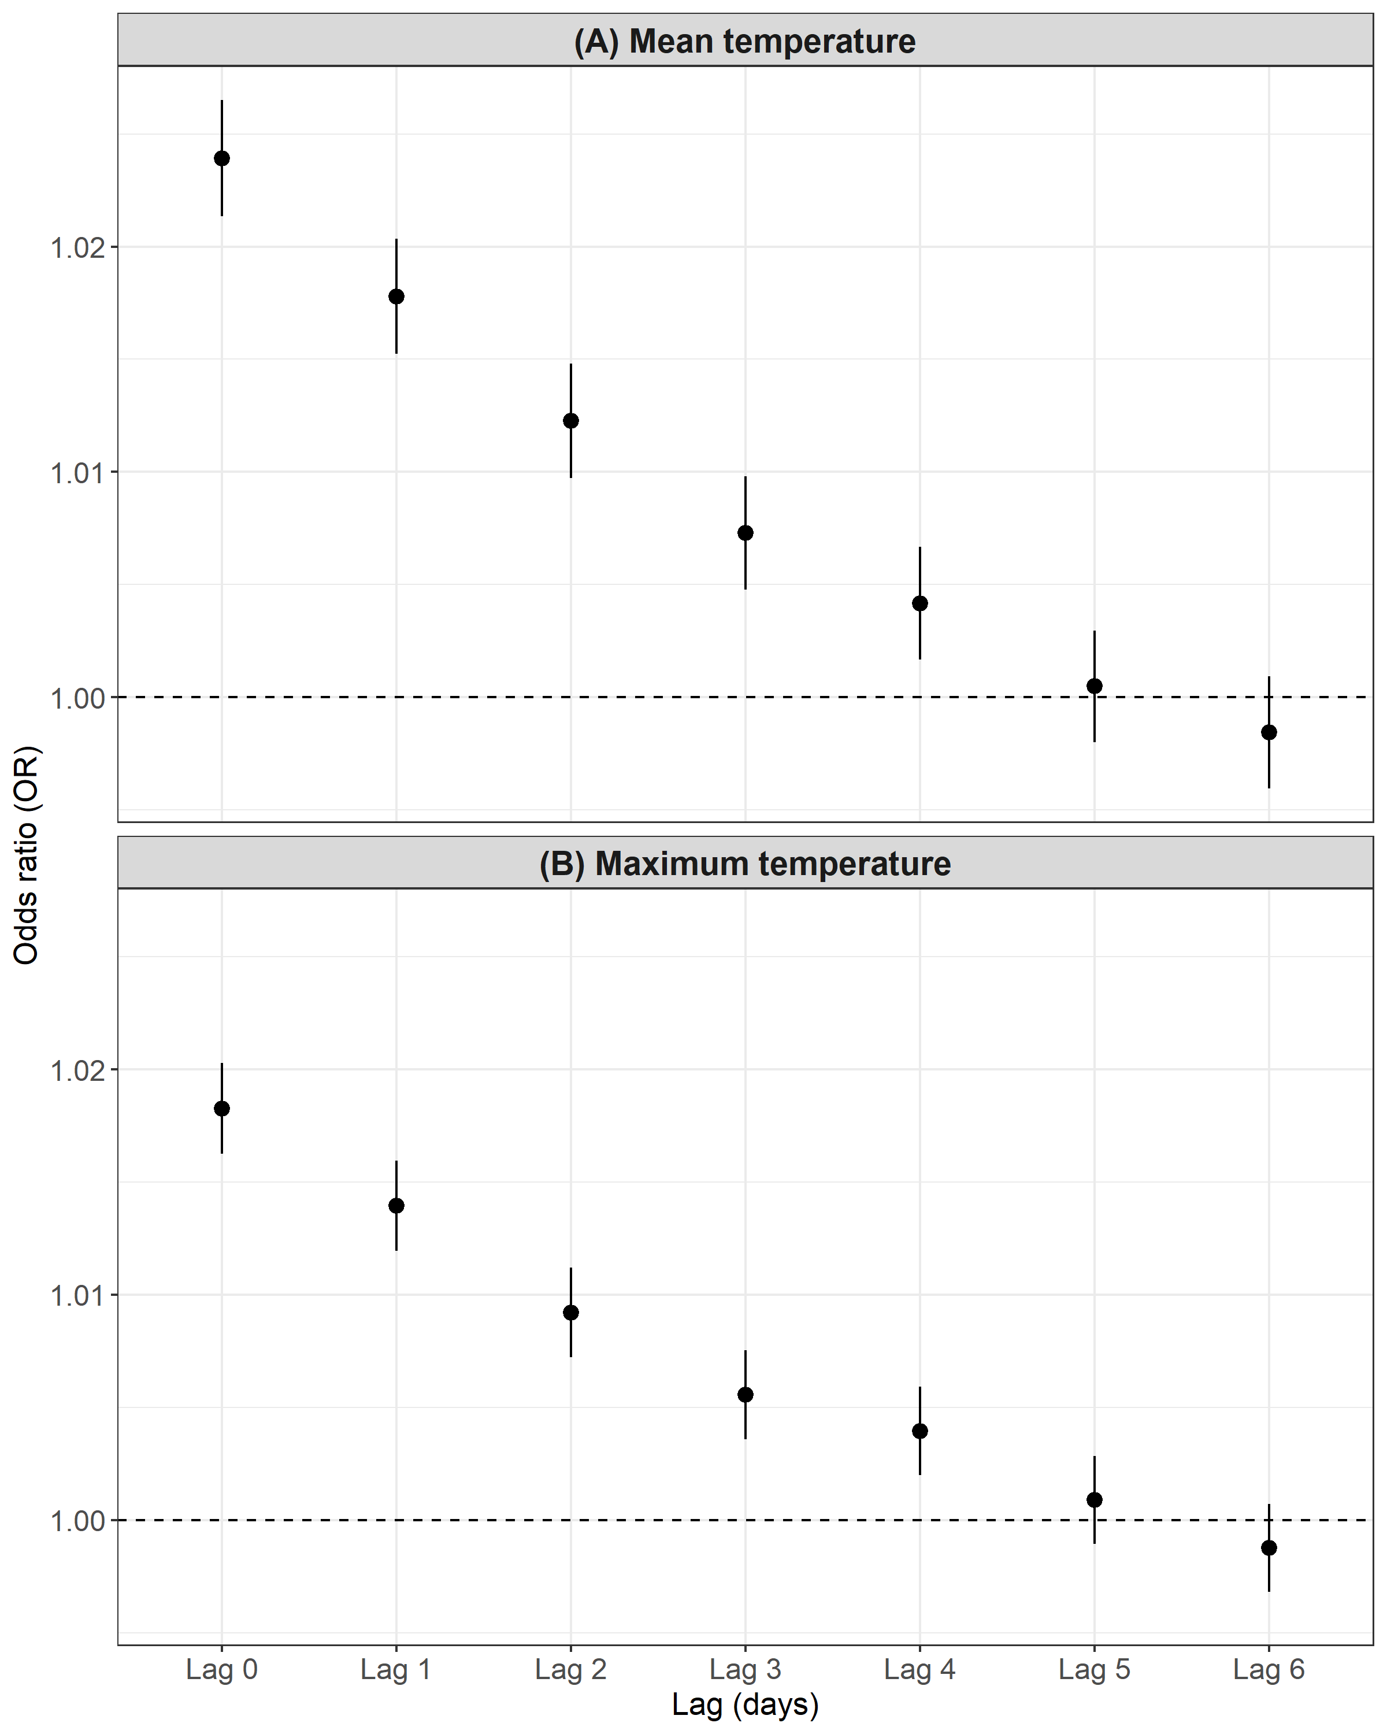
Figure S3. Lag-specific temperature associations with AKI hospitalization. Panels (A) and (B) show overall lag-specific odds ratios (ORs) for the association between mean and maximum temperature, respectively, and AKI hospitalization, estimated from the time-stratified case-crossover model with a distributed lag non-linear cross-basis. The largest OR was observed on the day of exposure (Lag 0), whereas later lag days contributed smaller ORs, indicating that the temperature effect on AKI hospitalization is predominantly acute rather than delayed.

Table S3. Odds ratios (ORs) for AKI hospitalization at the 90th, 95th, and 99th percentiles of mean temperature compared with the minimum morbidity temperature (MMT), stratified by age, sex, comorbidity, occupation, and socioeconomic status (2008–2019).
 | Mean temperature
 | T90 ª | Lower CI | Upper CI | T95 ª | Lower CI | Upper CI | T99 ª | Lower CI | Upper CI
Overall | 1.383 | 1.153 | 1.527 | 1.488 | 1.347 | 1.644 | 1.892 | 1.615 | 2.215
Age (year)
0-44 | 1.455 | 0.985 | 2.151 | 1.418 | 0.985 | 2.101 | 1.066 | 0.567 | 2.004
45-64 | 1.284 | 1.051 | 1.569 | 1.358 | 1.110 | 1.569 | 1.751 | 1.270 | 2.416
≥ 65 | 1.421 | 1.261 | 1.602 | 1.554 | 1.378 | 1.752 | 2.085 | 1.725 | 2.521
Sex
Male | 1.331 | 1.167 | 1.517 | 1.436 | 1.258 | 1.639 | 1.774 | 1.438 | 2.188
Female | 1.459 | 1.255 | 1.697 | 1.563 | 1.342 | 1.819 | 2.058 | 1.618 | 2.617
Hypertension
Yes | 1.388 | 1.235 | 1.560 | 1.494 | 1.328 | 1.680 | 1.891 | 1.571 | 2.277
No | 1.378 | 1.142 | 1.663 | 1.480 | 1.226 | 1.788 | 1.901 | 1.405 | 2.572
Diabetes
Yes | 1.300 | 1.132 | 1.492 | 1.394 | 1.213 | 1.602 | 1.666 | 1.336 | 2.077
No | 1.479 | 1.283 | 1.705 | 1.594 | 1.382 | 1.840 | 2.175 | 1.734 | 2.728
Farmer
Yes | 1.445 | 1.168 | 1.788 | 1.553 | 1.253 | 1.925 | 1.682 | 1.176 | 2.406
No | 1.365 | 1.221 | 1.527 | 1.467 | 1.310 | 1.642 | 1.941 | 1.627 | 2.316
Fisherman
Yes | 3.255 | 1.279 | 8.282 | 3.879 | 1.520 | 9.896 | 9.111 | 2.164 | 38.349
No | 1.370 | 1.240 | 1.514 | 1.471 | 1.331 | 1.626 | 1.852 | 1.580 | 2.172
Low income
Yes | 2.492 | 0.987 | 6.296 | 2.652 | 1.044 | 6.735 | 2.716 | 0.708 | 10.118
No | 1.372 | 1.242 | 1.516 | 1.476 | 1.335 | 1.632 | 1.884 | 1.607 | 2.209
ª Adjusted for PM_{2.5}, O₃, NO₂, and relative humidity.
Table S4. Odds ratios (ORs) for AKI hospitalization at the 90th, 95th, and 99th percentiles of maximum temperature compared with the minimum morbidity temperature (MMT), stratified by age, sex, comorbidity, occupation, and socioeconomic status (2008–2019).
 | Maximum temperature
 | T90 ª | Lower CI | Upper CI | T95 ª | Lower CI | Upper CI | T99 ª | Lower CI | Upper CI
Overall | 1.486 | 1.401 | 1.575 | 1.704 | 1.557 | 1.863 | 1.965 | 1.657 | 2.330
Age (year)
0-44 | 1.086 | 0.860 | 1.371 | 0.931 | 0.650 | 1.334 | 0.747 | 0.377 | 1.483
45-64 | 1.360 | 1.209 | 1.530 | 1.536 | 1.281 | 1.842 | 1.735 | 1.227 | 2.455
≥65 | 1.580 | 1.471 | 1.697 | 1.876 | 1.684 | 2.090 | 2.262 | 1.847 | 2.769
Sex
Male | 1.518 | 1.403 | 1.642 | 1.730 | 1.535 | 1.950 | 1.965 | 1.566 | 2.465
Female | 1.466 | 1.322 | 1.581 | 1.671 | 1.457 | 1.915 | 1.966 | 1.518 | 2.546
Hypertension
Yes | 1.470 | 1.371 | 1.575 | 1.732 | 1.558 | 1.925 | 2.082 | 1.707 | 2.540
No | 1.533 | 1.369 | 1.717 | 1.646 | 1.388 | 1.952 | 1.713 | 1.239 | 2.369
Diabetes
Yes | 1.441 | 1.327 | 1.565 | 1.674 | 1.475 | 1.898 | 1.955 | 1.544 | 2.475
No | 1.535 | 1.410 | 1.671 | 1.745 | 1.535 | 1.984 | 2.002 | 1.568 | 2.556
Farmer
Yes | 1.554 | 1.372 | 1.761 | 1.679 | 1.375 | 2.049 | 1.749 | 1.193 | 2.565
No | 1.463 | 1.368 | 1.564 | 1.705 | 1.542 | 1.886 | 2.024 | 1.677 | 2.444
Fisherman
Yes | 2.399 | 1.437 | 4.005 | 4.574 | 2.047 | 10.220 | 11.290 | 2.388 | 53.376
No | 1.470 | 1.373 | 1.569 | 1.715 | 1.537 | 1.893 | 1.912 | 1.624 | 2.213
Low income
Yes | 1.647 | 0.976 | 2.780 | 1.464 | 0.686 | 3.123 | 1.141 | 0.282 | 4.618
No | 1.483 | 1.398 | 1.574 | 1.708 | 1.560 | 1.870 | 1.982 | 1.669 | 2.354
ª Adjusted for PM_{2.5}, O₃, NO₂, and relative humidity.

Table S5. ORs for 1°C increments in mean and maximum temperature above the minimum morbidity temperature (MMT) on AKI hospitalizations, stratified by age, sex, comorbidity, occupation, and socioeconomic status (2008–2019).
 | Mean temperature |  |  |  | Maximum temperature
 | OR ª | Lower CI | Upper CI | OR ª |  | Lower CI | Upper CI
Overall | 1.023 | 1.019 | 1.027 | 1.022 |  | 1.018 | 1.025
Age (year)
0-44 | 1.007 | 0.992 | 1.022 | 1.004 |  | 0.991 | 1.017
45-64 | 1.015 | 1.007 | 1.023 | 1.016 |  | 1.010 | 1.023
≥65 | 1.028 | 1.023 | 1.032 | 1.025 |  | 1.021 | 1.029
Sex
Male | 1.024 | 1.019 | 1.029 | 1.023 |  | 1.018 | 1.027
Female | 1.022 | 1.016 | 1.028 | 1.021 |  | 1.015 | 1.026
Hypertension
Yes | 1.022 | 1.018 | 1.027 | 1.021 |  | 1.017 | 1.025
No | 1.026 | 1.019 | 1.033 | 1.023 |  | 1.017 | 1.030
Diabetes
Yes | 1.019 | 1.014 | 1.026 | 1.019 |  | 1.014 | 1.024
No | 1.027 | 1.022 | 1.033 | 1.025 |  | 1.020 | 1.030
Farmer
Yes | 1.028 | 1.019 | 1.036 | 1.024 |  | 1.017 | 1.031
No | 1.022 | 1.017 | 1.026 | 1.021 |  | 1.017 | 1.025
Fisherman
Yes | 1.050 | 1.017 | 1.084 | 1.045 |  | 1.016 | 1.075
No | 1.023 | 1.019 | 1.027 | 1.021 |  | 1.018 | 1.025
Low income
Yes | 1.030 | 0.997 | 1.065 | 1.024 |  | 0.995 | 1.054
No | 1.023 | 1.019 | 1.027 | 1.022 |  | 1.018 | 1.025
ª Adjusted for PM_{2.5}, O₃, NO₂, and relative humidity.

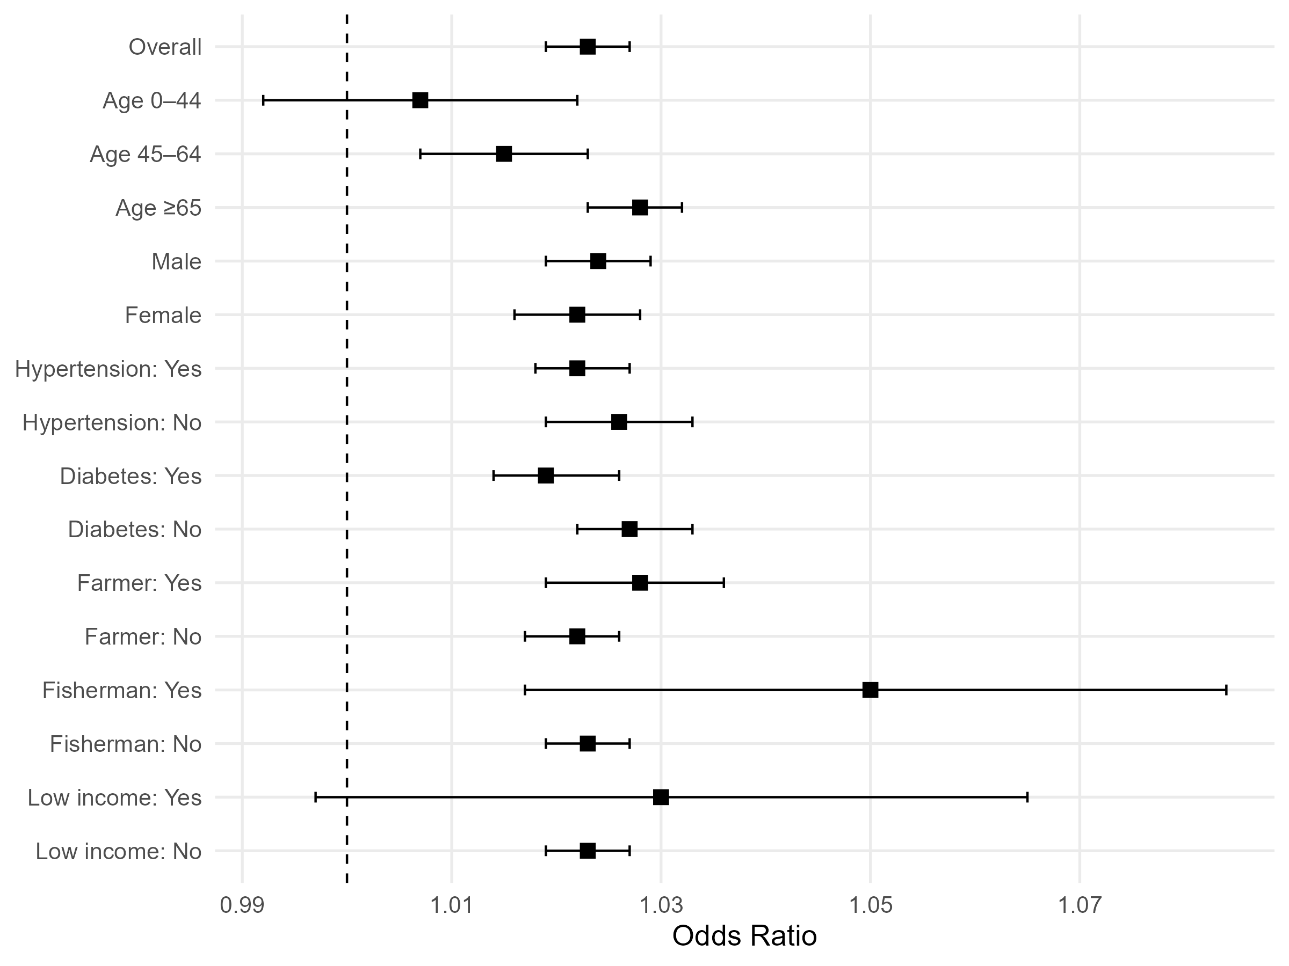
Figure S4. ORs of AKI hospitalization per 1°C increase in daily mean temperature above 10°C, stratified by age group, sex, hypertension, diabetes, occupation (farmers, fishermen), and income status (low-income vs. non-low-income).

Table S6. ORs for 1°C increments in mean and maximum temperature above the 90th temperature on acute kidney injury hospitalizations, stratified by study areas (2008–2019).
 | Mean temperature |  |  |  | Maximum temperature
 | OR ª | Lower CI | Upper CI | OR ª |  | Lower CI | Upper CI
Overall | 1.187 | 1.138 | 1.240 | 1.152 |  | 1.112 | 1.194
Study areas
Yilan County | 1.033 | 0.809 | 1.317 | 1.023 |  | 0.858 | 1.218
Hualien County | 1.587 | 1.205 | 2.088 | 1.473 |  | 1.191 | 1.823
Nantou County | 1.238 | 0.970 | 1.581 | 1.102 |  | 0.850 | 1.430
Pingtung County | 1.184 | 0.951 | 1.474 | 1.154 |  | 0.923 | 1.444
Miaoli County | 1.345 | 0.920 | 1.968 | 1.283 |  | 0.958 | 1.719
Taoyuan City | 1.156 | 1.007 | 1.329 | 1.106 |  | 0.996 | 1.228
Kaohsiung City | 1.207 | 1.057 | 1.378 | 1.221 |  | 1.076 | 1.386
Keelung City | 1.201 | 0.947 | 1.526 | 1.123 |  | 0.970 | 1.301
Yunlin County | 1.059 | 0.783 | 1.433 | 1.165 |  | 0.935 | 1.452
New Taipei City | 1.322 | 1.153 | 1.516 | 1.238 |  | 1.098 | 1.395
Hsinchu City | 1.096 | 0.808 | 1.487 | 0.997 |  | 0.808 | 1.230
Hsinchu County | 1.385 | 0.877 | 2.189 | 1.150 |  | 0.852 | 1.551
Chiayi City | 1.429 | 1.139 | 1.794 | 1.220 |  | 1.031 | 1.444
Chiayi County | 0.924 | 0.705 | 1.211 | 0.990 |  | 0.780 | 1.256
Changhua County | 1.317 | 1.095 | 1.585 | 1.217 |  | 1.045 | 1.417
Taichung City | 1.196 | 1.035 | 1.384 | 1.218 |  | 1.053 | 1.408
Taipei City | 1.085 | 0.990 | 1.190 | 1.091 |  | 1.012 | 1.178
Taitung County | 1.246 | 0.847 | 1.835 | 1.201 |  | 0.947 | 1.523
Tainan City | 1.182 | 0.992 | 1.409 | 1.200 |  | 1.021 | 1.410
ª Adjusted for PM_{2.5}, O₃, NO₂, and relative humidity.

