Supplementary Materials
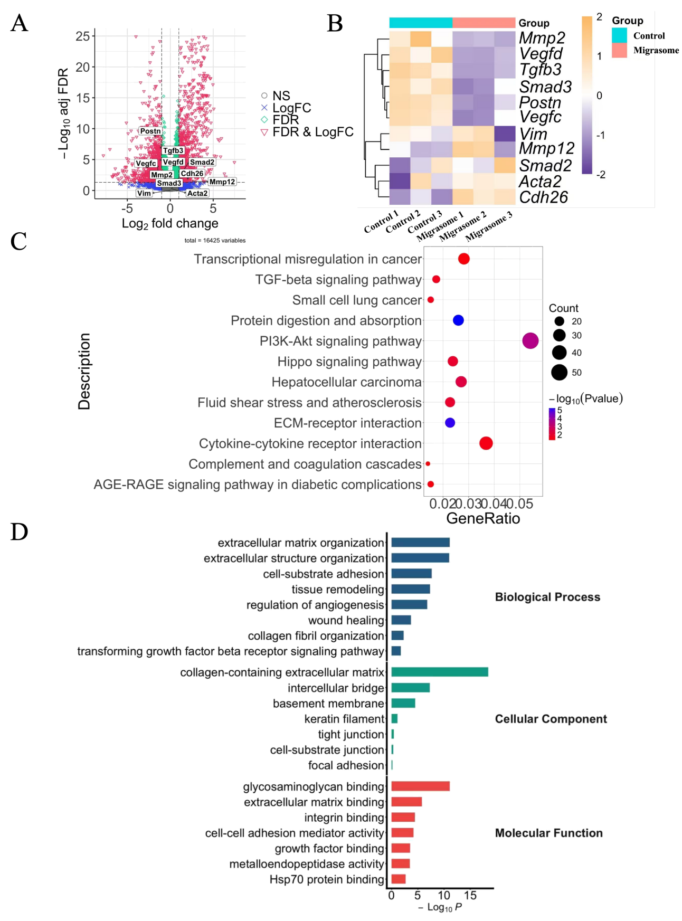
Supplementary figure 1. Exploratory transcriptomic profiling of migrasome-treated lesions.
(A) Volcano plot showing differentially expressed genes between migrasome-treated and control lesions. Selected genes related to fibrosis- and microenvironment-associated pathways are highlighted.
(B) Heatmap of representative genes associated with extracellular matrix remodeling, TGF-β/Smad-related signaling, angiogenesis, and epithelial–mesenchymal plasticity.
(C) KEGG pathway enrichment analysis of differentially expressed genes, showing enrichment of pathways related to extracellular matrix remodeling, cytokine signaling, and TGF-β-associated signaling.
(D) GO enrichment analysis showing representative Biological Process, Cellular Component, and Molecular Function terms associated with extracellular matrix organization, adhesion, and tissue remodeling.

Because of RNA quality limitations, these transcriptomic data were interpreted as exploratory and were not used as primary mechanistic evidence.
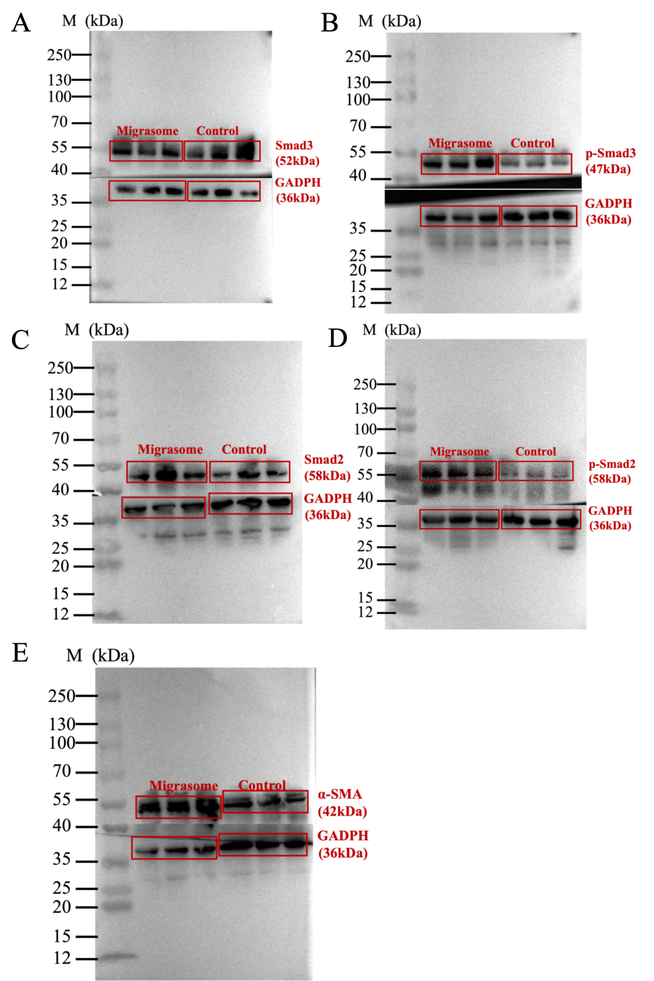
Supplementary figure 2. Uncropped original Western blot images corresponding to Figure 6C–G.
Uncropped immunoblot images for Smad3 (A), p-Smad3(B), Smad2(C), p-Smad2(D), and α-SMA(E), together with their corresponding GAPDH loading controls.

