Supporting Information
Single-molecule switching via controlled tautomerization at room temperature
Chun Tang^{1,3,4}, Thijs Stuyver^{2,4}, Yiling Ye¹, Jun-yang Liu¹, Jia Shi¹, Sason Shaik^{2*}, Haiping Xia^{1,3*}, Wenjing Hong^{1*}
¹State Key Laboratory of Physical Chemistry of Solid Surfaces, College of Chemistry and Chemical Engineering, Xiamen University, Xiamen, 361005, P. R. China.
²Institute of Chemistry, Edmond J. Safra Compus at Givat Ram, The Hebrew University, Jerusalem 91904, Israel
³Shenzhen Grubbs Institute, Department of Chemistry, Southern University of Science and Technology, Shenzhen, 518055, P. R. China.
⁴These authors contributed equally: Chun Tang, Thijs Stuyver.
*e-mail: sason@yfaat.ch.huji.ac.il; xiahp@sustech.edu.cn; whong@xmu.edu.cn

Outline
S1. Synthetic details and characterization 2
S2. In-depth discussion of the impact of inclusion of the -SMe anchors on the calculated PESs 6
S3. Valence Bond interpretation of the impact of oxidation on the potential energy surface 9
S4. Marcus theory analysis of the charge transfer event 16
S5. Geometries and energies 19

S1. Synthetic details and characterization

All the syntheses were performed with standard Schlenk techniques. The inert atmosphere is nitrogen. The used reagents and solvents were received from the commercial sources and directly used without further purification. The NMR spectra were collected from Bruker AV-400 (400 MHz) or Bruker-500 (500 MHz) spectrometers. The chemical shift of ¹H and ¹³C is relative to tetramethylsilane. The High-resolution mass spectra (HRMS) were collected bt a Bruker En Apex Ultra 7.0T Fourier Transform Mass Spectrometer. The theoretical molecular mass was calculated by Compass Isotope Pattern software supplied by Bruker Co.

Figure S1. The ¹³C NMR (125 MHz, CDCl₃) spectrum of compound A.

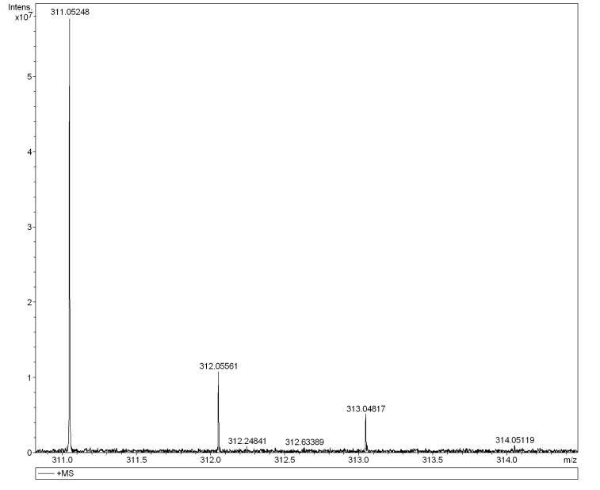
Figure S2. Positive-ion ESI-MS spectrum of [A+Na⁺] [C₁₆H₁₆NaOS₂]⁺ measured in methanol. The theoretical mass is 311.05348.
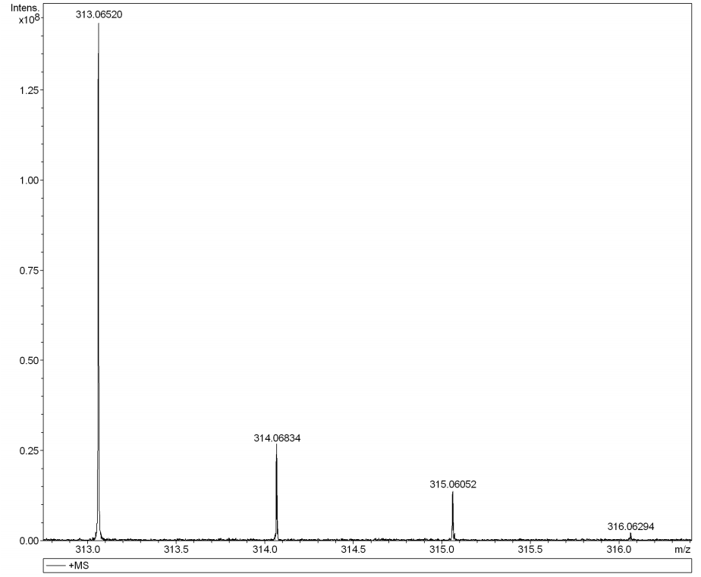
Figure S3. Positive-ion ESI-MS spectrum of [A-d₂+Na⁺] [C₁₆H₁₄D₂NaOS₂]⁺ measured in methanol. The theoretical mass is 313.06603.
Figure S4. The ¹H NMR (400 MHz, CDCl₃) spectrum of compound B-OMe.
Figure S5. The ¹³C NMR (100 MHz, CDCl₃) spectrum of compound B-OMe.

S2. In-depth discussion of the impact of inclusion of the -SMe anchors on the calculated PESs

It should be clear that the model system without -SMe anchors and Au-contacts is merely a crude approximation of the full molecular device. In the actual experimental setup, a lot of factors are at work which may affect the PES associated with this tautomerization process. Among others, the molecular bridge will generally not be in its equilibrium geometry: the separating Au-contacts interact with the molecule directly and induce significant – and varying – strain. Additionally, the -SMe anchors can be expected to hybridize to a significant extent with the molecular bridge and thus affects its electronic structure, and a significant bias is present across the device (i.e. the chemical potential is not equal on both sides of the bridge). Finally, local heating may also occur, which can be expected to significantly affect the kinetics of the tautomerization process as well.^{1,2}
An in-depth exploration of the effects, associated with all these factors, is beyond the scope of this work, but we did consider the effect of inclusion of the -SMe anchor units into the model system in isolation as a test of the robustness of our results. On the thermodynamic front, the switch in preference upon oxidation is retained when these units are included in the model system: in the neutral species, the keto-form is now more stable than the enol by 9.3 kcal/mol, in the charged species the enol drops 7.2 kcal/mol below the keto-form.
On the kinetic front however, a complication emerges due to the proneness to oxidation of the sulfur atoms: in the charged keto-form, the positive charge/radical electron tends to localize almost completely on the anchor and the adjacent phenyl units of the model system (cf. Fig. S6), so that the electronic structure of the keto-part of the molecule is barely affected upon oxidation. Even though the tautomerization reaction triggers a partial transfer of this charge from the -Ph-SMe units towards the central part of the molecule (cf. Fig. S7), the difference in the charge distribution on the central part of the model system affects the barrier height reduction upon oxidation: this time, the reaction barrier goes from 59.3 kcal/mol in the neutral species to 35.8 kcal/mol in the charged one. Even though at room temperature, the obtained reaction barrier for this modified model system is unrealistically high – which indicates that the other factors mentioned above should play a significant role as well –, both the thermodynamic switching and the dramatic reaction barrier reduction are still clearly obtained, underscoring the robustness of the results reported for the initial model system.
Figure S6. a) The atom-condensed Mulliken spin densities, calculated at B3LYP/def2-TZVP(PCM = tetrachloroethene) level-of-theory with F_{Z} = +0.05 V/Å, for the keto-form of the cationic model system without linker units; b) the atom-condensed Mulliken spin densities for the transition state of the cationic model system without linker units.

Figure S7. a) The atom-condensed Mulliken spin densities, calculated at B3LYP/def2-TZVP(PCM = tetrachloroethene) level-of-theory with F_{Z} = +0.05 V/Å, for the keto-form of the cationic model system with linker units included; b) the atom-condensed Mulliken spin densities for the transition state of the cationic model system with linker units included.

The potential energy profile associated with the (rejected) alternative H₂O-assisted mechanism in the presence of the linkers is shown in Fig. S8.
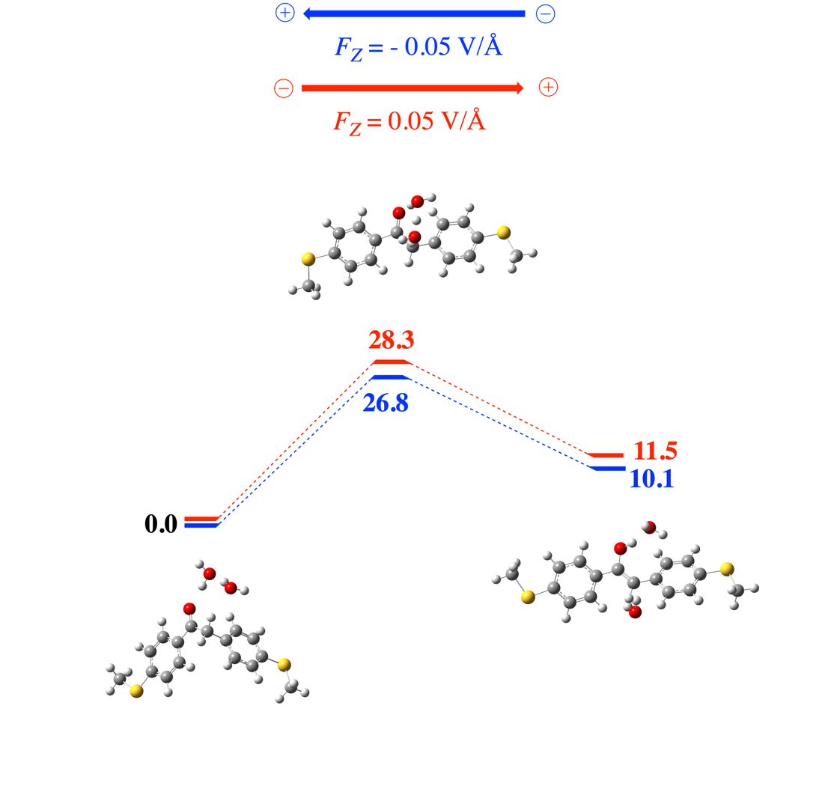
Figure S8. The potential energy profiles associated with the rejected alternative H₂O-assisted reaction mechanism for the uncharged species with -SMe linkers included in case F_{Z} = -0.05 V/Å (blue) and F_{Z} = +0.05 V/Å (red). Energies are denoted in kcal/mol.

S3. Valence Bond interpretation of the impact of oxidation on the potential energy surface

In this section, we will take a closer look at the root cause for the dramatic difference in tautomerization behavior of the uncharged and charged species of the molecular bridge. The electron transfer-triggered switch in thermodynamic preference can be straightforwardly understood by simply considering some common bond dissociation enthalpy (BDE) tables found in the literature.³
In the case of the uncharged species, the reactant bonds broken throughout the reaction are an RR’C=O (BDE $≈98$ kcal/mol) and HRR’C-H (BDE $≈105$ kcal/mol) bond, the product bonds being formed are the RO-H (BDE$≈110$ kcal/mol) and RR’C=CHR” (BDE$≈85$ kcal/mol) bond (Fig. S9a). As such, the thermodynamic driving force $∆E_{rp}$ associated with this reaction can be estimated at +8 kcal/mol (i.e. 98 + 105 – 110 – 85). Note that this crude estimate agrees perfectly with the calculated value presented in Fig. 4a of the main text.
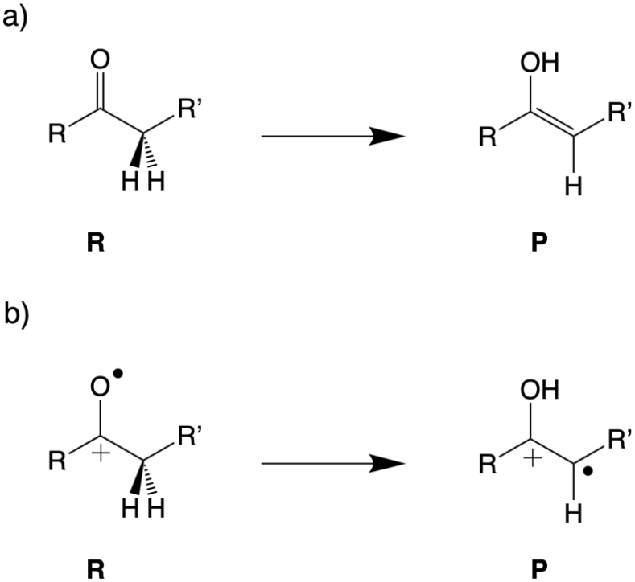
Figure S9. Schematic description of the tautomerization reaction for (a) the neutral, uncharged species and (b) the (positively) charged species.

In the case of charged species, it is straightforward to see that – in the idealized situation that the electron is removed exclusively from the keto-/enol-moiety of the molecule under consideration – there is only a single active bond in the tautomerization process: the HRR’C-H bond is broken in the reactant and replaced by the RO-H one in the product (Fig. S9b). Using the same bond dissociation enthalpy values as for the uncharged species,³ one ends up with an estimated thermodynamic driving force $∆E_{rp}$ of -5 kcal/mol. As such, we readily recover the experimentally observed thermodynamic switching, i.e. $∆E_{rp}$ goes from $+8→ -5$ kcal/mol upon removing an electron from the system. However, it should be clear that the obtained driving force does not correspond numerically to the calculated value presented in Fig. 4a in the main text, i.e. $∆E_{rp, calculated}$ = -22 kcal/mol.
The reason for this discrepancy is that the unpaired (radical) electron in the cation can readily delocalize, and will do so to a much greater extent in the enol-form than in the keto-form, due to the conjugation of the lone pair on the oxygen moiety with the adjacent π-type C-C^{•+} system (cf. Fig. S10a). The fingerprints of this resonance delocalization can be seen among others in the bond lengths: both the C-C and C-O bond lengths in the enol are intermediate between a single and double bond (Fig. S10b),³ similar to what one observes for a prototypical delocalized allyl radical. As some of us discussed in detail in a recent contribution, a loss or gain of delocalization is inherently connected to a relative thermodynamic penalty paid throughout the reaction.⁴ In the tautomerization reaction under consideration, it is the enol-form which is resonance stabilized compared to the keto-form. Based on the preceding argument, the magnitude of the resonance penalty associated with the tautomerization reaction can thus be crudely estimated at 17 kcal/mol, i.e. the magnitude of the discrepancy between the naively estimated and the actual, calculated $∆E_{rp}$.
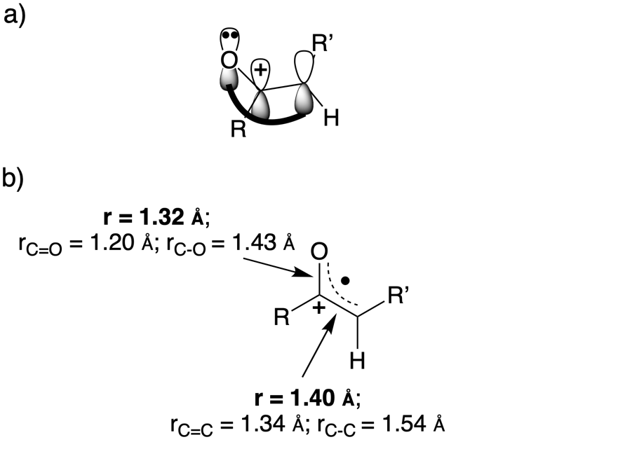
Figure S10. (a) The delocalized π-system in the charged enol; (b) the bond lengths for R, R’ = Ph.

Next to the switching in thermodynamic preference, the dramatic change in the kinetics of the tautomerization upon oxidation can also be readily understood from a qualitative valence bond (VB) analysis.⁵ Central to VB reactivity theory is the construction of so-called valence bond state correlation diagrams (VBSCD), which depict the evolution of individual diabatic states, corresponding to the electronic configuration of the reactant and, along the reaction coordinate. In practice, these diabatic states interact and mix as the reaction proceeds, and collectively they give rise to the adiabatic curve, i.e. the full ground-state PES associated to the chemical reaction under consideration (Fig. S11).
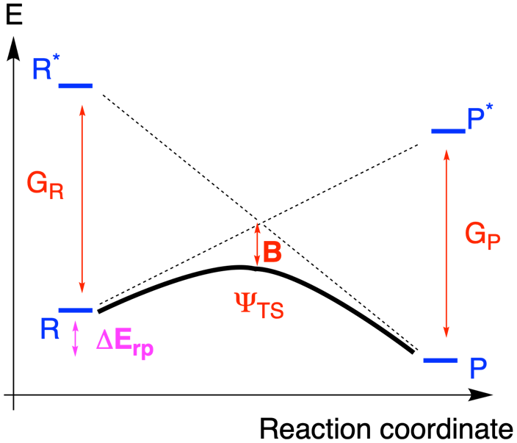
Figure S11. Generic VBSCDs, depicting the energy curves along the reaction coordinate, which connects the geometry of the reactants (R) to that of the products (P). The reactant diabatic curve connects state R with state P* (the “promoted” product state), and thus depicts the evolution of the (non-interacting) reactant electronic configuration throughout the reaction; the product diabatic curve connects state R* (the “promoted” reactant state) with state P, and thus depicts the evolution of the product configuration. G_{R} and G_{P} correspond to the promotion energies separating the diabatic curves respectively in the reactant and product geometry. The mixing of these two diabatic VB curves leads to the adiabatic state represented by the bold curve, with B corresponding to the interaction energy between the two curves. ΔE_{rp} corresponds to the thermodynamic driving force and Ψ_{TS} corresponds to the transition state.

Within this VB framework, the approximate barrier height associated with a generic chemical reaction can be estimated with the help of the following expression,

${∆E}^{≠} =f_{0}G_{0}+0.5 ∆E_{rp}-B$, | (S1)

where $f_{0}G_{0}$ corresponds to a fraction ($f_{0}$) of the average of the promotion gap on the reactant and product side,

$G_{0}=0.5 \left(G_{R}+G_{P}\right)$ . | (S2)

Let us now try to estimate the barrier height associated with the tautomerization reaction for both the uncharged and charged species.
For the neutral species, a schematic VBSCD with the main representative VB structures for the reactant and product diabatic curves in respectively the reactant and product geometry are shown in Fig. S12a.
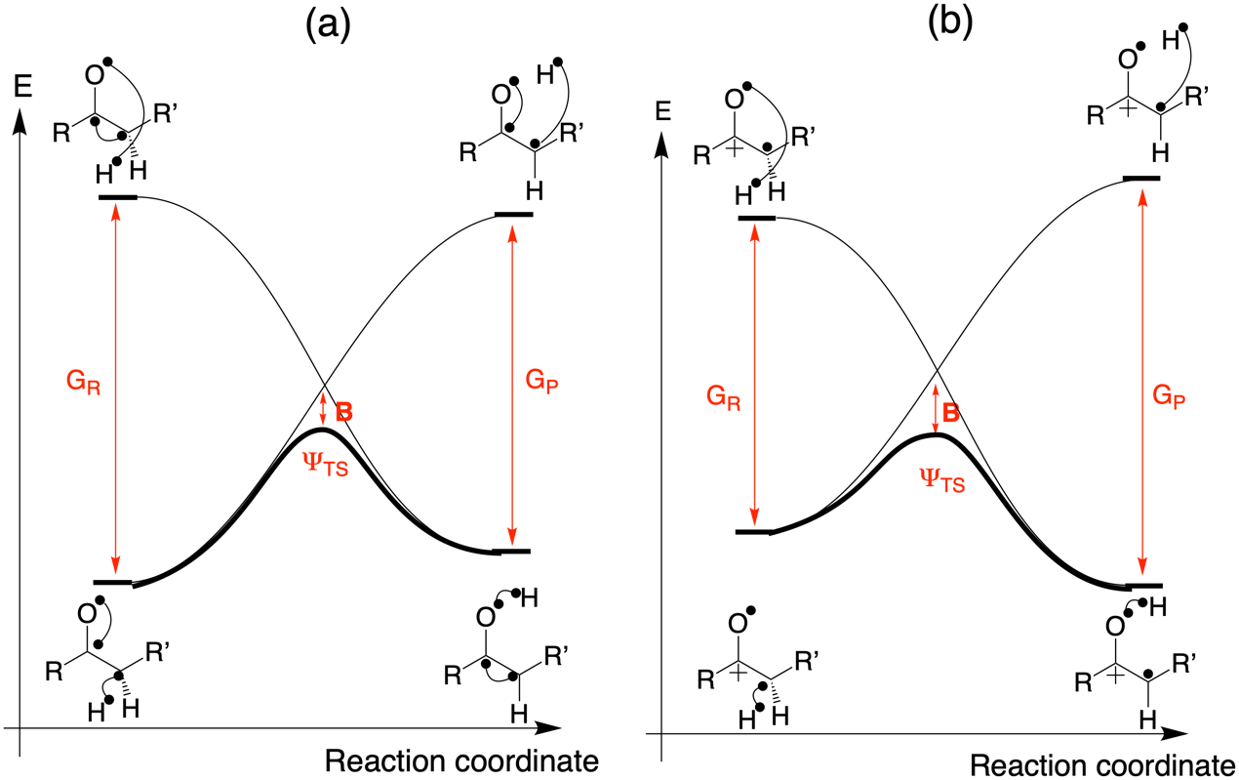
Figure S12. Schematic VBSCDs for the tautomerization reaction involving (a) the neutral, uncharged species and (b), the (positively) charged species.

The (vertical) promotion gap between R and R* can be estimated upon inspection of these two structures. In essence, R can be turned into R* by unpairing the RR’C=O and HRR’C-H bonds and at the same time re-pairing the resulting unpaired electrons residing on the adjacent carbon atoms into an RR’C=CHR” bond (the O and H centres are too far away in the reactant geometry for them to exhibit an actual bonding interaction). As explained in refs. 4 and 5, the energy required to “(un)pair” the electrons involved in a bond can be expressed as the corresponding singlet-triplet excitation energy. In Table S1, these quantities, calculated at B3LYP/def2-TZVP(PCM = tetrachloroethene) level of theory, are presented.

Table S1. ΔE_{ST} values for each of the bonds broken/formed during the promotion from R to R* and from P to P* respectively. The subscripts “R” and “P” denote whether the reactant or product geometry was used in the single-point calculations; the subscripts “broken” and “formed” denote whether the bond is an existing bond that is being broken during the promotion event, or a new bond that is being formed during the promotion.
bond | ΔE_{ST} (kcal/mol)
[C-H]_{R,broken} | 241
[C=O]_{R,broken} | 72
[C=C]_{R,formed} | 40
[O-H]_{P,broken} | 251
[C=C]_{P,broken} | 95
[C=O]_{P,formed} | 57

Based on the values in Table S1, one can estimate G_{R} to amount to 273 kcal/mol and G_{P} to 289 kcal/mol. Recall that we had already calculated $∆E_{rp}$ to amount to 8 kcal/mol. Based on these quantities and taking the common f₀ – value for concerted and radical reactions, 0.3, one ends up with an estimate for the crossing point of the two diabatic curves in the VBSCD of 88 kcal/mol, i.e. . 0.3 x 0.5 x (273 + 289) + 0.5 x 8. Since the actual calculated barrier amounts to 59 – 61 kcal/mol, depending on the direction of the electric field, we can estimate the B-factor in Eq. S1 at 27 – 29 kcal/mol. This (relatively low) value is perfectly in line with what one would expect for a 4-electron, 4-membered ring transition state geometry: due to symmetry reasons, mixing of the individual VB structures is limited in such a situation; taking cyclobutadiene (the most “notorious” square system) for example, B has previously been determined to amount to approximately 21 kcal/mol.⁶
We can now follow the same approach to estimate the barrier for the charged species (cf. the VBSCD in Fig. S12b). With the help of Table S1, G_{R} and G_{P} can now respectively be estimated at 241 and 251 kcal/mol. As discussed above, $∆E_{rp}$ amounts to -22 kcal/mol. Setting f₀ again to 0.3, one ends up with an estimate for the crossing point of the two diabatic curves in the VBSCD of 63 kcal/mol. Our calculations indicate that in reality, ${∆E}^{≠}$ amounts to 22.9 kcal/mol. Based on this value, we can estimate that B amounts to approximately 40 kcal/mol. This is again a reasonable value: it is higher than the typical B values for the square (and thus resonance-hampered) transition states, and it is lower than the typical B values of approximately 50 kcal/mol previously determined for intramolecular H-abstraction reactions in which the reactants are unrestraint and thus approach optimally, which maximizes the overlap of the involved orbitals, and thus also the magnitude of B.⁵
Putting everything together now, we can conclude that dramatic change in the kinetics upon oxidation of the molecular bridge is the collective effect of each of the individual factors in Eq. S1: the cationic species exhibits a lower promotion energy, a bigger thermodynamic driving force and a bigger B. The difference in promotion energy results in approximately 12 kcal/mol barrier lowering, the change in ΔE_{rp} lowers the barrier by an additional 15 kcal/mol, and B pushes the barrier 15 kcal/mol down as well.
One final issue that remains to be addressed is the role of the (weak) electric field. As evident from comparison of Fig. 4a and Extended Data Fig. S7, application of a field of +0.05 V/A leads to reaction barriers and thermodynamic driving forces that are a couple of kcal/mol lower (22.9 kcal/mol and -22.0 kcal/mol respectively) than when the field is applied in the opposite direction, i.e. – 0.05 V/A (24.9 kcal/mol and -19.4 kcal/mol respectively). The root cause of these slight shifts is a change in the delocalization of the keto-form: under the influence of a field of +0.05 V/Å, the spin density on the O-atom (which is the reactive site in the H-abstraction reaction) amounts to 0.29e, under the influence of a field of -0.05 V/Å, this spin density decreases to 0.22e (cf. Fig. S13). The higher extent of localization in the positive field means that a bigger gain of delocalization energy is associated with the tautomerization reaction towards the enol under these circumstances. Hence, the thermodynamic driving force increases, and according to the Bell-Evans-Polanyi principle (as well as Eq. S1), this will also reduce the reaction barrier.⁴

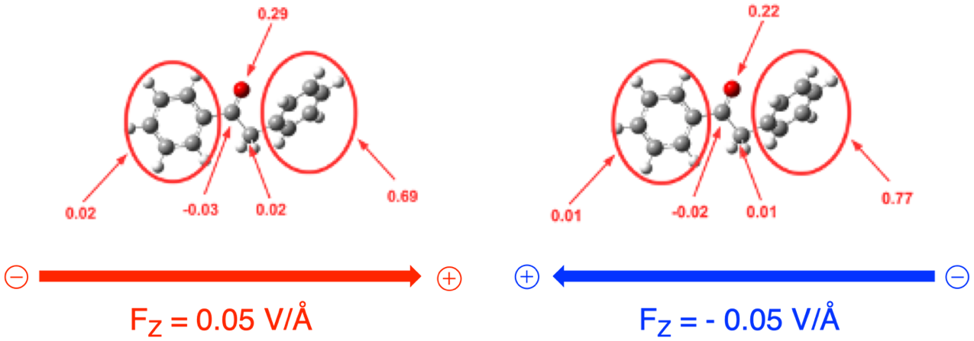
Figure S13. The atom-condensed Mulliken spin densities, calculated at B3LYP/def2-TZVP(PCM = tetrachloroethene) level-of-theory with F_{Z} = +0.05 V/Å (left) and F_{Z} = -0.05 V/Å (right), for the keto-form of the cationic model system.

S4. Marcus theory analysis of the charge transfer event

To gauge whether a thermal transition from the uncharged to charged Marcus parabola is feasible and can consequently explain the tautomerization giving rise to the observed switching behavior in the conductance, we followed the analysis by Nitzan and co-workers⁷. Let us first consider the thermodynamic driving force, i.e. the energy difference between the minimum of the two parabolas in Fig. 4b. This energy difference, $ΔE_{MB-{MB}^{+}}$, can be expressed as follows:
$ΔE_{{MB}^{+}-MB}=IP\left(MB\right)-E_{F}\left(electrode\right)-eV/2$ , | (S3)
where IP(MB) corresponds to the ionization potential of the molecular bridge, $E_{F}\left(electrode\right)$ corresponds to the (unbiased) Fermi energy of the electrodes and V corresponds to the applied voltage.
From the TVS, presented in Fig. 3c, this energy difference can be estimated straightforwardly. By definition, the transition voltage, determined at 0.8 V, is the tipping point at which the HOMO transport channel gets emptied/filled, i.e. $E_{{MB}^{+}}$ and $E_{MB}$ cross at this voltage. Hence, a voltage of 0.8 V corresponds to the point where $ΔE_{{MB}^{+}-MB}$ = 0 kcal/mol. From Eq. S3, one can then reason that at a voltage of 0.45 – 0.50 V, $ΔE_{{MB}^{+}-MB}$ ~ 3.5 kcal/mol.
According to Marucs theory, the reaction barrier height for the charge transfer event amounts to,
${ΔE}_{{MB}^{+}-MB}^{≠}= \frac{{(λ+ΔE_{MB^{+}-MB} )}^{2}}{4λ}$ , | (S4)
where $λ$ corresponds to the reorganization energy. In accordance with the methodology used by Nitzan and co-workers in Ref. 7, the reorganization energy was estimated from gas-phase calculations on the isolated molecular bridge (with linkers included): the energy difference between $E_{MB}$ and $E_{{MB}^{+}}$ was determined in the optimal geometry of the uncharged molecular bridge, after which the resulting value was corrected to reflect the actual alignment between the two Marcus parabolas as inferred from the experimental data, i.e. $ΔE_{{MB}^{+}-MB}$ = 3.5 kcal/mol (cf. Eq. S3). Using this approach, an approximate $λ$ value of 5.5 kcal/mol could be determined. Plugging this value into Eq. S4, one ends up with a barrier height of 3.7 kcal/mol (in the limit of no interaction between the two diabatic parabolas; in reality this value will be even lower).
As such, the inferred thermodynamic driving force together with the crudely estimated reaction barrier suggest that a transition from the uncharged parabola to the charged parabola and vice versa will occur rapidly at room temperature. Hence, this thermal charge transfer mechanism is a plausible trigger of the tautomerization reaction; the bias window does not need to reach the HOMO peak in the transmission spectrum for the electron transfer to occur.

S5. Geometries and energies

Units:
- Coordinates are expressed in Å
- Energies are expressed in a.u.

- Direct tautomeric switch mechanism (F_{z} = +0.05 V/Å)

Keto-form of the charged model system without linkers

B3LYP/def2-TZVP geometry:

C 1.210243 0.499384 2.486519
C 1.305255 0.978064 3.799224
C 0.207481 0.917274 4.625983
C -1.031975 0.435044 4.092236
C -1.108509 -0.093150 2.788548
H 2.086524 0.511779 1.851273
H 2.254555 1.342480 4.168132
H -1.947194 0.595554 4.643943
H -2.050743 -0.473767 2.420193
C 0.270008 1.232148 6.094345
H -0.303593 2.135629 6.331578
H 1.293230 1.422353 6.418498
C -0.302210 0.042732 6.845077
O -0.809042 -0.852607 6.167473
C -0.256430 -0.041490 8.310263
C 0.310488 0.981524 9.082613
C -0.798969 -1.169528 8.944399
C 0.331564 0.876250 10.464789
H 0.733762 1.859874 8.615324
C -0.772007 -1.268823 10.323921
H -1.236041 -1.955138 8.343915
H 0.767926 1.668335 11.058347
H -1.189669 -2.140137 10.810407
C 0.000928 -0.046811 1.984752
H -0.038305 -0.400627 0.963780
C -0.207520 -0.246694 11.084707
H -0.188073 -0.326641 12.164004

B3LYP/def2-TZVP energy: -615.8958591

Transition state of the charged model system without linkers

B3LYP/def2-TZVP geometry:

C 0.926946 1.195908 2.625885
C 0.350102 1.778560 3.730473
C -0.166267 0.972039 4.780871
C -0.108696 -0.440128 4.652921
C 0.468651 -1.010532 3.542479
H 1.329788 1.812997 1.834594
H 0.292082 2.855995 3.814616
H -0.516031 -1.070685 5.432414
H 0.518656 -2.086775 3.449788
C -0.766639 1.615915 5.908116
H -2.158371 1.690952 5.778388
H -0.511337 2.655911 6.106273
C -1.355450 0.910797 7.079997
O -2.604635 1.053890 6.897485
C -0.760115 0.245291 8.193374
C 0.641172 0.189587 8.307945
C -1.575585 -0.345408 9.179017
C 1.215582 -0.445517 9.393794
H 1.265627 0.644646 7.550488
C -0.990172 -0.978836 10.256384
H -2.651521 -0.298893 9.080396
H 2.291605 -0.490313 9.489519
H -1.607732 -1.436861 11.016781
C 0.989028 -0.198669 2.525207
H 1.436209 -0.654696 1.651920
C 0.401375 -1.027892 10.362984
H 0.853907 -1.526078 11.210735

B3LYP/def2-TZVP energy: -615. 8509068

Enol-form of the charged model system without linkers

B3LYP/def2-TZVP geometry:

C 0.855896 1.560319 2.543221
C 0.824901 1.481604 3.914375
C 0.123391 0.429636 4.577436
C -0.540107 -0.544103 3.774675
C -0.495848 -0.455270 2.403246
H 1.387672 2.365141 2.054732
H 1.332994 2.227610 4.511719
H -1.072367 -1.355400 4.242002
H -0.996908 -1.199775 1.799729
C 0.157716 0.442088 5.989861
H 0.738962 1.237659 6.433295
C -0.473122 -0.396835 6.918271
C -0.289434 -0.247252 8.354324
C 0.892706 0.303978 8.882389
C -1.295382 -0.673374 9.242300
C 1.062956 0.410909 10.250950
H 1.693018 0.610724 8.223981
C -1.122799 -0.550261 10.608918
H -2.240274 -1.050050 8.869481
H 1.982817 0.820259 10.645987
H -1.911430 -0.861896 11.280153
C 0.195566 0.591458 1.779754
H 0.220674 0.648990 0.699456
C 0.057829 -0.012646 11.116899
H 0.192049 0.079491 12.186610
O -1.296263 -1.330603 6.465032
H -1.599440 -1.921234 7.171103

B3LYP/def2-TZVP energy: -615.9287424

Keto-form of the uncharged model system without linkers

B3LYP/def2-TZVP geometry:

C 1.227624 0.171861 2.513355
C 1.248212 0.378836 3.887913
C 0.084818 0.720972 4.576363
C -1.101877 0.853891 3.855998
C -1.127663 0.648006 2.481556
H 2.141028 -0.091476 1.994836
H 2.180459 0.273668 4.431176
H -2.015614 1.121734 4.374218
H -2.057810 0.757081 1.938019
C 0.107772 0.938481 6.065345
H -0.626303 1.697974 6.350247
H 1.079587 1.331938 6.377999
C -0.172593 -0.313729 6.897989
O -0.386211 -1.388294 6.378309
C -0.175083 -0.178556 8.393847
C 0.058268 1.034810 9.047593
C -0.423116 -1.322415 9.160170
C 0.043414 1.102155 10.435749
H 0.252682 1.935439 8.482120
C -0.437520 -1.255530 10.544554
H -0.602833 -2.257091 8.646659
H 0.225189 2.047982 10.930128
H -0.630377 -2.148300 11.126019
C 0.038326 0.305622 1.805565
H 0.020853 0.147687 0.734732
C -0.204176 -0.041535 11.186106
H -0.215371 0.011804 12.267675

B3LYP/def2-TZVP energy: -616.17687

Transition state of the uncharged model system without linkers

B3LYP/def2-TZVP geometry:

C 1.026955 1.298271 2.623581
C 0.569364 1.730782 3.861351
C -0.187157 0.892246 4.693860
C -0.462648 -0.403212 4.229984
C -0.000353 -0.832827 2.993157
H 1.607297 1.972992 2.005834
H 0.800072 2.736281 4.193803
H -1.050264 -1.082760 4.834312
H -0.227066 -1.840047 2.664718
C -0.651492 1.431662 6.001945
H -2.125497 1.157209 5.837039
H -0.048888 2.266890 6.348281
C -1.205254 0.568994 7.007496
O -2.400516 0.227086 6.649573
C -0.651790 0.134111 8.280208
C 0.704854 0.338118 8.565345
C -1.465859 -0.515468 9.220015
C 1.237253 -0.098868 9.768651
H 1.334651 0.823821 7.832338
C -0.925899 -0.962758 10.414463
H -2.514783 -0.656482 8.998217
H 2.285880 0.058368 9.984599
H -1.553882 -1.469013 11.136096
C 0.746343 0.011644 2.177306
H 1.101110 -0.326789 1.212577
C 0.423715 -0.751678 10.690507
H 0.842033 -1.097363 11.627588

B3LYP/def2-TZVP energy: -616.0739266

Enol-form of the uncharged model system without linkers

B3LYP/def2-TZVP geometry:

C 0.816654 1.564365 2.507539
C 0.784849 1.485942 3.891425
C 0.109999 0.445774 4.555346
C -0.539443 -0.517046 3.762153
C -0.502997 -0.436294 2.376621
H 1.345039 2.378526 2.027122
H 1.291786 2.242365 4.479534
H -1.071989 -1.326944 4.234722
H -1.009787 -1.191131 1.787820
C 0.143407 0.443368 6.013879
H 0.691635 1.267428 6.451835
C -0.416011 -0.400184 6.903129
C -0.258518 -0.253158 8.364804
C 0.940566 0.202069 8.928743
C -1.313069 -0.582510 9.227934
C 1.073136 0.338661 10.302888
H 1.779417 0.426709 8.283657
C -1.176547 -0.448329 10.604180
H -2.261362 -0.911145 8.820424
H 2.011374 0.686652 10.716737
H -2.009075 -0.696825 11.250551
C 0.171694 0.600340 1.739421
H 0.192932 0.656953 0.658613
C 0.015879 0.013843 11.148343
H 0.123237 0.116358 12.220734
O -1.225969 -1.424664 6.485469
H -1.321058 -2.069956 7.196275

B3LYP/def2-TZVP energy: -616.1642926

Keto-form of the charged model system with linkers

B3LYP/def2-TZVP geometry:

16 0.080020 0.116116 0.157019
16 -0.102691 -0.057299 12.908037
C 1.365005 0.475950 2.590557
C 1.295282 0.691730 3.944452
C 0.056668 0.822461 4.605482
C -1.128579 0.722957 3.852033
C -1.085031 0.511659 2.498910
C 0.169777 0.381937 1.840280
H 2.327419 0.382173 2.110646
H 2.210907 0.763293 4.516871
H -2.085745 0.813387 4.347145
H -1.999508 0.439163 1.924582
C 0.004914 1.040521 6.078386
H -0.734767 1.811901 6.316491
H 0.967821 1.392275 6.448687
C -0.407414 -0.228760 6.871212
O -0.788519 -1.218810 6.283773
C -0.322355 -0.166994 8.348250
C 0.023713 0.993317 9.055215
C -0.607836 -1.327275 9.077844
C 0.076886 0.992780 10.435002
H 0.248885 1.914296 8.534780
C -0.552942 -1.337873 10.459338
H -0.876851 -2.226103 8.539925
C -0.208863 -0.174557 11.159779
H 0.342295 1.900484 10.962196
H -0.779781 -2.253085 10.986056
C 1.771931 -0.033001 -0.441194
H 2.323377 0.887949 -0.260763
H 2.263411 -0.886167 0.023000
H 1.678887 -0.200903 -1.512180
C -0.525497 -1.714612 13.498425
H -1.538810 -1.991972 13.213223
H 0.188580 -2.457151 13.146691
H -0.467166 -1.653216 14.583913

B3LYP/def2-TZVP energy: -1491.0345859

Transition state of the charged model system with linkers

B3LYP/def2-TZVP geometry:

C 1.031295 1.145164 2.684134
C 0.458938 1.722212 3.781106
C -0.140007 0.932564 4.801696
C -0.136594 -0.476963 4.629961
C 0.435182 -1.061670 3.529379
H 1.487353 1.764404 1.922315
H 0.460797 2.799774 3.882126
H -0.596070 -1.109198 5.378816
H 0.420993 -2.137343 3.436556
C -0.777391 1.575421 5.904246
H -2.213106 1.599884 5.799883
H -0.503334 2.607225 6.113856
C -1.386988 0.863331 7.062390
O -2.645588 0.972251 6.871292
C -0.797106 0.224123 8.187080
C 0.604017 0.208747 8.356144
C -1.607015 -0.387239 9.165837
C 1.167146 -0.386834 9.457648
H 1.240839 0.676009 7.616746
C -1.044866 -0.987841 10.268049
H -2.681559 -0.381321 9.042160
H 2.242206 -0.389298 9.581502
H -1.688088 -1.451020 11.000715
C 1.033667 -0.265177 2.528452
C 0.352832 -0.995204 10.435010
16 1.179727 -1.711162 11.786751
16 1.780073 -0.864796 1.098263
C -0.132760 -2.382839 12.836064
H -0.703503 -3.149332 12.315544
H 0.386630 -2.837520 13.677842
H -0.787441 -1.595692 13.205304
C 1.599086 -2.661201 1.168528
H 0.549029 -2.946852 1.174453
H 2.064787 -3.026403 0.255243
H 2.123498 -3.073346 2.028353

B3LYP/def2-TZVP energy: -1490.9681977

Enol-form of the charged model system with linkers

B3LYP/def2-TZVP geometry:

16 -2.051937 1.707286 0.439839
16 1.077545 -0.413513 12.692711
C -0.454101 0.569098 2.414785
C -0.179418 0.307821 3.734047
C -1.018495 0.785995 4.778984
C -2.129667 1.589787 4.393985
C -2.416083 1.841151 3.082197
C -1.588671 1.325800 2.053997
H 0.222427 0.203634 1.656820
H 0.742505 -0.210152 3.961985
H -2.772819 1.992884 5.165713
H -3.278690 2.440539 2.820493
C -0.807733 0.563696 6.164376
H -1.375634 1.201211 6.826444
C -0.029459 -0.402441 6.792083
C 0.234553 -0.415387 8.212200
C -0.011157 0.707596 9.032642
C 0.775891 -1.566219 8.817600
C 0.257051 0.672780 10.378498
H -0.390688 1.625458 8.606667
C 1.043560 -1.606792 10.169377
H 0.973957 -2.439178 8.213251
C 0.787526 -0.488129 10.977080
H 0.067771 1.548828 10.985357
H 1.448684 -2.512778 10.594516
C -0.809413 0.935455 -0.620916
H 0.175828 1.361441 -0.441755
H -0.801072 -0.144744 -0.490301
H -1.122898 1.171238 -1.636090
C 1.756175 -2.035289 13.118338
H 1.037571 -2.828701 12.921304
H 2.691333 -2.221752 12.593814
H 1.951175 -1.988749 14.188241
O 0.515817 -1.432465 6.127623
H 0.123880 -1.533263 5.249273

B3LYP/def2-TZVP energy: -1491.044299

Keto-form of the uncharged model system with linkers

B3LYP/def2-TZVP geometry:

16 -0.027061 0.248391 0.042299
16 -0.343687 0.009927 12.947168
C 1.298770 0.411040 2.513370
C 1.290870 0.581915 3.894470
C 0.108180 0.790602 4.596242
C -1.083012 0.824506 3.868011
C -1.091292 0.655691 2.494157
C 0.103855 0.445498 1.794958
H 2.242604 0.254587 2.011138
H 2.233816 0.551725 4.428969
H -2.023237 0.985788 4.382897
H -2.030356 0.687895 1.954974
C 0.106726 0.967949 6.089458
H -0.651600 1.699645 6.384628
H 1.063052 1.380478 6.424726
C -0.148799 -0.313554 6.886985
O -0.312449 -1.382464 6.334631
C -0.190760 -0.214438 8.378511
C -0.014455 0.986106 9.077332
C -0.419220 -1.377550 9.117942
C -0.066026 1.019901 10.459511
H 0.164868 1.910996 8.546827
C -0.472645 -1.355507 10.501713
H -0.556174 -2.308207 8.583836
C -0.296642 -0.151799 11.191754
H 0.072205 1.960260 10.978857
H -0.651737 -2.278179 11.034267
C 1.678767 -0.010881 -0.500277
H 2.304811 0.853345 -0.282199
H 2.106135 -0.910200 -0.058886
H 1.620809 -0.140587 -1.579900
C -0.660983 -1.670040 13.539465
H -1.619221 -2.044840 13.183036
H 0.140788 -2.351039 13.258164
H -0.693474 -1.590393 14.625031

B3LYP/def2-TZVP energy: -1491.2729931

Transition state of the uncharged model system with linkers

B3LYP/def2-TZVP geometry:

16 -0.264784 1.322037 0.507534
16 -1.699329 0.980629 12.051796
C 1.410895 1.332208 2.638965
C 1.862074 0.984662 3.900396
C 1.156772 0.086558 4.717202
C -0.029455 -0.441988 4.194824
C -0.489835 -0.093694 2.929999
C 0.222764 0.798132 2.128845
H 1.988843 2.027156 2.040985
H 2.786343 1.418587 4.264143
H -0.611950 -1.146914 4.775051
H -1.416051 -0.528771 2.581695
C 1.715385 -0.248034 6.055591
H 2.376599 0.525002 6.438544
H 1.786783 -1.747385 5.904200
C 0.938751 -0.975466 7.023075
O 0.894762 -2.221003 6.663252
C 0.323785 -0.530865 8.253965
C 0.206681 0.838264 8.545888
C -0.195102 -1.458656 9.168080
C -0.407019 1.260935 9.705894
H 0.587835 1.566827 7.842914
C -0.823856 -1.040839 10.326382
H -0.095037 -2.514721 8.957049
C -0.935606 0.326362 10.611676
H -0.494300 2.319752 9.914780
H -1.216323 -1.781340 11.007417
C -2.307149 -0.473937 12.939605
H -3.035642 -1.025045 12.347250
H -1.490735 -1.126700 13.244135
H -2.797468 -0.081250 13.828981
C -1.742723 0.340000 0.156366
H -2.555857 0.574253 0.842454
H -2.042349 0.619223 -0.852647
H -1.526344 -0.727414 0.178284

B3LYP/def2-TZVP energy: -1491.170376

Enol-form of the uncharged model system with linkers

B3LYP/def2-TZVP geometry:

16 -2.219567 1.472522 0.373501
16 1.083477 -0.493651 12.756099
C -0.440036 0.683974 2.398052
C -0.108415 0.514783 3.738018
C -0.996308 0.857452 4.769080
C -2.229310 1.413362 4.380859
C -2.566030 1.584863 3.053078
C -1.677679 1.213168 2.033355
H 0.287414 0.411815 1.646853
H 0.888618 0.161056 3.971229
H -2.937553 1.709318 5.145799
H -3.528157 2.011569 2.796005
C -0.702764 0.704116 6.192995
H -1.217567 1.390226 6.851943
C 0.058314 -0.241230 6.784863
C 0.319814 -0.313908 8.231055
C 0.184766 0.803351 9.069163
C 0.725038 -1.515952 8.818378
C 0.417791 0.713363 10.427867
H -0.083218 1.763933 8.650142
C 0.962612 -1.613753 10.183945
H 0.849352 -2.391456 8.197345
C 0.809004 -0.500611 11.008970
H 0.311842 1.596306 11.046648
H 1.267795 -2.567294 10.590205
C -0.837811 0.892145 -0.639496
H 0.062239 1.479538 -0.463623
H -0.639324 -0.166185 -0.476149
H -1.157127 1.036300 -1.670445
C 1.626575 -2.180028 13.122319
H 0.851973 -2.910184 12.891794
H 2.546342 -2.426689 12.593646
H 1.819144 -2.195537 14.194110
O 0.639743 -1.273850 6.101017
H 0.274326 -1.310685 5.206558

B3LYP/def2-TZVP energy: -1491.2619616

- Alternative H₂O-assisted mechanism

Keto-form without linkers (F_{z} = -0.05 V/Å)

B3LYP/def2-TZVP geometry:

C 2.610119 -1.936590 1.319557
C 1.718024 -0.911861 1.616759
C 1.455301 0.098861 0.691928
C 2.108714 0.061239 -0.541844
C 2.997927 -0.963987 -0.842165
C 3.251538 -1.967566 0.086872
H 2.804427 -2.708488 2.053661
H 1.229562 -0.893566 2.584072
H 1.925490 0.840421 -1.271541
H 3.496413 -0.975625 -1.803542
C 0.510103 1.237457 1.040516
H 1.082428 2.158898 1.167665
H 0.020125 1.025348 1.990557
C -0.527683 1.490875 -0.039640
O -0.354614 2.386167 -0.857867
C -1.753177 0.646655 -0.117320
C -1.979849 -0.429124 0.747038
C -2.713670 0.948145 -1.091323
C -3.138510 -1.187055 0.638967
H -1.251805 -0.687978 1.501573
C -3.871825 0.195598 -1.194235
H -2.533582 1.781728 -1.755893
C -4.086394 -0.874987 -0.328789
H -3.301896 -2.019051 1.311470
H -4.610877 0.441054 -1.946244
O 1.663730 4.323341 -1.026284
H 0.947491 3.657319 -0.983013
H 1.223056 5.178038 -1.080762
O 2.873231 3.917532 1.492939
H 3.706756 3.453754 1.364257
H 2.542157 4.114331 0.595057
H -4.991958 -1.463175 -0.408457
H 3.945889 -2.764758 -0.146443

B3LYP/def2-TZVP energy = -769.1291904355553

TS without linkers (F_{z} = -0.05 V/Å)

B3LYP/def2-TZVP geometry:

C 3.930923 -1.357027 0.937541
C 2.567949 -1.175678 1.117796
C 1.793063 -0.435040 0.206894
C 2.460179 0.114997 -0.902047
C 3.826023 -0.073582 -1.082957
C 4.574490 -0.803056 -0.165707
H 4.493650 -1.933611 1.661762
H 2.083095 -1.617835 1.980982
H 1.893773 0.667962 -1.637385
H 4.308162 0.351789 -1.955638
C 0.346518 -0.303383 0.460306
H -0.059394 -1.096166 1.077114
C -0.582398 0.388732 -0.343738
O -0.288256 1.365009 -1.108062
C -2.043111 0.050122 -0.229569
C -2.504704 -1.212417 0.157136
C -2.984866 1.033025 -0.552062
C -3.866517 -1.477748 0.235415
H -1.799973 -2.003383 0.375436
C -4.345392 0.772046 -0.466272
H -2.628335 2.002384 -0.872537
C -4.791692 -0.485230 -0.069922
H -4.205302 -2.463194 0.529909
H -5.059796 1.548927 -0.709494
O 1.087291 3.130363 0.070293
H 0.609090 2.443948 -0.536956
H 2.020776 3.137424 -0.174824
H 0.887750 2.527031 1.257790
O 0.654326 1.836353 2.093084
H 0.417195 0.908486 1.540636
H -0.124883 2.132591 2.584821
H 5.638695 -0.941620 -0.308128
H -5.852680 -0.691932 -0.005329

B3LYP/def2-TZVP energy = -769.0814798359439

Enol-form without linkers (F_{z} = -0.05 V/Å)

B3LYP/def2-TZVP geometry:

C 4.072798 -1.327019 0.207968
C 2.687003 -1.351556 0.278419
C 1.908801 -0.290885 -0.215210
C 2.586705 0.785547 -0.814145
C 3.974207 0.807731 -0.885795
C 4.727354 -0.243219 -0.369344
H 4.643933 -2.157190 0.604964
H 2.188184 -2.202822 0.726430
H 2.022007 1.600837 -1.246283
H 4.469147 1.647054 -1.359328
C 0.451686 -0.388817 -0.136060
H 1.859895 2.736245 2.517688
H 0.065774 -1.398518 -0.082961
C -0.469999 0.598427 -0.069862
O -0.194178 1.922204 0.054769
C -1.924043 0.325419 -0.092962
C -2.452387 -0.799066 -0.742686
C -2.811745 1.201760 0.542409
C -3.817195 -1.056898 -0.721980
H -1.793077 -1.462015 -1.287195
C -4.176783 0.943792 0.559064
H -2.419851 2.083131 1.029826
C -4.686180 -0.188604 -0.066231
H -4.204488 -1.930134 -1.232036
H -4.844494 1.629536 1.065571
O 2.002780 2.723819 1.563976
H 0.656761 2.090952 0.512707
H 2.777722 2.166502 1.416135
O -1.825277 -3.274702 1.500964
H -2.288123 -2.527050 1.101548
H -1.668627 -3.011019 2.414394
H -5.750041 -0.388452 -0.053465
H 5.808183 -0.222021 -0.425571

B3LYP/def2-TZVP energy = -769.1112264357016

Keto-form without linkers (F_{z} = +0.05 V/Å)

B3LYP/def2-TZVP geometry:

C 2.598709 -1.972845 1.274210
C 1.727429 -0.934252 1.584958
C 1.464959 0.079661 0.663552
C 2.097594 0.031241 -0.580623
C 2.965476 -1.007966 -0.894667
C 3.218737 -2.014740 0.030972
H 2.791464 -2.749133 2.004396
H 1.252030 -0.908732 2.558845
H 1.914745 0.811843 -1.308741
H 3.445170 -1.029599 -1.865062
C 0.537733 1.228911 1.023896
H 1.115947 2.147658 1.141582
H 0.059697 1.023802 1.981795
C -0.515591 1.491924 -0.041060
O -0.350055 2.393160 -0.852818
C -1.742197 0.649252 -0.108468
C -1.972796 -0.412659 0.772121
C -2.698480 0.935494 -1.091177
C -3.131842 -1.170690 0.672144
H -1.246228 -0.661518 1.531600
C -3.856255 0.181170 -1.187489
H -2.514425 1.755582 -1.771160
C -4.075177 -0.874509 -0.305324
H -3.297368 -1.993998 1.355007
H -4.588898 0.411142 -1.950275
O 1.745120 4.247799 -0.947184
H 0.993341 3.621471 -0.955655
H 1.432102 5.050154 -1.377370
O 2.728444 4.147846 1.674852
H 3.575076 3.701349 1.571601
H 2.406596 4.284235 0.761221
H 3.894296 -2.824036 -0.215220
H -4.978712 -1.466066 -0.382939

B3LYP/def2-TZVP energy = -769.1296896355511

TS without linkers (F_{z} = +0.05 V/Å)

B3LYP/def2-TZVP geometry:

C 3.925583 -1.331541 0.938059
C 2.568589 -1.132814 1.146410
C 1.778569 -0.411989 0.233678
C 2.422684 0.100867 -0.905544
C 3.782138 -0.103634 -1.114231
C 4.546602 -0.813894 -0.194977
H 4.500807 -1.896469 1.661972
H 2.099659 -1.549034 2.031284
H 1.844660 0.634936 -1.646229
H 4.244761 0.289328 -2.011878
C 0.335747 -0.265072 0.513349
H -0.070111 -1.068414 1.116865
C -0.597659 0.427426 -0.289967
O -0.308873 1.421272 -1.031009
C -2.053146 0.066918 -0.203272
C -2.497877 -1.213993 0.139691
C -3.005593 1.041676 -0.519260
C -3.855723 -1.506654 0.179416
H -1.781973 -1.998345 0.345351
C -4.362176 0.753093 -0.471066
H -2.661303 2.024274 -0.811393
C -4.792415 -0.523219 -0.120142
H -4.182091 -2.508028 0.431163
H -5.085620 1.520819 -0.716053
O 1.179164 3.097670 0.091355
H 0.643543 2.426865 -0.502730
H 2.106480 3.047410 -0.172790
H 0.969077 2.537046 1.252381
O 0.686919 1.868048 2.124583
H 0.433527 0.928435 1.571228
H -0.112811 2.199596 2.556029
H 5.604764 -0.969129 -0.362440
H -5.850252 -0.753165 -0.093548

B3LYP/def2-TZVP energy = -769.0788674359652

Enol-form without linkers (F_{z} = +0.05 V/Å)

B3LYP/def2-TZVP geometry:

C 3.851911 -1.100139 1.436619
C 2.464969 -1.058946 1.467738
C 1.727294 -0.435526 0.448140
C 2.446831 0.119811 -0.624792
C 3.835305 0.076458 -0.655713
C 4.547825 -0.526421 0.377335
H 4.391562 -1.587785 2.239216
H 1.933971 -1.517277 2.293774
H 1.914976 0.566662 -1.454439
H 4.362068 0.500218 -1.501910
C 0.264135 -0.453250 0.518700
H 1.818253 3.490287 1.165201
H -0.157924 -1.265719 1.096057
C -0.625527 0.442527 0.024543
O -0.295959 1.618335 -0.560775
C -2.090282 0.240977 0.097866
C -2.658733 -1.037833 0.163900
C -2.945034 1.350362 0.091885
C -4.034614 -1.197910 0.249338
H -2.026852 -1.914232 0.111749
C -4.321353 1.186875 0.177039
H -2.519639 2.341226 0.021440
C -4.872744 -0.086940 0.260217
H -4.454577 -2.195178 0.289151
H -4.965220 2.057607 0.173516
O 1.932373 3.042564 0.319033
H 0.566917 1.970756 -0.255292
H 2.703716 2.469473 0.420642
O -0.169748 -2.965902 -1.696091
H -0.686058 -2.732203 -2.475475
H 0.050773 -2.120607 -1.281671
H 5.629140 -0.563506 0.346532
H -5.946394 -0.214618 0.317502

B3LYP/def2-TZVP energy = -769.1095979357149

Keto-form with linkers (F_{z} = -0.05 V/Å)

B3LYP/def2-TZVP geometry:

C 2.552961 -2.001188 1.118963
C 1.690895 -0.970654 1.482102
C 1.426540 0.095084 0.627240
C 2.058661 0.102278 -0.620054
C 2.916106 -0.918624 -0.994006
C 3.175537 -1.988297 -0.128261
H 2.729243 -2.803965 1.820166
H 1.226657 -1.001585 2.461101
H 1.883624 0.919937 -1.308557
H 3.394889 -0.885237 -1.965349
C 0.517574 1.233559 1.055046
H 1.110559 2.137800 1.208192
H 0.050398 0.985840 2.008226
C -0.544549 1.556918 0.016117
O -0.374589 2.493472 -0.759665
C -1.773563 0.734784 -0.077170
C -2.021508 -0.367509 0.752588
C -2.737936 1.067130 -1.035332
C -3.181362 -1.106909 0.625608
H -1.301723 -0.662112 1.502129
C -3.904612 0.336227 -1.167727
H -2.556402 1.917179 -1.678733
C -4.141916 -0.766379 -0.337723
H -3.350280 -1.956235 1.275667
H -4.625302 0.628500 -1.917217
S 4.285271 -3.236280 -0.714171
S -5.576897 -1.779504 -0.410102
O 1.690979 4.362330 -0.919643
H 0.952879 3.719700 -0.869247
H 1.281578 5.233675 -0.891983
O 3.077046 3.773572 1.468066
H 3.842809 3.236679 1.240604
H 2.674825 4.027879 0.614558
C -6.569672 -1.055761 -1.738036
H -6.866032 -0.034513 -1.504035
H -6.046561 -1.091797 -2.692393
H -7.461480 -1.677567 -1.798971
C 4.415562 -4.392877 0.670763
H 4.824278 -3.909797 1.557097
H 3.456080 -4.854477 0.899780
H 5.108080 -5.164696 0.338360

B3LYP/def2-TZVP energy = -1644.226106708019

TS with linkers (F_{z} = -0.05 V/Å)

B3LYP/def2-TZVP geometry:

S 6.327650 -0.887979 -0.543193
S -6.556763 -0.745752 -0.106088
C 3.953883 -1.327173 0.902030
C 2.587923 -1.159627 1.084646
C 1.794357 -0.422354 0.193072
C 2.456380 0.144084 -0.911951
C 3.819260 -0.021588 -1.101952
C 4.594548 -0.753558 -0.196601
H 4.507332 -1.908768 1.625696
H 2.120893 -1.620466 1.948049
H 1.886633 0.700821 -1.642083
H 4.289814 0.422339 -1.972076
C 0.347783 -0.308494 0.453675
H -0.049614 -1.121152 1.050012
C -0.585715 0.394298 -0.336734
O -0.289091 1.392739 -1.075293
C -2.039804 0.045269 -0.245983
C -2.510907 -1.201203 0.172361
C -2.989729 1.002970 -0.626265
C -3.870175 -1.482831 0.230043
H -1.813808 -1.984584 0.437733
C -4.344433 0.736920 -0.566780
H -2.640535 1.966608 -0.970942
C -4.806828 -0.513709 -0.134052
H -4.186113 -2.464436 0.552485
H -5.056104 1.501297 -0.855451
O 1.077842 3.120540 0.148431
H 0.597332 2.444114 -0.475809
H 2.011927 3.132983 -0.094127
H 0.877016 2.498575 1.314622
O 0.638434 1.788195 2.139824
H 0.407198 0.872058 1.561138
H -0.147971 2.072094 2.627164
C 6.986793 -1.805333 0.870007
H 6.820587 -1.271714 1.804932
H 6.567032 -2.808658 0.929602
H 8.058500 -1.881684 0.692439
C -6.773997 -2.409043 0.571846
H -6.339945 -3.167342 -0.078144
H -6.358563 -2.486789 1.575445
H -7.851048 -2.561021 0.622364

B3LYP/def2-TZVP energy = -1644.177611808414

Enol-form with linkers (F_{z} = -0.05 V/Å) - final

B3LYP/def2-TZVP geometry:

C 4.092980 -1.249264 -0.284781
C 2.706325 -1.293685 -0.228721
C 1.905967 -0.230872 -0.671403
C 2.576885 0.882080 -1.212111
C 3.959040 0.934218 -1.272958
C 4.742930 -0.128009 -0.802397
H 4.655921 -2.097375 0.078146
H 2.227735 -2.178418 0.174710
H 2.007990 1.711843 -1.609896
H 4.439210 1.805749 -1.702507
C 0.452505 -0.357493 -0.605568
H 1.787778 2.655790 2.205127
H 0.084469 -1.375335 -0.592810
C -0.487889 0.610621 -0.508232
O -0.229961 1.933981 -0.328915
C -1.933565 0.319747 -0.556846
C -2.447475 -0.794273 -1.238951
C -2.847255 1.160396 0.084598
C -3.802718 -1.072845 -1.242030
H -1.779369 -1.438402 -1.795441
C -4.209919 0.889234 0.084734
H -2.481288 2.037312 0.599940
C -4.707957 -0.235974 -0.572901
H -4.169005 -1.937301 -1.782817
H -4.874264 1.564670 0.604301
O 1.932110 2.704437 1.252848
H 0.607977 2.092468 0.154987
H 2.731240 2.191347 1.076812
O -1.808618 -3.420834 0.820805
H -2.299005 -2.667502 0.467603
H -1.720876 -3.240240 1.763198
S -6.413030 -0.689909 -0.647791
S 6.497552 0.056803 -0.928545
C -7.251988 0.582993 0.326260
H -8.307165 0.315074 0.302455
H -6.911125 0.583208 1.360514
H -7.127380 1.571196 -0.114108
C 7.154121 -1.450947 -0.174548
H 8.237240 -1.349141 -0.222032
H 6.853084 -1.539360 0.868411
H 6.857929 -2.339812 -0.729909

B3LYP/def2-TZVP energy = -1644.2072595081725

Keto-form with linkers (F_{z} = +0.05 V/Å)

B3LYP/def2-TZVP geometry:

C 2.432908 -2.047452 0.975858
C 1.547709 -1.042258 1.355456
C 1.477220 0.165076 0.667877
C 2.328889 0.343494 -0.427633
C 3.210506 -0.649806 -0.816967
C 3.274657 -1.863313 -0.119943
H 2.454513 -2.966321 1.544107
H 0.908560 -1.210500 2.214506
H 2.304627 1.272244 -0.983988
H 3.857493 -0.485004 -1.670085
C 0.518582 1.263684 1.093404
H 1.064581 2.196356 1.244943
H 0.055952 0.997826 2.042524
C -0.537368 1.527448 0.027489
O -0.336929 2.391795 -0.819932
C -1.783522 0.727276 -0.013003
C -2.135070 -0.201785 0.976111
C -2.663754 0.906236 -1.087028
C -3.314854 -0.915809 0.896072
H -1.487477 -0.373714 1.823305
C -3.844955 0.193065 -1.179125
H -2.401751 1.617976 -1.857799
C -4.189443 -0.730327 -0.184339
H -3.566132 -1.626815 1.673302
H -4.492648 0.358939 -2.027143
S 4.442536 -3.054860 -0.707435
S -5.660153 -1.692536 -0.181848
O 1.878218 4.058829 -1.002449
H 1.064809 3.512936 -0.971230
H 1.664318 4.835025 -1.530119
O 2.891899 4.120350 1.611185
H 3.696681 3.596899 1.539988
H 2.562341 4.195037 0.693425
C -6.513539 -1.219302 -1.705868
H -6.779441 -0.163623 -1.703693
H -5.920675 -1.462651 -2.585821
H -7.425408 -1.814191 -1.718243
C 4.200601 -4.478896 0.380667
H 4.434525 -4.237603 1.416901
H 3.188187 -4.873374 0.303242
H 4.901455 -5.233772 0.027325

B3LYP/def2-TZVP energy = -1644.2267219080138

TS with linkers (F_{z} = +0.05 V/Å)

B3LYP/def2-TZVP geometry:

S 6.288932 -0.923714 -0.535186
S -6.545053 -0.798899 -0.020884
C 3.947876 -1.236327 0.994702
C 2.588978 -1.036874 1.200024
C 1.782039 -0.354619 0.278312
C 2.420441 0.120371 -0.881433
C 3.774847 -0.079431 -1.095990
C 4.565493 -0.753859 -0.159430
H 4.514122 -1.772015 1.743769
H 2.137834 -1.429885 2.104685
H 1.838551 0.624493 -1.639841
H 4.224000 0.283735 -2.013282
C 0.340884 -0.205941 0.563222
H -0.057565 -0.992106 1.194153
C -0.601579 0.451804 -0.259629
O -0.320257 1.425153 -1.033950
C -2.048161 0.083803 -0.159824
C -2.490067 -1.184688 0.220664
C -3.017501 1.034888 -0.505770
C -3.843173 -1.496457 0.272054
H -1.772786 -1.960811 0.452473
C -4.365941 0.739865 -0.447595
H -2.690408 2.012930 -0.831349
C -4.800198 -0.534357 -0.055264
H -4.138379 -2.495967 0.556925
H -5.094118 1.494838 -0.718863
O 1.146401 3.149734 0.023652
H 0.614583 2.447978 -0.545352
H 2.071867 3.114728 -0.248660
H 0.957480 2.626893 1.197470
O 0.687574 1.981817 2.097697
H 0.436123 1.021367 1.574474
H -0.112358 2.320746 2.522725
C 6.924147 -1.966347 0.799358
H 6.845214 -1.475771 1.768949
H 6.419498 -2.931540 0.823934
H 7.976852 -2.123220 0.568637
C -6.721102 -2.553468 0.383900
H -6.247641 -3.183412 -0.367763
H -6.326092 -2.781570 1.372956
H -7.793385 -2.743223 0.379421

B3LYP/def2-TZVP energy = -1644.1737432084453

Enol-form with linkers (F_{z} = +0.05 V/Å)

B3LYP/def2-TZVP geometry:

C 3.900553 -1.240526 1.038748
C 2.516574 -1.169437 1.122673
C 1.748199 -0.432097 0.210579
C 2.449460 0.212095 -0.827165
C 3.828948 0.145456 -0.919198
C 4.581364 -0.575481 0.018143
H 4.437465 -1.823068 1.773810
H 2.014342 -1.704535 1.920269
H 1.906953 0.748149 -1.594341
H 4.329850 0.639227 -1.743539
C 0.292244 -0.434582 0.340150
H 1.830862 3.421851 1.213427
H -0.113143 -1.266475 0.901757
C -0.612770 0.481418 -0.088786
O -0.291259 1.678910 -0.640303
C -2.071015 0.281323 0.015499
C -2.647971 -0.994442 0.114714
C -2.933479 1.381807 0.004066
C -4.015730 -1.154692 0.226502
H -2.025456 -1.877578 0.064342
C -4.309196 1.228327 0.116107
H -2.517553 2.374742 -0.090829
C -4.870369 -0.043490 0.234426
H -4.432186 -2.152943 0.286317
H -4.933780 2.110013 0.107677
S 6.336124 -0.574084 -0.196116
S -6.598755 -0.372785 0.387210
O 1.936107 3.057387 0.327104
H 0.564650 2.027815 -0.313335
H 2.710416 2.480414 0.365848
O -0.243117 -2.966155 -1.810135
H -0.766731 -2.757185 -2.591637
H 0.010169 -2.107950 -1.443803
C 6.932538 -1.719577 1.070517
H 6.716138 -1.359188 2.075460
H 6.519379 -2.717430 0.929232
H 8.012329 -1.761225 0.935717
C -7.376671 1.249696 0.196938
H -7.098439 1.927545 1.002728
H -7.138662 1.692411 -0.769148
H -8.448347 1.063091 0.246408

B3LYP/def2-TZVP energy = -1644.2049384081913

- Molecular junctions

Off-state
B3LYP/Lanl2MB geometry:

S 6.17278200 3.63798200 -1.80305400
S -6.23032700 3.70014900 1.78188500
C 3.50081400 4.35312800 -2.29257300
C 2.13719300 4.22263400 -2.04720200
C 1.64916400 3.32500700 -1.10333500
C 2.57587200 2.55040300 -0.40218700
C 3.93522400 2.66922500 -0.63475000
C 4.41863100 3.57582200 -1.58650400
H 3.83267200 5.06192200 -3.03756900
H 1.44480100 4.83818700 -2.61061500
H 2.23030000 1.84016400 0.34029700
H 4.63109400 2.05449600 -0.07665500
C 0.17467600 3.19412500 -0.83894400
H -0.08349900 2.15076900 -0.63323600
H -0.39776400 3.47115200 -1.72928900
C -0.34521600 4.03988900 0.32638400
O 0.39122600 4.76930000 0.95888500
C -1.79790200 3.94479300 0.66828400
C -2.69960100 3.12132200 -0.01697000
C -2.28551700 4.71467100 1.72720000
C -4.03412800 3.07061300 0.34453600
H -2.36709200 2.50799000 -0.84297000
C -3.61936200 4.67199000 2.09760200
H -1.59384900 5.35288900 2.26051000
C -4.51300200 3.84580900 1.40848800
H -4.71328600 2.42553100 -0.19926300
H -3.95425300 5.28374600 2.92259600
C 6.65392900 5.21062400 -1.05022300
H 6.19887700 6.05681300 -1.56331900
H 6.41224200 5.23587300 0.01147100
H 7.73502000 5.26713400 -1.16777100
C -6.95110100 5.24073000 1.16473200
H -6.53957500 6.10813100 1.67854000
H -6.81994400 5.34022400 0.08833700
H -8.01478600 5.16923700 1.38680400
Au -7.28296400 2.09718000 0.25710900
Au -8.52035000 0.21287200 -1.53528100
Au -10.10708700 1.56485500 0.45188000
Au -8.20441800 -0.44406100 1.25093600
Au -11.34399700 -0.31962400 -1.34066200
Au -11.02806400 -0.97655800 1.44555600
Au -9.44132700 -2.32854100 -0.54160500
Au -9.75726000 -1.67160700 -3.32782200
Au -12.93073400 1.03235800 0.64650000
Au -9.12539100 -2.98547900 2.24461900
Au 7.26331300 2.07780700 -0.26062200
Au 8.54524400 0.24380600 1.55252300
Au 10.08941700 1.56852100 -0.48587400
Au 8.19523900 -0.47497900 -1.21428500
Au 11.37087600 -0.26565300 1.32743300
Au 11.02087100 -0.98443800 -1.43937600
Au 9.47669700 -2.30915300 0.59902100
Au 9.82670300 -1.59036700 3.36582900
Au 12.91504900 1.05906100 -0.71096400
Au 9.12668800 -3.02794300 -2.16779400

B3LYP/Lanl2MB energy = -3415.6177382

On-state

B3LYP/Lanl2MB geometry:

S 6.24746700 -2.99515200 0.58763000
S -5.60074100 1.87479100 0.01496200
C 3.48928700 -3.17533000 0.91768900
C 2.22777400 -2.65027200 0.78703600
C 2.01167500 -1.36025000 0.22691400
C 3.16966800 -0.61962100 -0.14662300
C 4.42644800 -1.14252600 -0.03224200
C 4.61872000 -2.44362700 0.49459600
H 3.60680600 -4.14962800 1.36790800
H 1.40279900 -3.21772800 1.19643100
H 3.04260400 0.37659100 -0.55049300
H 5.28588800 -0.56179900 -0.34202300
C 0.74524700 -0.74342200 0.05711500
H 0.77084100 0.31947500 -0.13488700
C -0.51891600 -1.32172900 0.03257600
C -1.74534700 -0.55862900 0.02049300
C -1.77837400 0.81615400 0.34216500
C -2.96417600 -1.18907200 -0.29726000
C -2.95875600 1.51692100 0.33225100
H -0.87425700 1.33415000 0.62890900
C -4.15140700 -0.48845500 -0.31181800
H -2.96762600 -2.23991600 -0.54674200
C -4.17172000 0.87941400 0.00101600
H -2.95993000 2.56812600 0.59019000
H -5.06142800 -1.00840800 -0.57102900
C 6.40896100 -4.26099200 -0.69157200
H 5.75334900 -5.10580300 -0.48975200
H 6.22164800 -3.84429600 -1.67911400
H 7.44503500 -4.58869800 -0.63154400
C -5.95480800 2.15169100 1.76705100
H -6.17722700 1.21675200 2.27806500
H -5.13597800 2.67480900 2.25723400
H -6.84036800 2.78453100 1.78043700
O -0.70345600 -2.64955000 -0.01859400
H 0.11245100 -3.11051700 -0.25750700
Au -7.55826500 0.53929800 -0.60717900
Au -9.85935400 -1.03058600 -1.33851300
Au -10.16565500 1.76017000 -0.69643600
Au -9.53253500 -0.13383100 1.37872800
Au -12.46646200 0.18984200 -1.42771600
Au -12.13964200 1.08659800 1.28952600
Au -11.83334200 -1.70415800 0.64744900
Au -12.16016100 -2.60091400 -2.06979200
Au -12.77276200 2.98059800 -0.78563900
Au -11.50652100 -0.80740400 3.36470000
Au 7.76131500 -1.28967700 -0.30798300
Au 9.54085800 0.71512600 -1.36078500
Au 10.59240400 -1.80354800 -0.44158400
Au 9.56297600 0.10495700 1.45374600
Au 12.37155900 0.20161300 -1.49436100
Au 12.39367800 -0.40855600 1.32017000
Au 11.34213200 2.11011800 0.40096900
Au 11.32001400 2.72028700 -2.41356300
Au 13.42310500 -2.31706100 -0.57515900
Au 11.36424900 1.49995100 3.21550900

B3LYP/Lanl2MB energy = -3415.4055336

References
1. Huang, Z. et al. Local ionic and electron heating in single-molecule junctions. Nat. Nanotechnol. 2, 698 (2007).
2. Li, H. B., Tebikachew, B. E., Wiberg, C., Moth-Poulsen, K. & Hihath, J. A Memristive Element Based on an Electrically Controlled Single-Molecule Reaction. Angew. Chem. Int. Ed. 59, 11641-11646 (2020).
3. Stevenson, D. The Strengths of chemical bonds. J. Am. Chem. Soc. 77, 2350-2350 (1955).
4. Stuyver, T., De Proft, F., Geerlings, P. & Shaik, S. How Do Local Reactivity Descriptors Shape the Potential Energy Surface Associated with Chemical Reactions? The Valence Bond Delocalization Perspective. J. Am. Chem. Soc. (2020).
5. Shaik, S. S. & Hiberty, P. C. A chemist's guide to valence bond theory. (John Wiley & Sons, 2007).
6. Ioffe, A. & Shaik, S. Intramolecular effects in the cycloaddition of three ethylenes vs. the Diels–Alder reaction. Journal of the Chemical Society, Perkin Transactions 2, 2101-2108 (1992).
7. Migliore, A., Schiff, P. & Nitzan, A. On the relationship between molecular state and single electron pictures in simple electrochemical junctions. Physical Chemistry Chemical Physics 14, 13746-13753 (2012).

For each of the active bonds, approximate ΔE_{ST} values were calculated by taking the geometry of the two bonded atoms without their environment and “passivating” them with H-atoms. For the O-H σ bond, this approach is not feasible, since the O-H bonds in H₂O are much stronger than regular O-H bonds in organic compounds, and passivating the HO· by any other cap than a simple H leads to the formation of a bond that is weaker than the O-H σ bond we want to probe the ΔE_{ST} of. Thus, for this bond, we assumed the DE_{ST} to be 4% stronger than the C-H σ bond, in analogy to the difference in BDE between these two bonds (cf. Ref. 3).
Since the bond length of the C-H and O-H bond being broken/formed differ by less than 0.004 Å

