Integrative Multi-Omics Framework Reveals Microbial and Chemical Biomarkers for Diagnosing Copper Contamination in False Yellowhead–Colonized Soils.
Quentin Lemoine^{1,2,3}, Mohamed Bouarfa⁴, Delphine Raviglione^{1,5}, Eve Toulza⁶, Bruno Charriere², Manuel Henry², Christophe Menniti², Cédric Bertrand^{1,4}, Dominique Aubert², Christophe Calvayrac^{3,†}, Marie-Virginie Salvia^{1,†}
¹PSL Université Paris: EPHE-UPVD-CNRS, UAR 3278 CRIOBE, Université de Perpignan Via Domitia, 52 Avenue Paul Alduy, 66860 Perpignan Cedex, France
²Cefrem CNRS-UMR5110, Université de Perpignan Via Domitia, 52 Avenue Paul Alduy, 66860 Perpignan Cedex, France
³Laboratoire de Biodiversité et Biotechnologies Microbiennes, Université de Perpignan Via Domitia, Sorbonne Université, CNRS, UMR 8176 F-66860 Perpignan, France
⁴S.A.S. AkiNaO, Perpignan, France
⁵Plateau technique MSXM, Plateforme Bio2mar, Université de Perpignan Via Domitia, 52 Avenue Paul Alduy, 66860 Perpignan Cedex, France
⁶IHPE, Université Montpellier, CNRS, Ifremer, Université de Perpignan Via Domitia, 66860 Perpignan, France
†These authors contributed equally to this work and share last authorship

S1. Sampling realized after 5 weeks of growth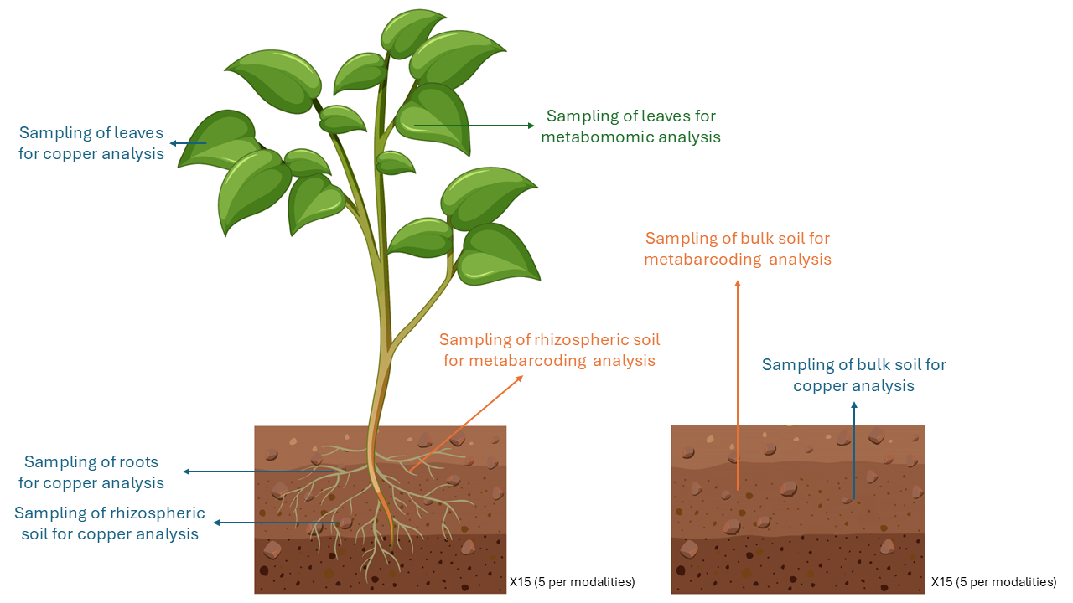

S2. Results of the Box-Behnken design
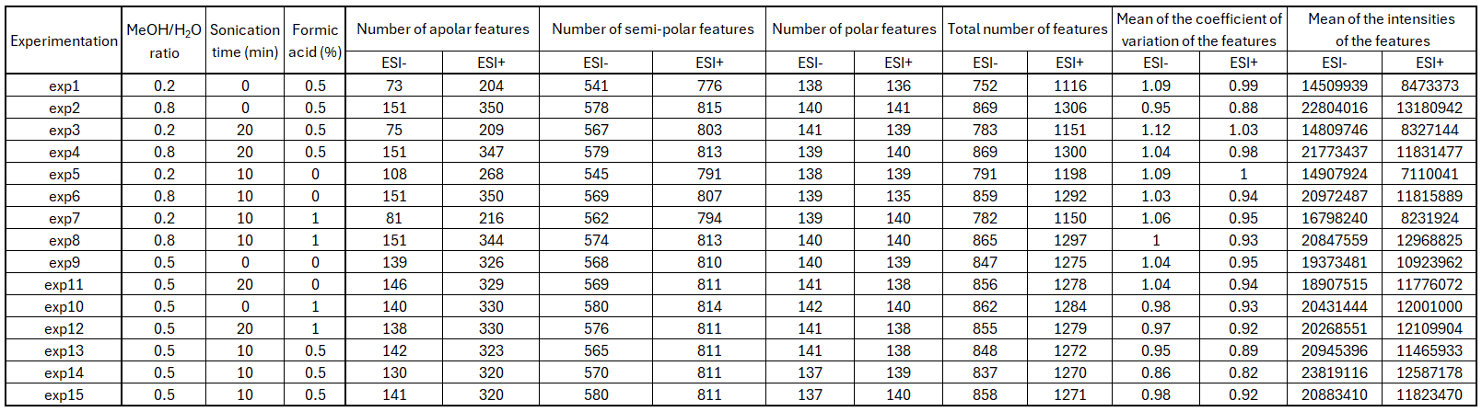
S3. Quantile-quantile plots of the loading scores in ESI-

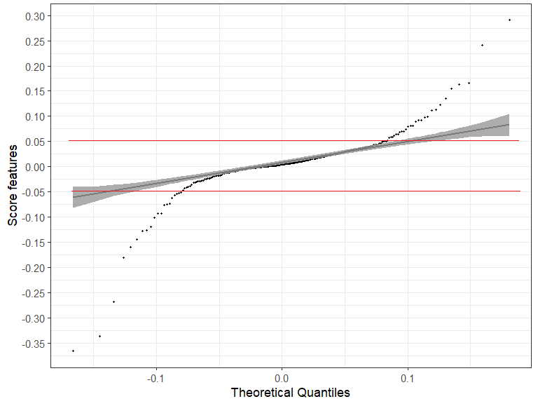
S4. Quantile-quantile plots of the loading scores in ESI+

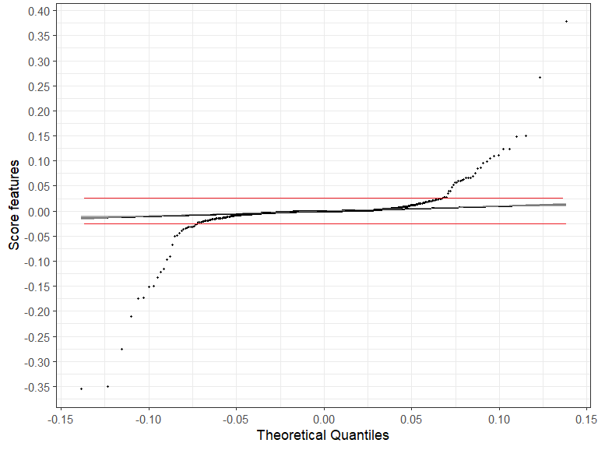
S5: Fragment ions of the proposed metabolites
Retention  time (min) | [M-H]- | [M+H]+ | Fragment ions | Molecular Formula | Proposed structure
Flavonoids
Flavanols
9.80 | 359.0783 | / | ESI- : 341, 299, 289, 284, 195, 193, 175, 167, 165 (100), 149, 139 | C₁₈H₁₆O₈ | 3-O-acetylpadmatin
8.52 | / | 319.0820 | ESI+ : 301, 273, 245, 209, 167 (100), 163, 123 | C₁₆H₁₄O₇ | Padmatin
Flavanons
9.52 | 301.0718 | / | ESI- : 165, 161, 136, 135 (100), 109, 97, 65 | C₁₆H₁₄O₆ | 5,3',(4' ou 5')-trihydroxy-7-methoxy flavanon
8.92 | 271.0609 | / | ESI- : 177, 151 (100), 119, 107, 93, 73 | C₁₅H₁₂O₅ | Naringenin
Flavonols
9.35 | 329.0678 | 331.0808 | ESI- : 314 (100), 299, 286, 285, 271, 257, 243  ESI+ : 316 (100), 301, 298, 297, 281, 273 | C₁₇H₁₄O₇ | (3,3' ou 3,4')-di-O-methylquercetin  3,7-di-O-methylquercetin
8.57 | / | 317.0662 | ESI+ : 303, 302 (100), 301, 274, 140, 137, 79 | C₁₆H₁₂O₇ | 3-O-Methylquercetin
8.38 | / | 303.0496 | ESI+ : 285, 257 (100), 229, 165, 153, 140, 137 | C₁₅H₁₀O₇ | Quercetin
Flavons
8.40 | 315.0521 | / | ESI- : 301, 300 (100), 272, 271, 228, 216, 200, 166, 137, 133, 96 | C₁₆H₁₂O₇ | 6-Methoxyluteolin  3-Methylquercetin
9.03 | 299.0558 | 301.0702 | ESI- : 285, 284 (100), 283, 271, 256, 228, 227, 212, 137  ESI+ : 286 (100), 283, 255, 186, 184, 168, 140, 75, 73 | C₁₆H₁₂O₆ | 6-Methoxyapigenin
8.37 | 285.0414 | / | ESI- : 241, 217, 199, 175, 151 (100), 149, 133, 71 | C₁₅H₁₀O₆ | Luteolin
Chalcons
8.25 | / | 289.0708 | ESI+ : 271, 187, 179, 171, 163 (100), 153, 145 | C₁₅H₁₂O₆ | 3,4,2',4',6'-Pentahydroxychalcon
Hydroxycinnamic acids derivatives
Quinic acids derivatives
0.75 | 191.0562 | / | ESI- : 173, 127, 111, 93, 87, 85 (100), 59 | C₇H₁₂O₆ | Quinic acid
5.88 | / | 355.1028 | ESI+ : 226, 209, 181, 172, 171, 164, 163 (100), 148, 145, 140, 135, 97, 83, 73, 59 | C₁₆H₁₈O₉ | (3 ou 5)-caffeoylquinic acid
7.25 | 515.1185 | 517.1358 | ESI- : 355, 354, 353, 193, 192, 191 (100), 181, 180, 179, 173, 161, 136, 135  ESI+ : 499, 337, 319, 163 (100),145, 135, 117 | C₂₅H₂₄O₁₂ | Dicaffeoylquic acid
6.35 | 337.0937 | / | ESI- : 191 (100), 173, 163, 119, 111, 93, 87 | C₁₆H₁₈O₈ | (3 ou 5)-coumaroylquinic acid
8.05 | 483.1290 | / | ESI- : 337, 319, 191, 145, 163 (100), 119 | C₂₅H₂₄O₁₀ | Dicoumaroylquinic acid
7.67 | 499.1262 | 501.1408 | ESI- : 337, 191 (100), 173, 163, 161, 119, 93  ESI+ : 483, 319, 303, 164, 163 (100), 148, 147, 145, 135, 119 | C₂₅H₂₄O₁₁ | Caffeoylcoumaroylquinic acid
Hexaric acids derivatives
0.7 | 209.0304 | / | ESI- : 191, 147, 133, 129, 101, 89, 85 (100), 71, 59, 57 | C₆H₁₀O₈ | Hexaric acid
8.08 | 857.1555 | / | ESI- : 695, 533, 371, 353, 209 (100), 191, 179, 161, 147, 129, 85 | C₄₂H₃₄O₂₀ | Tetracaffeoylhexaric acid
Others
0.7 | / | 118.0867 | ESI+ : 101, 91, 85, 75, 73, 72, 69, 59 (100), 58, 57, 56 | C₅H₁₁NO₂ | Glycine betaine
1.62 | 117.0195 | / | ESI- : 100, 99, 73 (100) | C₄H₆O₄ | Succinic acid

S6: Boxplots of the discriminant variables where a structure has been proposed
