Figure 1. The result of maximum femoral von Mises stress(MFVMS).(A) Under axial loading. (B) Under torsional loading.
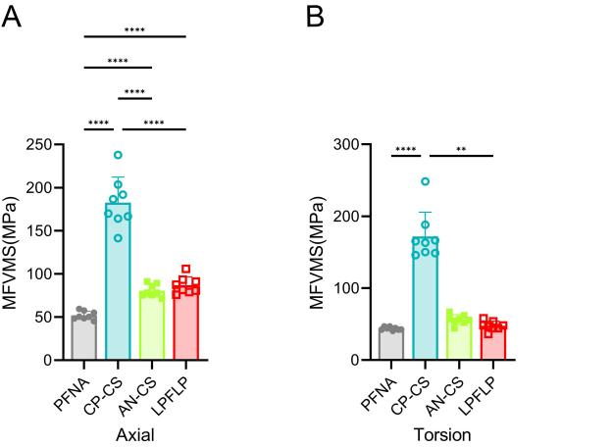

Figure 2. The result of maximum Implant von Mises stress(MIVMS).(A) Under axial loading. (B) Under torsional loading.
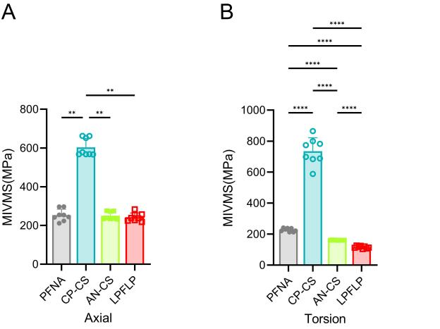
Figure 3. The result of maximum proximal femoral von Mises stress(MPFVMS).(A) Under axial loading. (B) Under torsional loading.
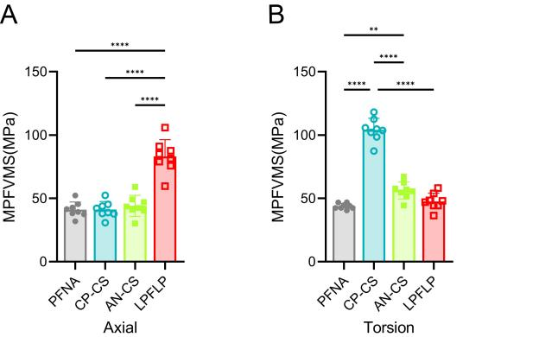
Figure 4. The result of maximum femoral displacement(MFD).(A) Under axial loading. (B) Under torsional loading.

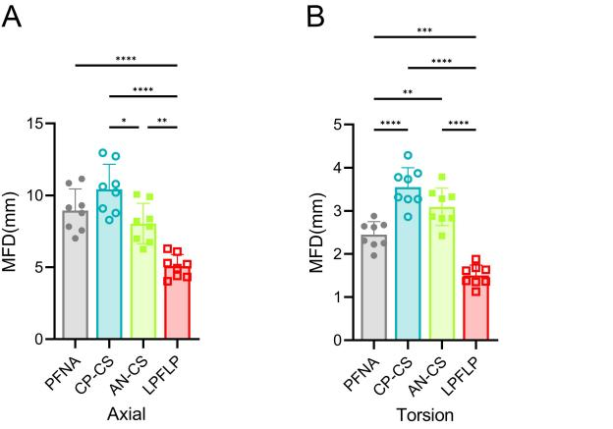
Figure 5. The result of maximum Implant displacement(MID).(A) Under axial loading. (B) Under torsional loading.
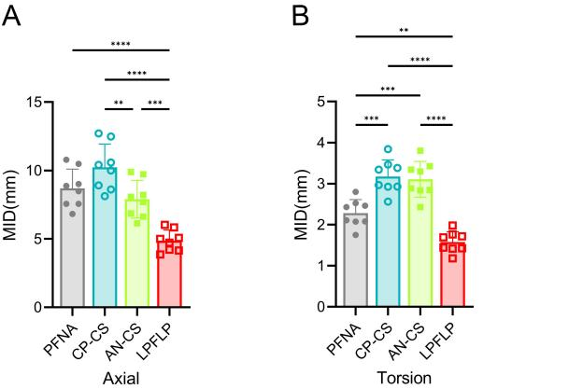
Figure 6. The result of maximum femoral head and neck interfragmentary motion
(MFHNIM).(A) Under axial loading. (B) Under torsional loading.
