Appendices
Appendix 1: Open Ocean Habitat at Singapore Oceanarium, Resorts World Singapore, Singapore
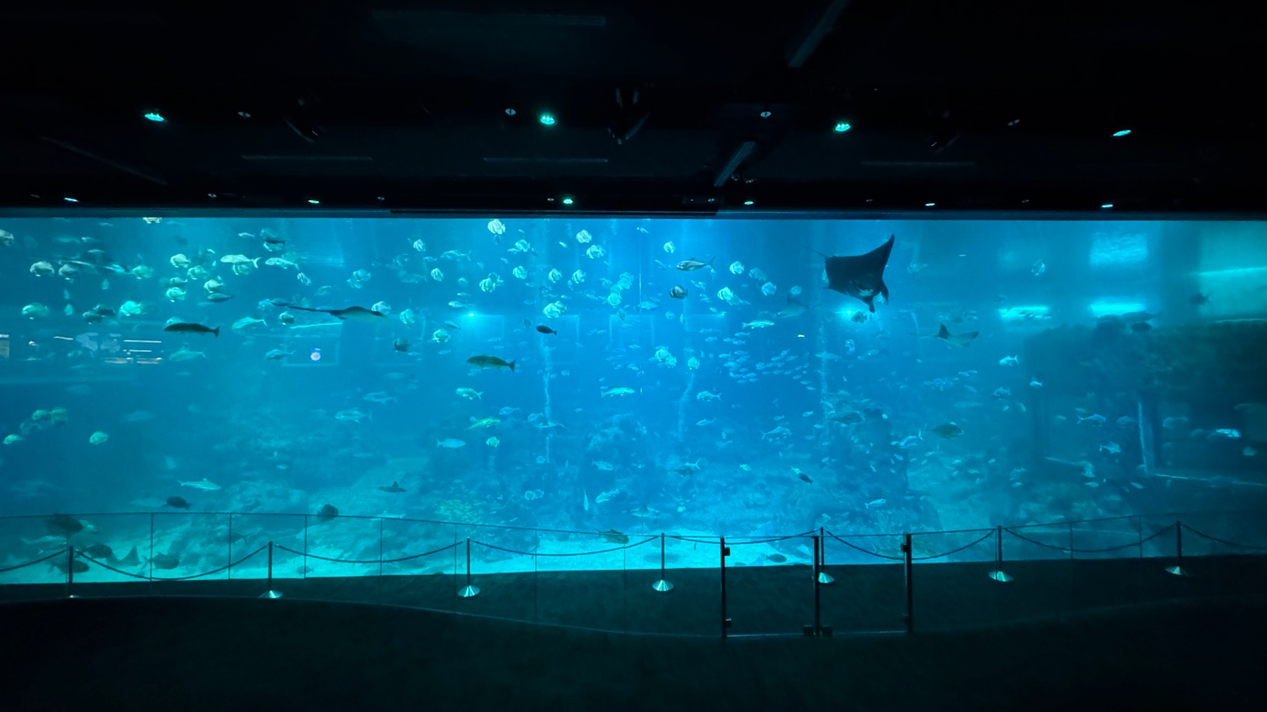
Appendix 2: Stretcher used for cownose ray training
