SUPPLEMENTAL INFORMATION
Multi-objective AI-driven optimization guides the discovery of high-performance organic photovoltaics
Feiyue Lu¹, Kang An^{1*}, Qin Wang¹, Zhipeng Yin¹, Xinhui Liu¹, Jialin Wu¹, Xingwang Kang¹, Hongyu Zhang¹, Xin Zhang¹, Wei Meng¹, Lei Ying¹, Liang Gao², Jiaping Lin², Ning Li^{1,3*}

¹Institute of Polymer Optoelectronic Materials and Devices, Guangdong Basic Research Center of Excellence for Energy and Information Polymer Materials, National Key Laboratory of Luminescent Materials and Devices, South China University of Technology, Guangzhou 510640, China.

²Shanghai Key Laboratory of Advanced Polymeric Materials, Key Laboratory for Ultrafine Materials of Ministry of Education, Frontiers Science Center for Materiobiology and Dynamic Chemistry, School of Materials Science and Engineering, East China University of Science and Technology, Shanghai 200237, China

³Guangdong Provincial Key Laboratory of Luminescence from Molecular Aggregates, South China University of Technology, Guangzhou, 510640 China

*Correspondence: mskangan@scut.edu.cn; ningli2022@scut.edu.cn

Supplementary Figure

Figure S1 PM6:D18:L8BO:BTP-eC9 external quantum efficiency (EQE) of optimal devices.

Figure S2 J-V characteristic curves of the optimal device at each iteration.

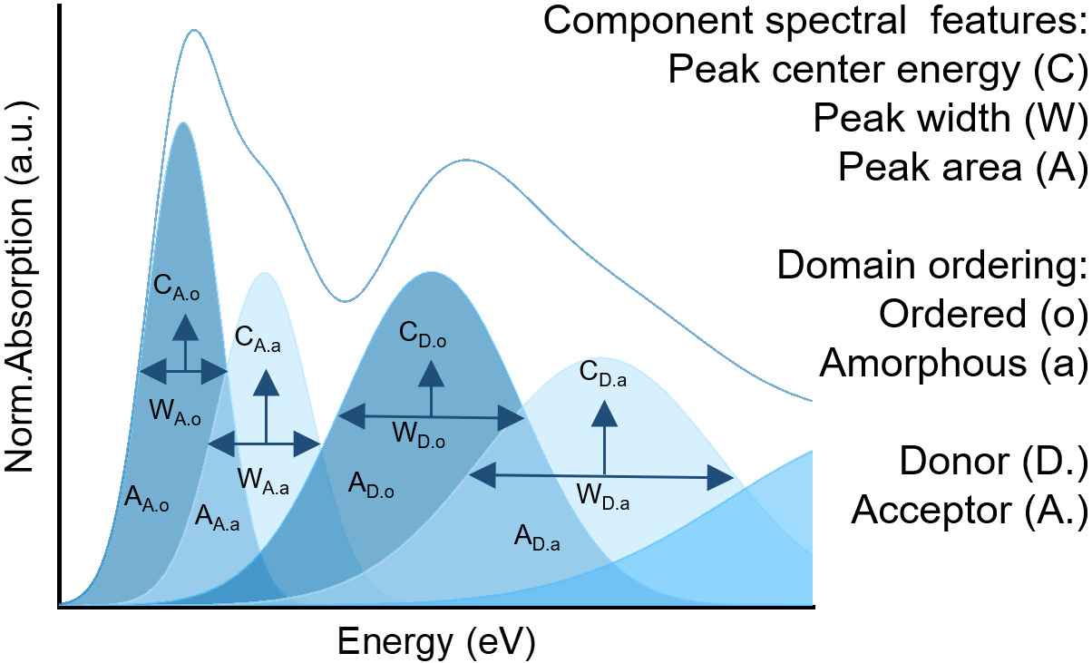
Figure S3 The absorption peaks are decomposed by Gaussian fitting.¹ C_{A.o}, W_{A.o} and A_{A.o} respectively represent the peak height, full width at half maximum and area of the receptor ordered phase. C_{A.a}, W_{A.a}, and A_{A.a} respectively represent the peak height, full width at half maximum and area of the receptor amorphous phase; C_{D.o}, W_{D.o}, and A_{D.o} respectively represent the peak height, full width at half maximum and area of the donor ordered phase. C_{D.a}, W_{D.a}, and A_{D.a} respectively represent the peak height, full width at half maximum and area of the donor amorphous phase.

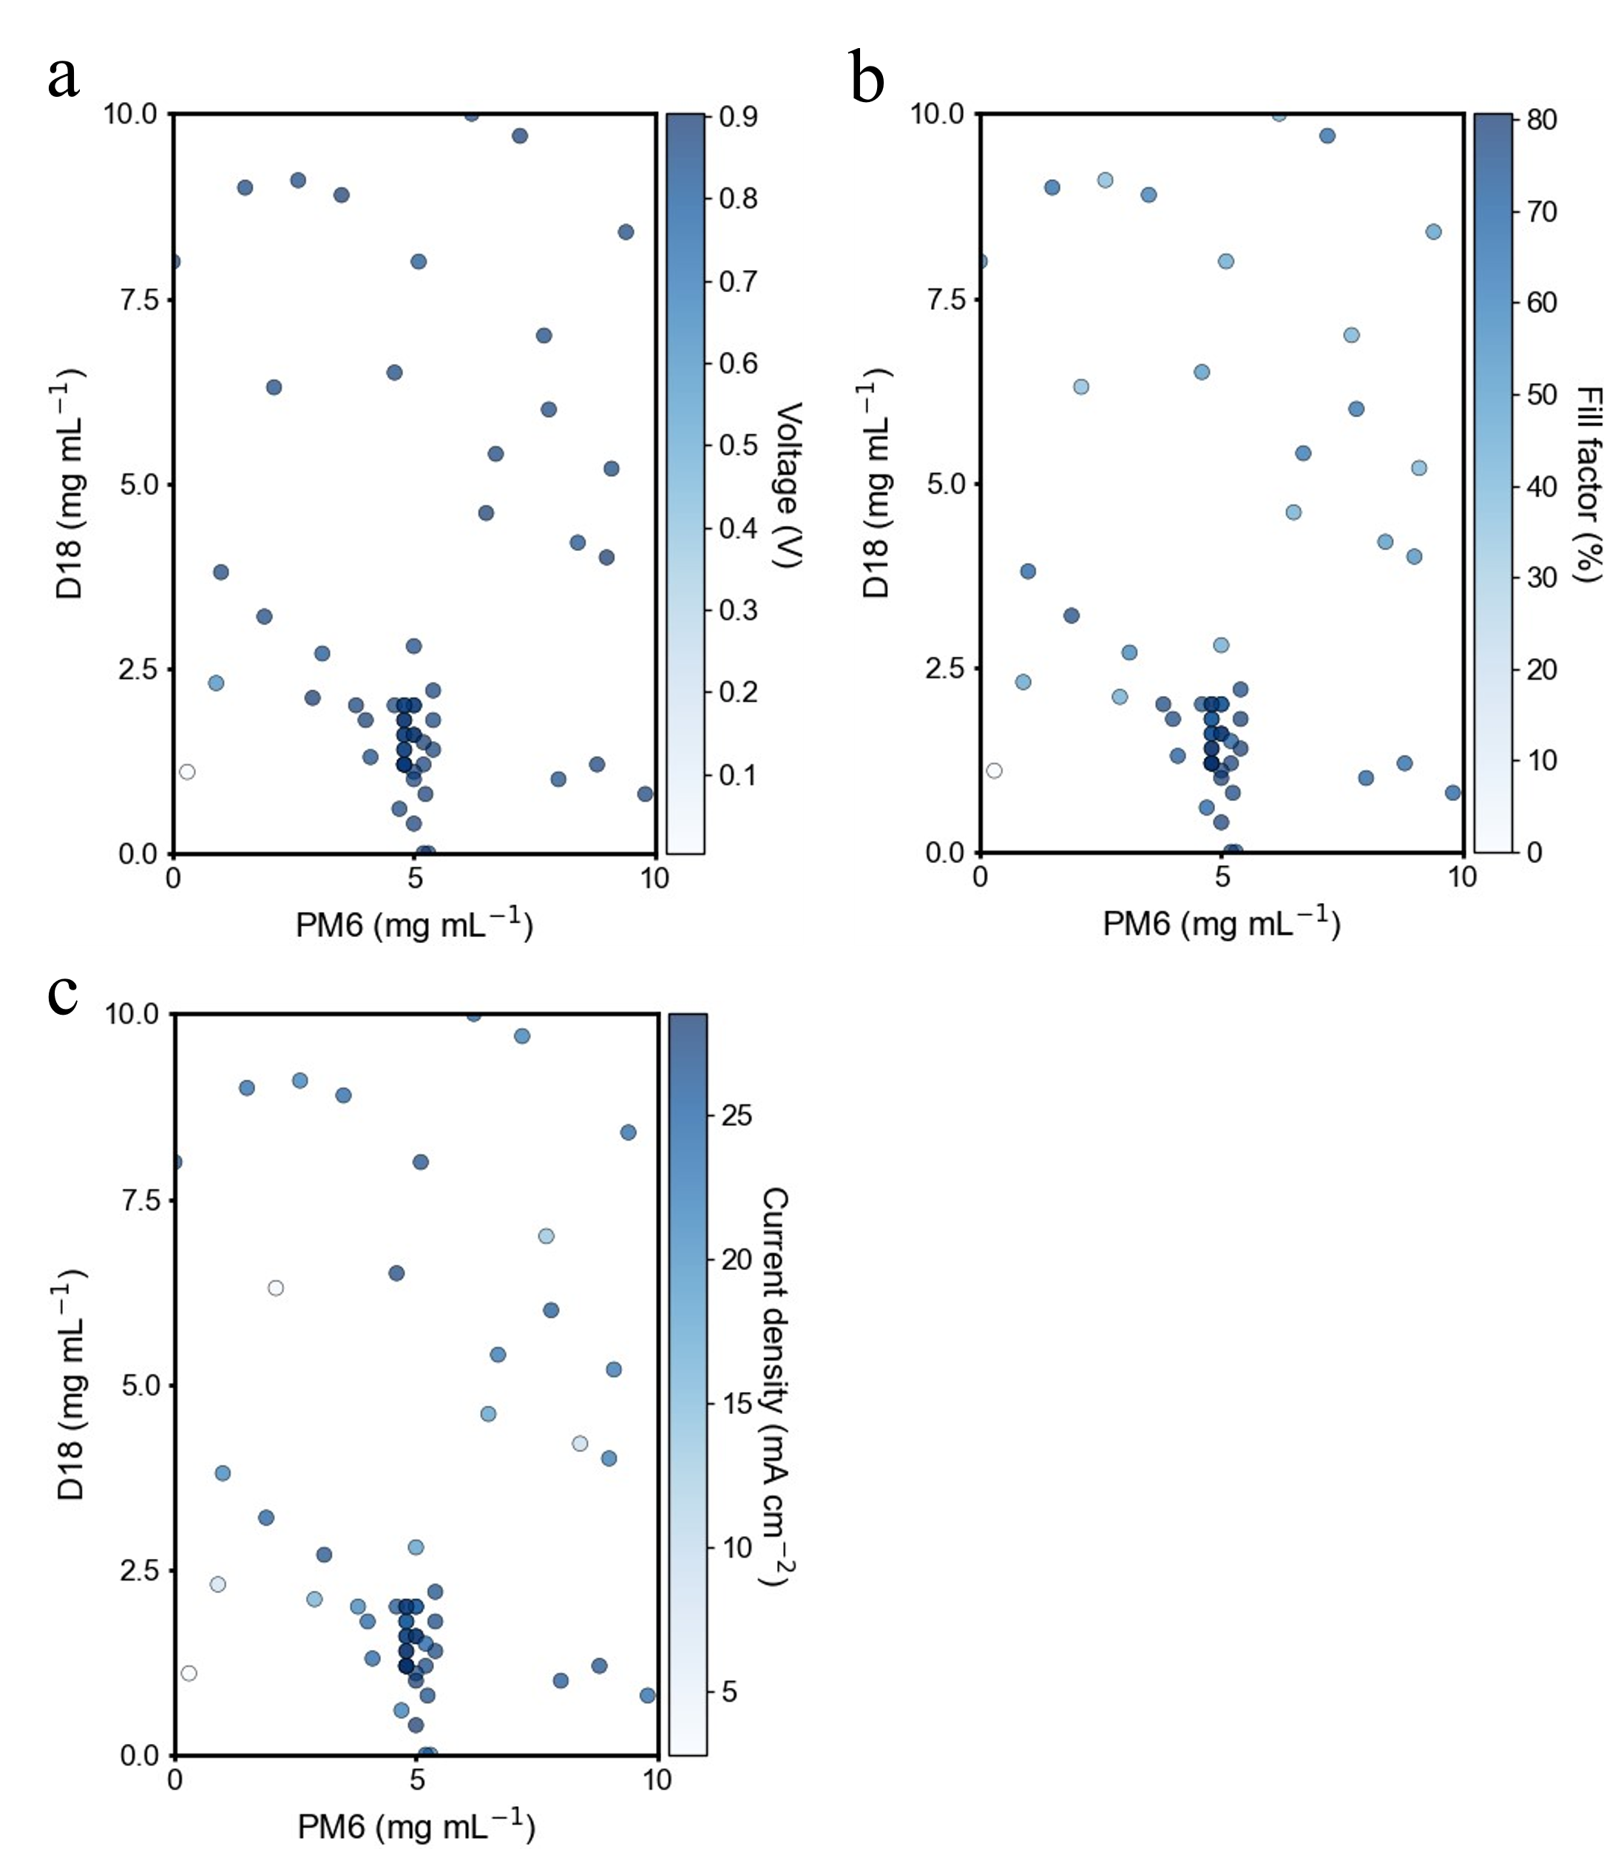
Figure S4 a-c performance of concentration control devices for PM6 and D18.

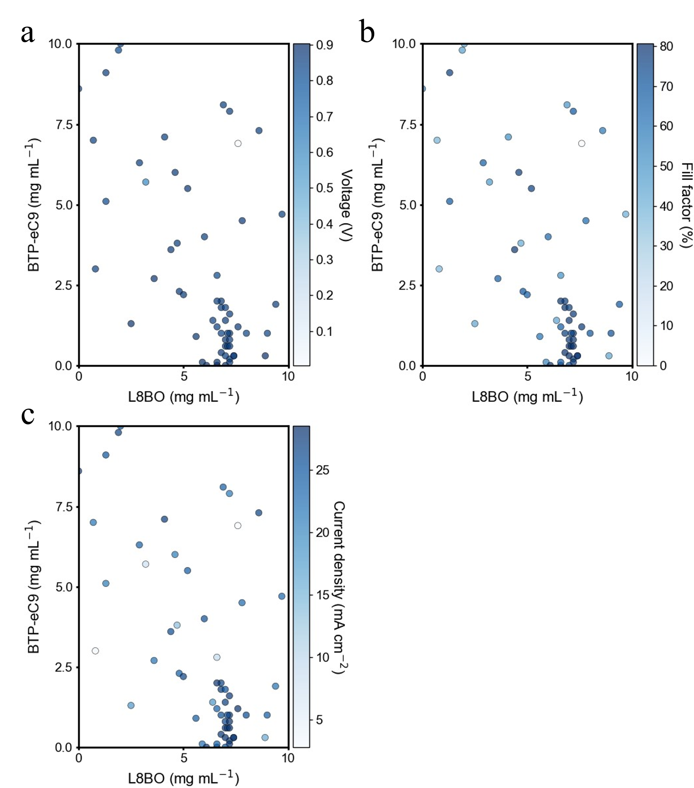
Figure S5 a-c performance of concentration control devices for L8BO and BTP-eC9.

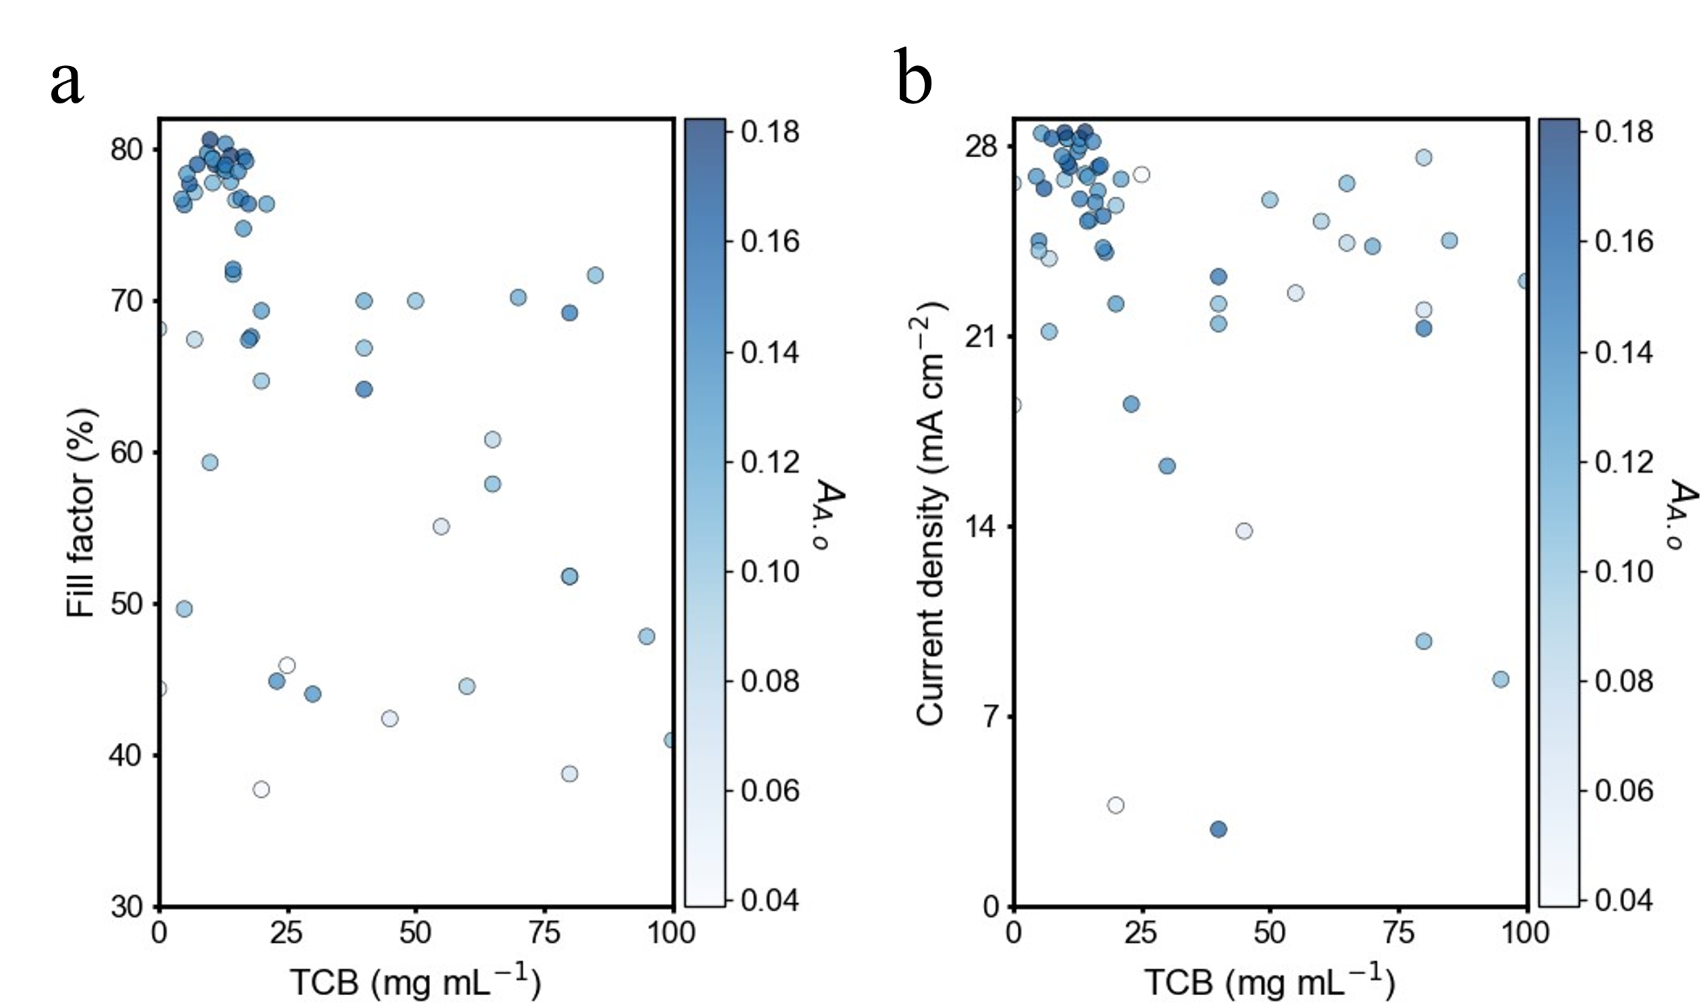
Figure S6 a, b performance of concentration control devices for TCB.
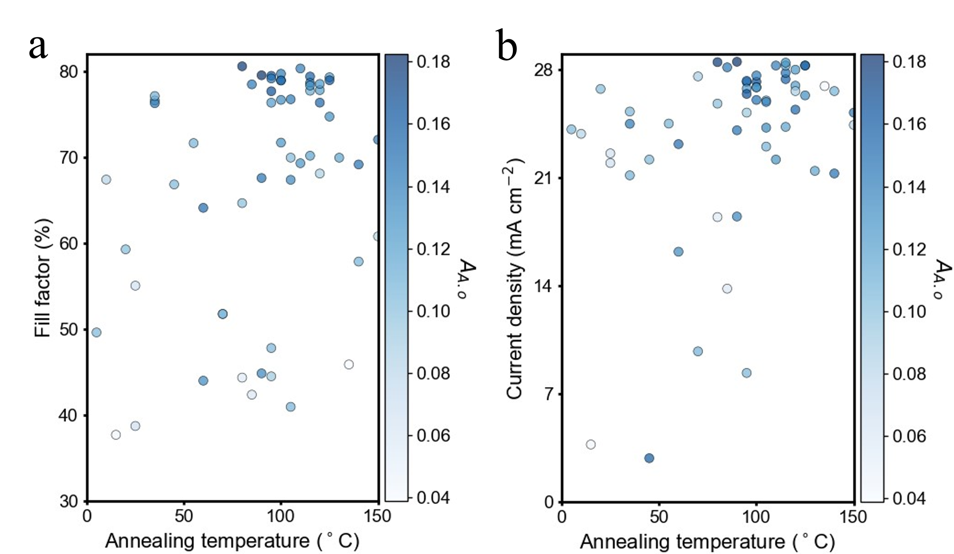
Figure S7 a, b performance of annealing temperature regulating devices.
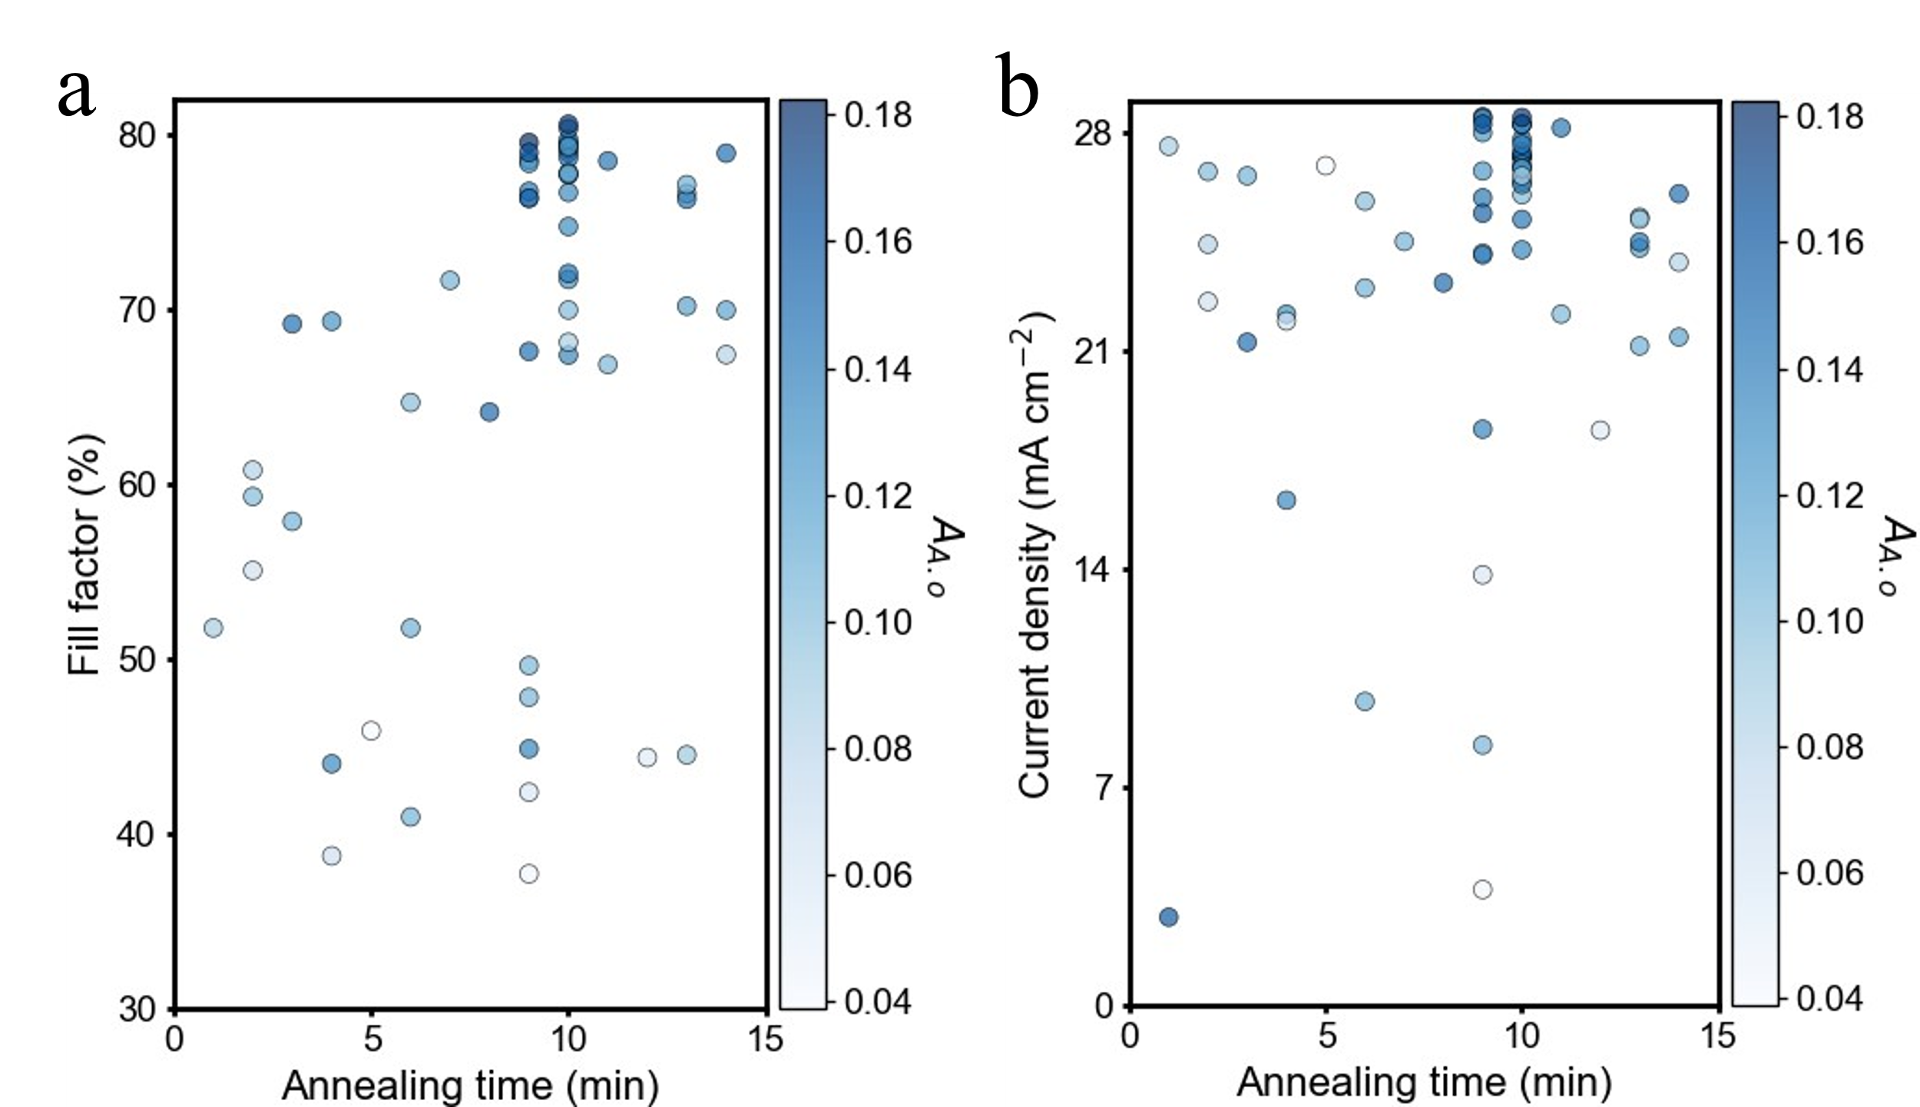
Figure S8 a, b performance of annealing time regulates devices.
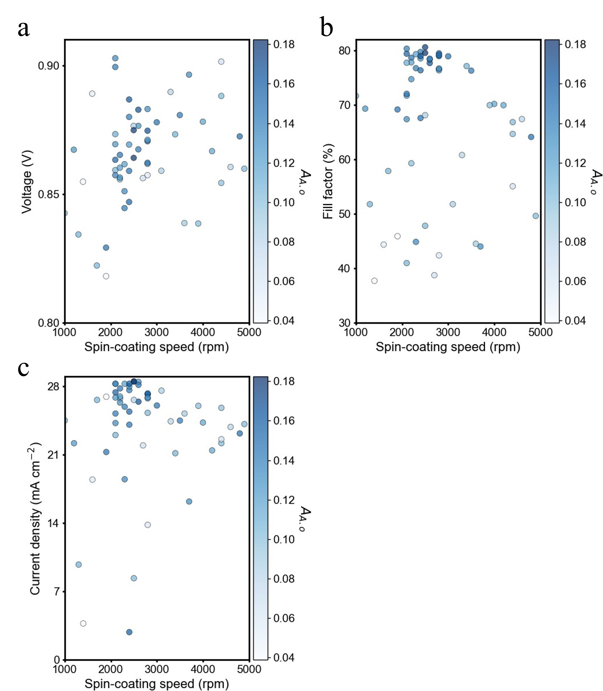
Figure S9 a-c performance of spin-coating speed devices.
Supplementary Table

Table S 1 Parameter range and sampling interval
Parameter | Range | Sampling interval
PM6 | 0-10 mg mL⁻¹ | 0.1 mg mL⁻¹
D18 | 0-10 mg mL⁻¹ | 0.1 mg mL⁻¹
L8BO | 0-10 mg mL⁻¹ | 0.1 mg mL⁻¹
BTP-eC9 | 0-10 mg mL⁻¹ | 0.1 mg mL⁻¹
TCB | 0-100 mg mL⁻¹ | 0.5 mg mL⁻¹
Spin-speed coating | 1000-5000 rpm | 100 rpm
Annealing temperature | 0-150 °C | 10 °C
Annealing time | 0-15 min | 1 min

Table S 2 30 sets of process parameters for initial sampling
Number | PM6  (mg mL⁻¹) | D18  (mg mL⁻¹) | L8BO  (mg mL⁻¹) | BTP-eC9  (mg mL⁻¹) | TCB  (mg mL⁻¹) | A. Tem. (℃) | SS (rpm) | A. Ti. (min)
1 | 0.9 | 2.3 | 3.2 | 5.7 | 95 | 95 | 2500 | 9
2 | 7.2 | 9.7 | 3.6 | 2.7 | 40.5 | 45 | 4400 | 11
3 | 1.9 | 3.2 | 1.3 | 9.1 | 15 | 35 | 2800 | 13
4 | 6.7 | 5.4 | 7.8 | 4.5 | 40 | 60 | 4800 | 8
5 | 4.7 | 0.6 | 9.4 | 1.9 | 20.5 | 110 | 1200 | 4
6 | 9.8 | 0.8 | 4.8 | 2.3 | 70.5 | 115 | 4000 | 13
7 | 5.3 | 0 | 1.3 | 5.1 | 80 | 140 | 1900 | 3
8 | 6.5 | 4.6 | 2.5 | 1.3 | 0 | 80 | 1600 | 12
9 | 3.1 | 2.7 | 0 | 8.6 | 65.5 | 140 | 1700 | 3
10 | 4 | 1.8 | 5.2 | 5.5 | 5 | 35 | 3500 | 13
11 | 5.1 | 8 | 1.9 | 9.8 | 25 | 135 | 1900 | 5
12 | 4.6 | 6.5 | 4.1 | 7.1 | 80 | 70 | 3100 | 1
13 | 7.7 | 7 | 4.7 | 3.8 | 45.5 | 85 | 2800 | 9
14 | 7.8 | 6 | 6 | 4 | 20 | 80 | 4400 | 6
15 | 9.1 | 5.2 | 9.7 | 4.7 | 100 | 105 | 2100 | 6
16 | 9 | 4 | 5.9 | 0.1 | 55 | 25 | 4400 | 2
17 | 1.5 | 9 | 2.9 | 6.3 | 7.5 | 10 | 4600 | 14
18 | 0 | 8 | 8.6 | 7.3 | 10 | 20 | 2200 | 2
19 | 2.9 | 2.1 | 8.9 | 0.3 | 30 | 60 | 3700 | 4
20 | 8 | 7.2 | 8.1 | 3.3 | 25 | 125 | 3200 | 10
21 | 3.5 | 8.9 | 5.6 | 0.9 | 65.5 | 150 | 3300 | 2
22 | 2.6 | 9.1 | 0.7 | 7 | 80 | 25 | 2700 | 4
23 | 9.4 | 8.4 | 6.9 | 8.1 | 5.5 | 5 | 4900 | 9
24 | 2.1 | 6.3 | 0.8 | 3 | 20 | 15 | 1400 | 9
25 | 8.4 | 4.2 | 6.6 | 2.8 | 80 | 70 | 1300 | 6
26 | 4.1 | 1.3 | 9 | 1 | 85.5 | 55 | 1000 | 7
27 | 0.3 | 1.1 | 7.6 | 6.9 | 40.5 | 45 | 2400 | 1
28 | 8 | 1 | 8 | 1 | 50 | 105 | 3900 | 10
29 | 6.2 | 10 | 2 | 10 | 60.5 | 95 | 3600 | 13
30 | 1 | 3.8 | 7.2 | 7.9 | 40 | 130 | 4200 | 14
A. Tem. denotes the annealing temperature., SS denotes the spin-coating speed, and A.Ti. denotes s the annealing time.

Table S 2 (Continued) Device performance of the initial 30 sets of process parameters
Number | V_{oc} (V) | FF (%) | J_{sc} (mA cm⁻²) | PCE (%)
1 | 0.608 | 47.801 | 8.347 | 2.416
2 | 0.888 | 66.852 | 22.181 | 13.112
3 | 0.862 | 76.633 | 25.293 | 16.629
4 | 0.872 | 64.128 | 23.183 | 12.913
5 | 0.867 | 69.322 | 22.181 | 13.276
6 | 0.878 | 70.195 | 24.299 | 14.912
7 | 0.829 | 69.177 | 21.279 | 12.152
8 | 0.889 | 44.354 | 18.452 | 7.244
9 | 0.822 | 57.872 | 26.619 | 12.611
10 | 0.881 | 76.313 | 24.498 | 16.392
11 | 0.818 | 45.885 | 26.945 | 10.134
12 | 0.859 | 51.771 | 27.571 | 12.285
13 | 0.857 | 42.370 | 13.812 | 5.027
14 | 0.854 | 64.679 | 25.806 | 14.287
15 | 0.859 | 40.953 | 23.020 | 8.117
16 | 0.901 | 55.064 | 22.583 | 11.231
17 | 0.861 | 67.416 | 23.849 | 13.862
18 | 0.856 | 59.294 | 26.758 | 13.603
19 | 0.896 | 43.997 | 16.206 | 6.404
20 | * | * | * | *
21 | 0.890 | 60.805 | 24.424 | 13.256
22 | 0.856 | 38.723 | 21.958 | 7.304
23 | 0.860 | 49.618 | 24.139 | 10.333
24 | 0.855 | 37.695 | 3.709 | 1.199
25 | 0.834 | 51.767 | 9.747 | 4.223
26 | 0.843 | 71.666 | 24.513 | 14.850
27 | 0.004 | 0.000 | 2.822 | 0.000
28 | 0.839 | 69.972 | 26.012 | 15.312
29 | 0.839 | 44.505 | 25.224 | 9.446
30 | 0.867 | 69.965 | 21.447 | 13.047
* Indicates that the solution concentration is too high to form a film and fabricate the device.

Table S 3 Recommended process parameters for the first round of iteration of the MOBO model
Number | PM6  (mg mL⁻¹) | D18  (mg mL⁻¹) | L8BO  (mg mL⁻¹) | BTP-eC9  (mg mL⁻¹) | TCB  (mg mL⁻¹) | A. Tem. (℃) | SS (rpm) | A.Ti (min)
31 | 3.8 | 2 | 4.6 | 6 | 7 | 35 | 3400 | 13
32 | 5.2 | 1.2 | 7.2 | 1 | 11 | 100 | 2800 | 10
33 | 5.4 | 1.4 | 7 | 1.4 | 16.5 | 95 | 2800 | 10
34 | 5.4 | 1.8 | 6.8 | 1.8 | 17 | 95 | 2800 | 10
35 | 5.4 | 2.2 | 6.8 | 2 | 21 | 95 | 2800 | 9
36 | 5 | 1.1 | 7 | 0.8 | 6 | 95 | 2600 | 10

Table S 3 (Continued) Device performance of the process parameters in the first round of iteration
Number | V_{oc} (V) | FF (%) | J_{sc} (mA cm⁻²) | PCE (%)
31 | 0.873 | 77.147 | 21.158 | 14.304
32 | 0.875 | 78.978 | 27.221 | 18.870
33 | 0.871 | 79.499 | 27.215 | 18.901
34 | 0.862 | 79.193 | 27.279 | 18.692
35 | 0.871 | 76.370 | 26.776 | 17.876
36 | 0.883 | 77.704 | 26.434 | 18.197

Table S 4 Recommended process parameters for the second round of iteration of the MOBO model
Number | PM6  (mg mL⁻¹) | D18  (mg mL⁻¹) | L8BO  (mg mL⁻¹) | BTP-eC9  (mg mL⁻¹) | TCB  (mg mL⁻¹) | A. Tem. (℃) | SS (rpm) | A. Ti (min)
37 | 4.8 | 1.2 | 7.2 | 0.2 | 10.5 | 115 | 2100 | 10
38 | 4.8 | 1.6 | 7 | 0.6 | 12.5 | 115 | 2200 | 10
39 | 4.8 | 1.8 | 7.1 | 0.6 | 14 | 120 | 2200 | 10
40 | 4.6 | 2 | 7.1 | 1 | 16.5 | 125 | 2200 | 10
41 | 5 | 2 | 6.8 | 1 | 16 | 105 | 2300 | 9
42 | 5.24 | 0.8 | 7.4 | 0.3 | 4.5 | 100 | 2800 | 10

Table S 4 (Continued) Device performance of the process parameters in the second round of iteration
Number | V_{oc} (V) | FF (%) | J_{sc} (mA cm⁻²) | PCE (%)
37 | 0.863 | 79.420 | 27.394 | 18.816
38 | 0.865 | 78.677 | 27.796 | 18.955
39 | 0.860 | 77.831 | 26.969 | 18.089
40 | 0.856 | 74.748 | 26.340 | 16.892
41 | 0.845 | 76.767 | 25.915 | 16.831
42 | 0.883 | 76.698 | 26.876 | 18.235

Table S 5 Recommended process parameters for the third round of iteration of the MOBO model
Number | PM6  (mg mL⁻¹) | D18  (mg mL⁻¹) | L8BO  (mg mL⁻¹) | BTP-eC9  (mg mL⁻¹) | TCB  (mg mL⁻¹) | A. Tem. (℃) | SS (rpm) | A. Ti (min)
43 | 4.8 | 1.2 | 7.2 | 0.1 | 10.5 | 115 | 2100 | 10
44 | 5 | 1.6 | 6.8 | 0.4 | 9.5 | 100 | 2400 | 10
45 | 4.8 | 1.4 | 7.2 | 1.6 | 13 | 120 | 2400 | 9
46 | 4.8 | 2 | 7 | 1.8 | 17.5 | 120 | 2400 | 9
47 | 5 | 2 | 6.6 | 1.2 | 18 | 90 | 2400 | 9
48 | 5 | 2.8 | 6.4 | 1.4 | 23 | 90 | 2300 | 9

Table S 5 (Continued) Device performance of the process parameters in the third round of iteration
Number | V_{oc} (V) | FF (%) | J_{sc} (mA cm⁻²) | PCE (%)
43 | 0.873 | 77.763 | 28.273 | 19.002
44 | 0.880 | 79.740 | 27.628 | 19.186
45 | 0.869 | 78.556 | 28.005 | 18.926
46 | 0.847 | 76.376 | 25.418 | 16.438
47 | 0.859 | 67.599 | 24.079 | 13.979
48 | 0.851 | 44.850 | 18.488 | 7.056

Table S 6 Recommended process parameters for the 4th round of iteration of the MOBO model
Number | PM6  (mg mL⁻¹) | D18  (mg mL⁻¹) | L8BO  (mg mL⁻¹) | BTP-eC9  (mg mL⁻¹) | TCB  (mg mL⁻¹) | A. Tem. (℃) | SS (rpm) | A. Ti (min)
49 | 4.8 | 1.2 | 7.4 | 0.3 | 10.5 | 125 | 2300 | 10
50 | 4.8 | 1.4 | 7 | 0.3 | 13 | 110 | 2100 | 10
51 | 4.8 | 1.6 | 6.6 | 0 | 14.5 | 100 | 2100 | 10
52 | 5 | 1 | 7.2 | 0.8 | 14 | 90 | 2500 | 9
53 | 5 | 0.4 | 7.6 | 1.2 | 5.5 | 115 | 2600 | 9
54 | 4.8 | 1.8 | 6.6 | 0.1 | 17.5 | 105 | 2100 | 10

Table S 6 (Continued) Device performance of the process parameters in the 4th round of iteration
Number | V_{oc} (V) | FF (%) | J_{sc} (mA cm⁻²) | PCE (%)
49 | 0.862 | 79.335 | 28.275 | 19.338
50 | 0.857 | 80.353 | 28.275 | 19.478
51 | 0.869 | 71.721 | 26.856 | 16.745
52 | 0.864 | 79.563 | 28.519 | 19.606
53 | 0.877 | 78.368 | 28.463 | 19.561
54 | 0.903 | 67.388 | 24.247 | 14.751

Table S 7 Recommended process parameters for the 5th round of iteration of the MOBO model
Number | PM6  (mg mL⁻¹) | D18  (mg mL⁻¹) | L8BO  (mg mL⁻¹) | BTP-eC9  (mg mL⁻¹) | TCB  (mg mL⁻¹) | A. Tem. (℃) | SS (rpm) | A. Ti (min)
55 | 8.8 | 1.2 | 5 | 2.2 | 0 | 120 | 2500 | 10
56 | 5.2 | 0 | 4.4 | 3.6 | 13 | 100 | 3000 | 14
57 | 4.8 | 1.2 | 7.2 | 0.6 | 10 | 80 | 2500 | 10
58 | 5 | 1.6 | 6.1 | 0 | 7.5 | 125 | 2400 | 9
59 | 5.2 | 1.5 | 7 | 0 | 14.5 | 150 | 2100 | 10
60 | 4.8 | 2 | 6.6 | 2 | 15.5 | 85 | 2600 | 11

Table S 7 (Continued) Device performance of the process parameters in the 5th round of iteration
Number | V_{oc} (V) | FF (%) | J_{sc} (mA cm⁻²) | PCE (%)
55 | 0.876 | 68.125 | 26.619 | 15.895
56 | 0.878 | 78.947 | 26.045 | 18.042
57 | 0.875 | 80.611 | 28.495 | 20.095
58 | 0.887 | 78.985 | 28.277 | 19.806
59 | 0.899 | 72.065 | 25.222 | 16.347
60 | 0.867 | 78.506 | 28.159 | 19.175

Table S 8 Correlation coefficient between process parameters, device performance and AA.o/AA.a
Name | AA.o/AA.a
PM6 (mg mL⁻¹) | -0.079949
Annealing temperature (℃) | 0.038964
D18 (mg mL⁻¹) | -0.112787
Spin-coating speed (rpm) | -0.140323
L8BO (mg mL⁻¹) | 0.242389
Annealing time (min) | -0.2711
BTP-eC9 (mg mL⁻¹) | -0.427337
TCB (mg mL⁻¹) | 0.066566
V_{oc} (V) | 0.226576
FF (%) | 0.06903
J_{sc} (mA cm⁻²) | 0.1597

Table S 9 Parameter range and sampling interval for D18:L8BO
Parameter | Range | Sampling interval
Solid additive | 0-4 | 1
Additive concentration | 0.2-6 mg mL⁻¹ | 0.2 mg mL⁻¹
D:A ratio | 0.5-2 | 0.1
BHJ concentration | 8-12 mg mL⁻¹ | 0.2 mg mL⁻¹
Spin-speed coating | 800-4000 rpm | 100 rpm
Annealing temperature | 25-150 °C | 25 °C
Annealing time | 5-20 min | 5 min
The values for solid additives are as follows: 0 indicates no additive, 1 c1ccc(cc1)COc1ccccc1, 2 c1ccc(cc1)COc1cccc(c1)Br, 3 c1ccc(cc1)COc1ccc(cc1)Br, and 4 c1ccc(cc1)COc1ccc(cc1)I.

Table S 10 32 sets of process parameters for D18:L8BO
Number | Solid  additive | Additive  concentration | D:A  ratio | BHJ  concentration | A. Tem. (℃) | A. Ti. (min) | SS (rpm)
1 | 0 | 0 | 0.6 | 10.2 | 100 | 15 | 900
2 | 0 | 0 | 0.5 | 12 | 150 | 5 | 4000
3 | 0 | 0 | 1.9 | 11.8 | 75 | 10 | 3100
4 | 0 | 0 | 1.5 | 11 | 50 | 10 | 2500
5 | 1 | 1.2 | 0.7 | 9.6 | 150 | 20 | 1700
6 | 1 | 0.6 | 1.2 | 11.8 | 75 | 15 | 1500
7 | 1 | 1.4 | 1.6 | 9.4 | 125 | 10 | 1200
8 | 1 | 0.4 | 1.2 | 11.6 | 50 | 5 | 2500
9 | 1 | 3.4 | 0.9 | 10.6 | 125 | 20 | 1700
10 | 1 | 1.6 | 1.5 | 10 | 25 | 10 | 2300
11 | 1 | 2.8 | 1.4 | 8.8 | 100 | 5 | 3300
12 | 1 | 5.6 | 0.6 | 8 | 125 | 20 | 3600
13 | 2 | 2 | 1.7 | 8.6 | 75 | 5 | 3800
14 | 2 | 1.8 | 0.9 | 10.6 | 125 | 15 | 1900
15 | 2 | 4.4 | 1.3 | 9.2 | 125 | 10 | 2000
16 | 2 | 3.2 | 2 | 10.2 | 125 | 10 | 1500
17 | 2 | 4 | 1.8 | 8.2 | 25 | 10 | 2900
18 | 2 | 5 | 1.9 | 8.4 | 100 | 10 | 2900
19 | 2 | 3 | 1.7 | 11.2 | 25 | 15 | 2000
20 | 2 | 0.8 | 1.1 | 9 | 50 | 15 | 3100
21 | 3 | 1 | 1.1 | 11 | 100 | 15 | 1400
22 | 3 | 4.8 | 1.9 | 9.8 | 50 | 20 | 2800
23 | 3 | 3.8 | 1.3 | 9 | 75 | 15 | 3500
24 | 3 | 5.2 | 1 | 8.8 | 100 | 15 | 3900
25 | 3 | 2.4 | 1 | 10.8 | 75 | 15 | 2200
26 | 3 | 5.4 | 0.8 | 11.2 | 100 | 10 | 3200
27 | 3 | 3.8 | 1.4 | 10.4 | 100 | 10 | 2100
28 | 3 | 6 | 0.6 | 8.4 | 75 | 15 | 2700
29 | 4 | 0.6 | 1.4 | 9.4 | 150 | 20 | 3500
30 | 4 | 5.6 | 1.7 | 9.8 | 50 | 20 | 900
31 | 4 | 4.2 | 1 | 10.4 | 75 | 5 | 1200
32 | 4 | 2.6 | 0.8 | 11.4 | 50 | 10 | 1000

Table S 10 (Continued) Device performance of the initial 32 sets of process parameters
Number | V_{oc} (V) | J_{sc} (mA cm⁻²) | FF (%) | PCE (%)
1 | 0.870 | 27.45 | 69.92 | 16.70
2 | 0.890 | 21.20 | 75.71 | 14.29
3 | 0.884 | 25.84 | 71.70 | 16.39
4 | 0.892 | 26.66 | 75.36 | 17.92
5 | 0.870 | 27.06 | 77.16 | 18.17
6 | 0.861 | 27.69 | 69.65 | 16.60
7 | 0.851 | 26.84 | 66.29 | 15.03
8 | 0.884 | 27.49 | 76.05 | 18.34
9 | 0.865 | 27.54 | 75.20 | 17.77
10 | 0.868 | 27.47 | 75.03 | 17.75
11 | 0.869 | 26.67 | 77.64 | 17.85
12 | 0.851 | 10.68 | 72.33 | 6.52
13 | 0.866 | 18.28 | 76.32 | 12.11
14 | 0.863 | 28.26 | 76.99 | 18.84
15 | 0.864 | 26.06 | 74.51 | 16.83
16 | 0.841 | 8.50 | 43.31 | 3.10
17 | 0.869 | 19.82 | 61.39 | 10.60
18 | 0.862 | 18.71 | 59.40 | 9.60
19 | 0.843 | 11.58 | 45.15 | 4.40
20 | 0.882 | 26.46 | 76.19 | 17.76
21 | 0.860 | 28.10 | 69.03 | 16.66
22 | 0.867 | 26.23 | 68.12 | 15.46
23 | 0.866 | 25.71 | 76.99 | 17.10
24 | 0.853 | 14.73 | 73.30 | 9.19
25 | 0.868 | 27.79 | 77.76 | 18.73
26 | 0.864 | 25.37 | 78.12 | 17.13
27 | 0.860 | 28.20 | 76.04 | 18.44
28 | 0.847 | 10.49 | 72.72 | 6.46
29 | 0.883 | 25.89 | 75.88 | 17.35
30 | 0.837 | 17.46 | 51.02 | 7.46
31 | 0.844 | 28.32 | 71.47 | 17.08
32 | 0.849 | 27.61 | 71.77 | 16.82

Table S 11 D18:L8BO MOBO 1-3 round iteration process parameters and device performance
Number | Solid  additive | Additive  concentration | D:A  ratio | BHJ  concentration | A. Tem. (℃) | A. Ti. (min) | SS (rpm)
R1-1 | 1 | 0.4 | 1 | 10.2 | 75 | 10 | 3400
R1-2 | 2 | 2.2 | 0.6 | 9.6 | 125 | 15 | 2500
R1-3 | 2 | 2 | 0.7 | 9.6 | 125 | 15 | 2300
R1-4 | 2 | 1.6 | 0.6 | 10 | 125 | 15 | 2200
R1-5 | 3 | 2 | 1.4 | 10.6 | 75 | 10 | 3400
R2-1 | 1 | 2 | 1.1 | 10 | 50 | 5 | 2600
R2-2 | 2 | 4.2 | 0.9 | 9.8 | 125 | 15 | 1900
R2-3 | 3 | 2 | 1.4 | 10 | 75 | 15 | 3300
R2-4 | 3 | 2.6 | 1.4 | 10.8 | 75 | 10 | 2800
R2-5 | 3 | 2.4 | 1.3 | 10.6 | 75 | 15 | 2900
R3-1 | 1 | 0.8 | 1.6 | 10 | 50 | 5 | 3400
R3-2 | 2 | 4.2 | 0.8 | 8.4 | 150 | 10 | 1800
R3-3 | 3 | 2.6 | 1.2 | 11.6 | 75 | 15 | 3100
R3-4 | 3 | 3.4 | 1.3 | 11.2 | 75 | 15 | 3000
R3-5 | 3 | 2.2 | 1.2 | 10.8 | 75 | 15 | 2900

Table S 11 (Continued) D18:L8BO MOBO 1-3 round iteration process parameters and device performance
Number | V_{oc} (V) | J_{sc} (mA cm⁻²) | FF (%) | PCE (%)
R1-1 | 0.887 | 26.87 | 76.09 | 18.02
R1-2 | 0.872 | 24.33 | 76.01 | 16.02
R1-3 | 0.880 | 24.93 | 76.17 | 16.60
R1-4 | 0.869 | 22.52 | 73.99 | 14.38
R1-5 | 0.890 | 27.78 | 79.27 | 19.59
R2-1 | 0.887 | 25.97 | 78.22 | 18.22
R2-2 | 0.862 | 27.02 | 78.75 | 18.56
R2-3 | 0.874 | 24.71 | 77.30 | 16.88
R2-4 | 0.898 | 26.75 | 79.77 | 19.36
R2-5 | 0.890 | 27.90 | 81.06 | 20.17
R3-1 | 0.902 | 26.12 | 76.31 | 18.18
R3-2 | 0.874 | 24.36 | 77.71 | 16.73
R3-3 | 0.876 | 27.25 | 78.37 | 18.91
R3-4 | 0.868 | 27.24 | 78.91 | 18.87
R3-5 | 0.882 | 27.18 | 79.39 | 19.24

Table S 12 Parameter range and sampling interval
Parameter | Range | Sampling interval
PM7 | 0-10 mg mL⁻¹ | 0.1 mg mL⁻¹
Y6 | 0-10 mg mL⁻¹ | 0.1 mg mL⁻¹
Spin-speed coating | 1000-5000 rpm | 100 rpm
Annealing temperature | 0-150 °C | 10 °C
Annealing time | 0-15 min | 1 min

Table S 13 PM7:Y6 initial sampling dataset
Number | PM7  (mg mL⁻¹) | Y6  (mg mL⁻¹) | A. Tem. (℃) | SS (rpm) | A. Ti (min) | V_{oc} (V) | J_{sc}  (mA cm⁻²) |  | FF (%) | PCE (%)
1 | 1.8 | 7.9 | 90 | 1300 | 13 | 0.864 | 24.114 | 61.178 |  | 12.746
2 | 9.9 | 6.2 | 25 | 2300 | 3 | 0.908 | 24.066 | 44.921 |  | 9.819
3 | 4.2 | 4.2 | 30 | 4800 | 11 | 0.867 | 10.262 | 45.725 |  | 4.068
4 | 1.8 | 1.7 | 135 | 2400 | 6 | 0.283 | 4.096 | 27.803 |  | 0.322
5 | 0.2 | 7 | 35 | 1800 | 11 | 0.701 | 7.216 | 29.717 |  | 1.504
6 | 7.3 | 8.6 | 75 | 4600 | 9 | 0.893 | 25.842 | 66.191 |  | 15.278
7 | 6.8 | 4.4 | 120 | 4300 | 4 | 0.881 | 17.115 | 51.877 |  | 7.825
8 | 2.9 | 2.5 | 130 | 1500 | 15 | 0.862 | 17.794 | 55.138 |  | 8.461
9 | 7.7 | 0.8 | 55 | 3800 | 3 | 0.359 | 0.872 | 24.622 |  | 0.077
10 | 5.2 | 5.6 | 70 | 3400 | 9 | 0.888 | 20.793 | 65.095 |  | 12.026
11 | 8.7 | 9.7 | 110 | 2900 | 2 | 0.875 | 27.918 | 62.166 |  | 15.133
12 | 6.2 | 0.1 | 15 | 3100 | 8 | 0.042 | 0.381 | 25.163 |  | 0.004

Table S 14 PM7:Y6 MOBO 1-4 round iteration process parameters and device performance
Number | PM7  (mg mL⁻¹) | Y6  (mg mL⁻¹) | A. Tem. (℃) | SS (rpm) | A. Ti (min) | Voc (V) | Jsc  (mA cm⁻²) | FF (%) | PCE (%)
R1-1 | 2.3 | 7 | 100 | 1400 | 13 | 0.863 | 21.603 | 66.920 | 12.526
R1-2 | 4.1 | 6.4 | 115 | 2000 | 13 | 0.866 | 22.781 | 70.514 | 13.981
R1-3 | 3.8 | 6 | 115 | 1800 | 15 | 0.863 | 23.094 | 66.937 | 13.394
R1-4 | 5.5 | 5.5 | 65 | 3900 | 10 | 0.885 | 18.027 | 66.636 | 10.612
R2-1 | 4.5 | 7.3 | 125 | 1800 | 14 | 0.856 | 27.140 | 67.792 | 15.804
R2-2 | 6.9 | 8.1 | 85 | 2600 | 5 | 0.887 | 26.815 | 66.157 | 15.794
R2-3 | 3.8 | 6.6 | 100 | 2100 | 12 | 0.859 | 20.955 | 61.795 | 11.172
R2-4 | 3.9 | 6.8 | 95 | 2200 | 12 | 0.860 | 19.553 | 63.332 | 10.697
R3-1 | 6.3 | 8.3 | 90 | 2400 | 6 | 0.876 | 25.089 | 68.615 | 15.085
R3-2 | 8.6 | 7.1 | 100 | 3800 | 6 | 0.885 | 25.892 | 66.655 | 15.233
R3-3 | 3.6 | 6.7 | 110 | 1800 | 13 | 0.864 | 21.550 | 69.581 | 12.914
R3-4 | 3.5 | 6.5 | 110 | 1800 | 13 | 0.860 | 21.344 | 69.358 | 12.703
R4-1 | 8.4 | 7.4 | 95 | 3600 | 6 | 0.887 | 27.404 | 60.880 | 14.798
R4-2 | 2.7 | 9.7 | 135 | 1300 | 10 | 0.844 | 25.532 | 61.240 | 13.195
R4-3 | 6.9 | 8.7 | 95 | 2600 | 5 | 0.879 | 27.396 | 67.078 | 16.148
R4-4 | 6.6 | 8.4 | 90 | 2600 | 5 | 0.877 | 27.544 | 65.361 | 15.786

Table S 15 Parameter range and sampling interval for D18:L8BO:PYIT
Parameter |  | Range | Sampling interval
D18/L8BO:PYIT (D:A ratio) |  | 0.6-1.6 | 0.1
L8BO/L8BO:PYIT (A ratio) |  | 0-1 | 0.1
Solution concentration (SC) |  | 0.5-1.5 mg mL⁻¹ | 0.1 mg mL⁻¹
Solution volume (SV) |  | 100-140 uL | 5 uL⁻¹
Gas pressure (GP) |  | 15-25 | 1
Solvent vapor annealing (SVA) | 15-60 °C |  | 5 °C
Annealing temperature (A. Tem.) | 25-155 °C |  | 10 °C
Annealing time (A. Ti.) |  | 1-20 min | 1 min

Table S16 32sets of process parameters for D18:L8BO:PYIT
Number | D:A ratio | A ratio | SC | SV | GP | SVA | A. Tem. |  | A. Ti.
1 | 0.7 | 0.4 | 1.3 | 135 | 24 | 40 | 110 | 9
2 | 0.7 | 0.2 | 1.3 | 105 | 16 | 35 | 50 | 20
3 | 1.1 | 0 | 0.9 | 125 | 20 | 15 | 70 | 4
4 | 1.4 | 0.6 | 1.4 | 135 | 19 | 35 | 80 | 9
5 | 1 | 0.7 | 1.5 | 110 | 22 | 55 | 80 | 3
6 | 1.3 | 0.7 | 0.8 | 115 | 22 | 55 | 30 | 7
7 | 0.8 | 0.2 | 1.2 | 125 | 21 | 40 | 50 | 16
8 | 1.5 | 0.5 | 1.2 | 125 | 25 | 55 | 90 | 14
9 | 0.9 | 0.3 | 0.7 | 140 | 23 | 40 | 130 | 12
10 | 1.4 | 0.3 | 1.1 | 115 | 20 | 30 | 80 | 19
11 | 1.2 | 0.1 | 1.1 | 110 | 22 | 25 | 110 | 10
12 | 0.6 | 0.9 | 1 | 130 | 17 | 20 | 110 | 19
13 | 1.3 | 0.8 | 1.3 | 130 | 15 | 30 | 150 | 15
14 | 1 | 0.4 | 0.6 | 135 | 19 | 30 | 70 | 5
15 | 1.1 | 0.6 | 1 | 110 | 20 | 25 | 140 | 5
16 | 1.4 | 0.4 | 1.2 | 100 | 17 | 30 | 40 | 7
17 | 1.1 | 0.6 | 0.7 | 135 | 15 | 60 | 50 | 2
18 | 1.5 | 1 | 1.5 | 115 | 18 | 50 | 60 | 17
19 | 0.8 | 0.3 | 0.6 | 115 | 24 | 45 | 120 | 10
20 | 1.1 | 0.2 | 0.6 | 130 | 18 | 45 | 150 | 4
21 | 1.3 | 0.6 | 1.4 | 120 | 20 | 25 | 130 | 18
22 | 0.9 | 0.4 | 1.1 | 105 | 19 | 50 | 30 | 11
23 | 0.8 | 0.1 | 0.5 | 125 | 23 | 20 | 30 | 13
24 | 1.5 | 0.8 | 0.8 | 105 | 21 | 40 | 150 | 8
25 | 1.5 | 0.1 | 1 | 120 | 16 | 45 | 100 | 14
26 | 0.6 | 1 | 0.8 | 105 | 23 | 20 | 130 | 16
27 | 0.8 | 0.9 | 1.4 | 120 | 23 | 45 | 40 | 6
28 | 1.2 | 0.7 | 0.9 | 130 | 25 | 35 | 90 | 17
29 | 1.6 | 0.5 | 0.9 | 100 | 16 | 50 | 120 | 1
30 | 1.2 | 0.1 | 0.5 | 110 | 21 | 60 | 100 | 12
31 | 0.9 | 0.9 | 0.9 | 140 | 17 | 15 | 140 | 3
32 | 0.9 | 0.8 | 0.7 | 120 | 18 | 25 | 60 | 12

Table S 16 (Continued) Device performance of the initial 32 sets of process parameters for D18:L8BO:PYIT
Number | V_{oc} (V) | J_{sc} (mA cm⁻²) | FF (%) | PCE (%)
1 | 0.92 | 22.56 | 38.05 | 7.86
2 | 0.94 | 21.23 | 41.4 | 8.22
3 | 0.95 | 19.82 | 47.28 | 8.94
4 | 0.93 | 20.55 | 55.29 | 10.54
5 | 0.91 | 21.7 | 54.85 | 10.78
6 | 0.91 | 20.66 | 57.57 | 10.87
7 | 0.94 | 22.61 | 52.39 | 11.18
8 | 0.93 | 20.73 | 58.26 | 11.19
9 | 0.92 | 23.38 | 54.32 | 11.66
10 | 0.94 | 22.91 | 54.66 | 11.76
11 | 0.92 | 23.05 | 56.02 | 11.92
12 | 0.89 | 24.3 | 56.06 | 12.17
13 | 0.88 | 25.25 | 54.83 | 12.24
14 | 0.94 | 22.42 | 58.41 | 12.3
15 | 0.93 | 21.21 | 64.23 | 12.67
16 | 0.95 | 22.25 | 61.86 | 13.07
17 | 0.92 | 22.47 | 63.7 | 13.24
18 | 0.89 | 22.08 | 68.56 | 13.53
19 | 0.94 | 23.01 | 63.37 | 13.72
20 | 0.92 | 21.82 | 68.95 | 13.87
21 | 0.9 | 25.27 | 60.8 | 13.9
22 | 0.93 | 23.04 | 65.44 | 13.97
23 | 0.94 | 23.04 | 65.39 | 14.12
24 | 0.89 | 22.1 | 73.71 | 14.57
25 | 0.94 | 24.58 | 64.07 | 14.77
26 | 0.89 | 24.27 | 70 | 15.26
27 | 0.91 | 24.33 | 68.94 | 15.4
28 | 0.92 | 23.98 | 70.56 | 15.8
29 | 0.93 | 23.37 | 73.54 | 15.92
30 | 0.93 | 25.78 | 66.18 | 16.12
31 | 0.9 | 26.3 | 74.75 | 17.54
32 | 0.9 | 26.76 | 75.09 | 17.93

Table S17 D18:L8BO:PYIT MOBO 1-3 round iteration process parameters and device performance
Number | D:A ratio | A ratio | SC | SV | GP | SVA | A. Tem. | A. Ti
R1-1 | 0.8 | 0.8 | 1.1 | 120 | 18 | 25 | 45 | 14
R1-2 | 1.5 | 0.8 | 1.2 | 100 | 18 | 25 | 95 | 14
R1-3 | 1.2 | 0.8 | 1 | 140 | 20 | 25 | 115 | 20
R1-4 | 0.6 | 0.8 | 1.4 | 140 | 20 | 25 | 145 | 19
R1-5 | 1.6 | 0.8 | 1.2 | 125 | 20 | 25 | 85 | 19
R2-1 | 0.8 | 0.8 | 1 | 115 | 19 | 25 | 115 | 20
R2-2 | 0.9 | 0.8 | 1.5 | 125 | 23 | 25 | 85 | 20
R2-3 | 1.6 | 0.9 | 0.5 | 130 | 23 | 15 | 95 | 19
R2-4 | 1.6 | 0.9 | 1.4 | 130 | 18 | 15 | 125 | 16
R2-5 | 1.6 | 0.9 | 0.6 | 135 | 23 | 15 | 145 | 15
R3-1 | 0.8 | 0.8 | 0.9 | 125 | 16 | 25 | 125 | 17
R3-2 | 0.7 | 0.8 | 0.9 | 115 | 23 | 25 | 145 | 10
R3-3 | 0.7 | 1 | 0.5 | 135 | 24 | 15 | 155 | 18
R3-4 | 0.7 | 1 | 0.5 | 120 | 17 | 15 | 155 | 6
R3-5 | 1.6 | 1 | 0.5 | 120 | 19 | 15 | 155 | 1

Table S 17 (Continued) D18:L8BO:PYIT MOBO 1-3 round iteration process parameters and device performance
Number | V_{oc} (V) | J_{sc} (mA cm⁻²) | FF (%) | PCE (%)
R1-1 | 0.907 | 26.66 | 75.17 | 17.97
R1-2 | 0.906 | 26.52 | 69.03 | 16.59
R1-3 | 0.908 | 26.47 | 73.4 | 17.63
R1-4 | 0.909 | 26.65 | 73.73 | 17.87
R1-5 | 0.913 | 24.96 | 71.3 | 16.25
R2-1 | 0.908 | 26.7 | 75.63 | 18.12
R2-2 | 0.903 | 26.24 | 75.43 | 17.88
R2-3 | 0.899 | 25.91 | 74.64 | 17.39
R2-4 | 0.905 | 25.26 | 71.71 | 16.39
R2-5 | 0.9 | 26.47 | 75.07 | 17.89
R3-1 | 0.905 | 26.74 | 72.67 | 17.59
R3-2 | 0.902 | 26.04 | 73.77 | 17.32
R3-3 | 0.895 | 26.56 | 72.19 | 17.15
R3-4 | 0.893 | 26.54 | 72.95 | 17.29
R3-5 | 0.891 | 26.1 | 72.94 | 16.97

Reference
1. Du, X., Lüer, L., Heumueller, T., Wagner, J., Berger, C., Osterrieder, T., Wortmann, J., Langner, S., Vongsaysy, U., Bertrand, M., et al. (2021). Elucidating the Full Potential of OPV Materials Utilizing a High-Throughput Robot-Based Platform and Machine Learning. Joule 5, 495–506. https://doi.org/10.1016/j.joule.2020.12.013.

