Comparison of the treatment efficiency of aerobic granular sludge with bacterial-algal symbiotic aerobic granular sludge on wastewater containing dibutyl phthalate and the effect of DBP on the system processing of traditional pollutants

Xin Liª, Yun Ji^{b}, Shenbao Qu ^{a,c}, Man Wei ª, Xia Hu ^{a *}, Aijiang Yang ª, Shiying Song ^{d,e}
ªCollege of Resource and Environmental Engineering, Guizhou University, Guizhou Karst Environmental Ecosystems Observation and Research Station, Key Laboratory of Karst Georesources and Environment, Ministry of Education, Guiyang 550025, China
^{b}Guizhou Key Laboratory of Agricultural Biotechnology, Guiyang 550009, China;
^{c}School of Civil Engineering, Wuhan University, No. 8, East Lake South Road, Wuhan 430072, China
^{d}Ministry of Agriculture and Rural Affairs Key Laboratory of Crop Genetic Resources and Germplasm Innovation in Karst Region, Guiyang 550009, China.
^{e}Liupanshui Polytechnic, Liupanshui 553000, China

Corresponding authors：
E-mail addresses: xhu5@gzu.edu.cn (X. Hu).

Table S1 List of main chemical agents for experiments
Reagent | Purity | Manufacturer
Sodium acetate | AR | Sinopharm Chemical Reagents Co., Ltd.
Ammonia chloride | AR | Sinopharm Chemical Reagents Co., Ltd.
Magnesium sulfate | AR | Tianjin Kemio Chemical Reagents Co., Ltd.
DBP | AR | Shanghai Aladdin Biochemical Technology Co., Ltd.
Calcium chloride | AR | Shanghai McLean Biochemical Technology
Muriate | AR | Tianjin Kemio Chemical Reagents Co., Ltd.
Monopotassium phosphate | AR | Tianjin Benchmark Chemical Reagents Co., Ltd.
Silver sulfate | AR | Tianjin Tiangan Chemical Technology Development Co., Ltd.
complexon II | AR | Xilong Chemical Co., Ltd.
Nessler's reagent | AR | Changde Beimank Biotechnology Co., Ltd.
Seignette salt | AR | Tianjin Kemio Chemical Reagents Co., Ltd.
acetonitrile | chromatographic pure | American TEDIA "Tian Di" Company
antimony potassium tartrate | AR | Wuhan Dinggao Technology Co., Ltd.
methyl alcohol | chromatographic pure | American TEDIA "Tian Di" Company
sodium hydrate | AR | Harbin Chemical Reagents Factory
Comass Bright Blue G250 | AR | Beijing Solabao Technology Co., Ltd.

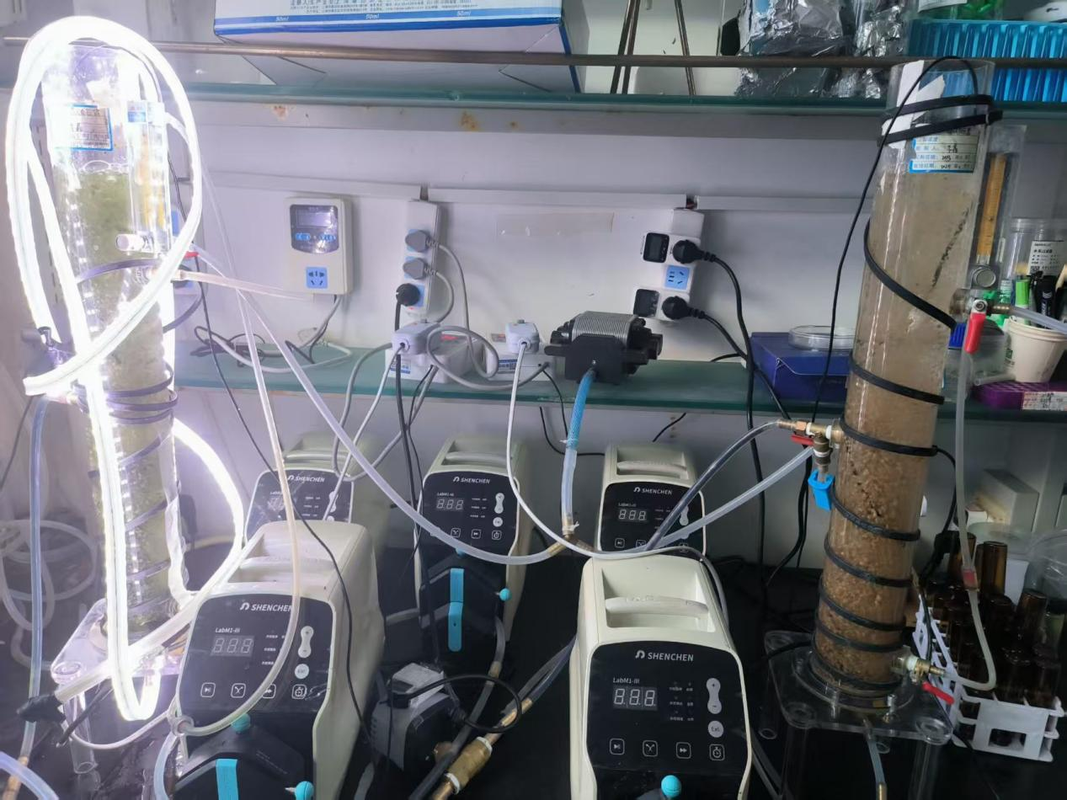
Fig. S1 Physical image of the reactor.

Table S2 Synthetic Sewage Formulations
Component | Reagent | Concentration（mg/L）
COD | Anhydrous sodium | 300
DBP | DBP | 0.5、1、5、10
Magnesian ion | Magnesium sulfate | 20
Calcium ion | Calcium chloride | 20
Potassium ion | Muriate | 20
Ammonia nitrogen | Ammonia chloride | 30
TP | Monopotassium phosphate | 10

Sample | sobs | ACE | Chao | shannon | simpson | shannoneven | coverage | Pielou_e
R1-Ⅰ | 4706.67 | 4706.67 | 4706.67 | 5.05 | 0.05 | 0.60 | 1.00 | 0.60
R1-Ⅴ | 4589.67 | 4589.67 | 4589.67 | 4.84 | 0.06 | 0.57 | 1.00 | 0.57
R2-Ⅰ | 4989.33 | 4989.33 | 4989.33 | 5.09 | 0.05 | 0.60 | 1.00 | 0.60
R2-Ⅴ | 4656.67 | 4656.67 | 4656.67 | 4.87 | 0.06 | 0.58 | 1.00 | 0.58
Table S3 Alpha diversity parameters of microorganisms

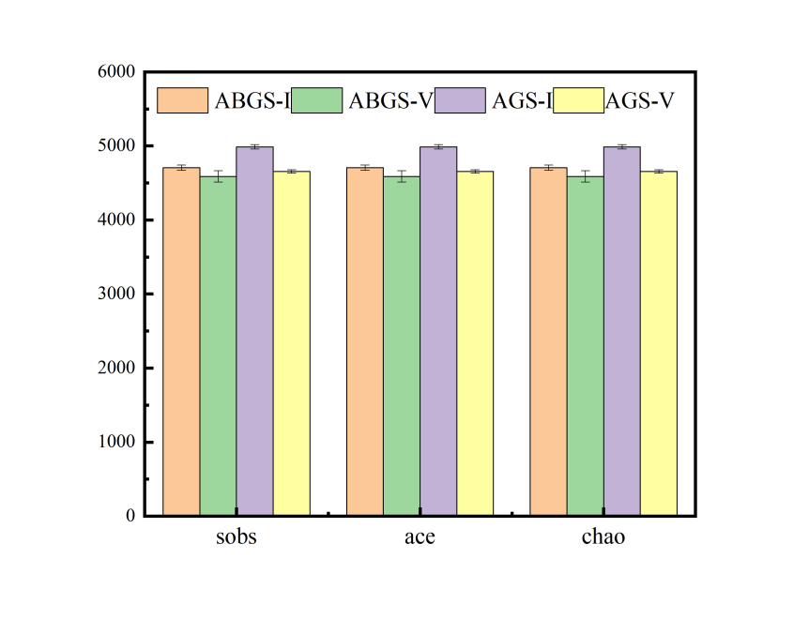
Fig.S2 Sobs, ACE, Chao indices
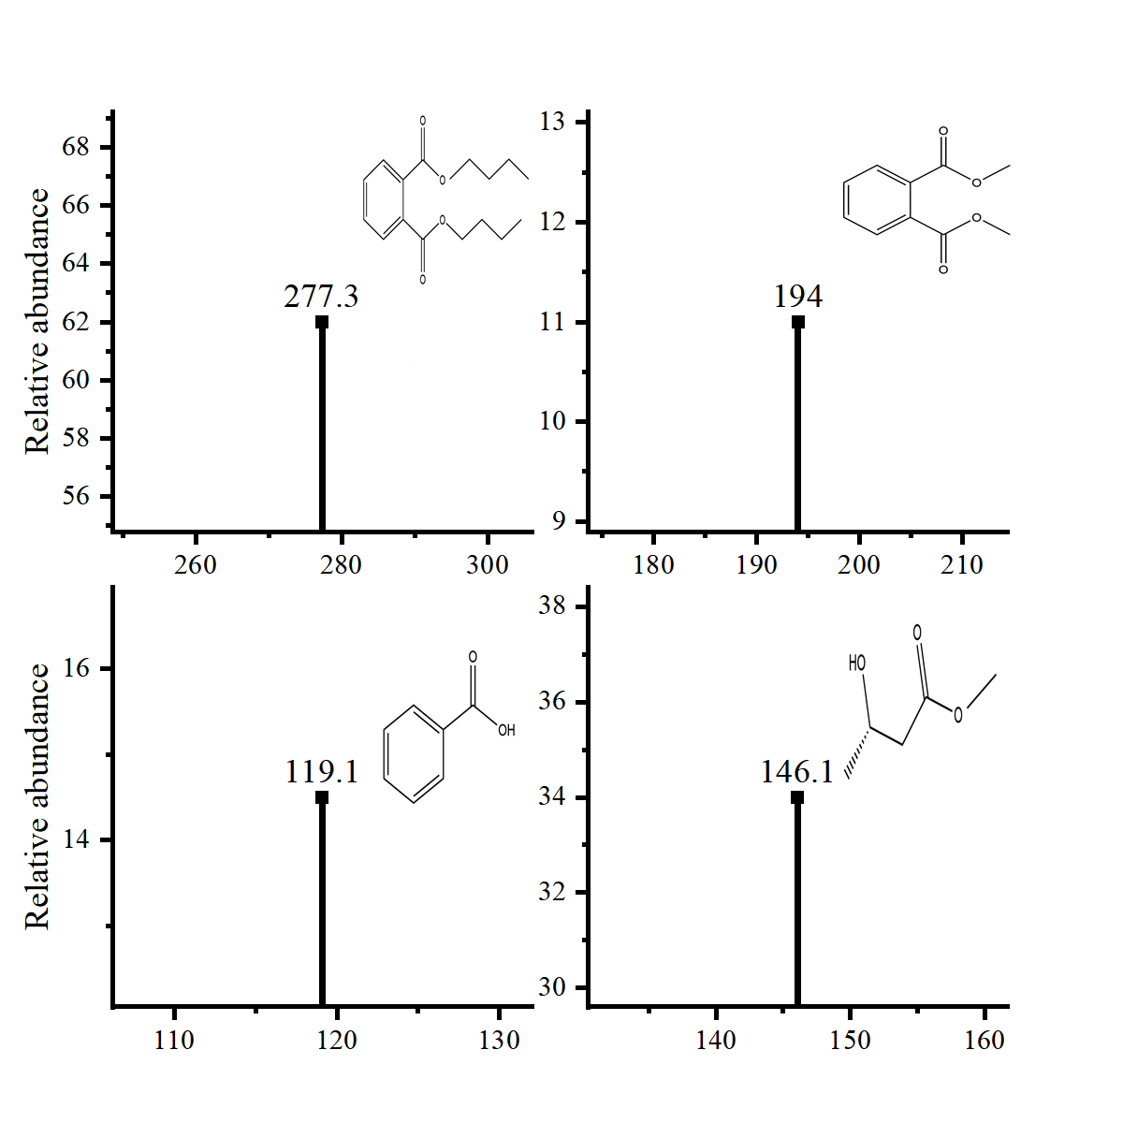
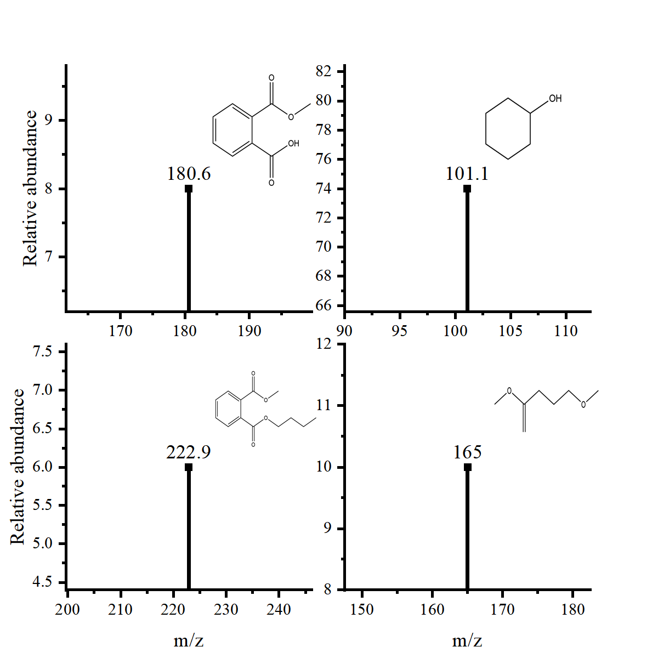
Fig.S3 Intermediate detected by GC/MS

