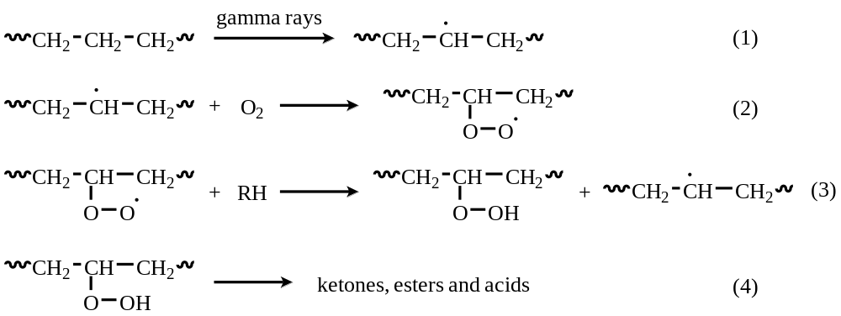
Scheme 1 The oxidation cascade in PE following irradiation.

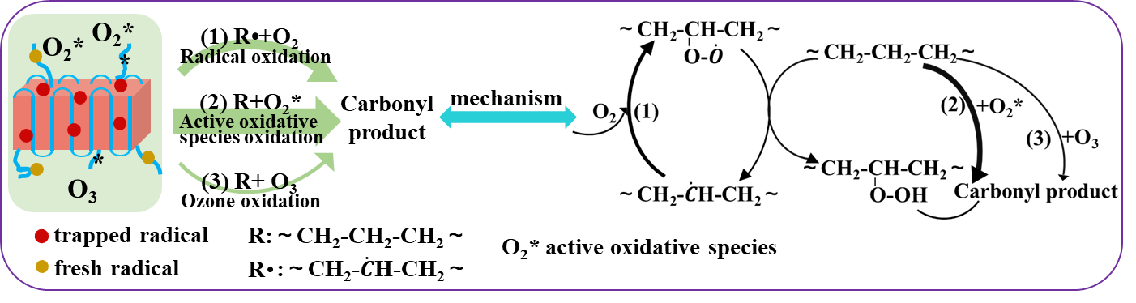
Scheme 2 Direct irradiation oxidation mechanism.

