Supporting Information for
A dipolar bidentate molecule for efficient and stable all-inorganic perovskite solar cells
Cong Shen^{1,2}, Tengling Ye¹, Artem Kuklin^{1,3}, Peixia Yang¹, Hans Ågren^{1,3}, Lijie Sun⁴, and Guanying Chen1^{,2,4*}
¹ MllT Key Laboratory of Critical Materials Technology for New Energy Conversion and Storage, School of Chemistry and Chemical Engineering, Harbin Institute of Technology, Harbin 150001, People’s Republic of China
² Harbin KY Semiconductor, Inc., Harbin, 150028, People’s Republic of China
³ Department of Physics and Astronomy, Division of X-ray Photon Science, Uppsala University, Uppsala, SE-75121 Sweden
⁴ Shanghai Institute of Space Power-Sources, State Key Laboratory of Space Power-Sources, Shanghai 200245, China
*Correspondence: chenguanying@hit.edu.cn

Fig. S1 Molecular structures of BA, ABA, and AMBA.

Fig. S2 FTIR spectra of (a) BA, BA-TiO₂, (b) ABA, ABA-TiO₂, (c) AMBA, and AMBA-TiO₂.
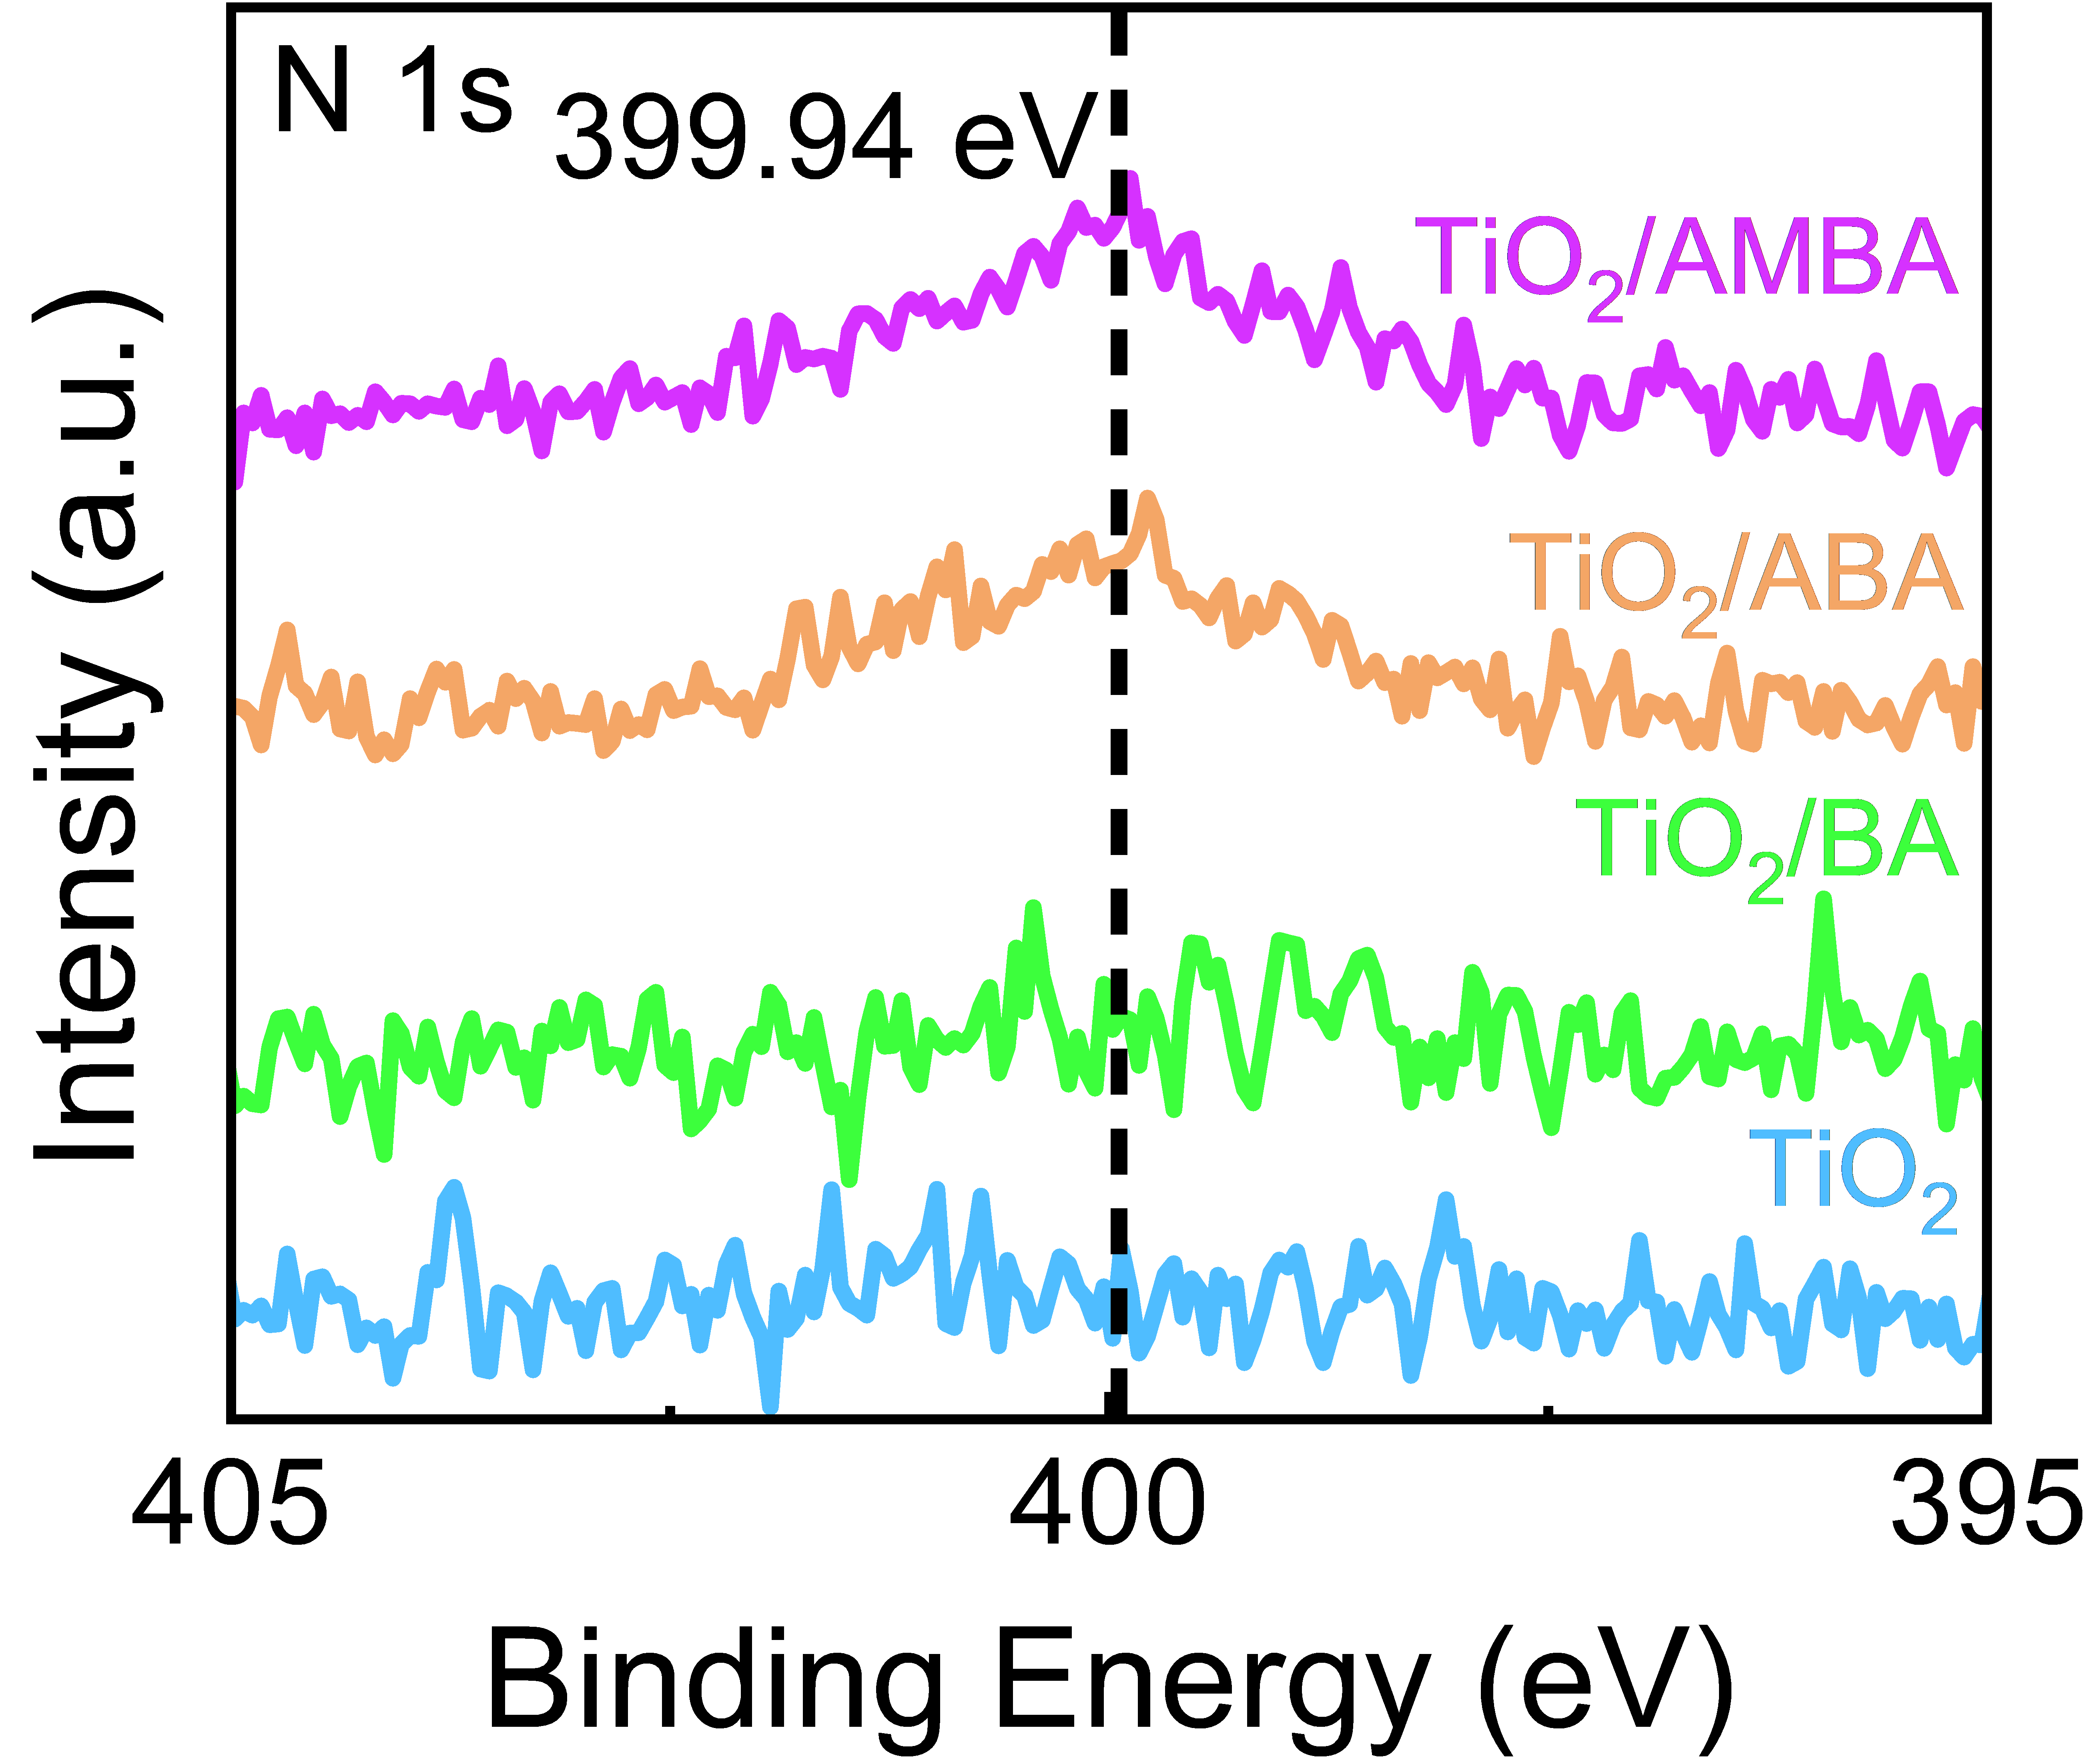
Fig. S3 XPS spectra of N 1s for TiO₂ and TiO₂/BSAMs films.
Fig. S4 Tauc plots of the TiO₂ (a) and CsPbI_{3-x}Br_{x} (b) without and with BSAMs.

Fig. S5 Cutoff regions, valence band edges of UPS spectra, and energy level diagram for TiO₂ films (a) with BA (b), ABA (c), AMBA (d), and CsPbI_{3-x}Br_{x} (e).

Fig. S6 Schematic diagrams of work function (WF) for TiO₂ films with BSAMs.

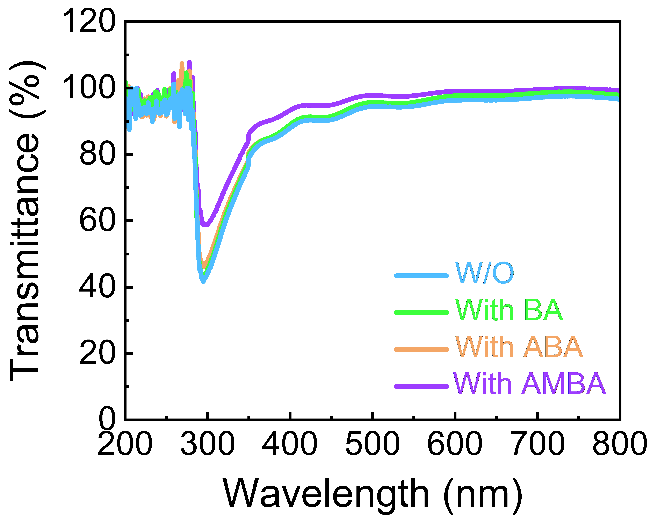
Fig. S7 UV-vis transmittance spectra of FTO/TiO₂ layer without and with BSAMs.

Fig. S8 Top-view SEM images and CA results for TiO₂ (a), with BA (b), ABA (c), and AMBA (d).

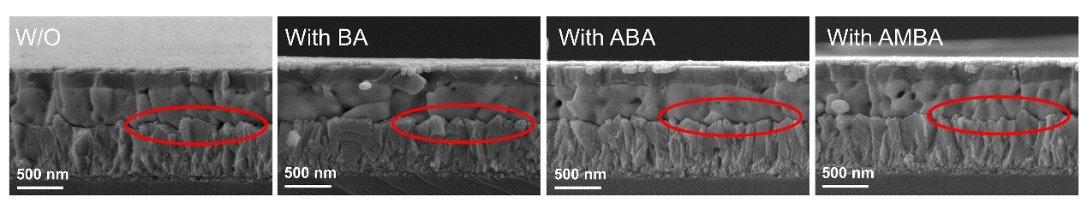
Fig. S9 The cross-sectional SEM images without and with BSAMs.

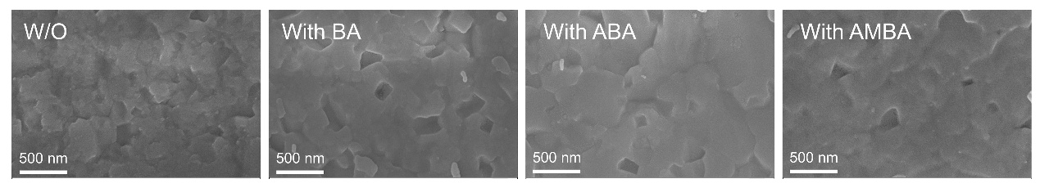
Fig. S10 SEM images of the bottom surface for the perovskite films deposited on TiO₂ without and with BSAMs.
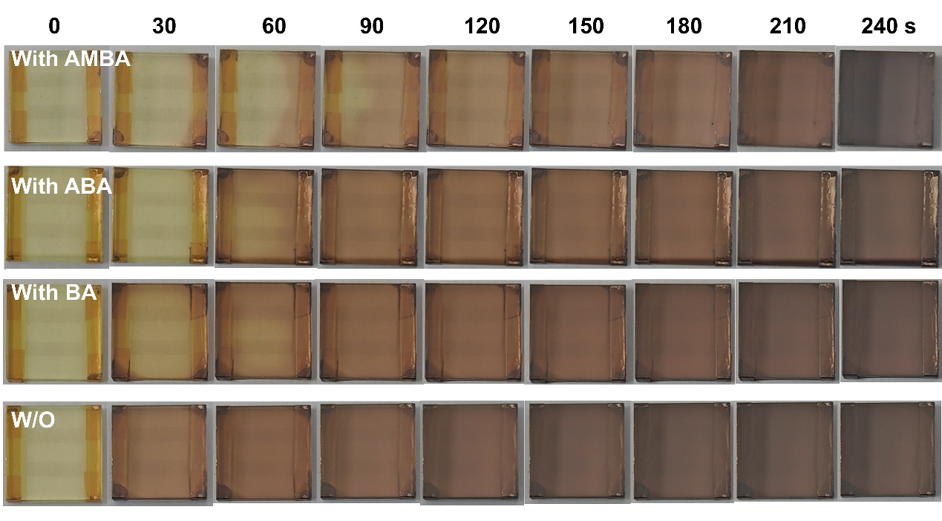
Fig. S11 Photos of films without and with BSAMs annealed at 190°C.

Fig. S12 The XRD pattern of perovskite films without and with ABA/AMBA during the annealing.

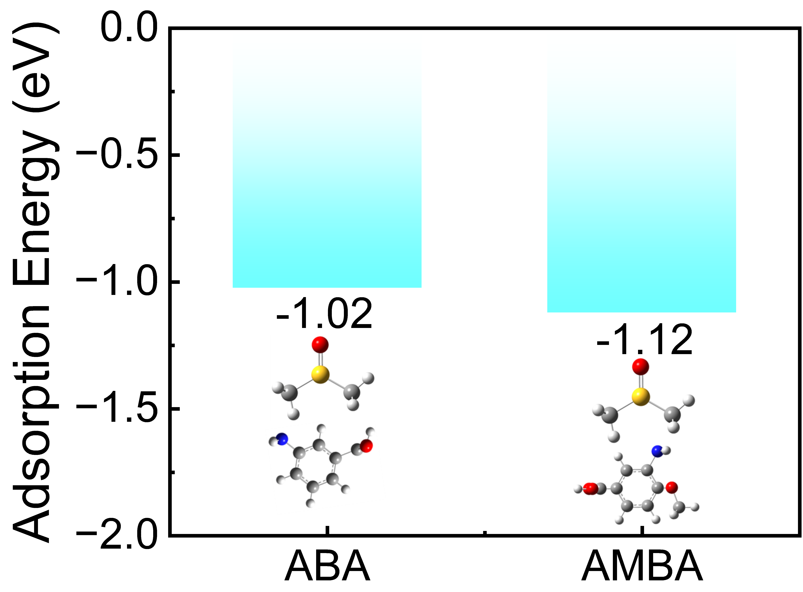
Fig. S13 Adsorption energies between ABA/AMBA and DMSO.

Fig. S14 The schematic diagram of perovskite crystallization in the annealing process.

Fig. S15 FTIR spectra for (a) ABA and ABA+PbI₂ and (b) AMBA and AMBA+PbI₂.

Fig. S16 Statistical results of the perovskite grain size without and with BSAMs.

Fig. S17 AFM images of perovskite layers without and with BSAMs.

Fig. S18 XRD spectra for CsPbI_{3-x}Br_{x} films without and with BSAMs.

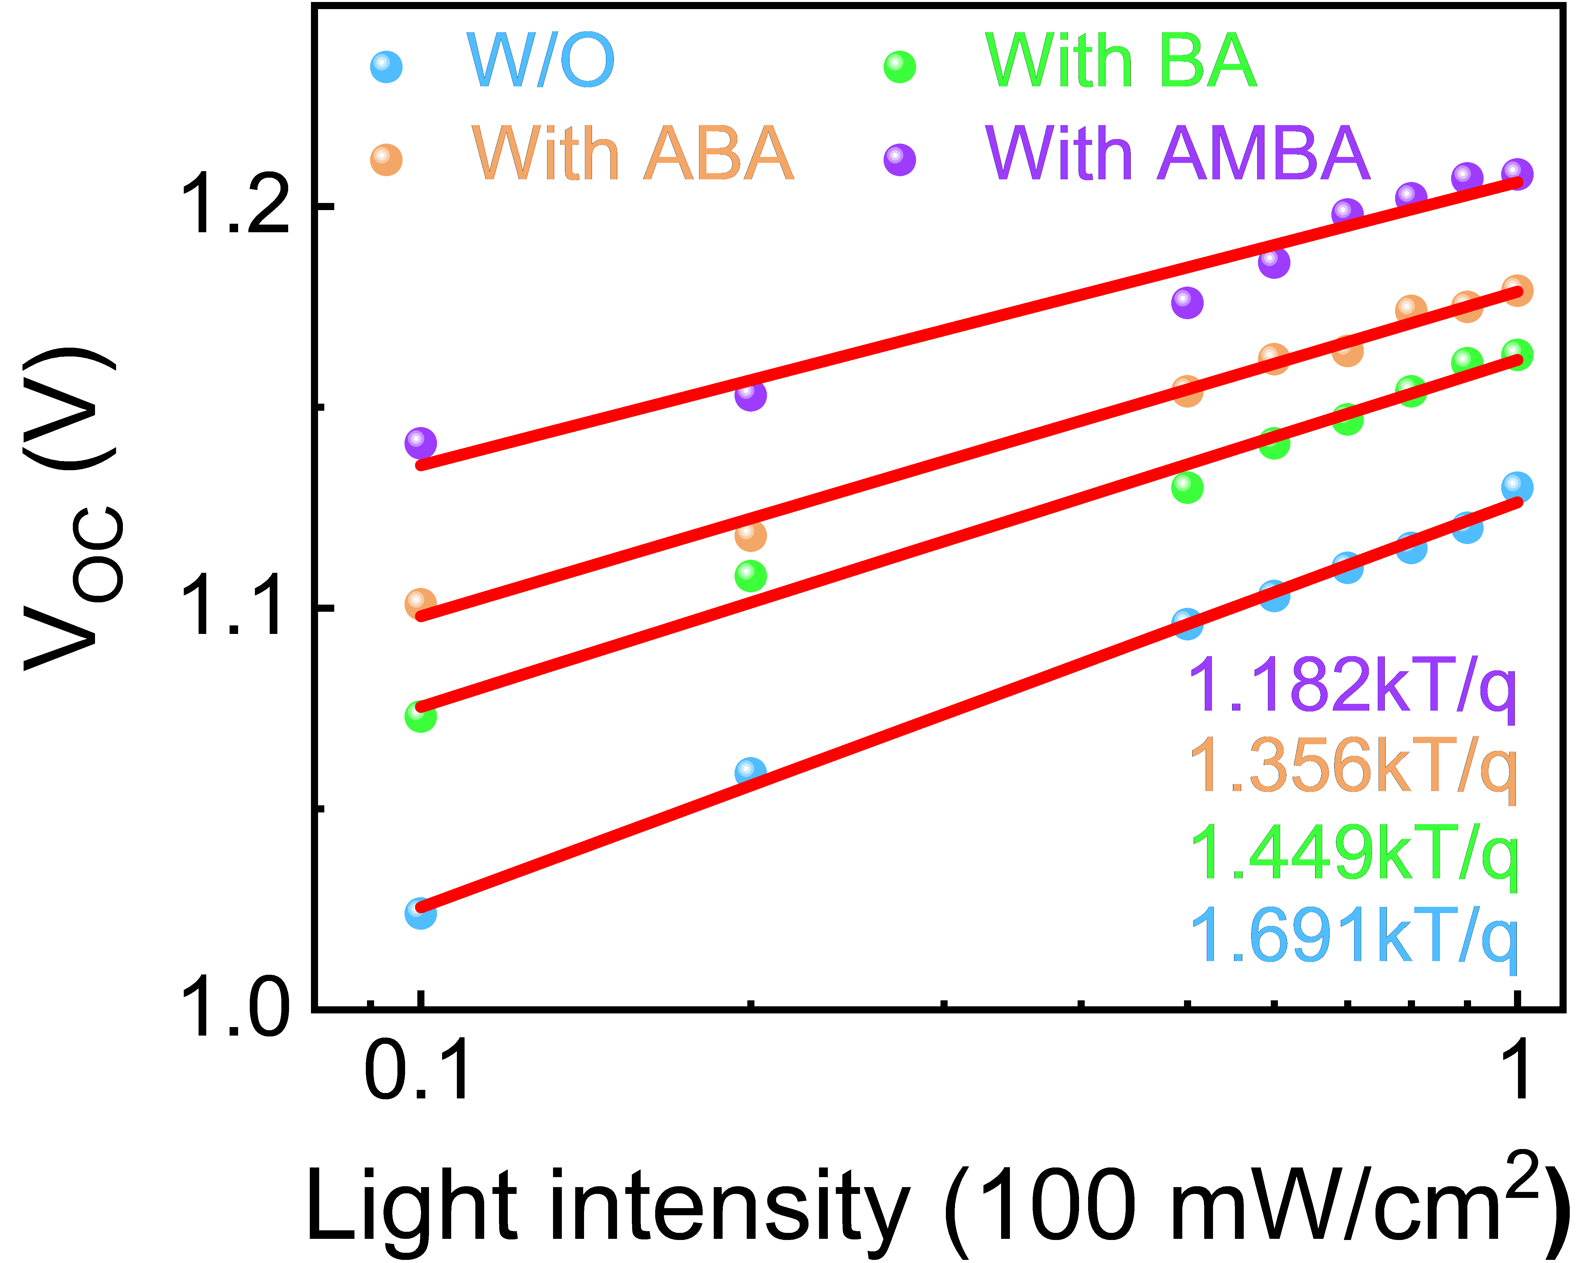
Fig. S19 V_{OC} dependence on light intensity for the CsPbI_{3-x}Br_{x} PSCs without and with BSAMs.

Fig. S20 The dark J-V curves of devices without and with BSAMs.

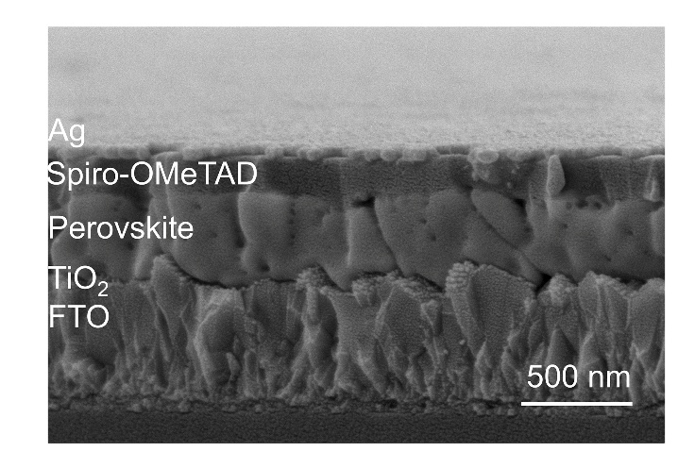
Fig. S21 Cross-sectional SEM image of the CsPbI_{3-x}Br_{x}-based device.

Fig. S22 PCE of devices with different concentrations of (a) BA, (b) ABA, and (c) AMBA.

Fig. S23 Photographs of films without and with BSAMs at different storage times.

Fig. S24 XRD results of perovskite layers without and with BSAMs at 0 and 168 h.

Fig. S25 The thermal stability of the devices in the N₂ environment without and with BSAMs.
Fig. S26 XRD results of perovskite layers without and with BSAMs under UVC irradiation for 0 h, 144 h, and 384 h.
Table S1 The band structure parameters of TiO₂, TiO₂/BSAMs, and CsPbI_{3-x}Br_{x} films, respectively.
Samples | E_{cutoff}  (eV) | E_{Fermi}  (eV) | E_{C}  (eV) | E_{V}  (eV) | WF  (eV) | E_{g}  (eV)
TiO₂ | 16.64 | 3.16 | 4.43 | 7.74 | 4.58 | 3.31
TiO₂/BA | 16.73 | 3.14 | 4.32 | 7.63 | 4.49 | 3.31
TiO₂/ABA | 16.86 | 3.13 | 4.18 | 7.49 | 4.36 | 3.31
TiO₂/AMBA | 16.97 | 3.11 | 4.05 | 7.36 | 4.25 | 3.31
CsPbI_{3-x}Br_{x} | 17.08 | 1.54 | 3.95 | 5.68 | 4.14 | 1.73

Table S2 Fitted TRPL parameters of the perovskite films deposited on the TiO₂ without and with BSAMs.
Samples | 𝜏_{ave} (ns) | 𝜏₁ (ns) | А₁ | 𝜏₂ (ns) | А₂
W/O | 26.85 | 8.80 | 0.38 | 29.41 | 0.8
With BA | 15.53 | 4.71 | 1.45 | 19.70 | 0.9
With ABA | 7.21 | 3.67 | 3.17 | 15.76 | 0.31
With AMBA | 4.87 | 2.29 | 7.22 | 7.73 | 1.93

Table S3 Fitted EIS parameters of PSCs without and with BSAMs.
Samples | R_{s} (Ω) | R_{rec} (Ω)
W/O | 58.61 | 74018
With BA | 19.92 | 99340
With ABA | 8.64 | 107820
With AMBA | 2.345 | 174670

Table S4 The photovoltaic parameters of PSCs without and with BSAMs.
Samples | J_{SC} (mA/cm²) | V_{OC} (V) | FF (%) | PCE (%)
W/O | 21.52 | 1.130 | 75.55 | cc
With BA | 21.52 | 1.163 | 77.73 | 19.45
With ABA | 21.65 | 1.179 | 78.41 | 20.02
With AMBA | 21.77 | 1.208 | 81.30 | 21.38

Table S5 The photovoltaic parameters of the control and AMBA-based PSCs under different voltage scanning directions.
Samples | J_{SC} (mA/cm²) | V_{OC} (V) | FF (%) | PCE (%) | HI (%)
W/O (F) | 21.50 | 1.098 | 72.06 | 17.01 | 7.40
W/O (R) | 21.52 | 1.130 | 75.55 | 18.37 | 7.40
With AMBA (F) | 21.75 | 1.203 | 79.32 | 20.75 | 2.95
With AMBA (R) | 21.77 | 1.208 | 81.30 | 21.38 | 2.95

Table S6 Summary of stability of CsPbI_{3-x}Br_{x} PSCs under UV irradiation.
Configuration | Champion PCE (%) | Environment | Aging time (h) | Remaining PCE (%) | λ (nm) | Ref.
FTO/TiO₂/CsPbI_{3-x}Br_{x}+MC/Spiro-OMeTAD/Au | 22.04 | Air | 150 | 91.1 | -- | ¹
FTO/TiO₂/Ti₃C₂T_{x}/CsPbI_{3-x}Br_{x}/Spiro-OMeTAD/Ag | 19.56 | Air | 450 | 81 | -- | ²
FTO/TiO₂/Cs₂PbI₂Cl₂/CsPbI₂Br/Cs₂PbI₂Cl₂/Spiro-OMeTAD/Ag | 16.65 | -- | 200 | 82 | 365 | ³
ITO/SnO₂/CsPbI₂Br/P₃HT/Ag | 16.86 | Air | 28 | 94 | 365 | ⁴
ITO/NiO_{x}/4-ABSA/CsPb_{0.6}Sn_{0.4}I_{3-x}Br_{x}/Au | 17.4 | N₂ | 240 | 80 | 365 | ⁵
FTO/TiO₂/AMBA/CsPbI_{3-x}Br_{x}/Spiro-OMeTAD/Ag | 21.38 | N₂ | 384 | 93.80 | 254 | This work

References
1. Zhou, T. et al. Innovative application of photochromic molecules in inorganic perovskite solar cells: simultaneous refinement in performance and environmental sustainability. Adv. Energy Mater. 15, 2404850 (2024).
2. Wang, M. et al. Buried interface modulation via preferential crystallization in all-inorganic perovskite solar cells: the case of multifunctional Ti₃C₂T_{x}. Adv. Funct. Mater. 33, 2300700 (2023).
3. Yang, S. et al. In situ tin(II) complex antisolvent process featuring simultaneous quasi-core-shell structure and hterojunction for improving efficiency and stability of low-bandgap perovskite solar cells. Adv. Energy Mater. 10, 2002882 (2020).
4. Hu, J. et al. Flattening of the cratered inorganic perovskite film via precursor engineering for CsPbI₂Br solar cells with 16.86% efficiency. ACS Sustainable Chem. Eng. 12, 13392-13400 (2024).
5. Zhang, W. et al. Oriented Molecular Dipole-Enabled Modulation of NiO_{x}/Perovskite Interface for Pb-Sn Mixed Inorganic Perovskite Solar Cells, Adv.Mater. 37, 2414125 (2025).

