8. APPENDIXES
Appendix 1: General questioner information data collection for sero prevalence
I. Purpose: Sero survey
A. Information collection at district level
1. Region________Zone:_______ District Number of Kebele in the District____
2. Animal Population in District; Shoats Sheep Goat_____
cattle________equine__________poultry__________
3. List name of kebeles in district
3.1._______________
3.2._____________________
3.3.______________________etc
4. List number of sheep________ and goats_________ in each kebele
5. List of accessibility of infrastructure and location of each kebele in km___ or Long__ and Lat__
6. No. of animal health posts in Wereda______ and kebele’s it found in____, _____, _____
7. Check if outbreak/vaccination record book is available at Woreda clinic level:
8. If available since when (Month/Year)
9. List of Endemic small ruminant disease in the woreda.
10. Check PPR outbreak and/or vaccination record in woreda in the last 3 years
B. Information collection at kebele level
1. District kebeles_________ Date _______
2. Geo-reference of kebele Long Latit Altit ______
3. Total No. of villages in kebele .
C. Questionnaire assessment at village level
1. District kebeles_________ Date _______
2. Specific name of village ____
3. Total No. of herds in village herd of sheep herd of goats___mixed herds _____
D. Questioners data collection at herd level
1. District kebeles_________ Village code________ herd no. _______Date _ _______
2. Owner's name (optional) sex _____ age; A. 20-30 B. 30-40 C. >40
3. Number of small ruminant owned, sheep goats _____ total________
4. Is there small ruminant’s disease surveillance carried out in past 3 years in your village?
A. yes B. No C. I don’t now
5. What type of disease commonly affects your small ruminants?
6. Is there any small ruminant’s disease outbreak(s) experience in your area in the 3 years past?
A. Yes B. No
7. When was it occurred? A. <1year B. 1-2 year C. 1 -3years D. >3years
8. Have you had enteritis-stomatitis, nasal discharge or diarrhoea syndrome in shoats at a time?
A. Yes B. No
9. Which species was more affected? A. sheep B. goat C. both
10. What was the most Source/origin of outbreak in to your village you think?
A. Neigh bores B. New introducing C. Contact wild animal D. I don’t no
11. Were your small ruminants vaccinated in 3 years past for any diseases? A. Yes B. No
12. For which disease vaccine was given? A. SGP B. Ovine pas C. PPR D. I don’t now
13. Was your herd contact with other herds at watering and grazing time? A. Yes B. No.
14. Did your flock Contacts with wildlife small ruminants? A. yes B. No
15. Is small ruminant flock movement/migration outside of your area (village)? A. Yes B. No
16. Have you bought new shoats or introduced new shoats since in 3years? A: Yes B: No

Appendix 2: Information sheet form for sample collection
Appendix 2.1.: Information sheet form for serum sample collection
Region ____ Woreda________kebele Name_____Village Name______ Date: _____
Sample No. | Owners‟ name | herd No. | No. animal in heard | Herd size | Species | Age | Sex | Serology  Result
1.
2
3
4
Key: for species; S- sheep, G-goats, for ages; young- 0.6-2 years, adult - 2-3years, Sex; male, Female; Herd size; small, M-medium, L-large
Appendix 2.2. Estimated age with different numbers of erupted permanent incisors
No. of permanent incisors | Estimated age range
 | Sheep | Goat
0 pair | Less than 1 year | Less than 1 year
1 pair | 1-2 years | 1 to 2 years
2 pairs | 1.5 to 2 years | 2-3 years
3 pairs | 2.5 to 3 years | 3-4 years
4 pairs | More than three years. | More than four years
Broken mouth | Aged | Aged
Source: ESGPIP (2009)
Appendix 2.3: General questioner information data collection for sero monitoring
A. Information collection at district level
I. Purpose; Sero-monitoring
1. Region________Zone:_______ District Number of Kebele in the District____
2. Animal Population in District; sheep goat _____
cattle____equine______poultry______
3. List name of kebeles in district and PPR vaccination carry out kebeles
3.1._______________
3.2._____________________
3.3.______________________etc
4. List number of sheep________ and goats_________ in each kebele
5. List of accessibility of infrastructure and location of each kebele in km___ or Long__ and Lat__
6. No. of animal health posts in Wereda______ and kebele’s it found in____, _____, _____
7. Have you had PPR outbreak in your District in the last 3 years? A: Yes B: No
8. If yes, how many times it occurred? A. 1 B: 2 C: 3 D > 3
9. Numbers of small ruminants vaccinated in each out break
10. In how many kebeles PPR outbreak was occurred by this year?
11. How many small ruminants were vaccinated?
12. Outbreak and/or vaccination record book available at District clinic level:
A: Yes B: No
Appendix 2.4: Information sheet form during serum sample collection for sero monitoring
PPR sero-monitoring blood sample collection forms: Region______Zone ___Woreda___ Date___
No. | District | Kebele | Village | Sample Number | Species | Age | Sex | Coordinate
1
2
Key: S-sheep, G-goats, Age; young- 0.6-2 years, Adult -2-3 years, C-coordinate for a village in decimal degree
Appendix 3: Laboratory procedure and results

Appendix 3.1. Laboratory procedure(cELISA)
The brief procedures were; 25 μL of dilution buffer-13 (supplied kit) was added to each well. 25 μL positive control was poured into wells A1 and B1 and 25 μL negative control was poured into C1 and D1 and 25 μL samples were poured into the remaining wells. ELISA plate was then incubated at 37°C for 45 minutes. Each well was washed manually 3 times with approximately 300 μL of wash solution, prepared by diluting the wash concentrate (20X) with distilled/deionized water. About 100 μL 1X conjugate was added to each well, which prepared by diluting the conjugate 10X to 1/10 in dilution buffer 4, and incubated at room temperature for 30 minutes again. After time last, further 3 times wash was done and 100 μL substrate solutions were added to each well and incubated for 15 minutes in a dark room. Lastly, stop solution (100 μL) was added to stop the reaction. The optical density (OD) readings were taken using ELISA micro plate reader with an inference filter of 450 nm. The OD (optical density) values of each sample were converted to competition percentage (S/N) (%) by using the following formula: S/N % = [OD sample/OD NC)] X 100.

Where, S/N is competition percentage, OD NC is optical density of negative control, OD sample is optical density of sample, a test serum samples showing a competition percentage value less than or equal to 50% were considered positive, greater than 50% and less than or equal to 60% were considered doubtful and greater than 60% were considered negative. The test was validated if the mean value of the negative control OD was greater than 0.7 and the mean value of the positive control (ODPC) was less than 30% of the ODNC (ODPC /ODNC <0.3) (Libeau et al., 1995).

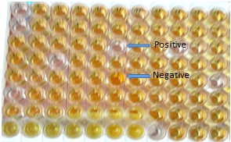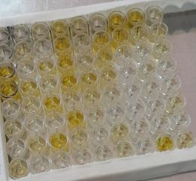
Figure 5: C-ELISA microplate showing positive Figure 6: C-ELISA microplate showing positive
and negative reactions in unvaccinated serum and negative reactions in vaccinated serum

Appendix 4: Geo-references where samples were taken
Kebeles | Geo Reference
Kebeles | Latitude | Longtude
Waltah Sura Hangaso | 7.018 | 39.364
Ititu Sura | 9.339 | 39.979
Waltahi Kubsa | 7.108 | 39.968
Wacho Mishirge | 7.003 | 40.116
Shedam | 6.867 | 39.977
Huru | 7.083 | 40.226
Solka | 7.067 | 40.232
Waltahi Arjo | 7.067 | 39.999
Kaso | 7.22 | 39.99

Appendix 5: PPR prevalence, risk factors and case distribution
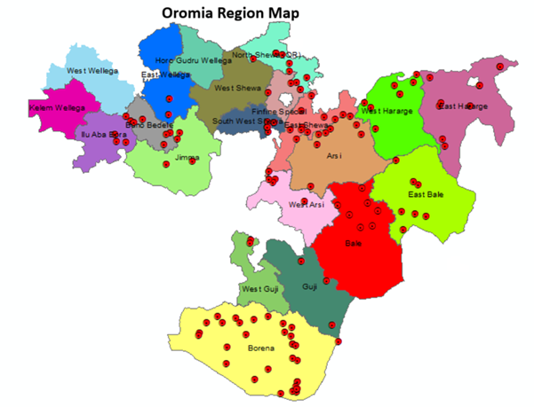

Figure 3: Spatial distribution of PPR cases across different areas in Oromia Zone (2017-2022).

