SUPPLEMENTARY INFORMATION

Microbial diversity, structure and predicted carbon-cycling pathways show partial convergence in restored and natural salt marshes in Venice lagoon
Anjali Gopakumar^{1,2*}, Md Masum Billah³, Alessandro Vezzi⁴, Fabio De Pascale⁴, Davide De Battisti⁴, Marco Bonato⁴, Katherine A. Dafforn^{2,5}, Laura Airoldi^{4,6}
¹Department of Biological, Geological, and Environmental Sciences, University of Bologna, Ravenna – 48123, Italy
²School of Natural Sciences, Macquarie University, Sydney, NSW – 2109, Australia
³Inter-Departmental Research Centre for Environmental Science-CIRSA, University of Bologna, Ravenna Campus, Via S. Alberto 163, 48123, Ravenna, Italy
⁴Department of Biology, University of Padova, Padova – 35121, Italy
⁵School for the Environment, University of Massachusetts Boston, Boston, MA – 02125, USA ⁶NBFC, National Biodiversity Future Center, Palermo 90133, Italy

*Corresponding author: Dr. Anjali Gopakumar, 12 Wally’s Walk, Macquarie University, North Ryde, NSW – 2109, Australia; Email: anjali.gopakumar@mq.edu.au; Phone: +61-452498757; ORCID ID: 0000-0001-5642-4951

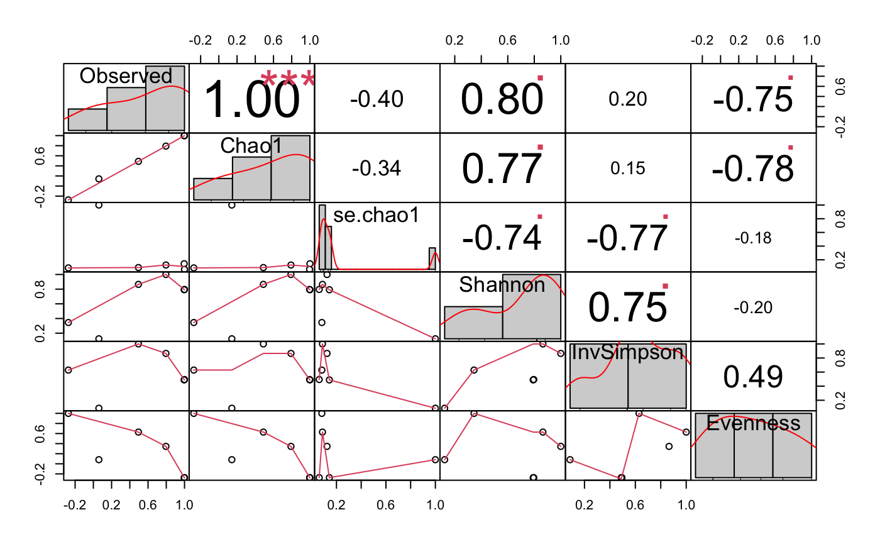

Fig. S1 Chart correlation of all alpha diversity indices measured in this study: Observed = Observed richness; Chao1 = Chao1 index; Shannon = Shannon diversity index; InvSimpson = Simpson’s diversity index.

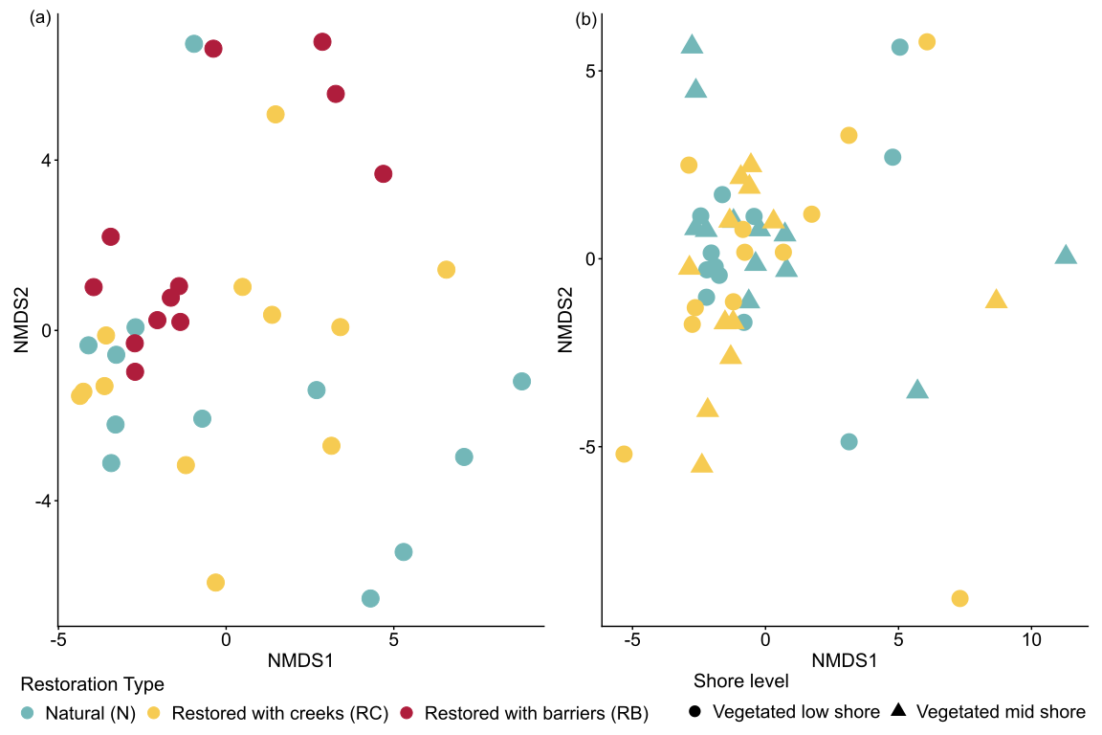
Fig. S2 (a) Multivariate nMDS plot, based on Euclidean dissimilarity representing clusters of CLR-transformed predicted carbon cycling pathway abundances grouped by Restoration type (depicted by colour: N: Natural, RC: Restored with creeks; RB: Restored with barriers) and shore level (Low and Mid, depicted by shape) in (a) unvegetated low marshes (Stress = 0.16) and (b) vegetated low and mid marshes (Stress = 0.14).

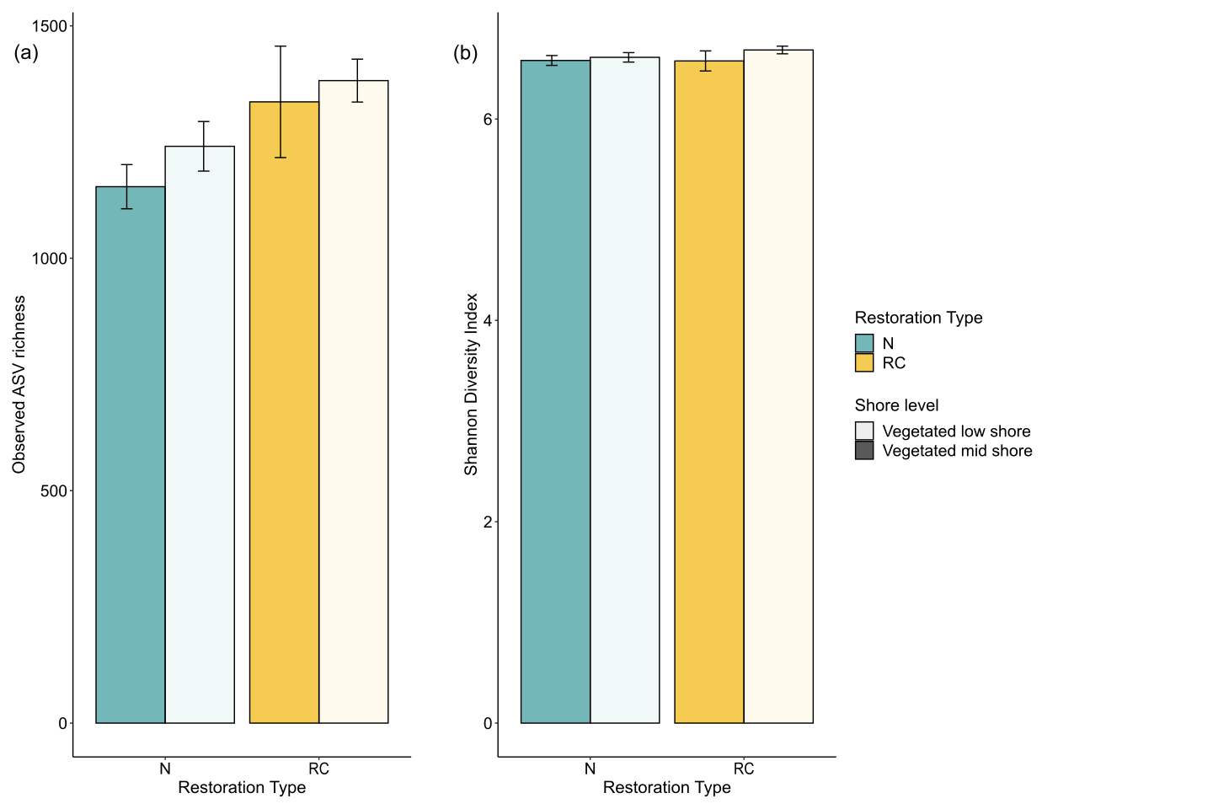
Fig. S3 Mean (a) Observed ASV richness and (b) Shannon diversity measures in the two restoration types (natural (N) and restored with creeks (RC)) and the two shore levels (vegetated low shore and vegetated mis shore).

Table S1 Microbial diversity measures, vegetation composition and physicochemical characteristics of sediment from each restoration type and habitat type. The values are expressed as mean ± standard deviation.
Restoration type | Habitat type | Vegetation species | Observed richness | Shannon diversity | Conductivity (μS/cm) | pH | Nitrogen (%) | Sulphur (%) | Organic matter (%) | Silt-clay (%) | Chlorophyll-a (µg/g)
Natural (N) | Unvegetated low shore | NA | 1112.583  ±304.442 | 6.413 ±0.173 | 10618.08  ±3632.78 | 7.91  ±0.23 | 0.27  ±0.12 | 0.94  ±0.31 | 15.03  ±2.61 | 80.1  ±20.1 | 13.83  ±8.04
Natural (N) | Vegetated low shore | Sporobolus anglicus | 1240.833 ±  184.781 | 6.613 ±0.162 | 12396.5  ±3458.52 | 7.81  ±0.12 | 0.32  ±0.09 | 0.62  ±0.36 | 16.92  ±2.71 | 74.47  ±30.52 | 14.66  ±5.77
Natural (N) | Vegetated mid shore | Limonium narbonense; Puccinellia festuciformis; Salicornia fruticosa | 1154 ±  164.582 | 6.582 ±0.171 | 19271.67  ±4835.09 | 7.66  ±0.26 | 0.53  ±0.12 | 0.77  ±0.38 | 23.58  ±2.58 | 85.06  ±14.33 | 32.01  ±10.26
Restored with creeks (RC) | Unvegetated low shore | NA | 435.25 ±  346.685 | 6.585 ±0.154 | 6170.36  ±2955.34 | 8.16  ±0.22 | 0.19  ±0.08 | 0.47  ±0.26 | 12.44  ±2.38 | 44.44  ±25.09 | 12.36  ±6.47
Restored with creeks (RC) | Vegetated low shore | Sporobolus anglicus | 1382.167 ±  159.853 | 6.686 ±0.132 | 5055.75  ±3409.53 | 8.36  ±0.34 | 0.28  ±0.17 | 0.34  ±0.28 | 14.27  ±3.07 | 37.95  ±32.08 | 14.13  ±9.3
Restored with creeks (RC) | Vegetated mid shore | Limonium narbonense; Puccinellia festuciformis; Salicornia fruticosa | 1336.417 ±  415.153 | 6.577 ±0.348 | 6143  ±4691.98 | 8.12  ±0.3 | 0.27  ±0.14 | 0.3  ±0.26 | 14.85  ±5.50 | 27.84  ±33.51 | 20.58  ±10.13
Restored with barriers (RB) | Unvegetated low shore | NA | 1112.833 ±  201.388 | 6.362 ±0.164 | 4140.5  ±2048.92 | 8.07  ±0.14 | 0.14  ±0.06 | 0.4  ±0.21 | 10.54  ±1.97 | 76.45  ±21.71 | 8.56  ±4.53

Table S2 Pairwise comparisons (using Estimated Marginal Means) of microbial Shannon diversity in the unvegetated low marsh among the three restoration types (N: Natural, RC: Restored with creeks, RB: Restored with barriers). Significant effects (p <0.05) are in bold.
Restoration type | Groups | Estimate | SE | Df | t | p-value
Shannon diversity
Unvegetated low marsh | N – RC | -0.172 | 0.074 | 31 | -2.314 | 0.069
Unvegetated low marsh | N – RB | 0.051 | 0.074 | 31 | 0.689 | 0.772
Unvegetated low marsh | RC > RB | 0.223 | 0.074 | 31 | 3.003 | 0.014

Table S3 Pairwise results of PERMANOVA comparing (a) microbial community structure and (b) microbial community composition between the restoration types (N: Natural, RC: Restored with creeks, RB: Restored with barriers). Significant effects (p <0.05) are in bold.
- Microbial community structure
Pairwise distinctions between restoration types
Pairs | Df | SS | F | R² | p | p-adj
N – RC | 1 | 0.322 | 2.297 | 0.095 | 0.005 | 0.005
N – RB | 1 | 0.762 | 5.138 | 0.189 | <0.001 | <0.001
RC – RB | 1 | .614 | 4.906 | 0.182 | <0.001 | <0.001
- Microbial community composition
Pairwise distinctions between restoration types
Pairs | Df | SS | F | R² | p | p-adj
N – RC | 1 | 0.438 | 2.061 | 0.086 | 0.002 | 0.002
N – RB | 1 | 0.867 | 3.920 | 0.151 | <0.001 | <0.001
RC – RB | 1 | 0.784 | 3.991 | 0.154 | <0.001 | <0.001

Table S4 ANOVA output from the distance-based redundancy analysis (dbRDA) plot, showing the sediment characteristics that explain the differences observed in the microbial community structure in the between restoration types (N: Natural, RC: Restored with creeks, RB: Restored with barriers) in the unvegetated habitats. Significant effects (p < 0.05) are in bold.
 | Df | SS | F | p
Nitrogen | 1 | 0.564 | 4.638 | 0.001
Conductivity | 1 | 0.210 | 3.330 | 0.001
pH | 1 | 0.207 | 1.699 | 0.054
Sulphur | 1 | 0.284 | 2.332 | 0.006
Silt-clay content | 1 | 0.295 | 2.427 | 0.003
Organic matter | 1 | 0.402 | 3.304 | 0.001
Residuals | 29 | 3.526

Table S5 Combined results of differential pathway analysis performed using limma on CLR-transformed PICRUSt2-predicted carbon-cycling pathways, in the unvegetated low shore habitats.
Pairwise contrasts | Pathway ID | logFC | AveExpr | t | p | p-adj | B
N vs RC | PWY-3481 | 1.030 | -2.917 | 1.387 | 0.174 | 0.826 | -4.490
 | FERMENTATION-PWY | -0.146 | 1.977 | -1.292 | 0.205 | 0.826 | -4.526
 | P461-PWY | -0.272 | 0.105 | -1.274 | 0.211 | 0.826 | -4.533
 | PWY-7111 | -0.140 | 2.423 | -1.266 | 0.214 | 0.826 | -4.535
 | CALVIN-PWY | -0.144 | 2.501 | -1.229 | 0.227 | 0.826 | -4.549
 | PWY-5209 | 0.448 | -0.701 | 1.203 | 0.237 | 0.826 | -4.558
 | PWY-6435 | 0.167 | 1.008 | 1.164 | 0.253 | 0.826 | -4.571
 | PWY-6641 | -0.281 | 1.226 | -1.163 | 0.253 | 0.826 | -4.571
 | PWY-5742 | 0.228 | -0.852 | 1.140 | 0.262 | 0.826 | -4.579
 | P23-PWY | -0.128 | 2.449 | -1.131 | 0.266 | 0.826 | -4.582
 | P42-PWY | -0.146 | 2.557 | -1.125 | 0.268 | 0.826 | -4.584
 | GLUCONEO-PWY | -0.131 | 2.401 | -1.096 | 0.281 | 0.826 | -4.593
 | PWY-5384 | -0.125 | 2.350 | -1.090 | 0.283 | 0.826 | -4.595
 | PWY-5130 | -0.157 | 2.141 | -1.067 | 0.293 | 0.826 | -4.603
 | PWY-7431 | -0.187 | 0.444 | -1.064 | 0.295 | 0.826 | -4.603
 | NONOXIPENT-PWY | -0.126 | 2.653 | -1.054 | 0.299 | 0.826 | -4.607
 | PWY-6969 | -0.128 | 2.578 | -1.051 | 0.301 | 0.826 | -4.607
 | PWY-8178 | -0.129 | 2.652 | -1.041 | 0.305 | 0.826 | -4.610
 | PWY-6628 | -0.113 | 2.330 | -1.035 | 0.308 | 0.826 | -4.612
 | COMPLETE-ARO-PWY | -0.113 | 2.473 | -1.033 | 0.309 | 0.826 | -4.613
 | PWY66-373 | 0.318 | -2.172 | 1.015 | 0.317 | 0.826 | -4.618
 | PWY-5659 | -0.110 | 2.531 | -0.974 | 0.337 | 0.826 | -4.630
 | REDCITCYC | 0.203 | 1.132 | 0.957 | 0.345 | 0.826 | -4.635
 | PWY0-321 | 0.136 | 0.367 | 0.951 | 0.348 | 0.826 | -4.637
 | PWY-5430 | 0.188 | -0.670 | 0.949 | 0.349 | 0.826 | -4.637
 | PWY-5022 | -0.154 | 1.239 | -0.943 | 0.352 | 0.826 | -4.639
 | GLYCOLYSIS | -0.105 | 2.427 | -0.935 | 0.356 | 0.826 | -4.641
 | P163-PWY | -0.231 | 0.064 | -0.912 | 0.368 | 0.826 | -4.647
 | PWY-7323 | -0.108 | 2.244 | -0.907 | 0.371 | 0.826 | -4.649
 | PWY-8187 | -0.163 | 1.586 | -0.902 | 0.373 | 0.826 | -4.650
 | PWY-5484 | -0.097 | 2.360 | -0.886 | 0.382 | 0.826 | -4.655
 | PWY-1042 | -0.106 | 2.731 | -0.850 | 0.401 | 0.826 | -4.664
 | P105-PWY | -0.270 | -1.854 | -0.845 | 0.404 | 0.826 | -4.665
 | P341-PWY | 1.130 | -6.738 | 0.845 | 0.404 | 0.826 | -4.665
 | PWY-5747 | -0.120 | 0.919 | -0.838 | 0.408 | 0.826 | -4.667
 | PWY0-42 | -0.120 | 0.919 | -0.838 | 0.408 | 0.826 | -4.667
 | PWY-7238 | -0.091 | 1.772 | -0.812 | 0.422 | 0.826 | -4.673
 | PWY-7254 | -0.121 | 0.186 | -0.727 | 0.472 | 0.826 | -4.693
 | PWY-6071 | 0.152 | -0.354 | 0.721 | 0.476 | 0.826 | -4.694
 | PWY-5431 | 0.151 | -0.447 | 0.721 | 0.476 | 0.826 | -4.694
 | SUCSYN-PWY | 0.992 | -3.654 | 0.692 | 0.493 | 0.826 | -4.700
 | PENTOSE-P-PWY | -0.070 | 2.063 | -0.652 | 0.519 | 0.826 | -4.708
 | PWY-7347 | 0.819 | -4.252 | 0.639 | 0.527 | 0.826 | -4.711
 | GLYCOLYSIS-E-D | -0.086 | 1.415 | -0.637 | 0.528 | 0.826 | -4.711
 | PWY-7118 | -0.076 | 1.674 | -0.636 | 0.529 | 0.826 | -4.712
 | PWY-5913 | 0.101 | 1.282 | 0.624 | 0.537 | 0.826 | -4.714
 | METH-ACETATE-PWY | -0.203 | -0.429 | -0.617 | 0.541 | 0.826 | -4.715
 | PWY-6992 | -0.143 | -0.170 | -0.613 | 0.544 | 0.826 | -4.716
 | CODH-PWY | -0.196 | -0.499 | -0.608 | 0.547 | 0.826 | -4.717
 | PWY-5677 | -0.202 | -2.945 | -0.591 | 0.559 | 0.827 | -4.720
 | PWY-5100 | -0.057 | 0.854 | -0.463 | 0.647 | 0.936 | -4.740
 | PWY-6317 | -0.084 | 1.718 | -0.442 | 0.661 | 0.936 | -4.743
 | PWY-3801 | 0.725 | -4.505 | 0.418 | 0.679 | 0.936 | -4.746
 | PWY-6731 | -0.062 | 0.850 | -0.343 | 0.734 | 0.936 | -4.755
 | PWY66-399 | -0.034 | 1.444 | -0.328 | 0.745 | 0.936 | -4.757
 | P108-PWY | -0.095 | -1.375 | -0.290 | 0.773 | 0.936 | -4.760
 | ANAEROFRUCAT-PWY | 0.029 | 1.409 | 0.290 | 0.773 | 0.936 | -4.760
 | LACTOSECAT-PWY | -0.381 | -7.440 | -0.289 | 0.774 | 0.936 | -4.760
 | PWY-6902 | -0.065 | 1.352 | -0.285 | 0.778 | 0.936 | -4.761
 | PWY-6906 | -0.084 | -1.135 | -0.268 | 0.790 | 0.936 | -4.762
 | ANAGLYCOLYSIS-PWY | 0.028 | 1.940 | 0.260 | 0.796 | 0.936 | -4.763
 | METHANOGENESIS-PWY | -0.121 | -1.849 | -0.259 | 0.797 | 0.936 | -4.763
 | PWY-5494 | -0.316 | -5.659 | -0.223 | 0.825 | 0.936 | -4.766
 | PWY-7784 | -0.065 | -0.812 | -0.220 | 0.828 | 0.936 | -4.766
 | PWY-8190 | -0.324 | -5.492 | -0.214 | 0.832 | 0.936 | -4.766
 | PWY-622 | 0.019 | 1.762 | 0.210 | 0.835 | 0.936 | -4.766
 | 3-HYDROXYPHENYLACETATE-DEGRADATION-PWY | 0.047 | -2.905 | 0.169 | 0.867 | 0.946 | -4.769
 | PWY-7480 | 0.035 | -0.257 | 0.165 | 0.870 | 0.946 | -4.769
 | PWY-7345 | 0.012 | 1.994 | 0.115 | 0.909 | 0.963 | -4.771
 | PWY-5647 | -0.041 | -0.018 | -0.112 | 0.911 | 0.963 | -4.771
 | PWY-5392 | 0.039 | -2.932 | 0.071 | 0.944 | 0.984 | -4.772
 | PWY4LZ-257 | -0.038 | -4.740 | -0.027 | 0.979 | 0.984 | -4.773
 | PWY-6588 | -0.009 | -2.485 | -0.022 | 0.983 | 0.984 | -4.773
 | PWY-1882 | 0.024 | -4.244 | 0.021 | 0.984 | 0.984 | -4.773
N vs RB | PWY-6071 | 0.677 | -0.354 | 3.201 | 0.003 | 0.083 | -1.658
 | REDCITCYC | 0.679 | 1.132 | 3.194 | 0.003 | 0.083 | -1.672
 | PWY0-321 | 0.435 | 0.367 | 3.052 | 0.004 | 0.083 | -1.978
 | PWY-5431 | 0.636 | -0.447 | 3.042 | 0.004 | 0.083 | -2.000
 | PWY-6435 | 0.410 | 1.008 | 2.864 | 0.007 | 0.083 | -2.370
 | PWY-5742 | 0.569 | -0.852 | 2.852 | 0.007 | 0.083 | -2.395
 | PWY-5913 | 0.458 | 1.282 | 2.823 | 0.008 | 0.083 | -2.454
 | PWY-5430 | 0.507 | -0.670 | 2.564 | 0.015 | 0.137 | -2.965
 | PWY-5130 | -0.288 | 2.141 | -1.952 | 0.059 | 0.485 | -4.041
 | PWY-5677 | -0.652 | -2.945 | -1.902 | 0.066 | 0.485 | -4.120
 | PWY-7347 | 2.237 | -4.252 | 1.745 | 0.090 | 0.580 | -4.355
 | SUCSYN-PWY | 2.468 | -3.654 | 1.722 | 0.094 | 0.580 | -4.388
 | PWY-5209 | 0.623 | -0.701 | 1.675 | 0.103 | 0.586 | -4.453
 | P42-PWY | -0.207 | 2.557 | -1.588 | 0.121 | 0.598 | -4.573
 | CALVIN-PWY | -0.185 | 2.501 | -1.578 | 0.124 | 0.598 | -4.586
 | PWY-7254 | 0.249 | 0.186 | 1.495 | 0.144 | 0.598 | -4.694
 | PWY-6906 | -0.457 | -1.135 | -1.463 | 0.153 | 0.598 | -4.735
 | PWY-6641 | -0.347 | 1.226 | -1.434 | 0.161 | 0.598 | -4.770
 | PWY-8187 | -0.259 | 1.586 | -1.433 | 0.161 | 0.598 | -4.771
 | P461-PWY | -0.306 | 0.105 | -1.431 | 0.162 | 0.598 | -4.774
 | P163-PWY | -0.343 | 0.064 | -1.355 | 0.184 | 0.604 | -4.865
 | PWY-6969 | -0.163 | 2.578 | -1.336 | 0.190 | 0.604 | -4.886
 | PWY-5384 | -0.151 | 2.350 | -1.316 | 0.197 | 0.604 | -4.909
 | PWY-8178 | -0.162 | 2.652 | -1.309 | 0.199 | 0.604 | -4.917
 | PWY-5392 | -0.700 | -2.932 | -1.279 | 0.209 | 0.604 | -4.950
 | NONOXIPENT-PWY | -0.150 | 2.653 | -1.251 | 0.219 | 0.604 | -4.981
 | PWY-6317 | -0.235 | 1.718 | -1.240 | 0.223 | 0.604 | -4.993
 | GLUCONEO-PWY | -0.146 | 2.401 | -1.226 | 0.228 | 0.604 | -5.008
 | PWY-3481 | 0.856 | -2.917 | 1.152 | 0.257 | 0.615 | -5.084
 | PWY-7323 | -0.135 | 2.244 | -1.136 | 0.264 | 0.615 | -5.101
 | PWY-7111 | -0.122 | 2.423 | -1.104 | 0.277 | 0.615 | -5.133
 | PWY-5100 | -0.132 | 0.854 | -1.067 | 0.293 | 0.615 | -5.167
 | 3-HYDROXYPHENYLACETATE-DEGRADATION-PWY | -0.292 | -2.905 | -1.057 | 0.298 | 0.615 | -5.177
 | P23-PWY | -0.119 | 2.449 | -1.046 | 0.303 | 0.615 | -5.187
 | PWY-1042 | -0.130 | 2.731 | -1.042 | 0.305 | 0.615 | -5.190
 | CODH-PWY | -0.334 | -0.499 | -1.036 | 0.308 | 0.615 | -5.196
 | METH-ACETATE-PWY | -0.334 | -0.429 | -1.013 | 0.318 | 0.615 | -5.217
 | PWY-7238 | -0.113 | 1.772 | -1.003 | 0.323 | 0.615 | -5.225
 | PWY-6628 | -0.109 | 2.330 | -1.000 | 0.324 | 0.615 | -5.228
 | P108-PWY | -0.320 | -1.375 | -0.981 | 0.333 | 0.616 | -5.245
 | PWY-622 | 0.088 | 1.762 | 0.964 | 0.342 | 0.617 | -5.259
 | COMPLETE-ARO-PWY | -0.103 | 2.473 | -0.940 | 0.354 | 0.624 | -5.280
 | PWY-5659 | -0.103 | 2.531 | -0.917 | 0.366 | 0.627 | -5.299
 | GLYCOLYSIS | -0.102 | 2.427 | -0.903 | 0.373 | 0.627 | -5.310
 | PWY-6731 | -0.155 | 0.850 | -0.849 | 0.402 | 0.639 | -5.352
 | PWY-5484 | -0.092 | 2.360 | -0.845 | 0.404 | 0.639 | -5.355
 | FERMENTATION-PWY | -0.094 | 1.977 | -0.832 | 0.411 | 0.639 | -5.365
 | PWY-6588 | 0.354 | -2.485 | 0.826 | 0.415 | 0.639 | -5.369
 | PWY-1882 | -0.871 | -4.244 | -0.741 | 0.464 | 0.701 | -5.429
 | PWY4LZ-257 | -1.026 | -4.740 | -0.715 | 0.479 | 0.709 | -5.445
 | LACTOSECAT-PWY | -0.808 | -7.440 | -0.613 | 0.544 | 0.789 | -5.506
 | PWY-7118 | 0.069 | 1.674 | 0.570 | 0.572 | 0.814 | -5.529
 | ANAGLYCOLYSIS-PWY | 0.053 | 1.940 | 0.483 | 0.632 | 0.864 | -5.571
 | PWY-5747 | 0.067 | 0.919 | 0.469 | 0.642 | 0.864 | -5.577
 | PWY0-42 | 0.067 | 0.919 | 0.469 | 0.642 | 0.864 | -5.577
 | PWY-6902 | -0.102 | 1.352 | -0.450 | 0.656 | 0.864 | -5.584
 | P341-PWY | -0.584 | -6.738 | -0.436 | 0.665 | 0.864 | -5.590
 | PWY-7345 | 0.041 | 1.994 | 0.404 | 0.689 | 0.879 | -5.602
 | GLYCOLYSIS-E-D | 0.045 | 1.415 | 0.338 | 0.737 | 0.925 | -5.624
 | PWY-6992 | -0.070 | -0.170 | -0.301 | 0.765 | 0.944 | -5.635
 | METHANOGENESIS-PWY | -0.128 | -1.849 | -0.274 | 0.786 | 0.945 | -5.642
 | PWY-7784 | -0.070 | -0.812 | -0.237 | 0.814 | 0.945 | -5.651
 | PENTOSE-P-PWY | 0.025 | 2.063 | 0.228 | 0.821 | 0.945 | -5.653
 | PWY-5647 | -0.052 | -0.018 | -0.145 | 0.885 | 0.945 | -5.667
 | ANAEROFRUCAT-PWY | 0.011 | 1.409 | 0.112 | 0.912 | 0.945 | -5.671
 | PWY-5022 | -0.018 | 1.239 | -0.108 | 0.914 | 0.945 | -5.671
 | PWY-7431 | 0.019 | 0.444 | 0.106 | 0.916 | 0.945 | -5.671
 | PWY66-373 | 0.032 | -2.172 | 0.103 | 0.919 | 0.945 | -5.672
 | PWY-3801 | -0.174 | -4.505 | -0.100 | 0.921 | 0.945 | -5.672
 | PWY66-399 | 0.009 | 1.444 | 0.089 | 0.930 | 0.945 | -5.673
 | PWY-5494 | -0.125 | -5.659 | -0.088 | 0.930 | 0.945 | -5.673
 | PWY-7480 | 0.017 | -0.257 | 0.081 | 0.936 | 0.945 | -5.673
 | PWY-8190 | -0.112 | -5.492 | -0.074 | 0.942 | 0.945 | -5.674
 | P105-PWY | -0.022 | -1.854 | -0.070 | 0.945 | 0.945 | -5.674
RC vs RB | PWY-6071 | 0.524 | -0.354 | 2.480 | 0.018 | 0.513 | -3.950
 | PWY-5431 | 0.485 | -0.447 | 2.321 | 0.026 | 0.513 | -4.040
 | REDCITCYC | 0.476 | 1.132 | 2.238 | 0.032 | 0.513 | -4.086
 | PWY-7254 | 0.370 | 0.186 | 2.222 | 0.033 | 0.513 | -4.095
 | PWY-5913 | 0.357 | 1.282 | 2.199 | 0.035 | 0.513 | -4.107
 | PWY0-321 | 0.300 | 0.367 | 2.101 | 0.043 | 0.531 | -4.159
 | PWY-5742 | 0.341 | -0.852 | 1.711 | 0.096 | 0.908 | -4.352
 | PWY-6435 | 0.243 | 1.008 | 1.700 | 0.098 | 0.908 | -4.357
 | PWY-5430 | 0.319 | -0.670 | 1.616 | 0.115 | 0.948 | -4.395
 | PWY-5392 | -0.739 | -2.932 | -1.350 | 0.186 | 0.988 | -4.504
 | PWY-5677 | -0.449 | -2.945 | -1.311 | 0.199 | 0.988 | -4.519
 | PWY-5747 | 0.188 | 0.919 | 1.307 | 0.200 | 0.988 | -4.521
 | PWY0-42 | 0.188 | 0.919 | 1.307 | 0.200 | 0.988 | -4.521
 | P341-PWY | -1.713 | -6.738 | -1.281 | 0.209 | 0.988 | -4.530
 | 3-HYDROXYPHENYLACETATE-DEGRADATION-PWY | -0.339 | -2.905 | -1.226 | 0.228 | 0.988 | -4.550
 | PWY-7118 | 0.145 | 1.674 | 1.206 | 0.236 | 0.988 | -4.557
 | PWY-6906 | -0.373 | -1.135 | -1.194 | 0.241 | 0.988 | -4.561
 | PWY-7431 | 0.206 | 0.444 | 1.170 | 0.250 | 0.988 | -4.569
 | PWY-7347 | 1.418 | -4.252 | 1.106 | 0.276 | 0.988 | -4.590
 | SUCSYN-PWY | 1.476 | -3.654 | 1.030 | 0.310 | 0.988 | -4.614
 | GLYCOLYSIS-E-D | 0.131 | 1.415 | 0.976 | 0.336 | 0.988 | -4.630
 | PWY66-373 | -0.286 | -2.172 | -0.912 | 0.368 | 0.988 | -4.648
 | PWY-5130 | -0.130 | 2.141 | -0.885 | 0.382 | 0.988 | -4.655
 | PENTOSE-P-PWY | 0.095 | 2.063 | 0.880 | 0.385 | 0.988 | -4.656
 | PWY-6588 | 0.364 | -2.485 | 0.847 | 0.403 | 0.988 | -4.664
 | PWY-5022 | 0.136 | 1.239 | 0.835 | 0.409 | 0.988 | -4.667
 | PWY-6317 | -0.151 | 1.718 | -0.798 | 0.430 | 0.988 | -4.677
 | P105-PWY | 0.248 | -1.854 | 0.775 | 0.444 | 0.988 | -4.682
 | PWY-1882 | -0.895 | -4.244 | -0.761 | 0.452 | 0.988 | -4.685
 | PWY-622 | 0.069 | 1.762 | 0.754 | 0.456 | 0.988 | -4.687
 | P108-PWY | -0.225 | -1.375 | -0.691 | 0.494 | 0.988 | -4.700
 | PWY4LZ-257 | -0.988 | -4.740 | -0.689 | 0.496 | 0.988 | -4.701
 | PWY-5100 | -0.075 | 0.854 | -0.604 | 0.550 | 0.988 | -4.717
 | PWY-8187 | -0.096 | 1.586 | -0.531 | 0.599 | 0.988 | -4.730
 | PWY-3801 | -0.898 | -4.505 | -0.518 | 0.608 | 0.988 | -4.732
 | PWY-6731 | -0.092 | 0.850 | -0.506 | 0.616 | 0.988 | -4.734
 | PWY-5209 | 0.176 | -0.701 | 0.473 | 0.639 | 0.988 | -4.739
 | P42-PWY | -0.060 | 2.557 | -0.463 | 0.646 | 0.988 | -4.740
 | FERMENTATION-PWY | 0.052 | 1.977 | 0.460 | 0.648 | 0.988 | -4.741
 | P163-PWY | -0.112 | 0.064 | -0.442 | 0.661 | 0.988 | -4.743
 | CODH-PWY | -0.138 | -0.499 | -0.427 | 0.672 | 0.988 | -4.745
 | PWY66-399 | 0.044 | 1.444 | 0.416 | 0.680 | 0.988 | -4.747
 | METH-ACETATE-PWY | -0.131 | -0.429 | -0.397 | 0.694 | 0.988 | -4.749
 | CALVIN-PWY | -0.041 | 2.501 | -0.349 | 0.729 | 0.988 | -4.754
 | LACTOSECAT-PWY | -0.427 | -7.440 | -0.324 | 0.748 | 0.988 | -4.757
 | PWY-6992 | 0.073 | -0.170 | 0.312 | 0.757 | 0.988 | -4.758
 | PWY-7345 | 0.029 | 1.994 | 0.289 | 0.774 | 0.988 | -4.760
 | PWY-6969 | -0.035 | 2.578 | -0.285 | 0.777 | 0.988 | -4.761
 | PWY-6641 | -0.065 | 1.226 | -0.270 | 0.788 | 0.988 | -4.762
 | PWY-8178 | -0.033 | 2.652 | -0.268 | 0.791 | 0.988 | -4.762
 | PWY-3481 | -0.174 | -2.917 | -0.234 | 0.816 | 0.988 | -4.765
 | PWY-7323 | -0.027 | 2.244 | -0.229 | 0.820 | 0.988 | -4.765
 | PWY-5384 | -0.026 | 2.350 | -0.226 | 0.822 | 0.988 | -4.765
 | ANAGLYCOLYSIS-PWY | 0.024 | 1.940 | 0.223 | 0.825 | 0.988 | -4.766
 | NONOXIPENT-PWY | -0.024 | 2.653 | -0.197 | 0.845 | 0.988 | -4.767
 | PWY-1042 | -0.024 | 2.731 | -0.192 | 0.849 | 0.988 | -4.768
 | PWY-7238 | -0.021 | 1.772 | -0.191 | 0.850 | 0.988 | -4.768
 | ANAEROFRUCAT-PWY | -0.018 | 1.409 | -0.179 | 0.859 | 0.988 | -4.768
 | PWY-6902 | -0.038 | 1.352 | -0.165 | 0.870 | 0.988 | -4.769
 | PWY-7111 | 0.018 | 2.423 | 0.163 | 0.872 | 0.988 | -4.769
 | P461-PWY | -0.033 | 0.105 | -0.156 | 0.877 | 0.988 | -4.769
 | PWY-8190 | 0.212 | -5.492 | 0.140 | 0.890 | 0.988 | -4.770
 | PWY-5494 | 0.190 | -5.659 | 0.134 | 0.894 | 0.988 | -4.770
 | GLUCONEO-PWY | -0.016 | 2.401 | -0.130 | 0.897 | 0.988 | -4.771
 | COMPLETE-ARO-PWY | 0.010 | 2.473 | 0.093 | 0.926 | 0.988 | -4.772
 | P23-PWY | 0.010 | 2.449 | 0.084 | 0.933 | 0.988 | -4.772
 | PWY-7480 | -0.018 | -0.257 | -0.084 | 0.934 | 0.988 | -4.772
 | PWY-5659 | 0.006 | 2.531 | 0.057 | 0.955 | 0.988 | -4.773
 | PWY-5484 | 0.004 | 2.360 | 0.041 | 0.968 | 0.988 | -4.773
 | PWY-6628 | 0.004 | 2.330 | 0.035 | 0.972 | 0.988 | -4.773
 | PWY-5647 | -0.012 | -0.018 | -0.033 | 0.974 | 0.988 | -4.773
 | GLYCOLYSIS | 0.004 | 2.427 | 0.032 | 0.974 | 0.988 | -4.773
 | PWY-7784 | -0.005 | -0.812 | -0.017 | 0.987 | 0.988 | -4.773
 | METHANOGENESIS-PWY | -0.007 | -1.849 | -0.015 | 0.988 | 0.988 | -4.773

Table S6 ANOVA table comparing microbial richness and Shannon diversity of microbial communities in vegetated low shore and mid shore, between N (Natural) and RC (Restored with creeks) salt marshes. Significant effects (p <0.05) are in bold.
 |  | ChiSq | Df | p
Microbial Richness | Restoration type | 3.569 | 1 | 0.059
 | Shore level | 1.714 | 1 | 0.190
 | Restoration type x Shore level | 0.002 | 1 | 0.966
Shannon diversity | Restoration type | 0.194 | 1 | 0.660
 | Shore level | 1.455 | 1 | 0.228
 | Restoration type x Shore level | 0.450 | 1 | 0.503

Table S7 Pairwise results of PERMANOVA comparing (a) microbial community structure and (b) microbial community composition between the restoration types (N: Natural, RC: Restored with creeks) and shore levels (vegetated low shore, vegetated mid shore). Significant effects (p <0.05) are in bold.
- Microbial community structure
Pairwise distinctions between restoration types
Pairs | Df | SS | F | R² | p | p-adj
N – RC | 1 | 0.536 | 2.218 | 0.0460 | 0.022 | 0.022
Pairwise distinctions between shore levels
Pairs | Df | SS | F | R² | p | p-adj
Vegetated low shore – Vegetated mid shore | 1 | 1.687 | 7.790 | 0.145 | < 0.001 | < 0.001
- Microbial community composition
Pairwise distinctions between restoration types
Pairs | Df | SS | F | R² | p | p-adj
N – RC | 1 | 0.536 | 2.218 | 0.0460 | 0.022 | 0.022
Pairwise distinctions between shore levels
Pairs | Df | SS | F | R² | p | p-adj
Vegetated low shore – Vegetated mid shore | 1 | 1.687 | 7.790 | 0.145 | < 0.001 | < 0.001

Table S8 ANOVA output from the distance-based redundancy analysis (dbRDA) plot, showing the sediment characteristics that explain the differences observed in the microbial community structure in the between the restoration types (N: Natural, RC: Restored with creeks) and shore levels (vegetated low and mid shore). Significant effects (p < 0.05) are in bold.
 | Df | SS | F | p
Nitrogen | 1 | 0.495 | 4.673 | 0.001
Conductivity | 1 | 0.347 | 3.275 | 0.001
pH | 1 | 0.184 | 1.737 | 0.045
Sulphur | 1 | 0.263 | 2.484 | 0.004
Silt-clay content | 1 | 0.266 | 2.510 | 0.004
Organic matter | 1 | 0.366 | 3.458 | 0.001
Residuals | 29 | 3.071

Table S9 PERMANOVA and multivariate dispersion of the predicted carbon cycling pathway abundances across the restoration types (N: Natural, RC: Restored with creeks) and shore levels (vegetated low shore, vegetated mid shore). Significant effects (p <0.05) are in bold.
 | Df | SS | R² | F | p
Restoration type x Shore level | 1 | 52.22 | 0.032 | 1.580 | 0.079
Residual | 44 | 1454.46 | 0.896
Permutation test for homogeneity of multivariate dispersion: Restoration type
 | Df | SS | MS | F | p
Groups | 1 | 1.998 | 1.998 | 0.328 | 0.575
Residuals | 46 | 280.418 | 6.096
Permutation test for homogeneity of multivariate dispersion: Shore level
 | Df | SS | MS | F | p
Groups | 1 | 0.309 | 0.309 | 0.049 | 0.816
Residuals | 46 | 289.662 | 6.297

