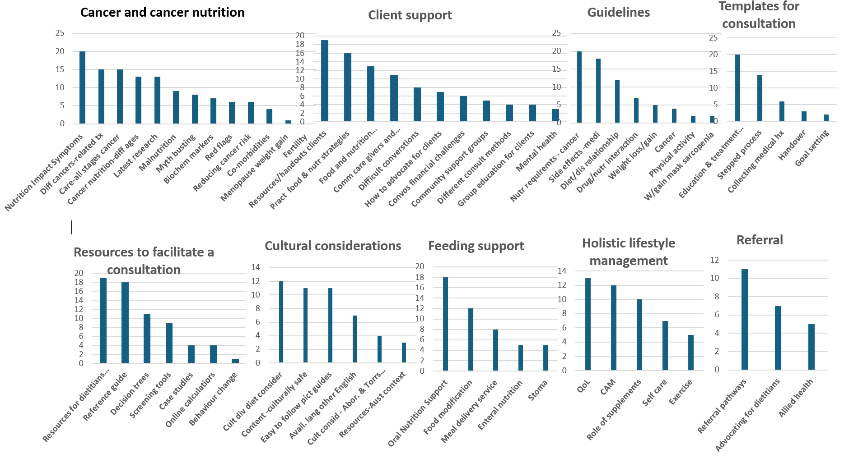
Supplementary Figure 1. Bar graphs depicting survey results for content subcategories

