APPENDIX 1

ECG STUDY QUESTIONNAIRE

Section A: Demographics (Pretest only)

1. Participant ID code:
2. Age:
3. Gender:
- Male
- Female
4. Current training status:
- House officer
- Medical officer
- Resident Doctor
- 600 level medical student
- 500 level medical student
- 400 level medical student
- Preclinical level medical student
5. Institution/Hospital:
6. Have you ever attended any prior ECG training course/workshop?
- Yes
- No

Section B: ECG Knowledge Assessment (Pre-/Post-/follow-up Test)
Each question has one correct answer. Choose the most appropriate option.
1. Which of the following is the correct placement for the V3 chest lead in a standard 12-lead ECG?
- 4th intercostal space, right sternal border
- 5th intercostal space, midclavicular line
- Between V2 and V4
- Left anterior axillary line
✅ Correct Answer: C
2. What does the PR interval represent on an ECG?
- Atrial repolarization
- Ventricular repolarization
- Time from SA node to ventricular depolarization
- Time from QRS to T wave
✅ Correct Answer: C

3. Which of the following is the correct first step in ECG interpretation?
- Check the QT interval
- Determine the axis
- Identify P waves
- Calculate the heart rate
✅ Correct Answer: D

4. A positive QRS in lead I and negative in aVF suggests:
- Left axis deviation
- Right axis deviation
- Normal axis
- Extreme axis
✅ Correct Answer: A

5. What is the hallmark of atrial fibrillation on ECG?
- Sawtooth flutter waves
- Irregularly irregular rhythm with no P waves
- Regular rhythm with absent T waves
- Ventricular rate of 300 bpm
✅ Correct Answer: B
6. Which of the following statements correctly correlates ECG findings, clinical presentation and troponin levels in acute coronary syndromes?
- ST-segment elevation with chest pain and elevated troponin is diagnostic of STEMI
- ST-segment depression or T-wave inversion with elevated troponin suggests NSTEMI
- Chest pain with normal ECG and normal troponin suggests unstable angina
- All of the above
- I don’t know
✅ Correct Answer: D

7. Which ECG change is typical of hyperkalemia?
- Tall peaked T waves
- ST depression
- U waves
- Prolonged QT
✅ Correct Answer: A

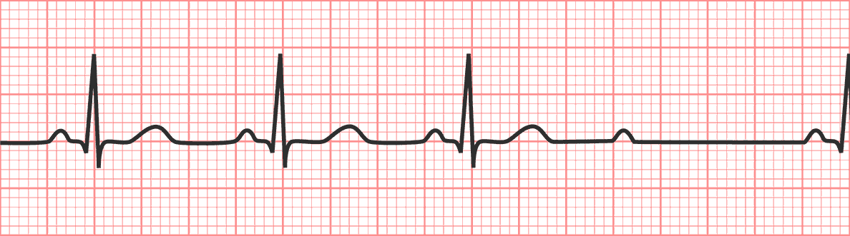
8. Identify the rhythm:
- A: Second degree sinoatrial exit block: type I
- B: Second degree sinoatrial exit block: type II
- C: Second degree AV block: Wenkebach’s block
- D: Second degree AV block: type II Mobitz
✅ Correct Answer: D

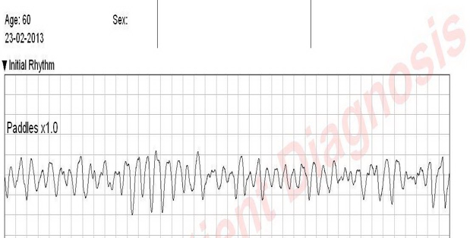

9. A 40 years old man found to have suddenly collapsed by the roadside. Immediate CPR was instituted and EMS team was contacted. Upon their arrival, EKG was obtained as displayed above and AED was used. What is the most likely initial rhythm?
- Ventricular fibrillation
- Ventricular tachycardia
- Pacemaker rhythm
- Atrial fibrillation with bundle branch block
✅ Correct Answer: A
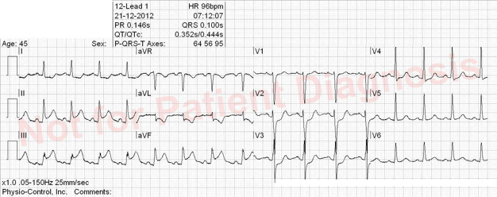
10. A 65 years old banker resented to the ER with 2 hours history of severe chest pain and diaphoresis not responsive to his usual antacid preparation. He’s a known hypertensive for 10 years and unconfirmed Acid peptic diseases, also smoked for 20 pack years. You requested for an EKG which was depicted above, what is the most likely diagnosis?
- Lateral STEMI
- Anterior STEMI
- Anterior-lateral STEMI
- Inferior STEMI
✅ Correct Answer: D

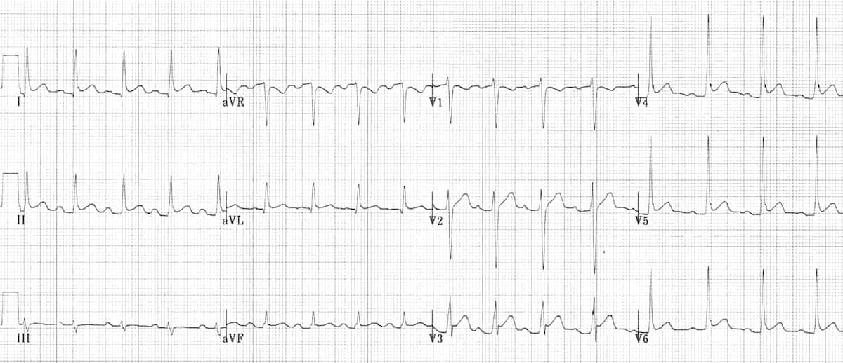
11. A 50 years old woman presented with chest pain, of three days duration with mild shortness of breath. Had a flu-like illness one week ago. Pain improves on leaning forward and not responsive to antacids. Cardiac troponin marginally elevated. An ECG was requested as shown above. What is the most likely diagnosis?
- Acute myocardial infarction
- Reflux esophagitis
- Acute pericarditis
- Pnemonia
✅ Correct Answer: C
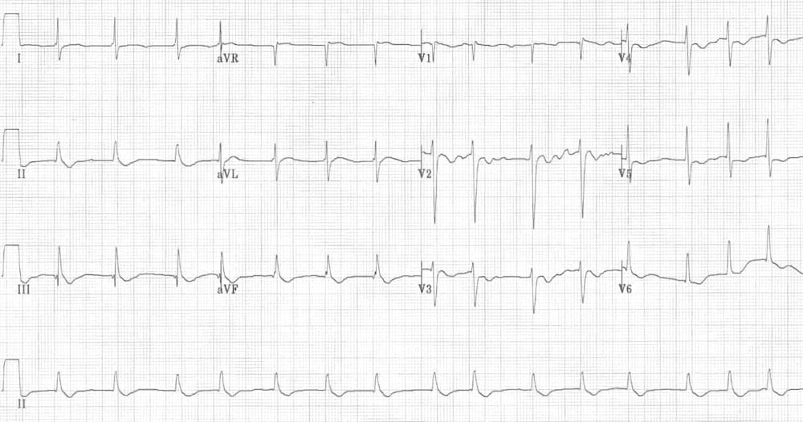
12. A 50-year-old man with a diagnosis of heart failure with reduced ejection fraction. His estimated ejection fraction was 28% when he was released and placed on medications including furosemide 40 mg 12 hourly, empaglifloxin 10 mg daily, captopril 12.5mg bd, and digoxin 1mg daily. He presented a week later with palpitations and diarrhea. An EKG requested as shown above. What is the most likely diagnosis?
- Atrial fibrillation
- Ventricular tachycardia
- Digoxin toxicity
- Hyperkalemia-induced arrhythmia
- I don’t know
✅ Correct Answer: C

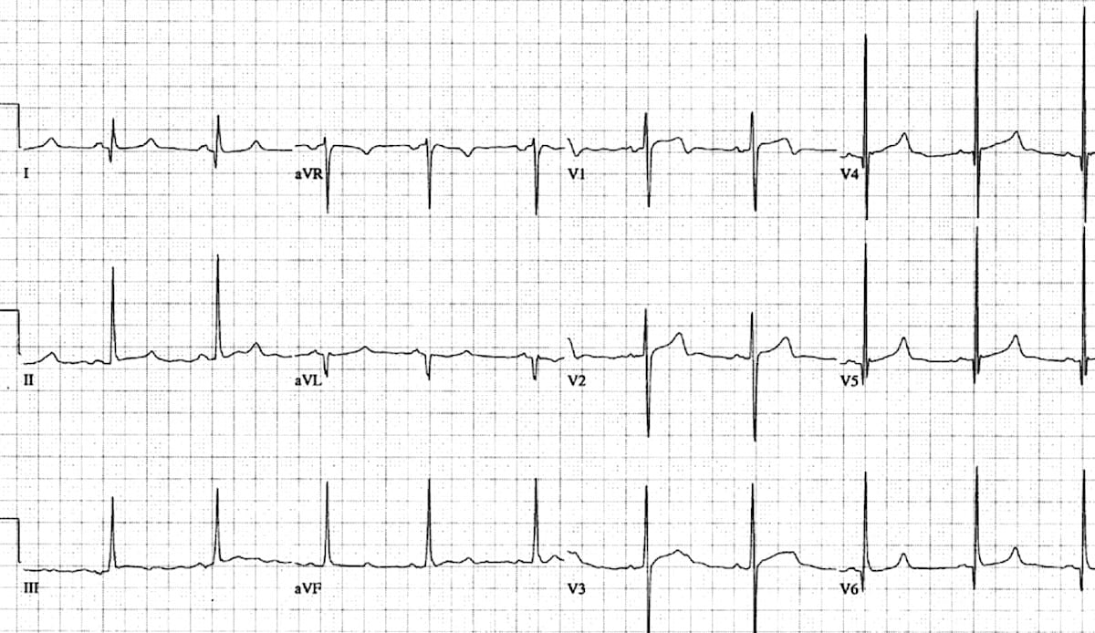
13. A 35-year-old athlete who suddenly collapse during a 30 km race was quickly rushed to a hospital. His father, a renown footballer died suddenly at the age of 40. His EKG was requested by the emergency response team as shown above. What is the most likely diagnosis?
- Wolff-Parkinson-White syndrome
- LVH due to Hypertrophic cardiomyopathy
- Right bundle branch block
- LVH due to Lateral STEMI
- I don’t know
✅ Correct Answer: B
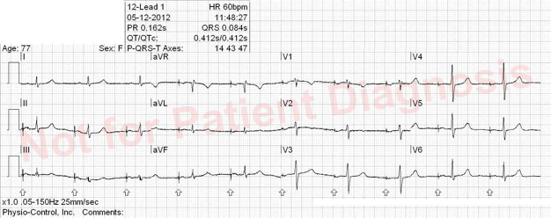
14. A 45 years old woman who had recurrent syncope and palpitations. Diagnosed with complete heart block and was treated 6 months ago. She presented for a cardiology follow-up, where an EKG was requested as shown above. What is the diagnosis?
- 2nd degree AV block Mobitz type II
- 3rd degree AV block
- Sinus bradycardia
- Pacemaker rhythm
✅ Correct Answer: D

Section C: Self-confidence assessment (Pre-/Post-Test)
Rate your confidence in the following areas on a scale of 1–5. 1 = Not confident, 5 = Very confident
- I am confident in placing ECG leads correctly.
- I understand ECG waveforms, intervals, and segments
- I can identify life-threatening arrhythmias on ECG.
- I can interpret ECG findings in myocardial infarction.
- I can interpret ECG findings in pericarditis.
- I can identify drug-induced ECG findings.
- I can identify electrolyte-induced ECG findings.
- I can integrate ECG findings with clinical presentations to guide management.
- I can integrate ECG findings with troponin levels to guide management.
- I can manage a case of Acute coronary syndrome.

Section D: Satisfaction Survey (Post-Test Only)
Please rate the following on a scale of 1 (Strongly Disagree) to 5 (Strongly Agree):
- The course content was well organized.
- The speakers were knowledgeable and engaging.
- The pacing and duration of the sessions were appropriate.
- The course met my expectations.
- I would recommend this course to others.

Section E: Open-Ended Questions (Post-Test Only)

1. What did you like most about the course?
2. What aspects could be improved?
3. Any suggestions for future sessions?

