Sensitivity Analysis: Including Wave2 and Wave3 Sleep Separately in the SEM Model Examining the Effects of ADHD Symptoms, Sleep Problems, Their Interaction, and Sex Across Time (T1–T3) on Children’s Psychological and Socioemotional Functioning
We ran a sensitivity analysis including sleep at Wave2 and Wave3 as separate predictors in the temporal SEM model. Due to the high correlation between sleep at W2 and W3 (r = 0.91; P<0.001), including both separately produced unstable estimates, with coefficients in opposite directions. This analysis supports the decision to use the mean of W2 and W3 sleep, which provides a stable and interpretable summary of overall sleep problems, reflecting their high temporal stability.
Full SEM results: Our temporal SEM (W2-W3) for the sensitivity analysis yielded acceptable model fit: χ²(244) = 1072.74, p < .001, CFI = 0.878, TLI = 0.861, RMSEA = 0.059 (90% CI: 0.055–0.063), SRMR = 0.058.
At Wave2, all nine Kidscreen indicators loaded significantly on the latent physical, psychological and socioemotional factor. Standardized factor loadings ranged from 0.385 for bullying to 0.825 for parent relations, indicating generally strong measurement properties. The proportion of explained variance (R²) for W2 indicators ranged from 0.149-0.680.
At Wave3, all nine Kidscreen indicators also loaded significantly on the latent physical, psychological and socioemotional factor. Standardized loadings ranged from 0.484 for bullying to 0.813 for psychological wellbeing. The proportion of explained variance (R²) for W3 indicators ranged from 0.234-0.660.
Regarding ADHD stability, ADHD symptoms at W3 significantly predicted ADHD symptoms at W3 (β = 0.718, p < .001), explaining 51.6% of the variance in ADHD at W3.
The model explained 59.3% of the variance in the physical, psychological, and socioemotional functioning factor at W3. The W2 latent factor was a significant predictor of this same factor at W3 (β = 0.578, p < .001), indicating temporal stability.
ADHD symptoms at W2 were not significantly associated with W3 physical, psychological, and socioemotional functioning after controlling for W2 functioning and sleep problems (β = -0.035, p = .4). Sleep problems at W2 was positively associated with W3 functioning (β = 0.233, p < .001), whereas sleep problems at W3 was negatively associated (β = -0.468, p < .001). These differing beta coefficients likely reflect the high collinearity between sleep problems at W2 and W3 (r = 0.90).
The interaction between ADHD symptoms and sleep problems at W2 was not statistically significant (β = 0.082, p = .071). Sex was not significantly associated with W3 functioning (β = -0.028, p = .4).
Covariances were included to account for interrelations among variables. ADHD symptoms at W2 were positively associated with W2 sleep (β = 0.175, p <.001). W2 sleep problems was significantly associated with sex (β = 0.092, p = .008).
Notably, the high correlation between sleep at W2 and W3 (r = 0.90) confirms strong temporal stability, supporting the use of a mean sleep score in the main analysis. Residual associations between W2 ADHD symptoms, W2 sleep, and W3 functioning were consistent with the main analysis.

Supplementary Figure 1. Structural Equation Model Illustrating the Effects of ADHD symptoms, Sleep Problems, their Interaction term including sex over time (W2-W3) on children’s Physical, Psychological and Socioemotional functioning Outcomes
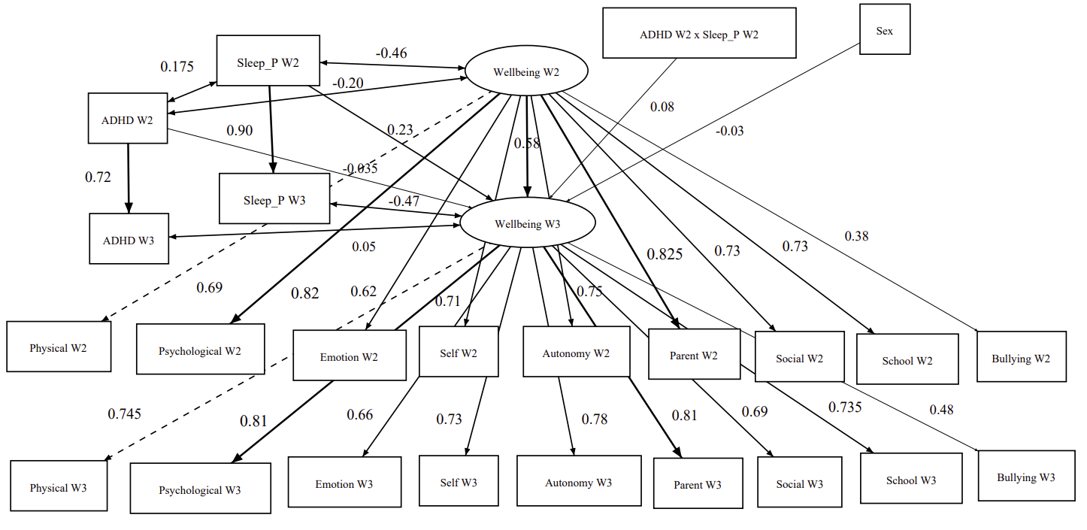

Note. Predictors: ADHD W2 =Attention-deficit/hyperactivity disorder at Wave 2; ADHD W3=Attention-deficit/hyperactivity disorder at Wave 3, Sleep_P W2 =Sleep problems at Wave2 ;
Interaction term: ADHD symptoms (W2) * Sleep problems at W2
Latent construct (functional outcome): wellbeing at Wave 2 and wellbeing at Wave 3; Outcomes: Physical, physical adjustment; Psychological, psychological adjustment; Emotion, mood and emotions; Self, self-perception; Autonomy, autonomy; Parent, parental relations and home life; Social, social support and peers; School, school environment; Bullying, all at Wave 2 respectively at Wave3. Covariates: Sex

