Supplementary Figure 1: Trends in Hyperlipidemia and AF-related AAMR per 100,000, stratified by urbanisation, in the United States from 2001-2024.
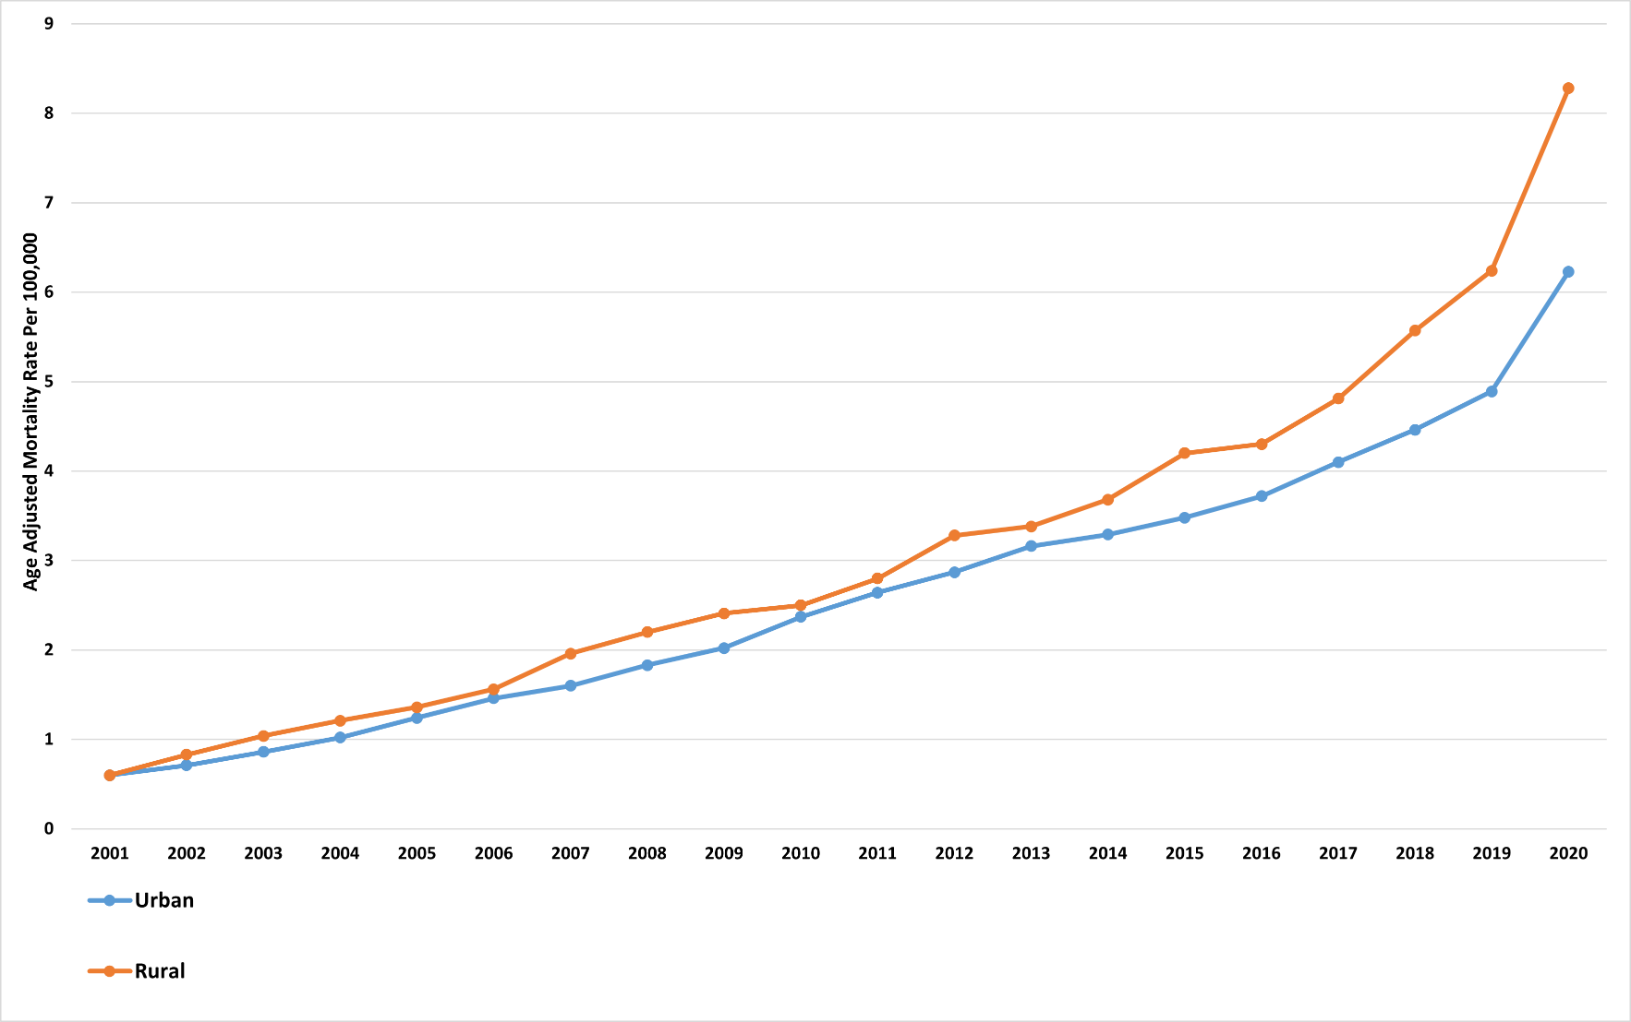

2001–2005: APC: 20.41% [95% CI: 15.91% to 32.64%] 2005–2011: APC: 13.56% [95% CI: 7.78% to 15.38%] 2011–2016: APC: 7.17% [95% CI: 4.68% to 8.30%] 2016–2020: APC: 18.86% [95% CI: 14.76% to 21.77%]
2001–2007: APC: 19.56% [95% CI: 15.42% to 27.81%] 2007–2012: APC: 9.45% [95% CI: 6.38% to 10.42%] 2012–2020: APC: 23.22% [95% CI: 14.99% to 27.89%]

Supplementary Figure 2: Trends in Hyperlipidemia and AF-related AAMR per 100,000, stratified by census region, in the United States from 2001-2024.
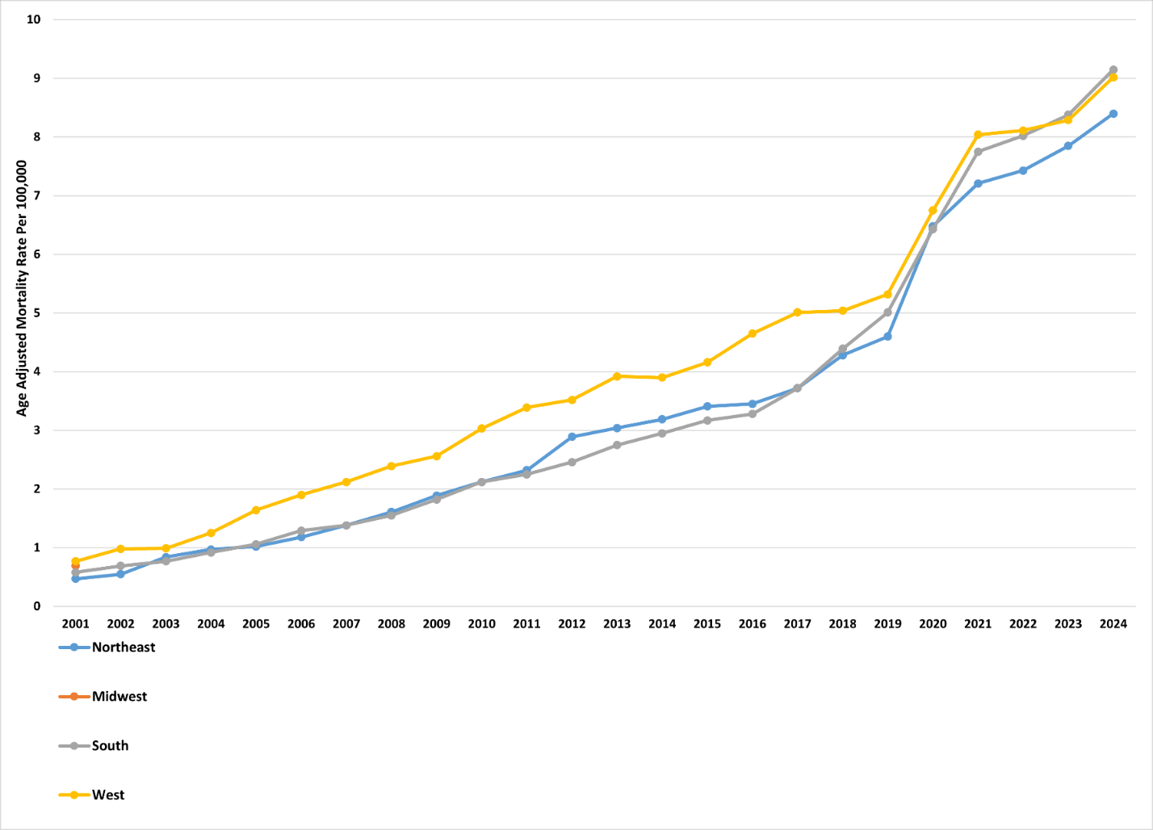

2001–2012: APC: 16.20% [95% CI: 14.62% to 18.72%] 2012–2017: APC: 1.67% [95% CI: -1.42% to 7.54%] 2017–2021: APC: 18.69% [95% CI: 15.36% to 23.96%] 2021–2024: APC: 4.85% [95% CI: 0.45% to 8.29%]
2001–2007: APC: 19.81% [95% CI: 14.80% to 37.41%] 2007–2024: APC: 9.17% [95% CI: 8.51% to 9.77%]
2001–2018: APC: 15.12% [95% CI: 13.84% to 17.17%] 2018–2019: APC: 7.99% [95% CI: 5.64% to 9.12%] 2019–2021: APC: 20.29% [95% CI: 18.74% to 23.48%] 2021–2024: APC: 5.81% [95% CI: 3.94% to 7.55%]
2001–2018: APC: 15.96% [95% CI: 13.68% to 19.63%] 2018–2019: APC: 5.96% [95% CI: 1.02% to 7.43%] 2019–2021: APC: 15.70% [95% CI: 11.11% to 18.69%] 2021–2024: APC: 4.42% [95% CI: -0.44% to 7.10%]

