SUPPLEMENTARY MATERIAL
Table S1—date of selected PC scores used to make composites in the positive phase (left) and negative phase (right) of Region 1.
PC scores | Year | Month |  | PC scores | Year | Month
2.57 | 1944 | 9 |  | -1.40 | 1945 | 11
2.95 | 1955 | 9 |  | -1.79 | 1945 | 12
3.89 | 1961 | 9 |  | -1.42 | 1950 | 11
3.43 | 1961 | 10 |  | -1.44 | 1953 | 11
2.53 | 1962 | 9 |  | -1.49 | 1956 | 11
2.95 | 1963 | 9 |  | -1.46 | 1961 | 12
4.31 | 1963 | 10 |  | -1.47 | 1962 | 12
 |  |  |  | -1.63 | 1964 | 10
 |  |  |  | -1.64 | 1964 | 11
 |  |  |  | -1.41 | 1964 | 12

Table S2—date of selected PC scores used to make composites in the positive phase (left) and negative phase (right) of Region 2.
PC scores | Year | Month |  | PC scores | Year | Month
1.91 | 1942 | 11 |  | -3.16 | 1941 | 9
1.81 | 1963 | 10 |  | -2.17 | 1947 | 9
1.71 | 1994 | 12 |  | -2.22 | 1968 | 9
1.73 | 2002 | 12 |  | -2.39 | 1976 | 9
2.14 | 2012 | 12 |  | -2.54 | 1980 | 9
1.75 | 2013 | 12 |  | -2.37 | 1983 | 9
1.71 | 2018 | 12 |  | -2.49 | 1990 | 9
1.76 | 2023 | 11 |  | -2.29 | 1992 | 9
2.22 | 2023 | 12

Table S3—date of selected PC scores used to make composites in the positive phase (left) and negative phase (right) of Region 3.
PC scores | Year | Month |  | PC scores | Year | Month
1.92 | 1957 | 11 |  | -2.16 | 1942 | 9
2.08 | 1962 | 10 |  | -2.07 | 1942 | 12
2.42 | 2015 | 10 |  | -2.09 | 1943 | 9
2.84 | 2015 | 11 |  | -2.49 | 1943 | 12
2.40 | 2015 | 12 |  | -2.03 | 1944 | 9
2.15 | 2018 | 10 |  | -2.27 | 1975 | 9
2.43 | 2023 | 10 |  | -2.97 | 1985 | 12
2.15 | 2023 | 11 |  | -2.04 | 1988 | 12

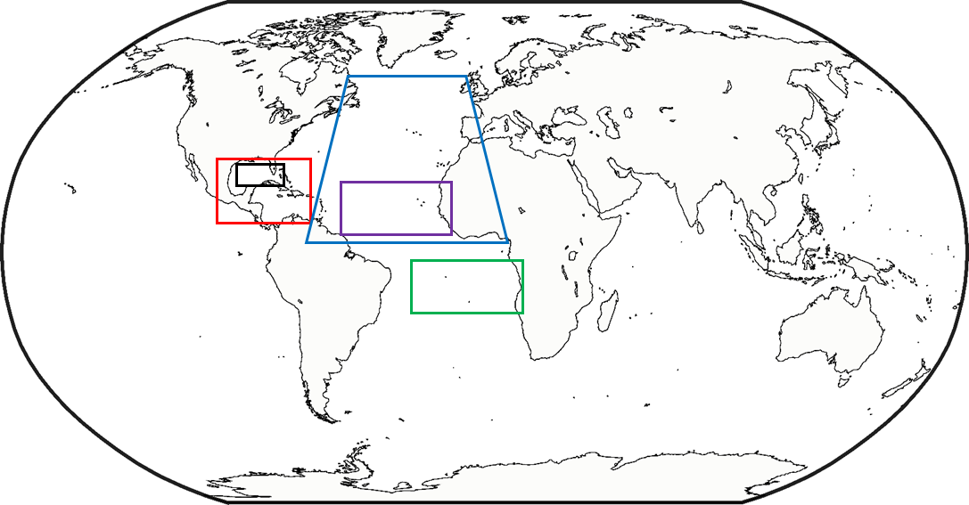
Western Hemisphere Warm Pool (WHWP)
Caribbean Index (CAR)
Atlantic Multidecadal Oscillation (AMO)
Tropical Southern Atlantic Index (TSA)
Tropical Northern Atlantic Index (TNA) and North Tropical Atlantic Index (NTA)

Figure S1—Region of area-averaged SST anomalies for the six modes of internal climate variability with positive correlation with all three Brazilian regions, based on NOAA’s Climate Prediction Center (CPC) archived climate indices list.

