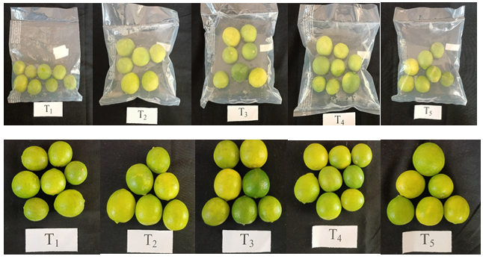
Plate 1. Effect of MAP on the quality of lime fruits at 10 days of storage

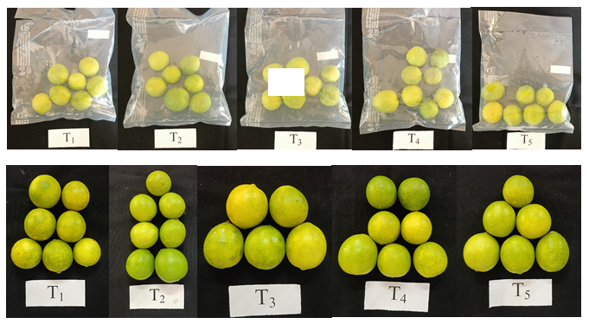
Plate 2. Effect of MAP on the quality of lime fruits at 20 days of storage
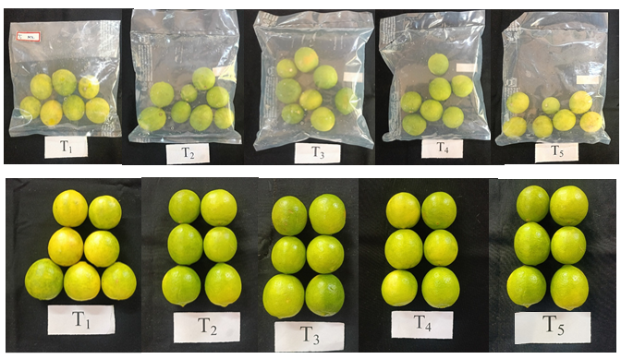
Plate 3. Effect of MAP on the quality of lime fruits at 30 days of storage

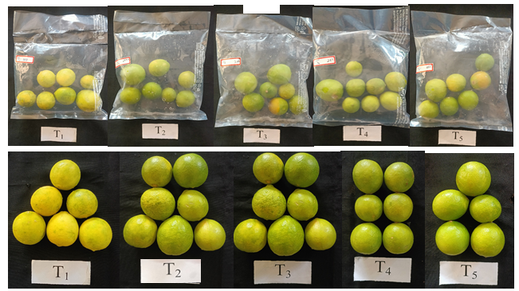
Plate 4. Effect of MAP on the quality of lime fruits at 40 days of storage
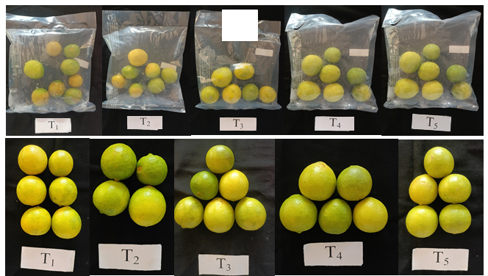
Plate 5. Effect of MAP on the quality of lime fruits at 50 days of storage

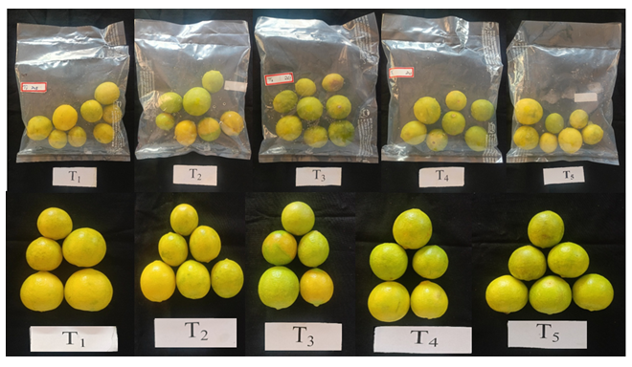
Plate 6. Effect of MAP on the quality of lime fruits at 60 days of storage

