Scenario Based Dynamic Material Flow Analysis of Dutch Macro Infrastructure Stocks: Assessing Future Material Demand and Circularity Potentials
Md Faysal Tareq¹, Peter Brill¹, Arnold Tukker^{1,2}
- Institute of Environmental Sciences (CML), Leiden University, Leiden, Zuid-Holland, Netherlands
- Netherlands Organisation for Applied Scientific Research (TNO), The Hague, Zuid-Holland, Netherlands

Supplementary Information

Annex I
Mathematical formulas used for dynamic material flow analysis is given below:
- $Stock \left(dS(t)\right)=\left(Inflow\left(t\right)-Outflow \left(t\right)\right). dt=net flow\left(t\right).dt$ ------(i)
- $Stock\left(y\right)= \sum_{{t=y}_{o}}^{y}{inflow\left(t\right)*surv(y-t)}$ ---------(ii)
- $Inflow\left(y\right)=(stock\left(y\right)- \sum_{{t=y}_{o}}^{y}{inflow\left(t\right)*surv\left(y-t\right)})/surv(0)$-------(iii)
- $NAS\left(y\right)=Stock\left(y\right)-stock(y-1)$ --------(iv)
- $Outflow\left(y\right)=inflow\left(y\right)-NAS(y)$----------(v)

Here, $NAS$ refers to Net addition to Stock, y and t refers to time and $surv$ refers to survival rate.

Annex II
Weibull survival curve of Dutch macro infrastructures and their average lifetime is given for the Annex II.
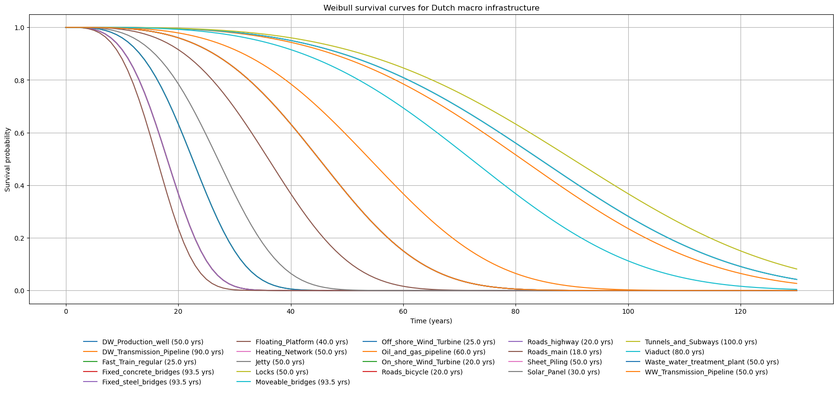
Figure 1: Weibull survival curve of Dutch macro infrastructures (Tareq, 2025)

Annex III
Developed Scenario Narrative

Reference Scenario
The Reference Scenario reflects a continuation of existing policy frameworks and implementation trajectories without major additional interventions. Population growth follows a moderate trend, consistent with recent demographic projections. Innovation progresses at a moderate-to-low pace, indicating incremental technological improvements rather than disruptive change. Renewable energy adoption is moderately strong, influenced by some fossil lobbies but primarily following planned trajectories rather than accelerated expansion. Regarding material circularity, the recovery and reuse of end-of-life (EoL) infrastructure materials continue at current historical rates, reflecting a baseline policy effectiveness where circularity targets exist but lack the enforcement mechanisms to significantly alter market behavior. Material efficiency improves only marginally, as existing regulations do not enforce aggressive new mandates for high-value recycling or secondary material procurement. Overall, the scenario represents a baseline pathway characterized by gradual progress and planned structural transformation, which is aligned with the long-term forecasts of infrastructure owners.

Low Scenario
The Low Scenario reflects a pathway in which policy action is postponed and structural change is limited over the scenario horizon. Population growth follows a lower trajectory, increasing demand for energy and materials. Innovation progresses at a low rate, with limited investment in low-carbon technologies and slow diffusion of existing solutions. Consequently, material efficiency remains stagnant. The absence of strong regulatory incentives for secondary material use and the delayed diffusion of advanced recycling infrastructure result in a continued reliance on virgin materials and the prevalent downcycling of EoL assets. In this scenario, policy effectiveness is judged to be very limited, with recovery rates stagnating or even regressing as existing infrastructure ages without modernized end-of-life logistics. Environmental impacts are high, as delayed mitigation efforts and continued reliance on conventional systems intensify pressures on natural environments. Renewable energy adoption remains low, reflecting weak policy support and persistent dependence on fossil-based energy sources. Overall, this scenario represents a low development pathway characterized by delayed action and entrenched system inertia.

High Scenario
The High Scenario represents a pathway characterized by rapid and transformative policy action aimed at sustainability objectives. Population growth follows a higher trajectory, reflecting demographic stabilization over the scenario horizon. Innovation occurs at a higher rate, driven by strong policy incentives, substantial investment, and accelerated diffusion of advanced low-carbon technologies. Crucially, this scenario assumes aggressive policy interventions designed to maximize material efficiency and advance closed-loop circularity. Driven by strict EoL recovery mandates and robust economic support for secondary material markets, there is a mass adoption of advanced recycling infrastructure, which significantly increases the high-value recovery of structural steel and concrete. The effectiveness of these policies is modeled as highly successful, bridging the economic gap between virgin and secondary materials and driving closed-loop recycling rates to their practical maximums. Renewable energy adoption is very high, reflecting an accelerated deployment of renewable technologies and a decisive shift away from fossil-based energy systems. Overall, this scenario depicts a highly ambitious transition pathway with substantial structural transformation.
Annex III
Developed Scenario Quantification

Highway Infrastructures :
To estimate Dutch road infrastructure requirements through 2070, this study applies a Pivot Point Model. This model forecasts demand iteratively from a calibrated baseline (T₂₀₂₄), derived from the National Data Warehouse (NWD, 2025).

The model is driven by exogenous socio-economic assumptions from the WLO-2025 scenarios (Welvaart en Leefomgeving), capturing a bandwidth between Global Economy (high growth) and Regional Communities (low growth). Demand is modeled recursively, with the demand index Dₜ in year t determined by the previous year’s demand and an annual growth factor Gₜ.
$$D_{t}=D_{t-1}×(1+G_{t})$$
Where:
- $D_{2024}=100$(base index)
- $G_{t}$is the annual compound growth rate in year t

The base growth rate ($G_{base}$) is calculated annually using elasticities from the KiM Handboek Elasticiteiten (2024)(RWS, 2024b):
$$G_{base}=(ε_{pop}×r_{pop})+(ε_{inc}×r_{gdp})$$
Where:
- $ε_{pop}$: elasticity of traffic volume with respect to population
- $r_{pop}$: annual population growth rate
- $ε_{inc}$: elasticity of traffic volume with respect to GDP per capita
- $r_{gdp}$: annual economic growth rate

To reflect non-linear behavioral effects—specifically infrastructure saturation and demographic aging—the growth factor is adjusted in three phases:

Phase 1 (2024–2050): Standard Growth
$$G_{t}=G_{base}$$
Phase 2 (2051–2055): Saturation
$$G_{t}=G_{base}×φ_{sat}$$
Phase 3 (2056–2070): Aging and Saturation
$$G_{t}=(G_{base}×φ_{sat})+δ_{aging}$$
Where:
- $φ_{sat}=0.8$: saturation coefficient, representing a 20% dampening due to capacity constraints and “peak car” effects
- $δ_{aging}=-0.002$: annual demographic penalty applied after 2045, reflecting reduced mobility among older cohorts

Parameter | Value (High / Low) | Source | Rationale
Income elasticity ($ε_{inc}$) | 0.45 / 0.35 | KiM Handboek Elasticiteiten (2024)(RWS, 2024b) | Weighted average of low commuting elasticity (0.2) and high leisure elasticity (0.8).
Population elasticity ($ε_{pop}$) | 0.98 / 0.95 | LMS model (RWS, 2024b) | Assumes near-proportional scaling of mobility with population size.
Aging penalty ($δ_{aging}$) | −0.2% per year | PBL demographic impact estimates | Represents a conservative reduction in vehicle-kilometers traveled among the 75+ population.
Assumption: A conservative reduction in vehicle-kilometres traveled among the 75+ population. We used 2045 to start the aging penalty as per CBS forecast of aging population of the Netherland.
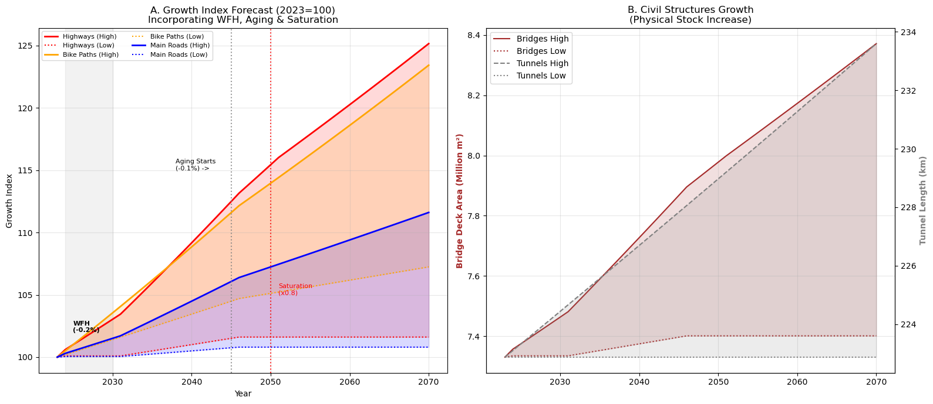
Figure 2: Infrastructure growth forecast for Highway infrastructures

The above figure 2 represents forecast for highway infrastructures ( highway roads, main roads, bike paths, bridges and tunnels) growth until 2070. The higher range represents high scenarios, and lower range represents Low scenarios whereas the middle of the range represents reference scenarios.

The below figure 3 represents material intensity reduction under different scenarios. The above forecast is based on the assumption that high strength steel and High strength concrete adoption along with efficient design work will increase the material efficiency (Buzzi SpA, 2025; RWS, 2024a). Similarly, introduction of Hoog Modulus Asphalt (HMA) with stiffer base layers (EME) allow thinner asphalt packages and replacing steel mesh with synthetic fibers allows thinner slabs effectively reduce the material efficiency (RWS, 2022; Van De Water, 2025).
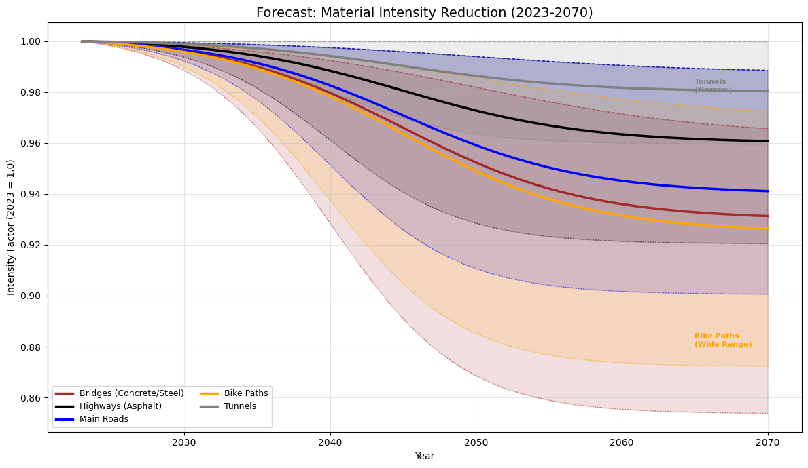
Figure 3: Material intensity forecast for Highway Infrastructures

Table 1: Forecast of infrastructure growth and material intensity by 2070 under different scenarios
Infrastructure Category | Infrastructure Growth until 2070 |  |  | Material Intensity until 2070 |  |  | Sources/Rational for material intensity
Infrastructure Category | Reference | Low | High | Reference | Low | High | Sources/Rational for material intensity
Highway Roads | 12.4% | 1.6% | 25.2% | -3.98% | -1.25% | -7.96% | Hoog Modulus Asfalt (HMA): Stiffer base layers (EME) allow thinner asphalt packages (RWS, 2022; Van De Water, 2025). Furthermore, replacing steel mesh with synthetic fibers allows thinner slabs also reduce material intensity of road infrastructures.
Main Roads | 4% | 0.8% | 11.6% | -5.97% | -1.25% | - 9.95%
Bike Paths | 15.1% | 7.2% | 23.4% | -6.39% | -3.00% | -12.79%
Bridges | 5.6% | 1% | 14.2% | -6.83% | -3.76% | -14.64% | High strength concrete adoption and efficient design work increase the material efficiency (Buzzi SpA, 2025; RWS, 2024a).
Tunnels | 2.4% | 0% | 4.8% | -1.62% | -0.00% | -4.05% | The adoption of High strength concrete and effective design options.

Railway Infrastructures:
Future railway line requirements are estimated by translating projected passenger rail kilometres into required network length using an empirically fitted logarithmic demand–capacity relationship, validated against observed and forecast capacity bottlenecks. As demand grows, network expansion slows logarithmically (diminishing returns) rather than linearly. This forecasting model was adopted from (Peter et al., 2021)
The required network length (Lt) for any future year t is calculated as:
Lt​=2548.9⋅ln(RPKt​)−361.64
Where:
- Lt: Total length of the railway network in year t (km).
- RPKt: Annual Rail Passenger Kilometers (in billions) derived from WLO Scenarios
For, WLO baseline scenario, a growth 20% in Annual Rail Passenger Kilometers (RPKt) is assumed compared to current level until 2050 and an additional 10% until 2070. The current Dutch Annual Rail Passenger Kilometers was 17.2 billion passenger Kilometer as per the data of CBS.

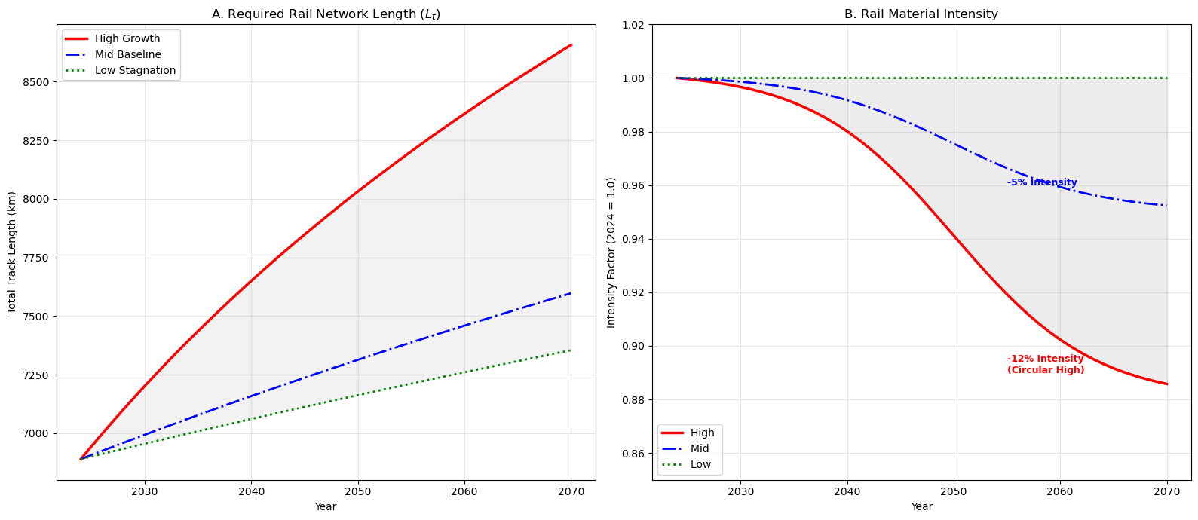Figure 4: Railway infrastructure growth and material intensity forecast by 2070

Table 2: Railway infrastructure growth and material intensity forecast by 2070 under different scenarios
Infrastructure Category | Infrastructure Growth until 2070 |  |  | Material Intensity until 2070 |  |  | Sources/Rational for material intensity
Infrastructure Category | Reference | Low | High | Reference | Low | High | Sources/Rational for material intensity
Railway Infrastructure | 10.28% | 6.75% | 25.66% | 5% | -o% | -12% | The adoption of high strength steel (e.g., R400HT) can reduce the material intensity in railway tract (SBQSteel, 2025).

Sources: The reduction in rail material intensity over time was modeled using a logistic S-curve. This non-linear approach accurately reflects the dynamics of socio-technical transitions in heavy infrastructure (Geels, 2002; Fisher & Pry, 1971), accounting for initial regulatory and R&D lag, followed by rapid industry-wide scaling. Furthermore, the maximum intensity reduction was capped at 12% to reflect the absolute thermodynamic and structural limits of relative dematerialization in high-mass transport networks (Smil, 2014).

Water Infrastructures:
As per the Dutch delta plan 2100, future water infrastructure development need to follow a rigorous risk-based adaptive management framework. Following the framework Dutch water board already made an extensive plan to improve and strengthen the existing water infrastructures to ensure a safe and prosperous delta. To quantify the future water infrastructures expansion we used a volume calculation approach. Infrastructure specific projection and their justification is listed below:

Sheet Piles:
For the projection of sheet pile we considered the infrastructure upgradation target set up in Dutch delta plan. As per the plan, an annual dike upgradation target of 50km/year is specified and a total of 1,274 km of dykes and 470 engineering structures must be reinforced by 2050(Delta Program, 2021). Furthermore, the need for introduction of some mega projects until 2070 will also increase the total material stock significantly compare to 2050 baseline(Delta Program, 2021). Currently Netherlands have around 1500km of sheet piles which is mostly build during 1953 to 1980(KpNK, 2023). Some of these old sheet light pile needs to be replaced/strengthen with heavier sheet pile in the next 50 years under the consideration of >1m sea level rise by the end of this century. Based on the mentioned targets above we made some numerical forecasting assumption in table 3 for the reference scenario.

Locks and Jetty:
For the projection of locks and jetty, we considered the "V&R" (Vervanging en Renovatie) tasking managed by Rijkswaterstaat (RWS, 2025). The Netherlands has a high density of "wet" infrastructure built between 1950 and 1980 (e.g., the Delta Works and Meuse weirs) which is now simultaneously reaching the end of its technical lifespan (60–100 years). The Delta Programme 2021 explicitly identifies a tasking of 470 engineering structures that must be reinforced or replaced by 2050 (Delta Program, 2021). Furthermore, the Sea Level Rise Knowledge Programme indicates that post-2050, passive locks may need to be converted into active pumping stations to manage higher sea levels and jetty piler height may need to increase accordingly, significantly increasing the material intensity (steel/concrete) per structure.

Table 3: Water infrastructure growth by 2070 under reference scenarios
Type of Infrastructure | Infrastructure Growth by 2070 | Assumption & Source
Sheet Pile | +120- 160% | Source: "1,274 km dykes + 470 structures".  Logic: Implementing this legal tasking in "complex" (urban) areas forces a shift from earth to steel (sheet piles) for space-saving vertical reinforcement. We assume 120-160% of current sheet piles length will need additional reinforcement and modern sheet pile are lighter than old heavy sheet pile (Arcelor Mittal, 2025). Furthermore, until 2070 the "comprehensive system analysis" for replacing the storm surge barrier implies a singular "Mega-Project" steel demand that spikes the steel demand further (Delta Program, 2021).
Locks & Jetty | +40% – +60% | Source: "470 engineering structures must be reinforced" (DP2021).  Logic: The "Replacement Wave" (V&R) peaks here. We assume a 1:1 replacement of aging assets (like the Zeeland locks: Grevelingensluis, Roompotsluis) but with heavier designs (WCN, 2025). Modern locks require massive steel "bubble screen" installations (against salinization) and heavier gates to handle the increased hydraulic load of a +1m sea level rise scenario, increasing the steel mass per lock by ~40% compared to 1960s designs (Chanson et al., 2021). Similarly, fixed jetty pile height also need to be increased as per the projection of sea level rise.

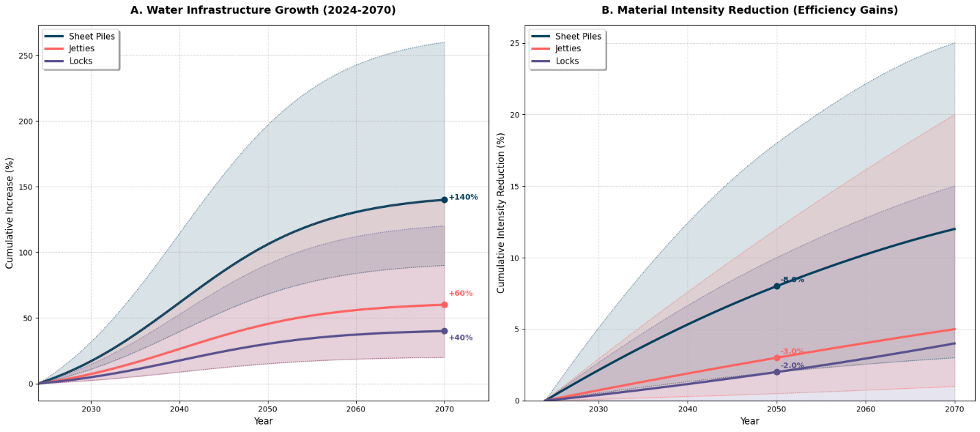
Figure 5: Water infrastructure growth and material intensity forecast by 2070

Table 4: Water infrastructure growth and material intensity forecast by 2070 under different scenarios
Infrastructure Category | Infrastructure Growth until 2070 |  |  | Material Intensity until 2070 |  |  | Sources/Rational for material intensity
Infrastructure Category | Reference | Low | High | Reference | Low | High | Sources/Rational for material intensity
Sheet Pile | 140% | 90% | 360% | -12% | -3% | -25% | High-Strength Steel (HSS): Adaption of S430 or S460 allows to achieve the same bending moment resistance with a significantly thinner, lighter web profile compare to conventional S355 Steel (Loris SAUFNAY et al., 2024; Tankova et al., 2022).
Locks | 40% | 20% | 120% | 3% | -0% | -15% | The adaptation of Ultra-High Performance Concrete (UHPC) can make the lock doors lighter (Songer et al., 2023).
Jetty | 60% | 20% | 140% | 5% | -1% | -20% | Application of hollow-core structures, ribbed slabs, or FRP (Fiber Reinforced Polymer) can reduce the material efficiency (Maxi et al., 2024; Modarelli et al., 2005).

Utility Infrastructures:
The utility infrastructures are broadly dominated by drinking water and wastewater infrastructure. For drinking water and wastewater infrastructure, we adopted the approach of (Emma van der Bent, 2022) which combines the scenarios of WLO and KNMI to develop a baseline (STOOM) scenario (Wolters et al., 2018). As per their projection we forecast infrastructure growth until 2050 and expand until 2070 considering the continuous growth trend as summarized in Table 5 (Emma van der Bent, 2022).

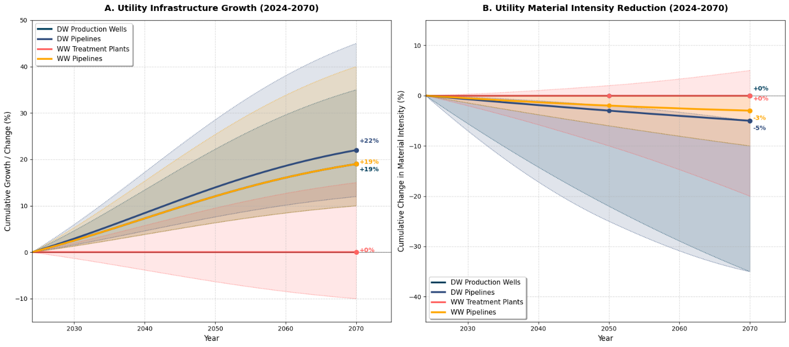
Figure 6: Utility infrastructure growth and material intensity forecast by 2070

Table 5: Utility infrastructure growth and material intensity forecast by 2070 under different scenarios
Infrastructure Category | Infrastructure Growth until 2070 |  |  | Material Intensity until 2070 |  |  | Sources/Rational for Material Intensity
Infrastructure Category | Reference | Low | High | Reference | Low | High | Sources/Rational for Material Intensity
DW Production well | +19% | +10% | +35% | 0% | +4% | -10% | Although the opportunity to limit material intensity is limited as per most Dutch utility asset owners but adoption of Fiberglass Reinforced Plastics (FRP) and advanced PVC for casings can reduce material intensity(Fardis & Khalili, 1981; Mahmood Amani & Ahmed Abdul Rauf, 2017).
DW Transmission Pipeline | +22% | +12% | +45 | 5% | 0% | -15% | Adoption of High-Density Polyethylene (HDPE) where applicable reduce material intensity(Hu et al., 2025; Simões et al., 2014).
WW treatment plant | 0% | -10% | +15% | 0% | 0% | -10% | Even though the possibility of material intensity reduction is very low due to locked in Hydraulic Retention Time" (HRT) and tight environmental regulation, adoption of modern treatment facility like Nereda and could increase resource efficiency (Haskoning, 2023; Triqua, 2025).
WW Transmission Pipeline | +17% | +10% | +40% | -3% | 0% | -20% | Limited scope for reduction under current circumstances but adoption of Fiberglass Reinforced Plastic (FRP) or Polymer Concrete along with decentralized transmission design can reduce material efficiency(Garrido-Baserba et al., 2018; Lech Czarnecki & Paweł Łukowski, 2010; Pipezy, 2025).

Energy Infrastructures:
To forecast the future energy infrastructures, we adopted the baseline scenario developed by (van Oorschot et al., 2022) which combines the projection of PBL and Dutch climate agreement (klimaatakkoord, 2019; PBL et al., 2020). As of 2024, Netherland has a total electricity generation capacity of 60.5 billion kwh and they consume around 55.8 billion kWh (CBS, 2024). Majority of that energy is coming from fossil-based sources predominantly natural gas. As we transition towards more clean energy, the generation wind and solar energy infrastructure will expand incrementally over the next 50 years where fossil-based energy such as oil and gas infrastructure will reduce incrementally. Table 1 represents the changes of energy infrastructures and material intensity until 2070 derived from existing literatures.

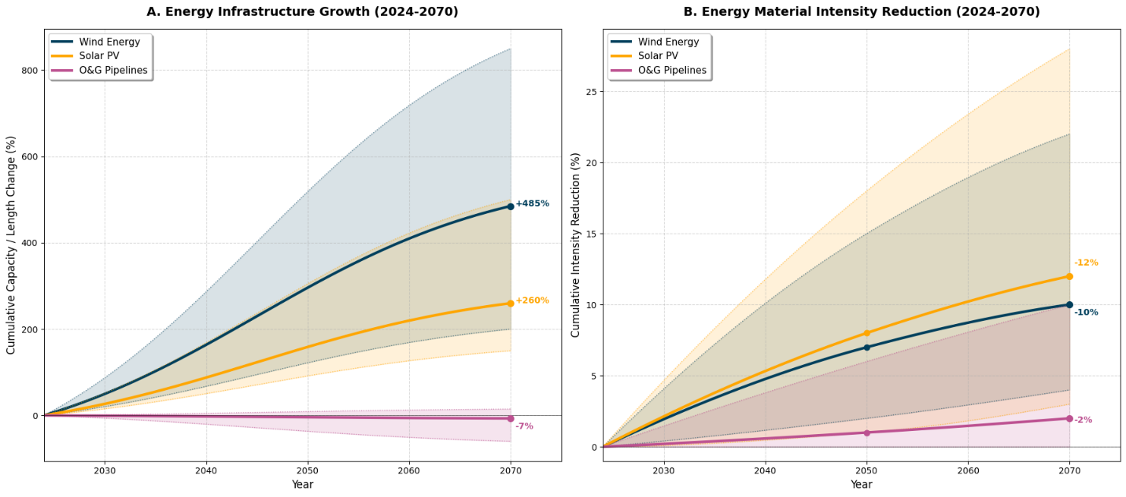
Figure 7: Energy infrastructure growth and material intensity forecast by 2070

Table 6: Energy infrastructure growth and material intensity forecast by 2070 under different scenarios
Infrastructure Category | Infrastructure Growth until 2070 |  |  | Material Intensity until 2070 |  |  | Sources/Rational for Material Intensity
Infrastructure Category | Reference | Low | High | Reference | Low | High | Sources/Rational for Material Intensity
Solar | +260% | +150% | +500% | -12% | -3% | -28% | Adoption of more efficient solar cell, historical efficiency increase and adoption of advanced cell like Perovskite tandem cells and thin-film solar PV can reduce the material intensity significantly (Green, 2019).
Wind | +485% | +300% | +850 | -10% | -4% | -22% | The shift from steel to lighter-weight hybrid concrete/steel structures for towers, and the large-scale use of Carbon Fiber Reinforced Polymers (CFRP) and thermoplastic composites in blades allows to reduce material intensity (Wiser et al., 2016).
Oil & Gas | -7% | +15% | -60% | -2% | -9% | -0% | The opportunity to reduce material intensity is very limited under the current circumstances where energy transition pushing phasing out oil and gas infrastructure gradually. Furthermore, the possibility to convert these existing pipeline for carrying hydrogen is very limited due to hydrogen embrittlement(Ćwiek & Michalska-Ćwiek, 2010). However, there is still scope to reduce material intensity by using nonmetallic composite piping materials(Zubail et al., 2021).

Annex V

Reuse/upcycle rate (RR) and actual recovery rate (ARR) under different scenarios

Table 7: Reuse/upcycle rate (RR) forecast by 2070 under different scenarios
Materials | Steel |  |  | Concrete |  |  | Asphalt |  |  | Sources/Rational for Projection
 | Reference | High | Low | Reference | High | Low | Reference | High | Low | Sources/Rational for Projection
2024 | 30.6% | 30.6% | 30.6% | 3% | 3% | 3% | 50% | 50% | 50% | (Eurostat, 2024; Oliveira & Silva, 2022; Watari et al., 2025; Zhang et al., 2020a).
2030 | 32% | 34% | 31% | 4% | 6% | 3% | 52% | 55% | 51% | With proper policy and financial incentives, thr closed loop circularity of steel could reach up to 60%, for concrete 25% and for asphalt 85% by 2070 (High Scenario). This is achievable through the mass adoption of electric arc furnaces in Europe, the adoption of C2CA, EVEROX and VEEP technology for concrete recycling and the use of innovative rejuvenator for achieving higher closed loop circularity in the asphalt industry (Bonoli et al., 2020; C2CA, 2024; EVEROX, 2025; Hagos et al., n.d.; Mantalovas & Di Mino, 2019; Mhatre et al., 2021; Zhang et al., 2020b).
2050 | 36% | 47% | 34% | 7% | 15% | 4% | 58% | 70% | 53%
2070 | 40% | 60% | 36% | 10% | 25% | 5% | 65% | 85% | 55%

For the actual recovery rate (ARR) or the collection rate for steel we considered 98% as the remaining 2% is system loss during collection and separation. This assumption has been made in consultation with recycling steel experts in the Netherlands (BMS, 2025). For concrete this rate is around 93%, and the remaining 7% 0f the stock gets lost during the demolition and collection process (Mulders, 2013; Zhang et al., 2020b). Lastly, for asphalt this ARR rate is 82% as the remainder is contaminated with tar and some of it also gets lost during the asphalt reclaim process(Oliveira & Silva, 2022).

Annex VI

Vergin Material Demand
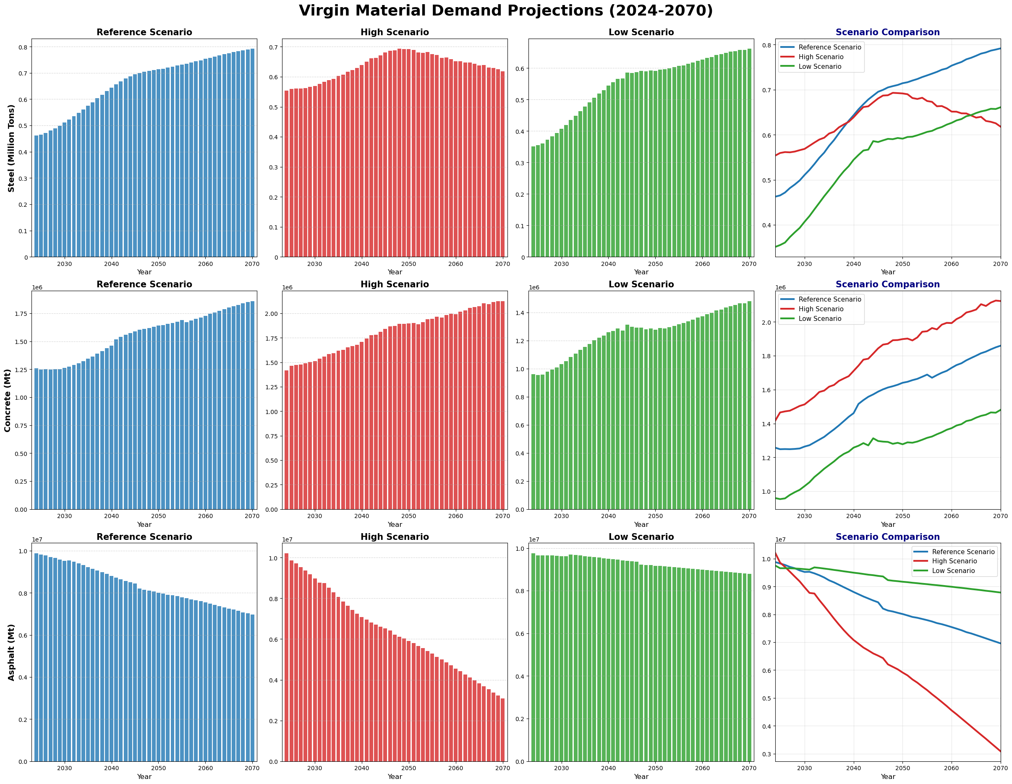

Figure 8: Virgin material demand until 2070 under different scenarios

Here, Figure 8 represents the future demand of virgin materials (steel, concrete and asphalt) under three different scenarios. By 2070, the use for virgin material such as steel and concrete is expected to increase where the use of asphalt will reduce. Under high scenario, primary steel use will increase initially until 2050 and later reduce gradually. This is due to high closed loop circularity potential for steel under this scenario. However, reference and low scenario show gradual increase in virgin steel use as the closed loop circularity is lower.

References:

Arcelor Mittal. (2025). AZ-700 and AZ-770 / AZ® sections | ArcelorMittal Sheet Piling. https://sheetpiling.arcelormittal.com/products/az-sections/az-700-and-az-770
Betonhuis. (2025). Concrete industry monitoring: CO₂ reduction in 2023 compared to 2022, growth in circularity | Betonhuis. https://betonhuis.nl/betonhuis/monitoring-betonindustrie-co2-daling-2023-tov-2022-groei-circulariteit
BMS. (2025). Publications | Building with Steel. https://www.bouwenmetstaal.nl/publicaties
Bonoli, A., Degli Esposti, A., & Magrini, C. (2020). A Case Study of Industrial Symbiosis to Reduce GHG Emissions: Performance Analysis and LCA of Asphalt Concretes Made With RAP Aggregates and Steel Slags. Frontiers in Materials, 7, 572955. https://doi.org/10.3389/fmats.2020.572955
Buzzi SpA. (2025). High Strength Concrete - Dyckerhoff Basal - Buzzi SpA. https://www.dyckerhoff-basal.nl/en/producten/hogesterktebeton
C2CA. (2024). Closing the concrete waste loop with C2CA. https://www.tudelft.nl/en/innovation-impact/pioneering-tech/articles/closing-the-concrete-waste-loop-1
CBS. (2024). Over half of electricity production now comes from renewable sources | CBS. https://www.cbs.nl/en-gb/news/2024/39/over-half-of-electricity-production-now-comes-from-renewable-sources
Chanson, H., Leng, X., Wang, H., & Hang, W. (2021). Journal of Hydraulic Research Challenging hydraulic structures of the twenty-first century-from bubbles, transient turbulence to fish passage Challenging hydraulic structures of the twenty-first century-from bubbles, transient turbulence to fish passage. Journal of Hydraulic Research, 59(1), 21–35. https://doi.org/10.1080/00221686.2020.1871429
Ćwiek, J., & Michalska-Ćwiek, J. (2010). Evaluation of hydrogen degradation of high-strength weldable steels. Achievements in Materials and Manufacturing Engineering, 42(2), 103–110.
Delta Program. (2021). Delta Programme 2021 (PDF) | Delta Programme. https://english.deltaprogramma.nl/documents/2020/09/15/dp2021-eng-printversie
Emma van der Bent. (2022). A DYNAMIC MATERIAL FLOW ANALYSIS OF THE URBAN MINE OF THE DUTCH URBAN WATER CYCLE INFRASTRUCTURE. CML.
EUROFER. (2024). EUROPEAN STEEL IN FIGURES. www.eurofer.eu
Eurostat. (2024). Circular material use rate. https://ec.europa.eu/eurostat/databrowser/view/env_ac_cur/default/table?lang=en
EVEROX. (2025). everox | circular concrete. https://www.everox.tech/
Fardis, M. N., & Khalili, H. (1981). Concrete Encased in Fiberglass-Reinforced Plastic. Journal Proceedings, 78(6), 440–446. https://doi.org/10.14359/10527
Garrido-Baserba, M., Vinardell, S., Molinos-Senante, M., Rosso, D., & Poch, M. (2018). The Economics of Wastewater Treatment Decentralization: A Techno-economic Evaluation. Environmental Science & Technology, 52(15), 8965–8976. https://doi.org/10.1021/acs.est.8b01623
Green, M. A. (2019). How Did Solar Cells Get So Cheap? Joule, 3(3), 631–633. https://doi.org/10.1016/j.joule.2019.02.010
Hagos, E., Shirazi, M., & Van De Wall, A. (n.d.). The development of 100% RAP asphalt mixture with the use of innovative rejuvenator. https://doi.org/10.14311/EE.2016.093
Haskoning. (2023). Nereda changes wastewater treatment with the 100th plant | Haskoning. https://nereda.haskoning.com/en/resources/news/2023/nereda-disrupts-the-world-of-wastewater-treatment-with-the-100th-plant
Hu, J., Sparrow, Z. M., Ernst, B. G., Mattes, S. M., Coates, G. W., DiStasio, R. A., & Fors, B. P. (2025). Designing Polymers with Molecular Weight Distribution-Based Machine Learning. Journal of the American Chemical Society, 147(12), 10238–10246. https://doi.org/10.1021/jacs.4c16325
klimaatakkoord. (2019). klimaatakkoord. https://www.klimaatakkoord.nl/binaries/klimaatakkoord/documenten/publicaties/2019/06/28/klimaatakkoord/klimaatakkoord.pdf.
Koolen, D., & Vidovic, D. (2022). Greenhouse gas intensities of the EU steel industry and its trading partners. https://doi.org/10.2760/170198
KpNK. (2023). Wet Works Knowledge Programme - Insight into the challenge. https://www.nattekunstwerkenvandetoekomst.nl/
Lech Czarnecki, & Paweł Łukowski. (2010). Betony polimerowo-cementowe Polymer-cement concretes. www.cementwapnobeton.pl
Loris SAUFNAY, Mihaylov, B., Demonceau, J.-F., Duchêne, L., Knobloch, M., & Veljkovic, M. (2024). High-strength steels and innovative design approaches for sustainable steel structures.
Mahmood Amani, & Ahmed Abdul Rauf. (2017). An Update on the Use of Fiberglass Casing and Tubing in Oil and Gas Wells. International Journal of Petroleum and Petrochemical Engineering, 3(4). https://doi.org/10.20431/2454-7980.0304004
Mantalovas, K., & Di Mino, G. (2019). The Sustainability of Reclaimed Asphalt as a Resource for Road Pavement Management through a Circular Economic Model. Sustainability 2019, Vol. 11, 11(8). https://doi.org/10.3390/su11082234
Maxi, M., Essam, R., & Ehab, M. (2024). Understanding Impact Resistance of Hollow Core Slabs Using FRP Retrofitting. A Comparative Analysis of GFRP And CFRP. IOP Conference Series: Earth and Environmental Science, 1396(1), 012001. https://doi.org/10.1088/1755-1315/1396/1/012001
Mhatre, P., Gedam, V. V., & Unnikrishnan, S. (2021). Material circularity potential for construction materials – The case of transportation infrastructure in India. Resources Policy, 74(4), 102446. https://doi.org/10.1016/j.resourpol.2021.102446
Modarelli, R., Micelli, F., & Manni, O. (2005). FRP-Confinement of Hollow Concrete Cylinders and Prisms. Special Publication, 230, 1029–1046. https://doi.org/10.14359/14879
Mulders, L. (2013). High quality recycling of construction and demolition waste in the Netherlands. https://studenttheses.uu.nl/handle/20.500.12932/13837
NWD. (2025). Stronger together, cheaper together | National Road Traffic Data Portal. https://www.ndw.nu/
Oliveira, C., & Silva, C. X. (2022). DECARBONISATION OPTIONS FOR THE DUTCH ASPHALT INDUSTRY Manufacturing Industry Decarbonisation Data Exchange Network Colophon Decarbonisation options for the Dutch asphalt industry. www.pbl.nl/en.
PBL, C. B. S., TNO, R., CBS, M., & RIVM, M. (2020). Klimaat-en Energieverkenning 2020.
Peter, L., E. (Ester) van der Voet, L.M. (Linda) Kamp, & (Janneke) van Oorschot. (2021). Towards a Circular Economy: Material Changes in the Dutch Railway Infrastructure until 2050.
Pipezy. (2025). FRP Continuous Winding Pipe. https://www.pipezy.net/frp-pipe/frp-continuous-winding-pipe.html
RWS. (2022). 294-verificatie-geschiktheid-wegenbouwmaterialen-v3-0-april-2022.
RWS. (2024a). Design Guidelines for Artworks (ROK). https://standaarden.rws.nl/
RWS. (2024b). Handbook of elasticities 2024 - Rijkswaterstaat Publication Platform. https://open.rijkswaterstaat.nl/overige-publicaties/2024/handboek-elasticiteiten-2024/
RWS. (2025). Replacement and renovation of infrastructure is a joint task | Infrastructure Task Force. https://www.vitaleinfrasector.nl/nieuws/3063183.aspx
SBQSteel. (2025). The Role of Sustainable Steel in Energy-Efficient Railways: A Path to a Greener Future - SBQSteels.com. https://www.sbqsteels.com/role-sustainable-steel-railways-path/
Simões, C. L., Pinto, L. M. C., & Bernardo, C. A. (2014). Environmental and economic analysis of end of life management options for an HDPE product using a life cycle thinking approach. Waste Management & Research, 32(5), 414–422. https://doi.org/10.1177/0734242X14527334
Songer, B., Scott, D., Wood, S., Hackbarth, E., Mack, T., Tillotson, A., & Walker, K. (2023). Laboratory Development and Characterization of UHPC for the Repair of Navigation Structures. International Interactive Symposium on Ultra-High Performance Concrete Papers, 3(1). https://doi.org/10.21838/uhpc.16636
Tankova, T., Simões da Silva, L., & Rodrigues, F. (2022). Buckling curve selection for HSS welded I-section members. Thin-Walled Structures, 177, 109430. https://doi.org/10.1016/j.tws.2022.109430
Triqua. (2025). Membrane Bioreactor MBR. https://www.triqua.eu/site/membrane-bioreactor
Van De Water, J. (2025). Samengesteld door Naam: Greet Leegwater Rol: Projectleider validatie NPDW. https://www.npdwegverharding.nl/
van Oorschot, J., Sprecher, B., Roelofs, B., van der Horst, J., & van der Voet, E. (2022). Towards a low-carbon and circular economy: Scenarios for metal stocks and flows in the Dutch electricity system. Resources, Conservation and Recycling, 178. https://doi.org/10.1016/j.resconrec.2021.106105
Watari, T., Fishman, T., Wieland, H., & Wiedenhofer, D. (2025). Global stagnation and regional variations in steel recycling. Resources, Conservation and Recycling, 220, 108363. https://doi.org/10.1016/J.RESCONREC.2025.108363
WCN. (2025). STROOOM consortium to deliver renovation of Zeeland locks. https://www.worldconstructionnetwork.com/news/strooom-consortium-renovation-zeeland-locks/?cf-view
Wiser, R., Jenni, K., Seel, J., Baker, E., Hand, M., Lantz, E., & Smith, A. (2016). Expert elicitation survey on future wind energy costs. Nature Energy 2016 1:10, 1(10), 16135-. https://doi.org/10.1038/nenergy.2016.135
Wolters, H., Hunink, J. , & E., R. B. (2018). Deltascenario’s voor de 21 e eeuw. https://media.deltares.nl/deltascenarios/Deltascenarios_actualisering2017_hoofdra pport.pdf
Zhang, C., Hu, M., Yang, X., Miranda-Xicotencatl, B., Sprecher, B., Di Maio, F., Zhong, X., & Tukker, A. (2020a). Upgrading construction and demolition waste management from downcycling to recycling in the Netherlands. Journal of Cleaner Production, 266, 121718. https://doi.org/10.1016/J.JCLEPRO.2020.121718
Zhang, C., Hu, M., Yang, X., Miranda-Xicotencatl, B., Sprecher, B., Di Maio, F., Zhong, X., & Tukker, A. (2020b). Upgrading construction and demolition waste management from downcycling to recycling in the Netherlands. Journal of Cleaner Production, 266, 121718. https://doi.org/10.1016/J.JCLEPRO.2020.121718
Zubail, A., Traidia, A., Masulli, M., Vatopoulos, K., Villette, T., & Taie, I. (2021). Carbon and energy footprint of nonmetallic composite pipes in onshore oil and gas flowlines. Journal of Cleaner Production, 305(1), 127150. https://doi.org/10.1016/j.jclepro.2021.127150

