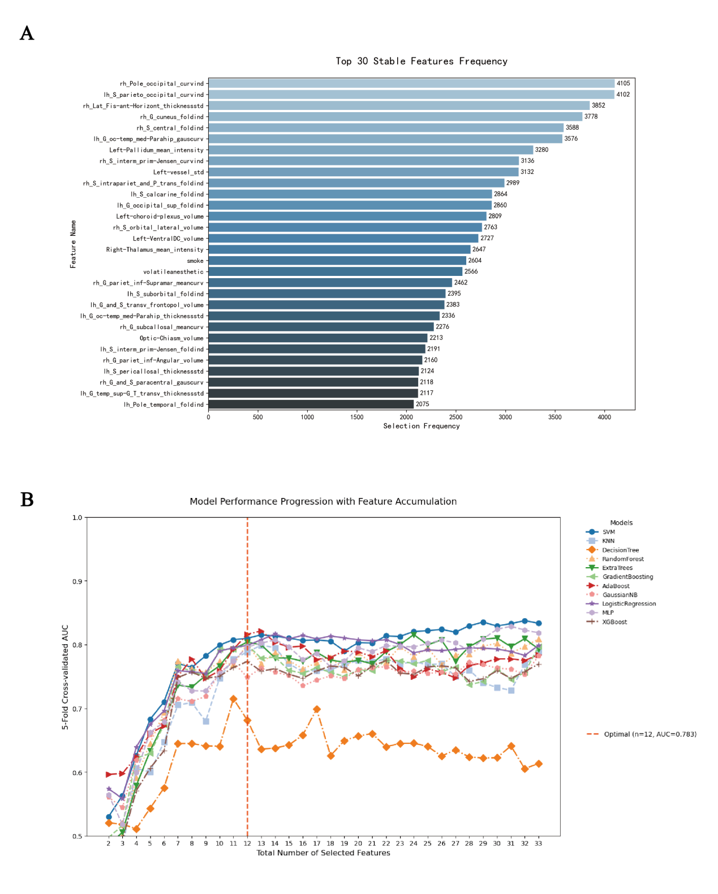
Supplementary FIGURE 1 | Feature stability analysis and model performance with feature accumulation.​​
(A) Frequency of the top 30 stable features across cross-validation iterations. Features are ranked by their stability. The x-axis represents the selection frequency, and the y-axis lists the top 30 features (e.g., rh_Pole_occipital_curv).
(B) Model performance (average AUC) of different classifiers (SVM, KNN, etc.) when ranked by increasing numbers of stability features. The orange vertical dashed line indicates the optimal number of features (n=12) that achieved the best average AUC (0.783) on the validation set.

Supplementary FIGURE 2| Model Calibration and Comprehensive Performance Analysis
- Training set (blue);Internal validation (green);External validation (red);Ideal calibration (black dashed line);Close alignment between predicted probabilities and actual outcomes across all datasets.
- Performance metrics (Accuracy, AUC, Sensitivity, Specificity, PPV, NPV, Precision, Recall) ;ExtraTrees achieves peak values in specificity.

