Table S1: Association between standardized log-transformed total testosterone [log(TT)] and coronary heart disease (CHD), stratified by sex and menopausal status
Group | Exposure | Model 1 OR (95% CI) | P value (M1) | Model 2 OR (95% CI) | P value (M2) | Model 3 OR (95% CI) | P value (M3)
Men | log(TT) per 1-SD | 0.71 (0.63–0.80) | <0.001 | 0.80 (0.71–0.92) | 0.001 | 0.85 (0.75–0.97) | 0.017
Women | log(TT) per 1-SD | 0.76 (0.66–0.89) | <0.001 | 0.88 (0.77–1.01) | 0.064 | 0.92 (0.80–1.06) | 0.226
Premenopause | log(TT) per 1-SD | 0.78 (0.56–1.07) | 0.123 | 0.84 (0.60–1.19) | 0.332 | 0.87 (0.60–1.27) | 0.479
Postmenopause | log(TT) per 1-SD | 0.87 (0.73–1.04) | 0.123 | 0.88 (0.75–1.03) | 0.122 | 0.92 (0.78–1.08) | 0.288
Odds ratios (ORs) and 95% confidence intervals (CIs) were estimated using survey-weighted logistic regression models with multiple imputation. Log (TT) was standardized, and ORs are reported per 1-standard deviation (SD) increase.
Model 1 was adjusted for age.
.Model 2 was additionally adjusted for race/ethnicity, education level, marital status, poverty–income ratio (PIR), smoking status, and alcohol consumption.
Model 3 was further adjusted for diabetes, hypertension, and hyperlipidemia.
All analyses accounted for the complex NHANES sampling design, including sample weights, strata, and primary sampling units. Estimates were pooled using Rubin’s rules. All P values are two-sided.

Table S2: Joint association of standardized log-transformed total testosterone [log(TT)] and testosterone-to-estradiol ratio [log(TT/E2)] with coronary heart disease (CHD) in men
Survey-weighted logistic regression models accounting for the complex NHANES sampling design were fitted within each imputed dataset. The fully adjusted joint model simultaneously included standardized log (TT) and standardized log (TT/E2), along with age, race/ethnicity, education level, marital status, poverty–income ratio category, alcohol consumption, smoking status, diabetes, hypertension, and hyperlipidemia. Coronary heart disease was modeled as a binary outcome using a quasibinomial link function. Sampling weights, strata, and primary sampling units were incorporated using the survey design framework.
Estimates from each imputed dataset were combined using Rubin’s rules to obtain pooled regression coefficients, standard errors, odds ratios (ORs), and 95% confidence intervals (CIs). This joint modeling strategy allowed direct comparison of the independent contributions of testosterone and hormonal balance while accounting for their intrinsic correlation. The results were interpreted to determine whether either exposure provided incremental predictive value for CHD risk beyond the other in men.
Exposure | OR | OR_low | OR_high | p_value
log(TT) per 1-SD | 0.929792495 | 0.760388208 | 1.136937783 | 0.47809895
log (TT/E2) per 1-SD | 0.857094161 | 0.68611477 | 1.070681514 | 0.17433852
Survey-weighted logistic regression models with multiple imputation were used to estimate odds ratios (ORs) and 95% confidence intervals (CIs). Both log(TT) and log(TT/E2) were standardized and simultaneously included in the fully adjusted model.
Models were adjusted for age, race/ethnicity, education level, marital status, poverty–income ratio (PIR), smoking status, alcohol consumption, diabetes, hypertension, and hyperlipidemia.
All analyses accounted for the complex NHANES sampling design. Estimates were pooled using Rubin’s rules. ORs are presented per 1-SD increase. All P values are two-sided.

Table S3: Association between standardized log-transformed estradiol [log(E2)] and coronary heart disease (CHD), stratified by sex and menopausal status
Group | Exposure | Model 1 OR (95% CI) | P value (M1) | Model 2 OR (95% CI) | P value (M2) | Model 3 OR (95% CI) | P value (M3)
Men | log(E2) per 1-SD | 0.89 (0.73–1.09) | 0.254 | 0.98 (0.82–1.17) | 0.832 | 0.97 (0.81–1.16) | 0.756
Women | log(E2) per 1-SD | 0.51 (0.44–0.58) | <0.001 | 0.84 (0.70–1.01) | 0.057 | 0.85 (0.71–1.02) | 0.076
Premenopause | log(E2) per 1-SD | 1.07 (0.82–1.40) | 0.628 | 1.19 (0.92–1.53) | 0.189 | 1.26 (0.98–1.62) | 0.077
Postmenopause | log(E2) per 1-SD | 0.70 (0.61–0.82) | <0.001 | 0.85 (0.72–1.01) | 0.072 | 0.83 (0.70–0.99) | 0.040
Odds ratios (ORs) and 95% confidence intervals (CIs) were estimated using survey-weighted logistic regression models with multiple imputation. Log(E2) was standardized, and ORs are reported per 1-standard deviation (SD) increase.
Model 1 was adjusted for age.
Model 2 was additionally adjusted for race/ethnicity, education level, marital status, poverty–income ratio (PIR), smoking status, and alcohol consumption.
Model 3 was further adjusted for diabetes, hypertension, and hyperlipidemia.
All analyses accounted for the complex NHANES sampling design. Estimates were pooled using Rubin’s rules. All P values are two-sided.
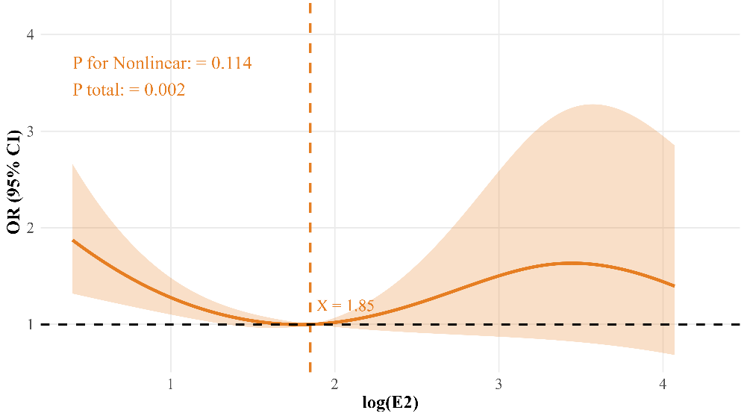
Fig S1: Restricted Cubic Spline Analysis of log(E2) and CHD in Postmenopausal Women
Survey-weighted restricted cubic spline depicting the association between log-transformed estradiol (log[E2]) and the odds of coronary heart disease (CHD) among postmenopausal women. The solid line represents the adjusted odds ratio, and the shaded area indicates the 95% confidence interval. The reference value was set at log(E2) = 1.85. P for overall association = 0.002; P for nonlinearity = 0.114.

Table S4: Survey-weighted mediation analysis of the association between log-transformed testosterone-to-estradiol ratio [log(TT/E2)] and coronary heart disease (CHD) with weight-adjusted waist index (WWI) as a mediator among premenopausal women
effect | estimate | se | CI_low | CI_high | p_value | p_formatted
ACME (indirect) | 0.000427 | 0.007045 | -0.01421 | 0.015938 | 0.951688 | 0.952
ADE (direct) | -0.2725 | 0.114076 | -0.49918 | -0.05601 | 0.016904 | 0.017
Total effect | -0.27056 | 0.116658 | -0.5012 | -0.04288 | 0.020382 | 0.02
Proportion mediated | 0.010808 | 1.032331 | -0.08608 | 0.073202 | 0.991647 | 0.992
Mediation analysis was conducted within a survey-weighted multiple imputation framework. Exposure: log(TT/E2); mediator: weight-adjusted waist index (WWI); outcome: coronary heart disease (CHD).
ACME represents the average causal mediation effect (indirect effect), ADE represents the average direct effect, and total effect is the sum of ACME and ADE. The proportion mediated was calculated as ACME divided by the total effect.
Models were adjusted for age, race/ethnicity, education level, marital status, poverty–income ratio (PIR), smoking status, alcohol consumption, diabetes, hypertension, and hyperlipidemia.
Estimates were pooled using Rubin’s rules. Confidence intervals were obtained using simulation-based methods. All P values are two-sided.

Table S5: Survey-weighted mediation analysis of the association between log-transformed estradiol [log(E2)] and coronary heart disease (CHD) with weight-adjusted waist index (WWI) as a mediator among postmenopausal women
effect | estimate | se | CI_low | CI_high | p_value | p_formatted
ACME (indirect) | 0.023655782 | 0.010762563 | 0.005727 | 0.047174 | 0.027951 | 0.028
ADE (direct) | -0.186972373 | 0.079116893 | -0.34418 | -0.03683 | 0.018116 | 0.018
Total effect | -0.158079521 | 0.076942709 | -0.3102 | -0.00791 | 0.039926 | 0.04
Proportion mediated | -4.144394874 | 261.9473852 | -0.98337 | -0.01089 | 0.987377 | 0.987
Mediation analysis was conducted within a survey-weighted multiple imputation framework. Exposure: log(E2); mediator: weight-adjusted waist index (WWI); outcome: coronary heart disease (CHD).
ACME represents the average causal mediation effect (indirect effect), ADE represents the average direct effect, and total effect is the sum of ACME and ADE. The proportion mediated was calculated as ACME divided by the total effect.
Models were adjusted for age, race/ethnicity, education level, marital status, poverty–income ratio (PIR), smoking status, alcohol consumption, diabetes, hypertension, and hyperlipidemia.
Estimates were pooled using Rubin’s rules. Confidence intervals were obtained using simulation-based methods. The proportion mediated should be interpreted with caution when the total effect is unstable. All P values are two-sided.

Table S6. Sensitivity analyses for the association between log-transformed testosterone-to-estradiol ratio [log(TT/E2)] and coronary heart disease (CHD) across sex and menopausal subgroups
Analysis | Group | Exposure | OR (95% CI) | P value | N
Main analysis (MI + weighted) | Men | Log (TT/E2) per 1-SD | 0.81 (0.70–0.94) | 0.006
Main analysis (MI + weighted) | Women | Log (TT/E2) per 1-SD | 1.08 (0.93–1.24) | 0.323
Main analysis (MI + weighted) | Premenopause | Log (TT/E2) per 1-SD | 0.73 (0.56–0.95) | 0.020
Main analysis (MI + weighted) | Postmenopause | Log (TT/E2) per 1-SD | 1.11 (0.95–1.29) | 0.200
Complete-case weighted | Men | Log (TT/E2) per 1-SD | 0.86 (0.75–0.98) | 0.019 | 3507
Complete-case weighted | Women | Log (TT/E2) per 1-SD | 1.13 (0.96–1.32) | 0.140 | 3633
Complete-case weighted | Premenopause | Log (TT/E2) per 1-SD | 0.69 (0.49–0.97) | 0.031 | 1370
Complete-case weighted | Postmenopause | Log (TT/E2) per 1-SD | 1.14 (0.96–1.35) | 0.123 | 2263
Complete-case unweighted | Men | Log (TT/E2) per 1-SD | 0.85 (0.76–0.96) | 0.006 | 3507
Complete-case unweighted | Women | Log (TT/E2) per 1-SD | 1.06 (0.87–1.28) | 0.575 | 3633
Complete-case unweighted | Premenopause | Log (TT/E2) per 1-SD | 0.68 (0.46–1.02) | 0.060 | 1370
Complete-case unweighted | Postmenopause | Log (TT/E2) per 1-SD | 1.13 (0.95–1.34) | 0.178 | 2263
Odds ratios (ORs) and 95% confidence intervals (CIs) are shown for the association between log (TT/E2) and CHD across men, women, premenopausal women, and postmenopausal women. The primary analysis was based on survey-weighted logistic regression with multiple imputation. Sensitivity analyses included complete-case weighted models and complete-case unweighted models. In all models, log (TT/E2) was standardized, and ORs are reported per 1-standard deviation (SD) increase. Fully adjusted models included age, race/ethnicity, education level, marital status, poverty–income ratio (PIR), smoking status, alcohol consumption, diabetes, hypertension, and hyperlipidemia. All P values are two-sided.

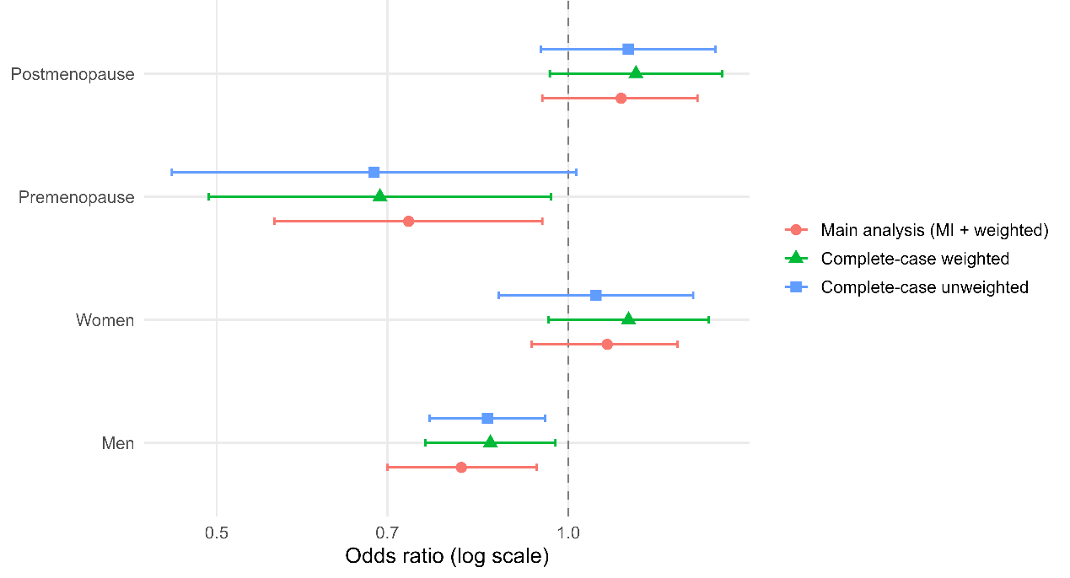
Figure S2. Sensitivity analyses for the association between log(TT/E2) and CHD across sex and menopausal subgroups
Forest plot comparing the effect estimates from the primary analysis (multiple imputation with survey weighting), complete-case weighted models, and complete-case unweighted models. Odds ratios (ORs) per 1-standard deviation (SD) increase in log (TT/E2) and 95% confidence intervals (CIs) are presented on a logarithmic scale for men, women, premenopausal women, and postmenopausal women. The vertical dashed line indicates OR = 1.0.

Table S7. Sensitivity analyses for the interaction of log-transformed testosterone-to-estradiol ratio [log(TT/E2)] with sex and menopausal status in relation to coronary heart disease (CHD)
Analysis | Interaction | term | OR (95% CI) | P value
Main analysis (MI + weighted) | log(TT/E2) × Gender | log(TT_E2):GenderWomen | 1.365 (1.058–1.760) | 0.017
Complete-case weighted | log(TT/E2) × Gender | log(TT_E2):GenderWomen | 1.378 (1.047–1.814) | 0.022
Main analysis (MI + weighted) | log(TT/E2) × Menopause status | log(TT_E2):menopause_statusYes | 1.424 (1.093–1.855) | 0.009
Complete-case weighted | log(TT/E2) × Menopause status | log(TT_E2):menopause_statusYes | 1.497 (1.087–2.061) | 0.014
Interaction ORs and 95% confidence intervals (CIs) are shown for the interaction between log (TT/E2) and sex and for the interaction between log (TT/E2) and menopausal status. The primary analysis was based on survey-weighted logistic regression with multiple imputation. Sensitivity analyses were performed using complete-case weighted models. Fully adjusted models included age, race/ethnicity, education level, marital status, poverty–income ratio (PIR), smoking status, alcohol consumption, diabetes, hypertension, and hyperlipidemia. All P values are two-sided.
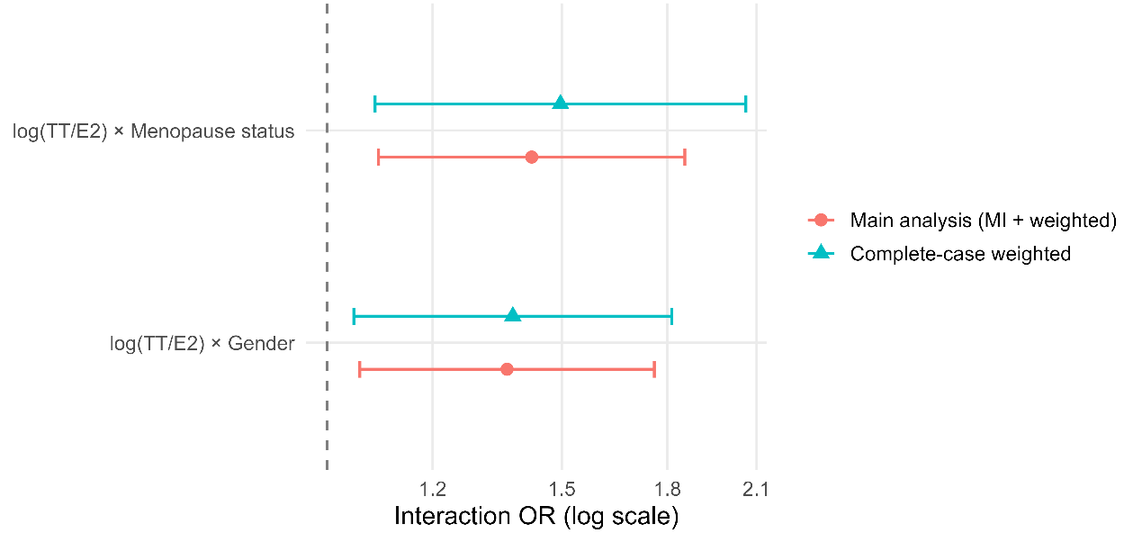
Figure S3. Sensitivity analyses for interaction terms between log(TT/E2) and sex and between log(TT/E2) and menopausal status
Forest plot comparing the interaction effect estimates from the primary analysis (multiple imputation with survey weighting) and complete-case weighted models. Interaction odds ratios (ORs) represent the multiplicative interaction effects between log (TT/E2) and sex or menopausal status. Estimates and 95% confidence intervals (CIs) are presented on a logarithmic scale. The vertical dashed line indicates OR = 1.0.

