Title:
“Interactive effects of fallow age and Chromolaena odorata invasion on tree regeneration in Central African agricultural landscapes”
Jean Pierre Azenge^{1, 2, 3,*}, Justin N’Dja Kassi², Paxie W. Chirwa¹

Supplementary material
Supplementary materials provide additional methodological details, extended statistical outputs, model diagnostics, and full results supporting the analyses presented in the main text. These materials aim to ensure transparency, reproducibility, and completeness of the modelling framework.

Text S1. Additional details on the sampling design
Detailed information on the sampling design is provided to clarify how spatial replication and treatment combinations were structured. The regeneration survey was based on a stratified design combining fallow age, Chromolaena odorata cover, and species identity across 15 villages in Mongala Province.
Each seed tree constituted an independent sampling unit, and seedling counts were aggregated at this level to avoid pseudoreplication. Transect-based measurements were standardised to account for variability in field size and ensure comparability across sites.

Exploratory data analysis
The figure S1 presents:
- Distribution of seedling density (histogram)
- Detection of extreme values (boxplot)
- Relationships between density and distance
- Relationships between density and invasion level
These analyses confirm:
- strong right-skewness
- high variance
- substantial zero inflation
Together, these patterns justify the use of zero-inflated negative binomial (ZINB) models.
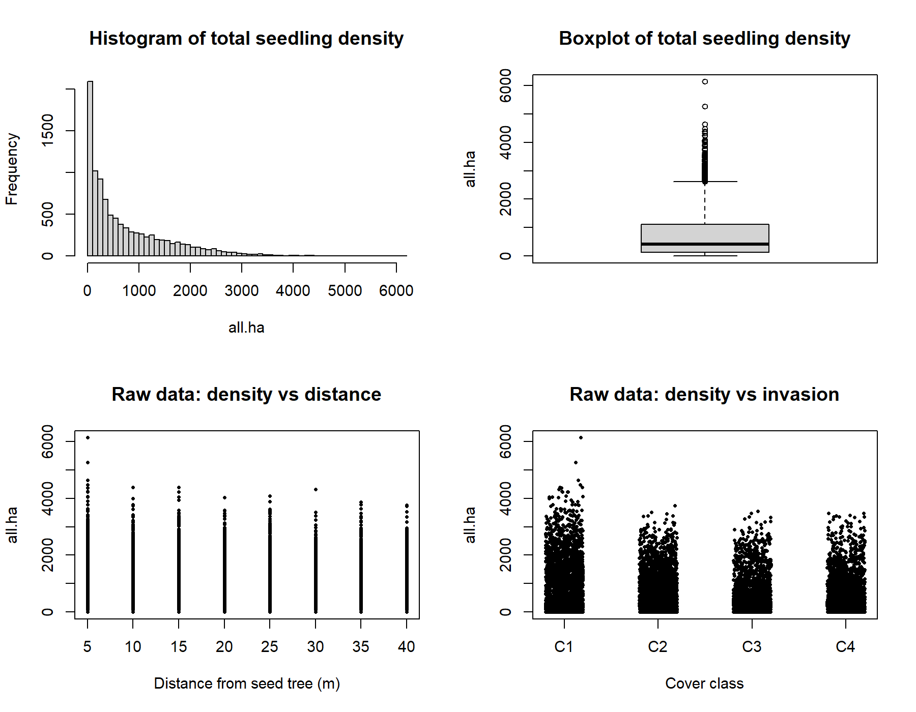
Figure S 1. Exploratory analysis of seedling density data showing distribution, outliers, and relationships with distance and Chromolaena odorata cover.

Model comparison
The comparison of candidate models used to identify the most appropriate modelling framework for seedling density is presented in Table S2.
Table S 1. Model comparison
Model | AIC | BIC | logLik
m3_zinb | 126626.61 | 127128.48 | -63243.31
m2_zinb | 126789.97 | 127255.99 | -63329.98
m1_nb | 136139.18 | 136598.03 | -68005.59
The zero-inflated negative binomial model showed the best fit (lowest AIC and BIC), confirming the relevance of accounting for both overdispersion and excess zeros.

Full pairwise comparisons of seedling density
Table S 2. Full pairwise comparisons of seedling density across Chromolaena odorata cover levels within each fallow age class and species (zero-inflated negative binomial model).
Species | Fallow age | Contrast | Rate ratio | SE | z-value | p-value
E. suaveolens | 0-3 years | C2 vs C1 | 0.53 | 0.08 | -6.26 | <0.001
 |  | C3 vs C1 | 0.22 | 0.04 | -10.35 | <0.001
 |  | C4 vs C1 | 0.06 | 0.01 | -14.89 | <0.001
 |  | C3 vs C2 | 0.41 | 0.06 | -7.92 | <0.001
 |  | C4 vs C2 | 0.12 | 0.02 | -11.67 | <0.001
 |  | C4 vs C3 | 0.29 | 0.05 | -6.43 | <0.001
 | 3-6 years | C2 vs C1 | 0.60 | 0.09 | -5.31 | <0.001
 |  | C3 vs C1 | 0.30 | 0.05 | -8.92 | <0.001
 |  | C4 vs C1 | 0.12 | 0.02 | -12.75 | <0.001
 | >6 years | C2 vs C1 | 0.70 | 0.10 | -4.21 | <0.001
 |  | C3 vs C1 | 0.39 | 0.06 | -7.54 | <0.001
 |  | C4 vs C1 | 0.15 | 0.02 | -11.18 | <0.001
P. africanum | 0-3 years | C2 vs C1 | 0.73 | 0.12 | -2.43 | 0.015
 |  | C3 vs C1 | 0.28 | 0.05 | -9.67 | <0.001
 |  | C4 vs C1 | 0.19 | 0.04 | -10.92 | <0.001
 | 3-6 years | C2 vs C1 | 0.81 | 0.13 | -1.75 | 0.081
 |  | C3 vs C1 | 0.21 | 0.04 | -11.54 | <0.001
 |  | C4 vs C1 | 0.17 | 0.03 | -12.38 | <0.001
 | >6 years | C2 vs C1 | 0.91 | 0.14 | -0.87 | 0.386
 |  | C3 vs C1 | 0.61 | 0.10 | -4.72 | <0.001
 |  | C4 vs C1 | 0.63 | 0.11 | -4.21 | <0.001
P. angolensis | 0-3 years | C2 vs C1 | 0.50 | 0.08 | -6.81 | <0.001
 |  | C3 vs C1 | 0.16 | 0.03 | -12.96 | <0.001
 |  | C4 vs C1 | 0.13 | 0.02 | -13.85 | <0.001
 | 3-6 years | C2 vs C1 | 0.76 | 0.12 | -1.86 | 0.063
 |  | C3 vs C1 | 0.26 | 0.05 | -10.44 | <0.001
 |  | C4 vs C1 | 0.16 | 0.03 | -12.11 | <0.001
 | >6 years | C2 vs C1 | 0.92 | 0.14 | -0.74 | 0.460
 |  | C3 vs C1 | 1.00 | 0.16 | 0.02 | 0.984
 |  | C4 vs C1 | 0.97 | 0.15 | -0.18 | 0.857
P. macrocarpus | 0-3 years | C2 vs C1 | 1.44 | 0.25 | 1.89 | 0.059
 |  | C3 vs C1 | 3.36 | 0.60 | 6.72 | <0.001
 |  | C4 vs C1 | 2.60 | 0.48 | 5.89 | <0.001
 | 3-6 years | C2 vs C1 | 1.51 | 0.27 | 2.13 | 0.033
 |  | C3 vs C1 | 3.72 | 0.68 | 7.15 | <0.001
 |  | C4 vs C1 | 7.32 | 1.45 | 9.84 | <0.001
 | >6 years | C2 vs C1 | 3.76 | 0.72 | 8.61 | <0.001
 |  | C3 vs C1 | 5.15 | 1.01 | 10.72 | <0.001
 |  | C4 vs C1 | 8.51 | 1.70 | 12.96 | <0.001
R. heudelotii | 0-3 years | C2 vs C1 | 0.52 | 0.08 | -6.74 | <0.001
 |  | C3 vs C1 | 0.13 | 0.02 | -13.42 | <0.001
 |  | C4 vs C1 | 0.08 | 0.01 | -14.88 | <0.001
 | 3-6 years | C2 vs C1 | 1.00 | 0.16 | 0.01 | 0.993
 |  | C3 vs C1 | 1.04 | 0.17 | 0.32 | 0.749
 |  | C4 vs C1 | 1.07 | 0.18 | 0.44 | 0.661
 | >6 years | C2 vs C1 | 1.07 | 0.18 | 0.41 | 0.682
 |  | C3 vs C1 | 1.00 | 0.17 | 0.02 | 0.985
 |  | C4 vs C1 | 1.01 | 0.17 | 0.05 | 0.961
Note: Pairwise contrasts were computed using estimated marginal means with Tukey adjustment for multiple comparisons. Results are expressed as rate ratios (exponentiated coefficients), where values < 1 indicate a decrease and values > 1 indicate an increase in seedling density relative to the reference level (C1).

DHARMa residual diagnostics
Simulation-based residual diagnostics for the ZINB model, including:
- Q–Q plot of residuals
- Residuals vs predicted values
- Uniformity test
- Dispersion test
- Outlier test
Results indicate:
- adequate modelling of zero inflation (non-significant test)
- no strong outlier influence
- moderate deviation in dispersion and uniformity (expected in large ecological datasets).
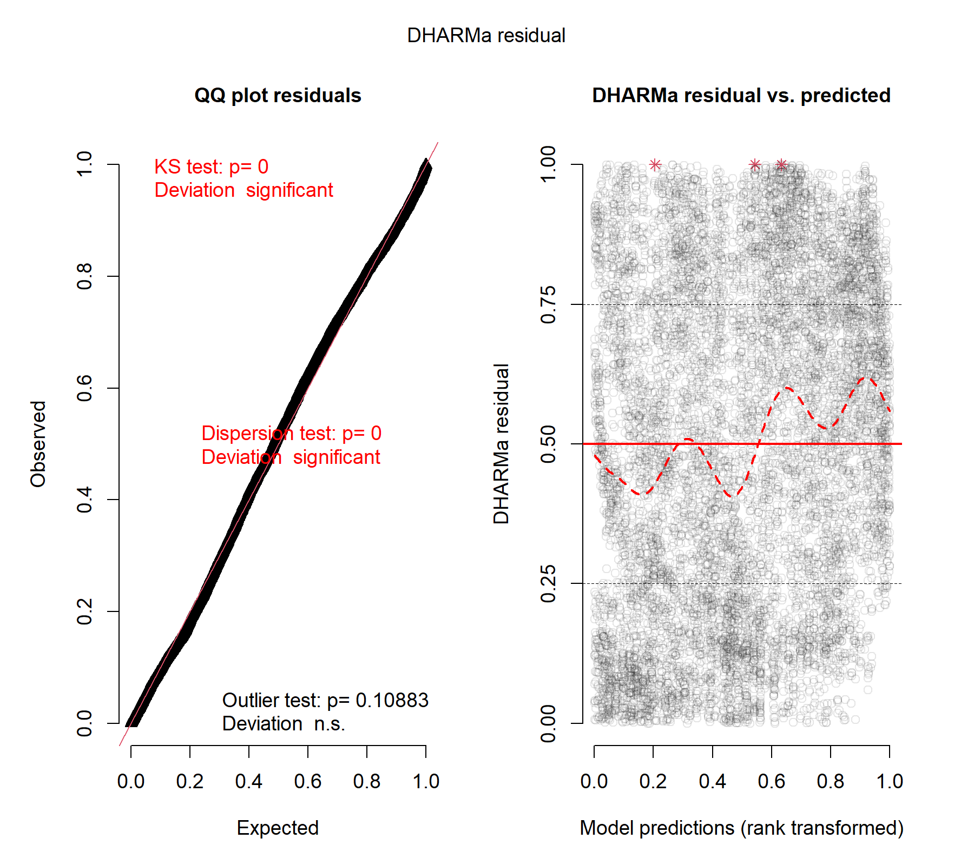
Figure S 2. DHARMa residual diagnostics for the zero-inflated negative binomial model.

Additional residual diagnostics
The Figure S3 presents complementary diagnostic plots including:
- Pearson residuals vs fitted values
- Histogram of residuals
- Q–Q plot (normal approximation)
These plots confirm:
- absence of strong systematic bias
- acceptable residual structure for inference

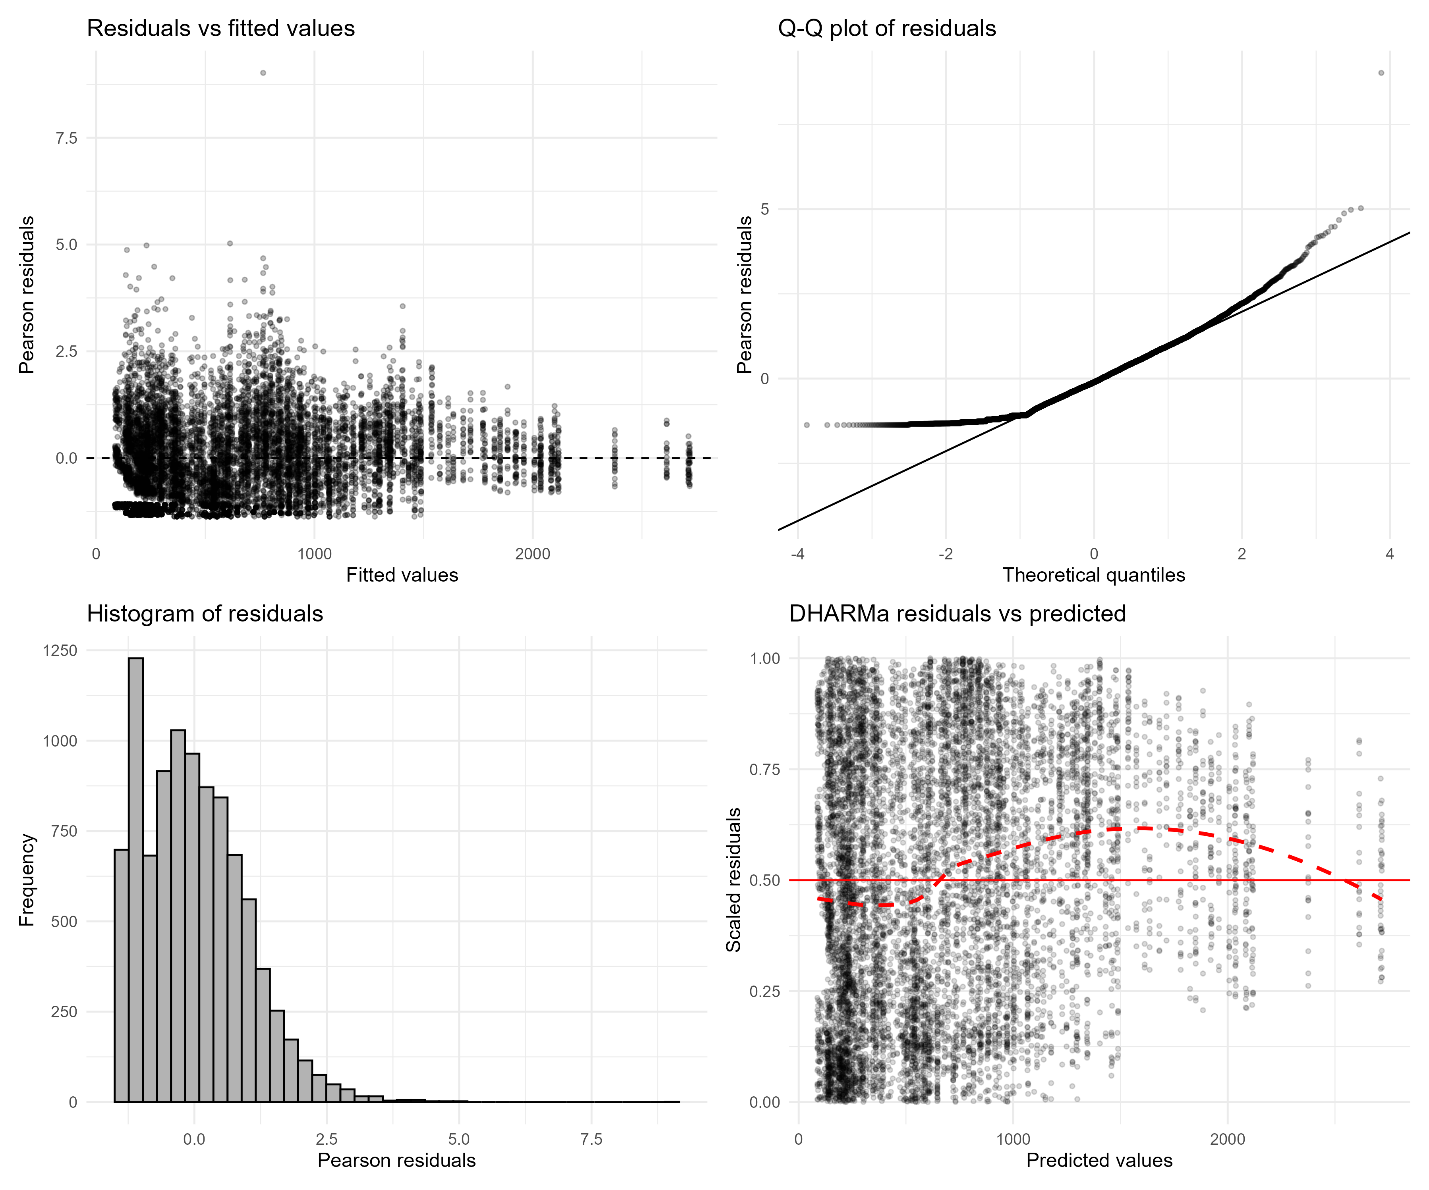
Figure S 3. Additional diagnostic plots including Pearson residuals, Q-Q plots, and residual distributions for the ZINB model.

Global estimated marginal means
Model-based predicted seedling densities across fallow age and invasion gradients, including:
- predicted values
- standard errors
- 95% confidence intervals
These estimates form the basis of the main results (Figure 3 in main text).
Table S 3. Estimated marginal means (EMMeans) of seedling density across fallow age and Chromolaena odorata cover levels derived from the zero-inflated negative binomial model.
Fallow age | Cover | Predicted density (ind. ha⁻¹) | SE | Lower CI | Upper CI
0–3 years | C1 | 1051.3 | 27.0 | 999.7 | 1105.5
0–3 years | C2 | 719.9 | 18.6 | 684.4 | 757.3
0–3 years | C3 | 365.0 | 9.1 | 347.5 | 383.3
0–3 years | C4 | 269.9 | 7.5 | 255.6 | 285.0
3–6 years | C1 | 783.5 | 20.2 | 744.9 | 824.0
3–6 years | C2 | 686.4 | 17.3 | 653.3 | 721.2
3–6 years | C3 | 502.1 | 13.2 | 476.9 | 528.7
3–6 years | C4 | 453.5 | 12.4 | 429.8 | 478.6
>6 years | C1 | 697.7 | 17.4 | 664.3 | 732.7
>6 years | C2 | 753.6 | 18.4 | 718.3 | 790.7
>6 years | C3 | 759.6 | 20.4 | 720.6 | 800.7
>6 years | C4 | 714.4 | 19.4 | 677.3 | 753.5
Note: Values represent model-based predictions with 95% confidence intervals.
C1: 0-25%; C2: 25-50%; C3: 50-75%; C4: >75%.

Species-specific estimated marginal means
Predicted seedling densities for each species across all combinations of:
- fallow age
- invasion level
These results highlight strong interspecific variability and support Figure 4 and Figure 5 in the main text.
Table S 4. Species-specific estimated marginal means (EMMeans) of seedling density across fallow age and Chromolaena odorata cover levels derived from the zero-inflated negative binomial model.
Species | Fallow age | Cover | Predicted density | Lower CI | Upper CI
E. suaveolens | 0 - 3 years | C1 | 1453.6 | 1314.4 | 1607.4
E. suaveolens | 0 - 3 years | C2 | 811.4 | 731.6 | 899.8
E. suaveolens | 0 - 3 years | C3 | 361.2 | 325.1 | 401.2
E. suaveolens | 0 - 3 years | C4 | 149.4 | 132.0 | 169.1
E. suaveolens | 3 - 6 years | C1 | 861.2 | 778.4 | 952.8
E. suaveolens | 3 - 6 years | C2 | 560.3 | 504.3 | 622.5
E. suaveolens | 3 - 6 years | C3 | 311.5 | 278.8 | 348.0
E. suaveolens | 3 - 6 years | C4 | 166.6 | 147.2 | 188.6
E. suaveolens | > 6 years | C1 | 717.9 | 649.1 | 794.1
E. suaveolens | > 6 years | C2 | 514.5 | 463.8 | 570.7
E. suaveolens | > 6 years | C3 | 330.8 | 296.1 | 369.5
E. suaveolens | > 6 years | C4 | 145.5 | 129.3 | 163.7
P. africanum | 0 - 3 years | C1 | 1274.6 | 1149.3 | 1413.6
P. africanum | 0 - 3 years | C2 | 885.3 | 802.3 | 976.8
P. africanum | 0 - 3 years | C3 | 374.8 | 338.0 | 415.6
P. africanum | 0 - 3 years | C4 | 253.8 | 229.4 | 280.8
P. africanum | 3 - 6 years | C1 | 1156.9 | 1041.5 | 1285.1
P. africanum | 3 - 6 years | C2 | 864.4 | 782.9 | 954.4
P. africanum | 3 - 6 years | C3 | 302.7 | 269.6 | 339.8
P. africanum | 3 - 6 years | C4 | 252.5 | 225.5 | 282.7
P. africanum | > 6 years | C1 | 773.5 | 697.1 | 858.3
P. africanum | > 6 years | C2 | 723.8 | 650.6 | 805.3
P. africanum | > 6 years | C3 | 895.8 | 772.8 | 1038.4
P. africanum | > 6 years | C4 | 862.0 | 746.5 | 995.2
P. angolensis | 0 - 3 years | C1 | 1326.8 | 1197.7 | 1469.8
P. angolensis | 0 - 3 years | C2 | 721.3 | 648.7 | 802.1
P. angolensis | 0 - 3 years | C3 | 266.6 | 238.7 | 297.7
P. angolensis | 0 - 3 years | C4 | 245.1 | 218.7 | 274.6
P. angolensis | 3 - 6 years | C1 | 726.8 | 655.0 | 806.4
P. angolensis | 3 - 6 years | C2 | 571.6 | 515.0 | 634.4
P. angolensis | 3 - 6 years | C3 | 298.1 | 263.7 | 336.9
P. angolensis | 3 - 6 years | C4 | 225.0 | 196.2 | 258.0
P. angolensis | > 6 years | C1 | 1051.7 | 949.6 | 1164.7
P. angolensis | > 6 years | C2 | 1007.5 | 909.2 | 1116.5
P. angolensis | > 6 years | C3 | 1026.7 | 928.8 | 1135.0
P. angolensis | > 6 years | C4 | 1034.1 | 934.2 | 1144.8
P. macrocarpus | 0 - 3 years | C1 | 203.4 | 178.9 | 231.1
P. macrocarpus | 0 - 3 years | C2 | 270.7 | 238.5 | 307.4
P. macrocarpus | 0 - 3 years | C3 | 457.4 | 413.1 | 506.5
P. macrocarpus | 0 - 3 years | C4 | 395.7 | 355.0 | 440.9
P. macrocarpus | 3 - 6 years | C1 | 205.6 | 180.9 | 233.7
P. macrocarpus | 3 - 6 years | C2 | 279.4 | 247.9 | 315.0
P. macrocarpus | 3 - 6 years | C3 | 557.0 | 501.1 | 619.2
P. macrocarpus | 3 - 6 years | C4 | 965.3 | 874.4 | 1065.6
P. macrocarpus | > 6 years | C1 | 228.1 | 203.2 | 256.1
P. macrocarpus | > 6 years | C2 | 489.8 | 443.6 | 540.8
P. macrocarpus | > 6 years | C3 | 666.3 | 603.7 | 735.4
P. macrocarpus | > 6 years | C4 | 1090.0 | 987.8 | 1202.7
R. heudelotii | 0 - 3 years | C1 | 2568.5 | 2328.2 | 2833.7
R. heudelotii | 0 - 3 years | C2 | 1378.6 | 1248.3 | 1522.5
R. heudelotii | 0 - 3 years | C3 | 392.3 | 353.2 | 435.7
R. heudelotii | 0 - 3 years | C4 | 389.3 | 338.7 | 447.4
R. heudelotii | 3 - 6 years | C1 | 1983.0 | 1797.3 | 2188.0
R. heudelotii | 3 - 6 years | C2 | 1969.9 | 1785.4 | 2173.4
R. heudelotii | 3 - 6 years | C3 | 2039.4 | 1848.5 | 2250.1
R. heudelotii | 3 - 6 years | C4 | 2099.4 | 1902.9 | 2316.2
R. heudelotii | > 6 years | C1 | 1240.4 | 1122.9 | 1370.3
R. heudelotii | > 6 years | C2 | 1322.9 | 1197.5 | 1461.4
R. heudelotii | > 6 years | C3 | 1247.6 | 1129.5 | 1378.1
R. heudelotii | > 6 years | C4 | 1316.6 | 1189.0 | 1457.9
Note: Predictions are derived from the count component of the zero-inflated negative binomial model.

Species-specific pairwise comparisons
Full set of contrasts for each species and fallow age class. These analyses demonstrate:
- strong negative responses for most species
- positive or neutral responses for P. macrocarpus and R. heudelotii
Table S 5. Pairwise comparisons of seedling density across Chromolaena odorata cover levels within each fallow age class and species based on zero-inflated negative binomial models.
Species | Fallow age | Contrast | z-value | p-value
E. suaveolens | 0 - 3 years | C1 vs C2 | 8.05 | 0.000
E. suaveolens | 0 - 3 years | C1 vs C3 | 18.98 | 0.000
E. suaveolens | 0 - 3 years | C1 vs C4 | 28.21 | 0.000
E. suaveolens | 0 - 3 years | C2 vs C3 | 10.89 | 0.000
E. suaveolens | 0 - 3 years | C2 vs C4 | 20.75 | 0.000
E. suaveolens | 0 - 3 years | C3 vs C4 | 10.73 | 0.000
E. suaveolens | 3 - 6 years | C1 vs C2 | 5.83 | 0.000
E. suaveolens | 3 - 6 years | C1 vs C3 | 13.41 | 0.000
E. suaveolens | 3 - 6 years | C1 vs C4 | 20.30 | 0.000
E. suaveolens | 3 - 6 years | C2 vs C3 | 7.59 | 0.000
E. suaveolens | 3 - 6 years | C2 vs C4 | 14.73 | 0.000
E. suaveolens | 3 - 6 years | C3 vs C4 | 7.43 | 0.000
E. suaveolens | > 6 years | C1 vs C2 | 4.56 | 0.000
E. suaveolens | > 6 years | C1 vs C3 | 10.24 | 0.000
E. suaveolens | > 6 years | C1 vs C4 | 20.35 | 0.000
E. suaveolens | > 6 years | C2 vs C3 | 5.76 | 0.000
E. suaveolens | > 6 years | C2 vs C4 | 15.90 | 0.000
E. suaveolens | > 6 years | C3 vs C4 | 10.03 | 0.000
P. africanum | 0 - 3 years | C1 vs C2 | 5.06 | 0.000
P. africanum | 0 - 3 years | C1 vs C3 | 16.59 | 0.000
P. africanum | 0 - 3 years | C1 vs C4 | 22.10 | 0.000
P. africanum | 0 - 3 years | C2 vs C3 | 11.98 | 0.000
P. africanum | 0 - 3 years | C2 vs C4 | 17.60 | 0.000
P. africanum | 0 - 3 years | C3 vs C4 | 5.35 | 0.000
P. africanum | 3 - 6 years | C1 vs C2 | 4.01 | 0.000
P. africanum | 3 - 6 years | C1 vs C3 | 17.02 | 0.000
P. africanum | 3 - 6 years | C1 vs C4 | 19.59 | 0.000
P. africanum | 3 - 6 years | C2 vs C3 | 13.70 | 0.000
P. africanum | 3 - 6 years | C2 vs C4 | 16.32 | 0.000
P. africanum | 3 - 6 years | C3 vs C4 | 2.23 | 0.115
P. africanum | > 6 years | C1 vs C2 | 0.89 | 0.811
P. africanum | > 6 years | C1 vs C3 | -1.62 | 0.370
P. africanum | > 6 years | C1 vs C4 | -1.21 | 0.618
P. africanum | > 6 years | C2 vs C3 | -2.33 | 0.091
P. africanum | > 6 years | C2 vs C4 | -1.94 | 0.210
P. africanum | > 6 years | C3 vs C4 | 0.37 | 0.982
P. angolensis | 0 - 3 years | C1 vs C2 | 8.25 | 0.000
P. angolensis | 0 - 3 years | C1 vs C3 | 21.13 | 0.000
P. angolensis | 0 - 3 years | C1 vs C4 | 21.78 | 0.000
P. angolensis | 0 - 3 years | C2 vs C3 | 12.87 | 0.000
P. angolensis | 0 - 3 years | C2 vs C4 | 13.68 | 0.000
P. angolensis | 0 - 3 years | C3 vs C4 | 1.05 | 0.723
P. angolensis | 3 - 6 years | C1 vs C2 | 3.27 | 0.006
P. angolensis | 3 - 6 years | C1 vs C3 | 11.01 | 0.000
P. angolensis | 3 - 6 years | C1 vs C4 | 13.53 | 0.000
P. angolensis | 3 - 6 years | C2 vs C3 | 8.02 | 0.000
P. angolensis | 3 - 6 years | C2 vs C4 | 10.74 | 0.000
P. angolensis | 3 - 6 years | C3 vs C4 | 3.02 | 0.013
P. angolensis | > 6 years | C1 vs C2 | 0.59 | 0.936
P. angolensis | > 6 years | C1 vs C3 | 0.33 | 0.987
P. angolensis | > 6 years | C1 vs C4 | 0.23 | 0.996
P. angolensis | > 6 years | C2 vs C3 | -0.26 | 0.994
P. angolensis | > 6 years | C2 vs C4 | -0.36 | 0.984
P. angolensis | > 6 years | C3 vs C4 | -0.10 | 1.000
P. macrocarpus | 0 - 3 years | C1 vs C2 | -3.16 | 0.009
P. macrocarpus | 0 - 3 years | C1 vs C3 | -9.83 | 0.000
P. macrocarpus | 0 - 3 years | C1 vs C4 | -7.86 | 0.000
P. macrocarpus | 0 - 3 years | C2 vs C3 | -6.40 | 0.000
P. macrocarpus | 0 - 3 years | C2 vs C4 | -4.51 | 0.000
P. macrocarpus | 0 - 3 years | C3 vs C4 | 1.93 | 0.214
P. macrocarpus | 3 - 6 years | C1 vs C2 | -3.46 | 0.003
P. macrocarpus | 3 - 6 years | C1 vs C3 | -11.86 | 0.000
P. macrocarpus | 3 - 6 years | C1 vs C4 | -18.93 | 0.000
P. macrocarpus | 3 - 6 years | C2 vs C3 | -8.53 | 0.000
P. macrocarpus | 3 - 6 years | C2 vs C4 | -15.80 | 0.000
P. macrocarpus | 3 - 6 years | C3 vs C4 | -7.53 | 0.000
P. macrocarpus | > 6 years | C1 vs C2 | -9.96 | 0.000
P. macrocarpus | > 6 years | C1 vs C3 | -14.00 | 0.000
P. macrocarpus | > 6 years | C1 vs C4 | -20.46 | 0.000
P. macrocarpus | > 6 years | C2 vs C3 | -4.38 | 0.000
P. macrocarpus | > 6 years | C2 vs C4 | -11.40 | 0.000
P. macrocarpus | > 6 years | C3 vs C4 | -7.03 | 0.000
R. heudelotii | 0 - 3 years | C1 vs C2 | 8.87 | 0.000
R. heudelotii | 0 - 3 years | C1 vs C3 | 25.95 | 0.000
R. heudelotii | 0 - 3 years | C1 vs C4 | 21.92 | 0.000
R. heudelotii | 0 - 3 years | C2 vs C3 | 17.28 | 0.000
R. heudelotii | 0 - 3 years | C2 vs C4 | 14.64 | 0.000
R. heudelotii | 0 - 3 years | C3 vs C4 | 0.09 | 1.000
R. heudelotii | 3 - 6 years | C1 vs C2 | 0.10 | 1.000
R. heudelotii | 3 - 6 years | C1 vs C3 | -0.40 | 0.978
R. heudelotii | 3 - 6 years | C1 vs C4 | -0.82 | 0.847
R. heudelotii | 3 - 6 years | C2 vs C3 | -0.50 | 0.960
R. heudelotii | 3 - 6 years | C2 vs C4 | -0.91 | 0.799
R. heudelotii | 3 - 6 years | C3 vs C4 | -0.41 | 0.976
R. heudelotii | > 6 years | C1 vs C2 | -0.91 | 0.800
R. heudelotii | > 6 years | C1 vs C3 | -0.08 | 1.000
R. heudelotii | > 6 years | C1 vs C4 | -0.83 | 0.839
R. heudelotii | > 6 years | C2 vs C3 | 0.83 | 0.842
R. heudelotii | > 6 years | C2 vs C4 | 0.07 | 1.000
R. heudelotii | > 6 years | C3 vs C4 | -0.75 | 0.876
Note: Tukey-adjusted p-values are reported to control for multiple testing.

Seedling size structure
Ternary plots and stacked bar charts illustrating the relative proportions of height classes across environmental gradients.
These results show:
- dominance of early-stage seedlings
- reduced proportion of larger individuals under high invasion.
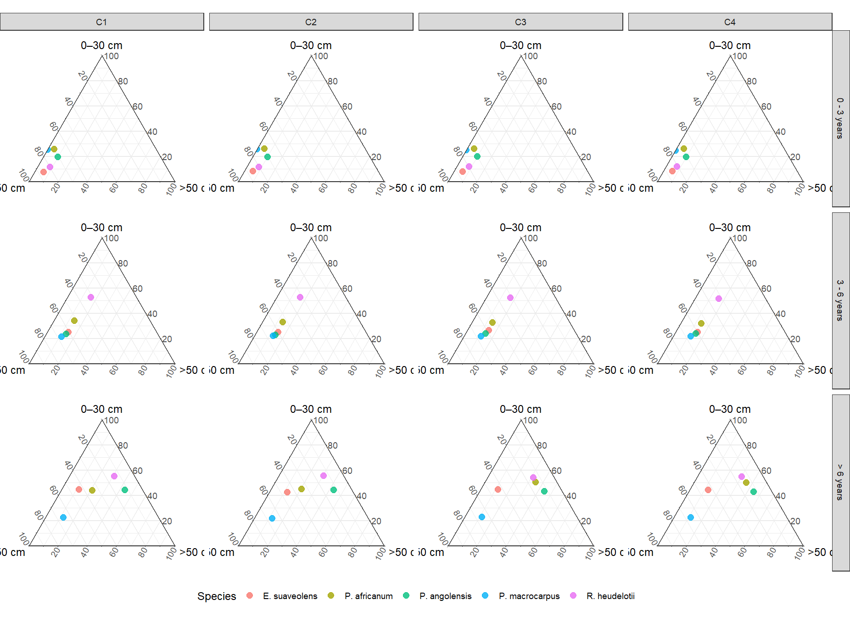
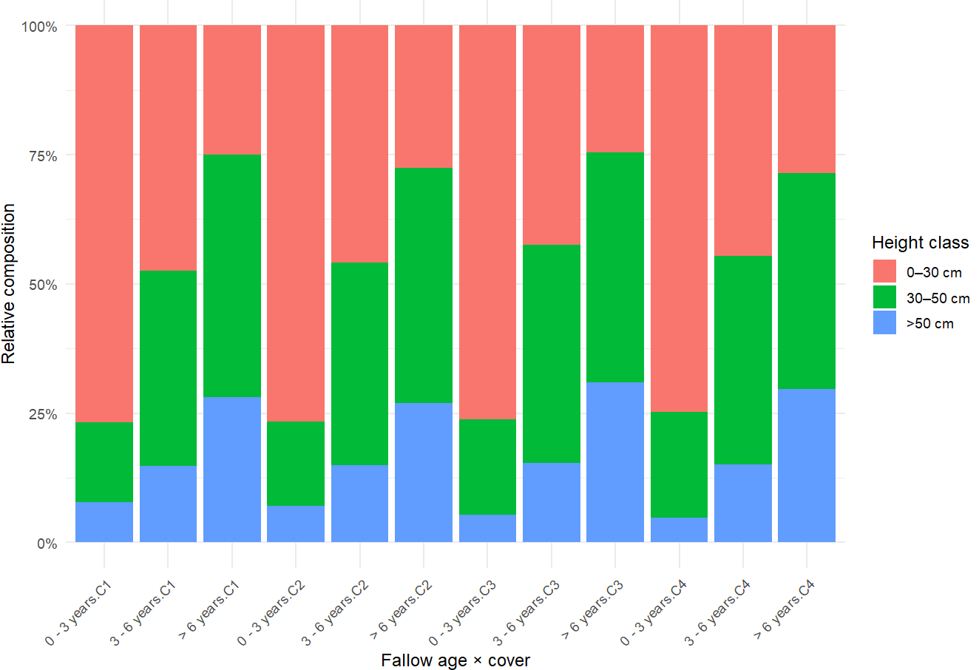
Figure S 4. Seedling size structure across fallow age and Chromolaena odorata cover gradients illustrated by ternary plots (top) and stacked bar charts (bottom), showing dominance of early-stage seedlings and reduced proportion of taller individuals under high invasion.

Text S2. Model diagnostics interpretation
Although statistical tests (e.g., dispersion and uniformity) indicated significant deviations, visual diagnostics showed that:
- deviations are moderate,
- model structure captures key ecological patterns,
- no violation critically affecting inference.
Such deviations are common in large ecological count datasets and do not invalidate model conclusions.

