Supplement Managing the unmanageable: Understanding the competing effects of salinity and nutrient loading on estuarine water quality
Marcus W Beck^{1,✉} (0000-0002-4996-0059), Edward T Sherwood¹ (0000-0001-5330-302X), Rebecca R Murphy² (0000-0003-3391-1823), Kerry Flaherty-Walia¹ (0000-0002-6032-0570), Qian Zhang² (0000-0003-0500-5655), Blake A Simmons¹ (0000-0002-1918-3463), and Maya C Burke¹ (0000-0002-3847-6501)
¹ Tampa Bay Estuary Program, 263 13th Ave S., Suite 350, St. Petersburg, Florida 33701 USA
² University of Maryland Center for Environmental Science/U.S. Environmental Protection Agency Chesapeake Bay Program, 1750 Forest Drive, Annapolis, Maryland 21401 USA
✉ Correspondence: Marcus W Beck <mbeck@tbep.org>

Figures
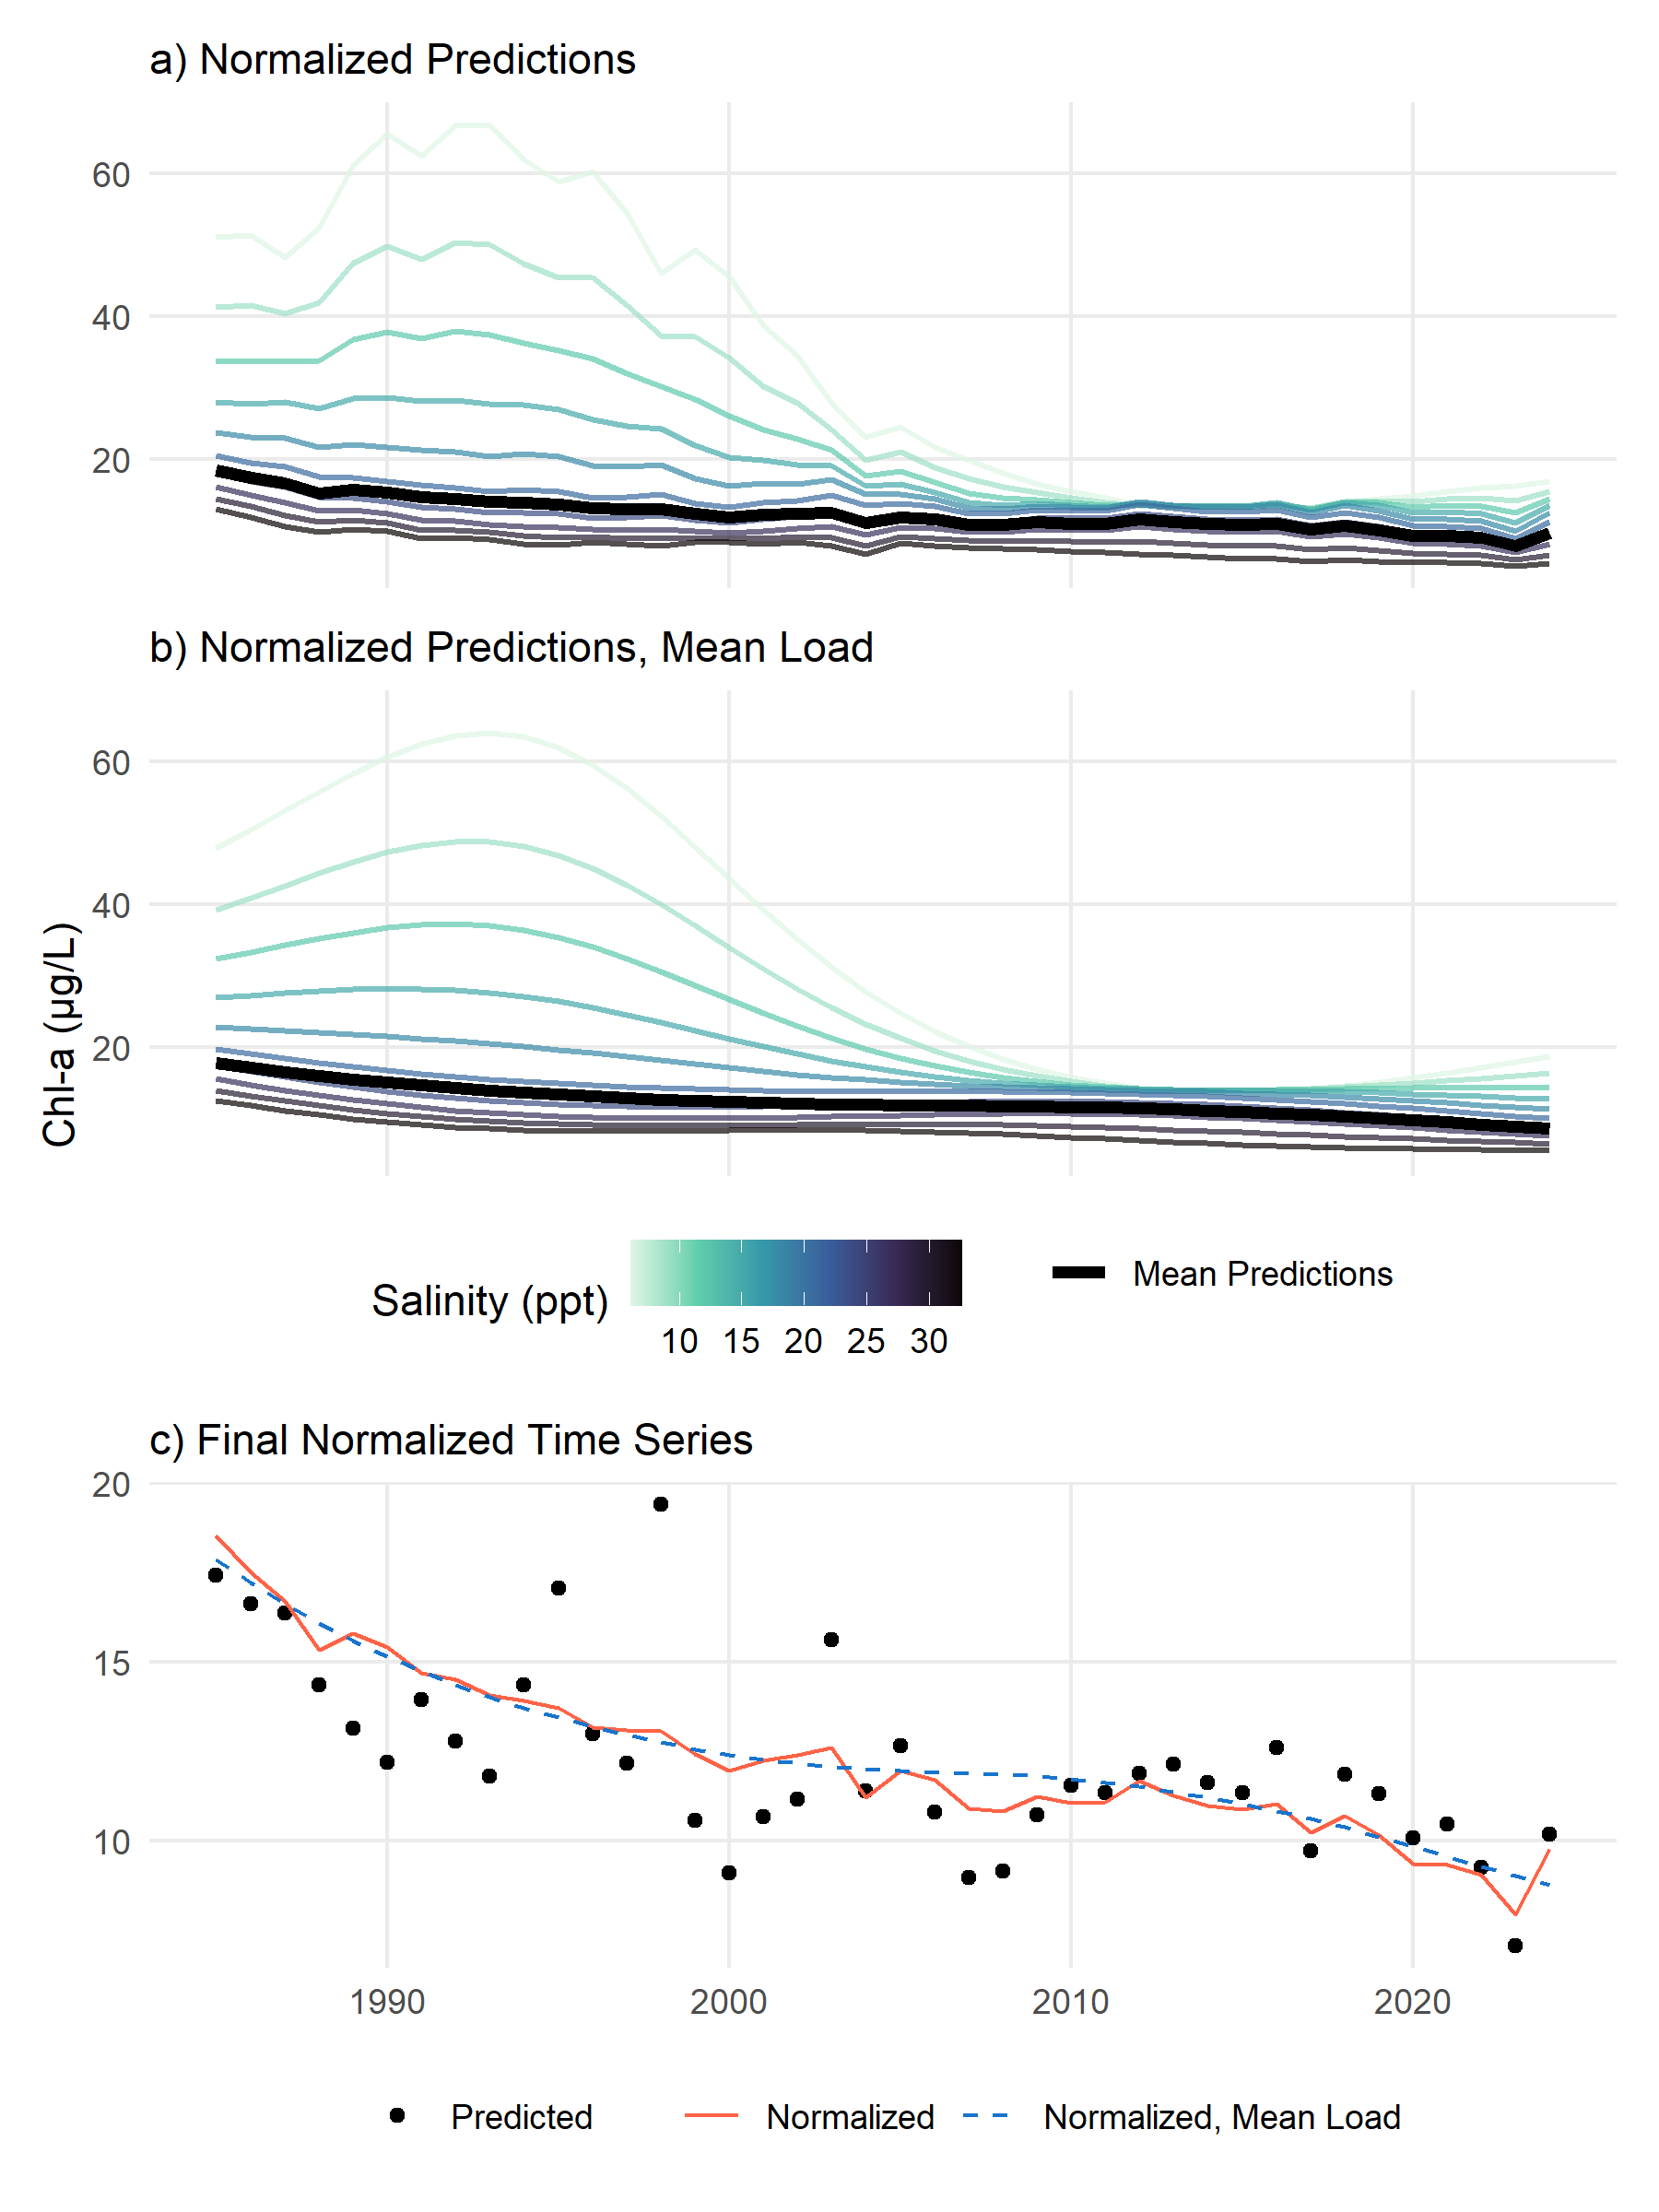
Fig. 1: Examples demonstrating the salinity normalization method (a), the salinity normalization method at mean loading (b), and the final results (c). Results are obtained by predicting chlorophyll-a concentrations from a fitted GAM across a range of salinities and estimating the average (a) or doing the same but using mean loading (b). The bottom plot (c) shows the normalized curves where the red line is the mean curve from (a), the blue dashed line is the mean curve from (b), and the points are the actual model predictions.

Tables
Table 1: Generalized Additive Model (GAM) summary statistics for chlorophyll-a predictions by bay segment in Tampa Bay (n = 480 for each). Results are shown for models with different total nitrogen loading lags, whether salinity or loading were corrected for seasonality, and constraints on the number of smoothers (K) for time, loading, and salinity (flexible or fixed). Loads were evaluated as cumulative sums for the current month up to a three month lag. Results for the overall model fit are shown with the Generalized Cross-Validation (GCV) scores in the top rows and deviance explained (Dev. Expl.) in the bottom rows. OTB: Old Tampa Bay; HB: Hillsborough Bay; MTB: Middle Tampa Bay; LTB: Lower Tampa Bay.
 |  |  | No Seasonal Correction |  | Seasonal Correction
Summary | Bay Segment | TN Load Lag | Flexible K | Fixed K | Flexible K | Fixed K
GCV
 | OTB | None | 1159 | 1160 | 1162 | 1161
 |  | 1 | 1157 | 1157 | 1162 | 1162
 |  | 2 | 1156 | 1157 | 1162 | 1162
 |  | 3 | 1157 | 1157 | 1161 | 1161
 | HB | None | 1347 | 1348 | 1356 | 1356
 |  | 1 | 1349 | 1349 | 1356 | 1356
 |  | 2 | 1348 | 1349 | 1351 | 1352
 |  | 3 | 1351 | 1352 | 1358 | 1357
 | MTB | None | 970 | 971 | 973 | 973
 |  | 1 | 967 | 968 | 970 | 970
 |  | 2 | 963 | 963 | 965 | 965
 |  | 3 | 960 | 960 | 959 | 959
 | LTB | None | 836 | 840 | 839 | 840
 |  | 1 | 839 | 840 | 836 | 837
 |  | 2 | 838 | 840 | 834 | 839
 |  | 3 | 830 | 832 | 828 | 828
Dev. Expl.
 | OTB | None | 0.74 | 0.74 | 0.74 | 0.74
 |  | 1 | 0.74 | 0.74 | 0.74 | 0.74
 |  | 2 | 0.75 | 0.75 | 0.74 | 0.74
 |  | 3 | 0.74 | 0.74 | 0.74 | 0.74
 | HB | None | 0.69 | 0.68 | 0.67 | 0.67
 |  | 1 | 0.69 | 0.69 | 0.69 | 0.69
 |  | 2 | 0.69 | 0.69 | 0.70 | 0.70
 |  | 3 | 0.68 | 0.68 | 0.67 | 0.68
 | MTB | None | 0.76 | 0.75 | 0.76 | 0.75
 |  | 1 | 0.75 | 0.75 | 0.76 | 0.75
 |  | 2 | 0.75 | 0.76 | 0.76 | 0.76
 |  | 3 | 0.76 | 0.76 | 0.77 | 0.77
 | LTB | None | 0.61 | 0.52 | 0.60 | 0.52
 |  | 1 | 0.60 | 0.55 | 0.55 | 0.55
 |  | 2 | 0.59 | 0.55 | 0.56 | 0.53
 |  | 3 | 0.61 | 0.57 | 0.57 | 0.57

Table 2: Concurvity estimates for the Old Tampa Bay Generalized Additive Models. Values range from 0 to 1 and assess the degree of multicollinearity among predictors. Results are shown for models with different total nitrogen loading lags, whether salinity or loading were corrected for seasonality, and constraints on the number of smoothers (K) for time, loading, and salinity (flexible or fixed). Loads were evaluated as cumulative sums for the current month up to a three month lag. Font size and shading are proportional among cells to emphasize differences.
Seasonal  Correction | K | TN Load Lag | s(dec_time) | s(doy) | s(sal) | s(tn_load) | ti(dec_time,doy) | ti(dec_time,sal) | ti(sal,doy) | ti(dec_time,tn_load) | ti(tn_load,doy) | ti(tn_load,sal)
No | Flexible | None | 0.87 | 0.67 | 0.97 | 0.97 | 0.57 | 0.58 | 0.62 | 0.60 | 0.78 | 0.66
 |  | 1 | 0.84 | 0.68 | 0.98 | 0.97 | 0.61 | 0.61 | 0.70 | 0.60 | 0.83 | 0.69
 |  | 2 | 0.85 | 0.66 | 0.98 | 0.98 | 0.63 | 0.64 | 0.73 | 0.63 | 0.84 | 0.70
 |  | 3 | 0.87 | 0.65 | 0.99 | 0.99 | 0.63 | 0.69 | 0.74 | 0.72 | 0.83 | 0.78
 | Fixed | None | 0.97 | 0.62 | 0.98 | 0.97 | 0.54 | 0.53 | 0.59 | 0.61 | 0.79 | 0.68
 |  | 1 | 0.90 | 0.63 | 0.98 | 0.97 | 0.59 | 0.56 | 0.66 | 0.59 | 0.84 | 0.69
 |  | 2 | 0.88 | 0.61 | 0.98 | 0.98 | 0.60 | 0.60 | 0.70 | 0.63 | 0.84 | 0.70
 |  | 3 | 0.87 | 0.62 | 0.98 | 0.99 | 0.63 | 0.65 | 0.72 | 0.70 | 0.84 | 0.77
Yes | Flexible | None | 0.94 | 0.55 | 0.97 | 0.92 | 0.41 | 0.78 | 0.56 | 0.55 | 0.62 | 0.53
 |  | 1 | 0.90 | 0.52 | 0.97 | 0.91 | 0.43 | 0.79 | 0.57 | 0.52 | 0.61 | 0.53
 |  | 2 | 0.81 | 0.48 | 0.95 | 0.90 | 0.43 | 0.79 | 0.56 | 0.57 | 0.61 | 0.58
 |  | 3 | 0.81 | 0.42 | 0.95 | 0.88 | 0.43 | 0.79 | 0.53 | 0.60 | 0.58 | 0.58
 | Fixed | None | 0.97 | 0.53 | 0.98 | 0.93 | 0.43 | 0.61 | 0.55 | 0.59 | 0.64 | 0.62
 |  | 1 | 0.96 | 0.51 | 0.97 | 0.91 | 0.45 | 0.60 | 0.56 | 0.52 | 0.59 | 0.54
 |  | 2 | 0.92 | 0.47 | 0.96 | 0.89 | 0.46 | 0.60 | 0.55 | 0.57 | 0.59 | 0.57
 |  | 3 | 0.85 | 0.48 | 0.95 | 0.91 | 0.46 | 0.59 | 0.53 | 0.57 | 0.58 | 0.54

Table 3: Concurvity estimates for the Hillsborough Bay Generalized Additive Models. Values range from 0 to 1 and assess the degree of multicollinearity among predictors. Results are shown for models with different total nitrogen loading lags, whether salinity or loading were corrected for seasonality, and constraints on the number of smoothers (K) for time, loading, and salinity (flexible or fixed). Loads were evaluated as cumulative sums for the current month up to a three month lag. Font size and shading are proportional among cells to emphasize differences.
Seasonal  Correction | K | TN Load Lag | s(dec_time) | s(doy) | s(sal) | s(tn_load) | ti(dec_time,doy) | ti(dec_time,sal) | ti(sal,doy) | ti(dec_time,tn_load) | ti(tn_load,doy) | ti(tn_load,sal)
No | Flexible | None | 0.88 | 0.63 | 0.98 | 0.99 | 0.45 | 0.67 | 0.71 | 0.71 | 0.84 | 0.85
 |  | 1 | 0.89 | 0.63 | 0.99 | 0.99 | 0.48 | 0.79 | 0.77 | 0.84 | 0.87 | 0.93
 |  | 2 | 0.96 | 0.62 | 0.99 | 0.99 | 0.51 | 0.78 | 0.79 | 0.82 | 0.85 | 0.93
 |  | 3 | 0.93 | 0.64 | 0.99 | 0.99 | 0.56 | 0.75 | 0.79 | 0.80 | 0.84 | 0.89
 | Fixed | None | 0.98 | 0.59 | 0.98 | 0.99 | 0.45 | 0.65 | 0.70 | 0.74 | 0.85 | 0.88
 |  | 1 | 0.97 | 0.58 | 0.99 | 0.98 | 0.48 | 0.76 | 0.78 | 0.86 | 0.88 | 0.93
 |  | 2 | 0.97 | 0.59 | 0.99 | 0.99 | 0.53 | 0.76 | 0.79 | 0.84 | 0.86 | 0.93
 |  | 3 | 0.97 | 0.60 | 0.98 | 0.99 | 0.55 | 0.74 | 0.79 | 0.80 | 0.85 | 0.91
Yes | Flexible | None | 0.97 | 0.52 | 0.95 | 0.94 | 0.41 | 0.73 | 0.48 | 0.50 | 0.62 | 0.55
 |  | 1 | 0.91 | 0.50 | 0.95 | 0.97 | 0.44 | 0.75 | 0.52 | 0.66 | 0.74 | 0.69
 |  | 2 | 0.94 | 0.50 | 0.96 | 0.96 | 0.47 | 0.75 | 0.56 | 0.68 | 0.71 | 0.70
 |  | 3 | 0.96 | 0.50 | 0.97 | 0.96 | 0.50 | 0.77 | 0.60 | 0.70 | 0.72 | 0.72
 | Fixed | None | 0.98 | 0.52 | 0.98 | 0.96 | 0.43 | 0.58 | 0.48 | 0.57 | 0.62 | 0.56
 |  | 1 | 0.95 | 0.50 | 0.97 | 0.96 | 0.47 | 0.60 | 0.52 | 0.68 | 0.73 | 0.71
 |  | 2 | 0.96 | 0.51 | 0.97 | 0.94 | 0.49 | 0.60 | 0.56 | 0.71 | 0.74 | 0.70
 |  | 3 | 0.98 | 0.50 | 0.98 | 0.92 | 0.51 | 0.61 | 0.61 | 0.70 | 0.74 | 0.72

Table 4: Concurvity estimates for the Middle Tampa Bay Generalized Additive Models. Values range from 0 to 1 and assess the degree of multicollinearity among predictors. Results are shown for models with different total nitrogen loading lags, whether salinity or loading were corrected for seasonality, and constraints on the number of smoothers (K) for time, loading, and salinity (flexible or fixed). Loads were evaluated as cumulative sums for the current month up to a three month lag. Font size and shading are proportional among cells to emphasize differences.
Seasonal  Correction | K | TN Load Lag | s(dec_time) | s(doy) | s(sal) | s(tn_load) | ti(dec_time,doy) | ti(dec_time,sal) | ti(sal,doy) | ti(dec_time,tn_load) | ti(tn_load,doy) | ti(tn_load,sal)
No | Flexible | None | 0.98 | 0.68 | 0.98 | 0.97 | 0.54 | 0.67 | 0.60 | 0.74 | 0.82 | 0.75
 |  | 1 | 0.91 | 0.67 | 0.98 | 0.98 | 0.59 | 0.72 | 0.68 | 0.74 | 0.85 | 0.80
 |  | 2 | 0.87 | 0.67 | 0.97 | 0.98 | 0.59 | 0.74 | 0.71 | 0.70 | 0.83 | 0.76
 |  | 3 | 0.86 | 0.65 | 0.97 | 0.98 | 0.59 | 0.76 | 0.72 | 0.69 | 0.79 | 0.78
 | Fixed | None | 0.99 | 0.61 | 0.98 | 0.97 | 0.55 | 0.58 | 0.59 | 0.76 | 0.83 | 0.78
 |  | 1 | 0.97 | 0.61 | 0.98 | 0.97 | 0.58 | 0.64 | 0.66 | 0.76 | 0.86 | 0.81
 |  | 2 | 0.93 | 0.61 | 0.98 | 0.98 | 0.59 | 0.69 | 0.70 | 0.69 | 0.83 | 0.76
 |  | 3 | 0.90 | 0.61 | 0.98 | 0.99 | 0.59 | 0.71 | 0.71 | 0.68 | 0.80 | 0.76
Yes | Flexible | None | 0.98 | 0.61 | 0.97 | 0.94 | 0.39 | 0.76 | 0.49 | 0.65 | 0.66 | 0.55
 |  | 1 | 0.93 | 0.56 | 0.93 | 0.96 | 0.40 | 0.77 | 0.51 | 0.63 | 0.66 | 0.57
 |  | 2 | 0.90 | 0.52 | 0.94 | 0.96 | 0.42 | 0.78 | 0.53 | 0.62 | 0.66 | 0.64
 |  | 3 | 0.84 | 0.46 | 0.92 | 0.96 | 0.43 | 0.79 | 0.55 | 0.69 | 0.67 | 0.67
 | Fixed | None | 0.99 | 0.56 | 0.98 | 0.94 | 0.43 | 0.58 | 0.50 | 0.73 | 0.73 | 0.66
 |  | 1 | 0.96 | 0.53 | 0.94 | 0.93 | 0.45 | 0.61 | 0.52 | 0.66 | 0.66 | 0.58
 |  | 2 | 0.96 | 0.51 | 0.95 | 0.92 | 0.45 | 0.61 | 0.52 | 0.61 | 0.66 | 0.59
 |  | 3 | 0.88 | 0.47 | 0.92 | 0.95 | 0.46 | 0.62 | 0.55 | 0.67 | 0.67 | 0.62

Table 5: Concurvity estimates for the Lower Tampa Bay Generalized Additive Models. Values range from 0 to 1 and assess the degree of multicollinearity among predictors. Results are shown for models with different total nitrogen loading lags, whether salinity or loading were corrected for seasonality, and constraints on the number of smoothers (K) for time, loading, and salinity (flexible or fixed). Loads were evaluated as cumulative sums for the current month up to a three month lag. Font size and shading are proportional among cells to emphasize differences.
Seasonal  Correction | K | TN Load Lag | s(dec_time) | s(doy) | s(sal) | s(tn_load) | ti(dec_time,doy) | ti(dec_time,sal) | ti(sal,doy) | ti(dec_time,tn_load) | ti(tn_load,doy) | ti(tn_load,sal)
No | Flexible | None | 0.92 | 0.66 | 0.95 | 0.96 | 0.53 | 0.72 | 0.64 | 0.61 | 0.76 | 0.69
 |  | 1 | 0.84 | 0.67 | 0.91 | 0.97 | 0.61 | 0.74 | 0.69 | 0.65 | 0.79 | 0.67
 |  | 2 | 0.80 | 0.65 | 0.91 | 0.97 | 0.63 | 0.74 | 0.71 | 0.62 | 0.76 | 0.66
 |  | 3 | 0.77 | 0.65 | 0.91 | 0.96 | 0.63 | 0.77 | 0.72 | 0.63 | 0.76 | 0.68
 | Fixed | None | 0.98 | 0.61 | 0.96 | 0.95 | 0.53 | 0.65 | 0.65 | 0.64 | 0.79 | 0.70
 |  | 1 | 0.91 | 0.62 | 0.92 | 0.98 | 0.61 | 0.68 | 0.69 | 0.65 | 0.80 | 0.69
 |  | 2 | 0.85 | 0.62 | 0.90 | 0.97 | 0.62 | 0.70 | 0.71 | 0.61 | 0.76 | 0.66
 |  | 3 | 0.82 | 0.61 | 0.90 | 0.97 | 0.62 | 0.71 | 0.71 | 0.64 | 0.77 | 0.70
Yes | Flexible | None | 0.93 | 0.57 | 0.94 | 0.95 | 0.37 | 0.72 | 0.46 | 0.57 | 0.65 | 0.57
 |  | 1 | 0.90 | 0.52 | 0.90 | 0.96 | 0.39 | 0.73 | 0.48 | 0.62 | 0.66 | 0.61
 |  | 2 | 0.90 | 0.49 | 0.89 | 0.97 | 0.39 | 0.73 | 0.45 | 0.63 | 0.72 | 0.63
 |  | 3 | 0.93 | 0.47 | 0.89 | 0.96 | 0.42 | 0.74 | 0.46 | 0.67 | 0.69 | 0.65
 | Fixed | None | 0.98 | 0.55 | 0.94 | 0.96 | 0.41 | 0.61 | 0.47 | 0.67 | 0.71 | 0.63
 |  | 1 | 0.97 | 0.52 | 0.95 | 0.96 | 0.43 | 0.63 | 0.49 | 0.63 | 0.69 | 0.66
 |  | 2 | 0.95 | 0.49 | 0.87 | 0.97 | 0.42 | 0.66 | 0.46 | 0.64 | 0.72 | 0.63
 |  | 3 | 0.95 | 0.49 | 0.87 | 0.97 | 0.43 | 0.67 | 0.47 | 0.65 | 0.68 | 0.65

