Supporting information for:

Engineering antiferromagnetic exchange coupling for single-pulse all-optical switching
Guanqi Li,^{1, †} Jiajun Li,^{1, †} Zihai Li,¹ Wei Xia,¹ Junlin Wang,^{1, *} Jing Wu,^{1, 2, *} Xujie Yang,² Zhendong Chen,^{1,} * Tiejun Zhou³, Bo Liu³，Roy Chantrell^{1,2} and Yongbing Xu^{1,2,4, *}
- School of Integrated Circuits, Guangdong University of Technology, Guangzhou 510006, China
- School of Physics, Engineering and Technology, University of York, York, YO10 5DD, United Kingdom
- State Key Laboratory for Spintronic Devices and Technologies, Hangzhou 311305, China
- National Key Laboratory of Spintronics, Nanjing University, Suzhou, China
†These authors contributed equally to this work.
*Corresponding authors, E-mail: junlin.wang@gdut.edu.cn; jing.wu@gdut.edu.cn; chenzd0105@gdut.edu.cn; yongbing.xu@york.ac.uk

Section 1. Interfacial Mixing and Its Effect on Co–Gd Antiferromagnetic Exchange

Section 2. First-Principles Calculation of Interlayer Exchange Coupling in Co–Gd

Section 3. Results of X-ray Magnetic Circular Dichroism measurements

Section 4. Single-pulse all-optical switching (SP-AOS) Experimental setup

Section 5. Calculation of the Switching Ratio in SP-AOS

Section 6. Atomic Spin Model Evaluation of SP-AOS Switching Ratios and Temperature-Dependent Magnetization (M–T) Curves

Section 1. Interfacial Mixing and Its Effect on Co–Gd Antiferromagnetic Exchange
High-resolution Transmission Electron Microscopy (TEM) imaging of the Pt/Co/Ru/Gd/Pt multilayers reveals that the Co/Ru/Gd interfaces are not atomically abrupt but instead contain transition regions (Fig. S1a). STEM–EDS elemental maps further confirm significant spatial overlap among Co, Ru, and Gd near the interface (Fig. S1b), indicating pronounced atomic interdiffusion during sputter growth. Additional structural evidence arises from X-ray Diffraction (XRD) measurements: as shown in Fig. S1c, a distinct GdRu₂ diffraction peak appears at 2θ ≈ 30°, verifying the formation of a mixed Ru–Gd intermetallic phase. These results collectively demonstrate that substantial chemical mixing occurs at the Co/Ru/Gd interfaces.
The presence of interfacial mixing has important implications for the effective Co–Gd exchange coupling. In an ideal, atomically sharp Ru/Gd interface, only the monolayer of Gd atoms directly adjacent to Ru can participate in the RKKY-mediated coupling with Co, whereas the deeper Gd atoms do not interact with Co. When intermixing is present, however, Gd atoms within the Ru–Gd mixed region are brought into the effective exchange range of Co. As a result, a larger fraction of Gd atoms contributes to the Co–Gd magnetic interaction. This increase in the number of Gd atoms participating in the exchange effectively strengthens the overall antiferromagnetic Co–Gd coupling in the real sputtered multilayers (Fig. S1d).
DFT calculations incorporating a Ru–Gd mixed layer support this interpretation. At certain Ru thicknesses, the calculated Co–Gd antiferromagnetic exchange energy is significantly stronger than that of an ideal abrupt interface, in agreement with the experimentally observed enhancement of coercivity and Gd magnetization at Ru ≈ 0.8 nm.
Together, the TEM/EDS/XRD characterizations and DFT calculations confirm that interfacial mixing plays a central role in enhancing the effective Co–Gd antiferromagnetic exchange, which is essential for interpreting the Ru-thickness-dependent magnetic behavior discussed in the main text.
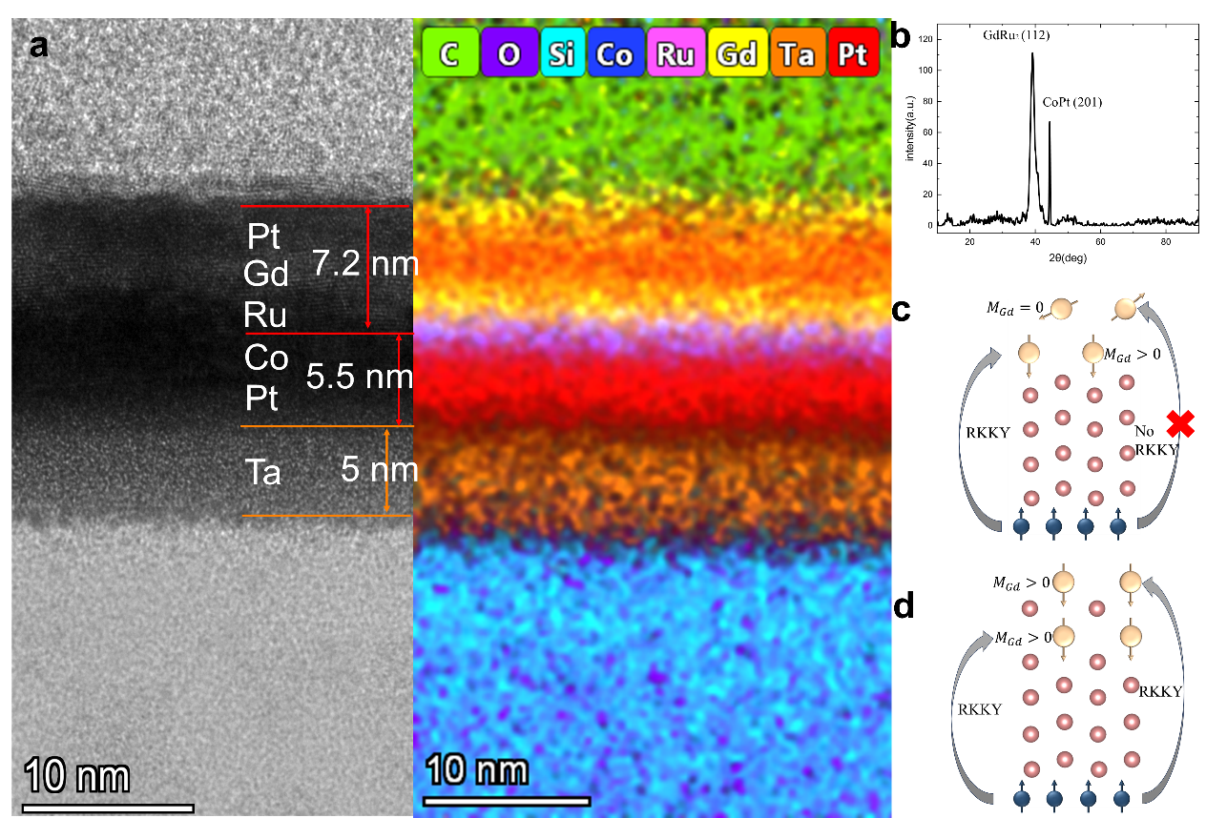
Figure S1 | a, TEM image of the sample Si/Ta (5 nm)/Pt (4 nm)/Co (1.5 nm)/Ru (0.8 nm)/Gd (3 nm)/Pt (2 nm) b, XRD pattern of the Co/Ru/Gd sample. c, Schematic illustration showing that, in the absence of Gd–Ru interfacial mixing, the RKKY interaction induces magnetic moments only in the Gd atoms adjacent to the interface. d, When Gd–Ru interfacial mixing is present, the RKKY interaction can induce magnetic moments in both the mixed-phase Gd atoms and those located at the Gd–Ru interface.

Section 2. First-Principles Calculation of Interlayer Exchange Coupling in Co–Gd
All first-principles calculations were performed using VASP within the framework of the projector augmented-wave (PAW) method and the generalized gradient approximation (GGA) of Perdew–Burke–Ernzerhof (PBE)¹ for the exchange–correlation functional.
A plane-wave energy cutoff of 400 eV was used. Electronic self-consistency was achieved with a convergence criterion of 10⁻⁸ eV for the total energy. The Brillouin zone was sampled using a Γ-centered Monkhorst–Pack mesh corresponding to a k-point spacing of 0.030 Å⁻¹, which yields a 3×7×1 k-point grid for the in-plane supercell.
The supercell model contained five atomic layers of Co and seven atomic layers of Gd, separated by a Ru spacer. In total, 68 magnetic atoms were considered. To correctly capture the localized nature of Gd-4f states and the itinerant character of Co-3d states, we applied the LDA+U correction (Dudarev scheme) with effective on-site interactions U_{eff}(Co-3d) = 2.5 eV and U_{eff} ​(Gd-4f) = 6 eV, respectively. The projection cutoff for the charge density mixing was set to LMAXMIX=6 to ensure numerical stability of 4f states.
The atomic positions were relaxed until the Hellmann–Feynman forces were smaller than 1×10⁻³ eV/Å. During relaxation, the in-plane lattice constants were fixed, while ionic positions were allowed to relax along the out-of-plane direction. After relaxation, a preconvergence static run (NSW=0, IBRION=-1) was carried out to obtain a stable electronic charge density, wave functions, and spin distribution without SOC.
SOC was explicitly included in subsequent static calculations. The orbital moments were evaluated. To probe the interfacial exchange coupling between Co and Gd layers, we imposed constrained local moments on selected atoms using the penalty functional. The initial magnetic moments were assigned as approximately +2 $μ_{B}$​ for Co and ±7 $μ_{B}$ for Gd, with the sign chosen according to the ferromagnetic FM or AFM alignment. The exchange energy was then extracted from the total energy difference between FM and AFM configurations:
$$∆E= E_{AFM}-E_{FM}$$
A negative ΔE corresponds to a stable antiferromagnetic coupling, while a positive ΔE favors ferromagnetism.
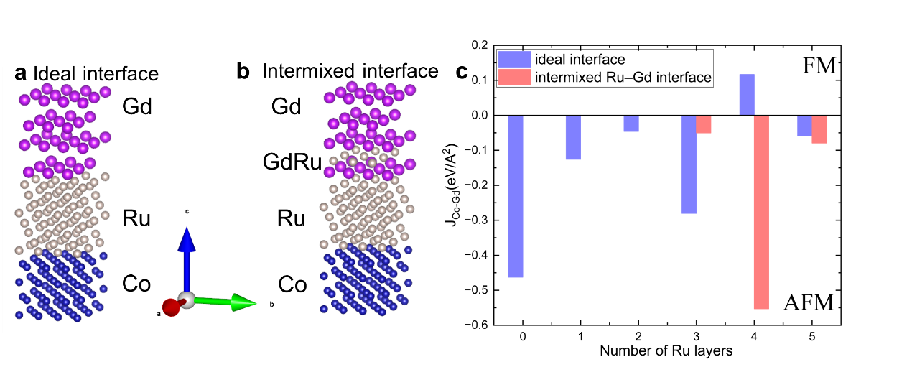
Figure S2| Effect of interfacial mixing on Co–Gd antiferromagnetic exchange coupling. a, Atomistic model of an ideal, atomically sharp Co/Ru/Gd interface used in the DFT calculations. b, Model of an intermixed Co/Ru/Gd interface, in which atomic interdiffusion generates a Ru–Gd mixed region. c, DFT-calculated Co–Gd interlayer exchange coupling as a function of Ru thickness. Red bars correspond to the ideal interface model, while blue bars represent the intermixed interface. Interfacial mixing enhances the effective Co–Gd antiferromagnetic exchange at several Ru thicknesses, in agreement with experimental observations.

Section 3. Results of X-ray Magnetic Circular Dichroism (XMCD) measurements
XMCD is an element-specific technique used to probe the local electronic character of the magnetic ground state ²⁻⁴. X-ray absorption spectra (XAS) at the Gd M4,5 edges (3d →4f) of Co/Ru/Gd thin films were measured at room temperature with a magnetic field of 500 Oe on beamline BL07U at Shanghai Synchrotron Radiation Facility (SSRF). The degree of circular polarization of the x-ray beam in the energy region of interest is close to 100%. XAS measurements were made in the total-electron yield (TEY) mode, which is surface sensitive with an exponentially decreasing probing depth of ∼6nm ⁵. The XMCD is obtained from the difference between two XAS spectra recorded with the x-ray helicity vector antiparallel and parallel to the applied magnetic field.
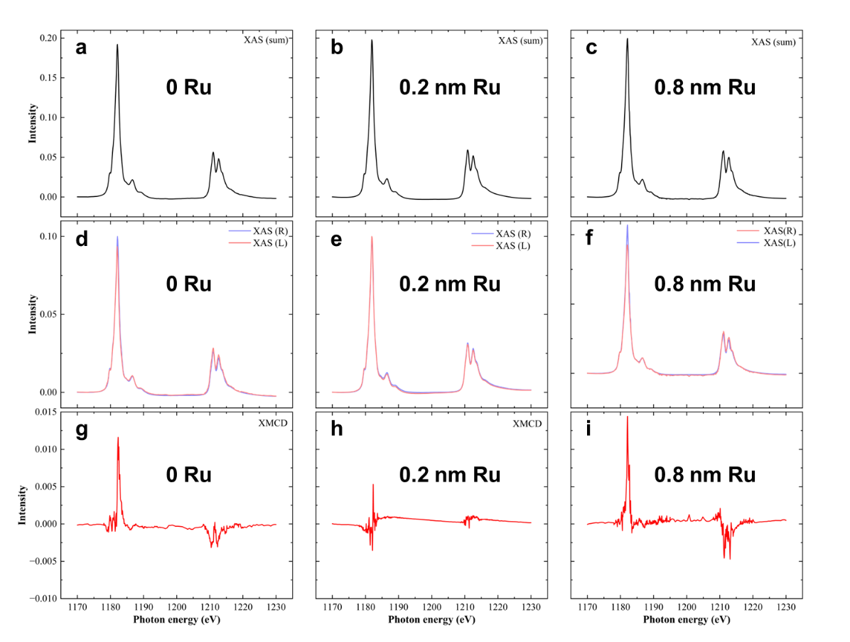
Figure S3 | Gd M-edge XAS and XMCD for Pt/Co/Ru/Gd/Pt multilayers with different Ru spacer thicknesses. a–c, Total X-ray absorption spectra at the Gd M_{4, 5} edges for Ru thicknesses of 0 nm (a), 0.2 nm (b) and 0.8 nm (c). d–f, Circularly polarized XAS measured with left- and right-circularly polarized light for the same three samples. g–i, Corresponding XMCD spectra obtained as the difference between the two helicities (μ⁺ − μ⁻) for Ru = 0 nm (g), 0.2 nm (h) and 0.8 nm (i). The strong evolution of the XMCD amplitude with Ru thickness reflects the Ru-induced modulation of the induced Gd magnetic moment and thus of the Co–Gd interlayer antiferromagnetic coupling.

Section 4. Single-pulse all-optical switching (SP-AOS) Experimental setup
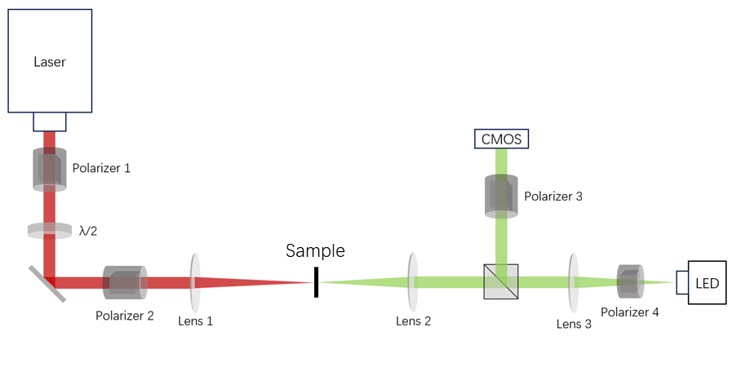
Figure S4 | Schematic of the experimental setup for SP-AOS. A Ti:sapphire femtosecond laser was used as the excitation source. The pulse energy was controlled by a pair of polarizers with a half-wave plate between them, and the beam was focused onto the sample by a lens to a spot size of approximately 20 µm. The transmitted light was analyzed by a polarizer and recorded by a CMOS camera for MOKE imaging.

Section 5. Calculation of the Switching Ratio, energy threshold and energy window in SP-AOS
- Switching Ratio
To quantitatively evaluate SP-AOS ratio under single-pulse excitation, a pixel-based analysis was performed on MOKE images before and after laser illumination. Two MOKE images were recorded from the same region of the sample: one before laser irradiation (initial magnetic state Fig S8. a) and one after a single laser pulse (excited state Fig S8. b). The two images were first aligned using a sub-pixel image registration algorithm to remove spatial drift and optical distortion. A subtracted image (Fig S8. c) was then generated by pixel-wise subtraction of the two aligned images, followed by normalization of brightness to suppress background variation and enhance magnetic contrast.
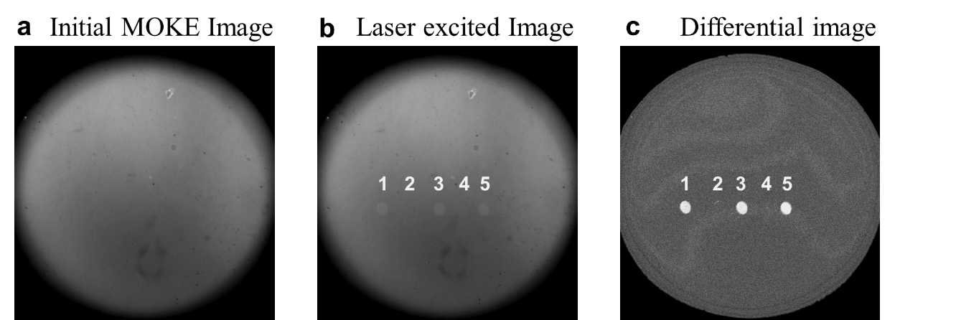
Figure S5 | MOKE images before and after single-pulse laser irradiation and their corresponding difference image. The numbers in the image indicate the number of laser pulses. a, Initial MOKE image before laser excitation. b, MOKE image acquired after three single-pulse exposures. c, Difference image obtained by subtracting the initial MOKE image from the post-irradiation image, clearly revealing the laser-induced magnetic switching spots.
In the normalized subtracted image, a circular region of 25 μm × 25 μm centered on the laser-irradiated spot was selected as the analysis region, representing the area where magnetization reversal may occur. To eliminate the effect of inhomogeneous illumination, a reference region of the same size and shape was chosen adjacent to the laser spot but outside the illuminated area. The reference region was subjected to the same optical conditions yet remained in the initial magnetic state. The average brightness of the reference region was calculated and defined as the threshold $T$, which corresponds to the characteristic intensity of the non-switched (initially magnetized) state. Each pixel in the analysis region was classified according to its brightness relative to $T$: pixels brighter than $T$ were identified as non-switched, whereas those darker than $T$ were identified as switched. This classification reflects the correlation between pixel brightness in the subtracted MOKE image and the local magnetization direction.
Within the analysis region, the number of switched pixels $N_{switched}$ and the total number of pixels $N_{total}$ were counted. The AOS switching ratio $R$was then calculated as:
$$R=\frac{N_{switched}}{N_{total}}.$$
Here, $R$ represents the fraction of the illuminated area that has undergone magnetization reversal. Since the laser spot is not perfectly circular and the analysis region is slightly larger than the actual optical excitation area, the absolute values of $R$ may be lower than unity even under complete switching. To account for this, all measured $R$ values were linearly normalized between 0 and 1:
$$R_{norm}=\frac{R-R_{min}}{R_{max}-R_{min}},$$
where $R_{min}$ and $R_{max}$ are the minimum and maximum switching ratios obtained within a given dataset. The normalized switching ratio $R_{norm}$ thus reflects the relative degree of magnetization reversal and allows direct comparison between samples or excitation conditions.
- Energy threshold and energy window
This section describes the procedure used to determine the lower fluence threshold for SP-AOS. This threshold corresponds to the minimum peak fluence required to generate a stable, circular, and fully switched magnetic domain under the action of a single laser pulse.
1. Relation between laser pulse energy and peak fluence
The laser beam profile in the sample plane is well described by a two-dimensional Gaussian distribution:
$$F(r)=F_{0}exp⁡(-\frac{2r^{2}}{w^{2}}),$$
Where $F_{0}$ is the peak fluence at the beam center, and $w$ is the $1/e^{2}$ beam radius. The total pulse energy $E$ is related to the peak fluence $F_{0}$ by:
$$E=\frac{πw^{2}}{2}F_{0}.$$
In our experiment, the laser beam has a $1/e^{2}$radius of 12 micrometers. Converting the above relation into practical units yields the simplified expression:
$$F_{0}(mJ/cm^{2})≈0.442×E(nJ),$$
meaning that the peak fluence at the beam center (in mJ/cm²) is obtained by multiplying the pulse energy (in nJ) by 0.442. For each sample, we identify the lowest pulse energy $E_{min}$ at which SP-AOS is first observed. At this energy, we extract the radius $r_{sw}$of the switched domain from the MOKE images. The SP-AOS fluence threshold is defined as the local fluence at the boundary of the switched domain:
$$F_{th}=F_{0}exp⁡(-\frac{2r_{sw}^{2}}{w^{2}}),$$
Where $F_{0}=0.442×E_{min}$ is the peak fluence corresponding to the lowest energy at which SP-AOS occurs. Based on this expression, we measured the SP-AOS radius achieved at 7.5 nJ for each sample and calculated the corresponding lower fluence threshold for SP-AOS as follows:
1.8 mJ/cm² for the sample with Ru = 0.8 nm,
2.67 mJ/cm² for the sample with Ru = 0 nm,
2.97 mJ/cm² (18 nJ) for the sample with Ru = 1.5 nm and
3.14 mJ/cm² (15.5 nJ) for the sample with Ru = 1.3 nm.
In an ideal scenario, the upper fluence limit for SP-AOS is defined as the incident fluence at which the local fluence at the beam center first exceeds the SP-AOS operational window, leading to the appearance of a demagnetized core at the center of the Gaussian laser spot (where the fluence is maximal). This fluence would naturally be taken as the upper fluence limit of SP-AOS. However, due to the presence of partial switching in our samples, the onset of a demagnetized core cannot be unambiguously identified, and the upper fluence limit cannot be determined with strict numerical precision. Nevertheless, when the central fluence exceeds the SP-AOS operational range, the switching ratio begins to decrease from unity. We therefore define the upper energy for SP-AOS as the lowest pulse energy at which a reduction in switching ratio is first observed within the laser-exposed region.
Using this criterion, we find that the switching ratio begins to decrease at
9.72 mJ/cm² (22 nJ) for the sample with Ru = 0.8 nm,
7.96 mJ/cm² (18 nJ) for the sample with Ru = 0 nm,
7.96 mJ/cm² (18 nJ) for the sample with Ru = 1.5 nm and
6.88 mJ/cm² (15.5 nJ) for the sample with Ru = 1.3 nm.

Section 6. Atomic Spin Model Evaluation of SP-AOS Switching Ratios and Temperature-Dependent Magnetization (M–T) Curves
To further verify the experimentally observed role of the Co–Gd antiferromagnetic exchange coupling strength in determining the efficiency of SP-AOS, we performed atomistic spin-dynamics simulations. The simulations allow us to examine how varying the inter-sublattice AFM coupling modifies the ultrafast spin dynamics under femtosecond laser excitation.
We constructed 25 independent simulation cells, each representing a 50 nm × 50 nm region subjected to the same laser pulse. For every simulation, the system evolves independently, providing a statistical ensemble that reflects the spatial variation in experimental laser-induced switching.
The only parameter varied across the dataset is the strength of the Co–Gd antiferromagnetic exchange interaction; all other parameters—including lattice geometry, intrinsic magnetic moments, damping constant, and laser-pulse temporal profile—were kept fixed. In our parameterization, 100% coupling strength corresponds to J_{Gd−Gd}​=1.26×10−21 J/link, with all other coupling ratios scaled linearly from this reference value.
Each simulation cell was evaluated after the completion of the laser-induced demagnetization–remagnetization cycle to determine whether a magnetic reversal occurred. The switching probability, shown in Fig. S6, is defined as:
$$P_{switch}=\frac{N_{reversed}}{25},$$
where $N_{reversed}$is the number of simulation cells that exhibit complete magnetization reversal. This definition corresponds directly to the switching ratio measured experimentally using wide-field MOKE imaging.
By tuning the Co–Gd AFM exchange strength, we observe a clear, monotonic evolution of the switching probability: (1) Weak AFM coupling: The demagnetization dynamics are slow and spatially non-uniform. The system fails to enter the transient ferromagnetic state required for deterministic reversal. Switching probability is low and exhibits large statistical fluctuations. (2) Strong AFM coupling: Inter-sublattice angular-momentum exchange becomes more efficient. Demagnetization is faster and more coherent across simulation cells. Nearly all 25 systems switch, yielding switching probabilities approaching unity. The simulated trends match the experimentally observed dependence of SP-AOS switching ratio on Ru spacer thickness, demonstrating that the AFM exchange strength—not the structural parameter itself—is the fundamental control variable governing single-pulse switching.
The simulations show that strengthening the Co–Gd antiferromagnetic exchange accelerates inter-sublattice angular-momentum transfer, enabling the system to access the dynamical pathway that produces a transient ferromagnetic state. This state is essential for SP-AOS. In contrast, weak AFM coupling forces the system to rely on the slower, more dissipative SOC-mediated demagnetization channel, preventing the formation of a TFS and suppressing deterministic switching. Thus, the atomistic simulations quantitatively confirm that the Co–Gd AFM exchange strength is the key microscopic parameter governing the probability of single-shot all-optical switching.
Figure s6 | Relationship between antiferromagnetic coupling strength and the SP-AOS switching ratio from atomistic spin-model simulations.
The switching ratio is obtained by simulating the magnetization reversal under 25 successive laser pulses for systems with different interlayer antiferromagnetic coupling strengths. A monotonic increase in the switching ratio is observed with stronger AFM coupling, highlighting the crucial role of AFM-mediated angular-momentum transfer in enabling deterministic SP-AOS.
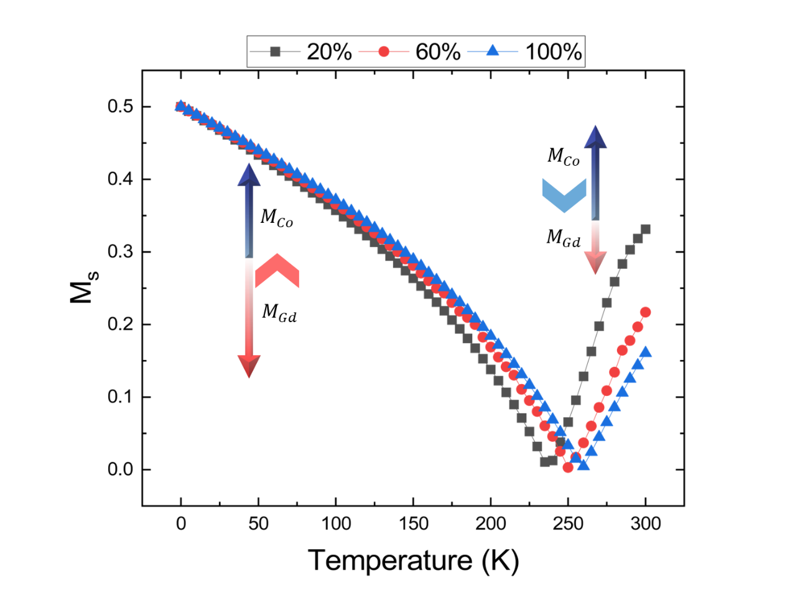
Figure s7 | M–T curves of Gd–Co systems with different antiferromagnetic coupling strengths obtained from atomistic spin-model simulations.
Temperature-dependent magnetization curves are calculated for Gd–Co bilayers with varying interlayer AFM coupling strengths. Stronger AFM coupling shifts the compensation point and modifies the relative sublattice contributions, reflecting the distinct thermal stability of the Co and Gd moments under different exchange conditions.

References
1 Perdew, J. P., Burke, K. & Ernzerhof, M. Generalized gradient approximation made simple. Physical review letters 77, 3865 (1996).
2 Funk, T., Deb, A., George, S. J., Wang, H. & Cramer, S. P. X-ray magnetic circular dichroism—a high energy probe of magnetic properties. Coordination Chemistry Reviews 249, 3-30 (2005).
3 Van der Laan, G. & Figueroa, A. I. X-ray magnetic circular dichroism—A versatile tool to study magnetism. Coordination Chemistry Reviews 277, 95-129 (2014).
4 Carra, P., Thole, B. T., Altarelli, M. & Wang, X. X-ray circular dichroism and local magnetic fields. Phys Rev Lett 70, 694-697 (1993). https://doi.org/10.1103/PhysRevLett.70.694
5 Thole, B. et al. 3d x-ray-absorption lines and the 3 d 9 4 f n+ 1 multiplets of the lanthanides. Physical Review B 32, 5107 (1985).

