SUPPLEMENTARY FIGURE

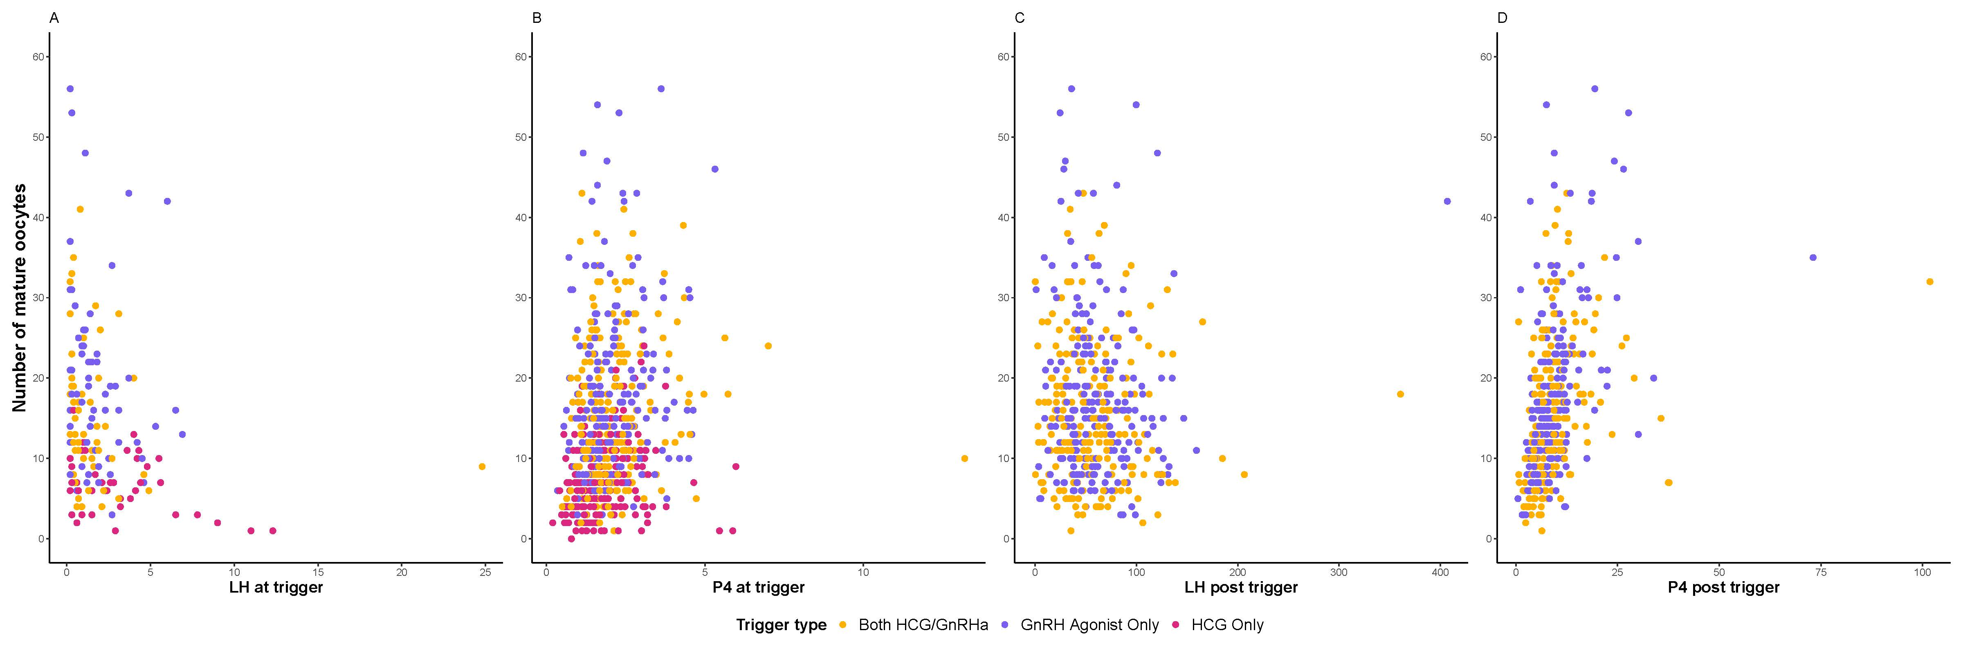
Supplementary Figure 1. Scatter plots demonstrating the relationships between LH (A) and P4 (B) levels on the day of trigger, and LH (C) and P4 (D) on the day following trigger with the number of mature oocytes retrieved by trigger type (HCG only, GnRH agonist only, both GnRH agonist/HCG).

