Bacterial alpha diversity index | Y1 | Y3 | Y6
ACE  Shannon  Simpson  Chao1 | 730.7409  6.6772  0.9715  729.7607 | 615.9202  6.0487  0.9245  614.8033 | 569.3164  6.2881  0.9584  568.2221
Fungal α-diversity index | Y1 | Y3 | Y6
ACE  Shannon  Simpson  Chao1 | 115.6510  2.3768  0.5911  116.5421 | 140.6770  3.4339  0.8128  141.8889 | 131.4937  3.1463  0.7740  129.0602

Table S1: α-diversity of endogenous microorganisms in roots

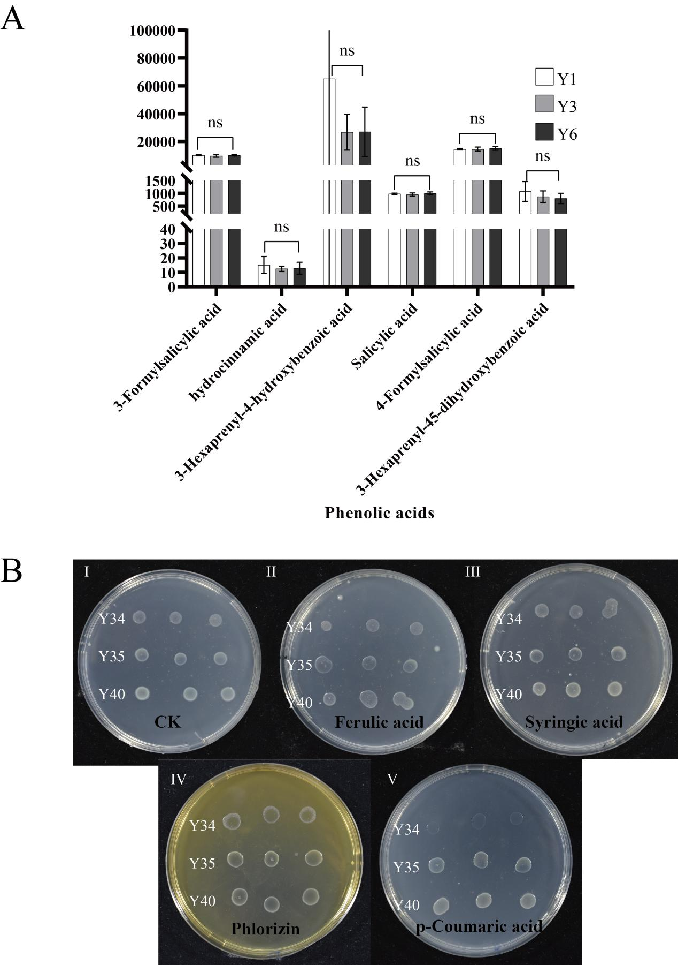

Figure S1: A. The content of various phenolic acids in the soil changed with the peak area of the continuous cropping years. B. The phenolic acid resistance of three PGPB was tested by plate experiment.

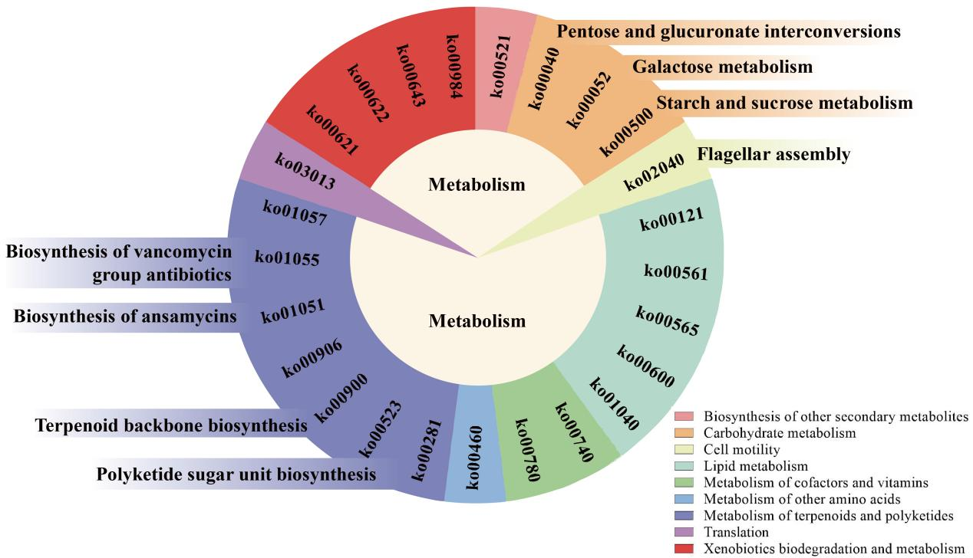
Figure S2: Compared with the initial planting of P. odoratum, the related functions of the significant decline of microorganisms in the rhizosphere of CCP were shown by KEGG pathway.

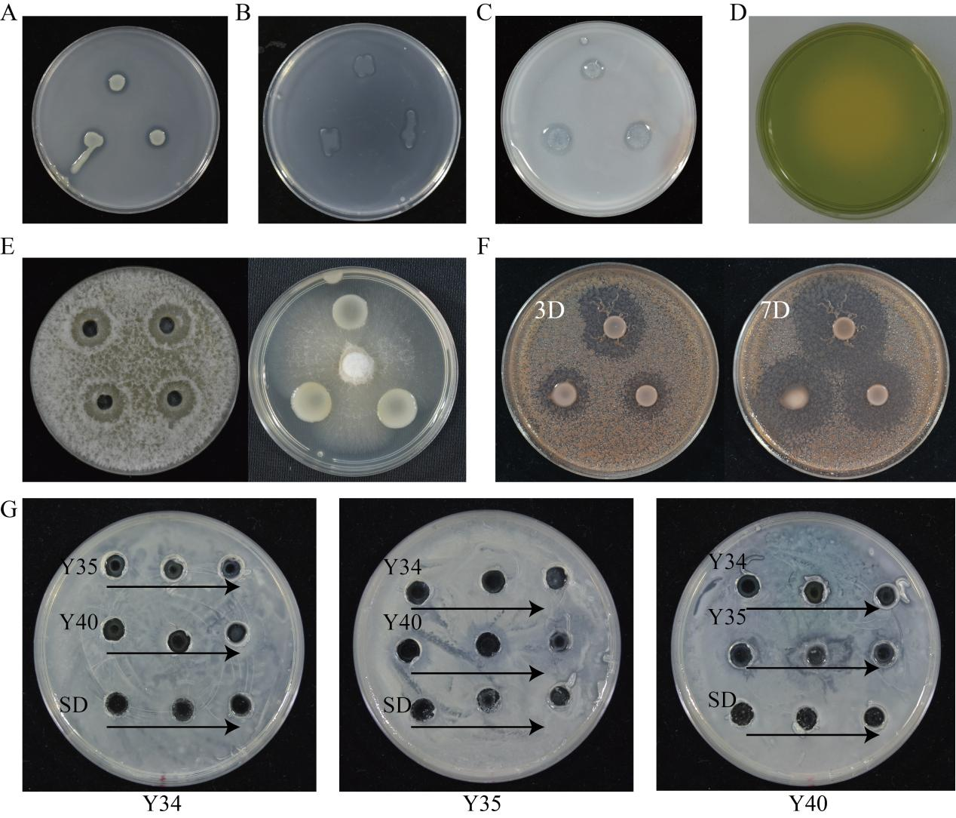

Figure S3: The results of the detection of the promoting characteristics of the separated microorganisms. A. Inorganic phosphorus-solubilizing activity. B. Organic phosph-solubilizing activity. C. Nitrogen-fixing activity. D. Potassium-solubilizing activity. E. Inhibition of Fusarium sp. spore germination mycelial growth. F. Inhibition of Ralstonia solanacearum growth G. Interference experiment among artificial synthetic microbial population

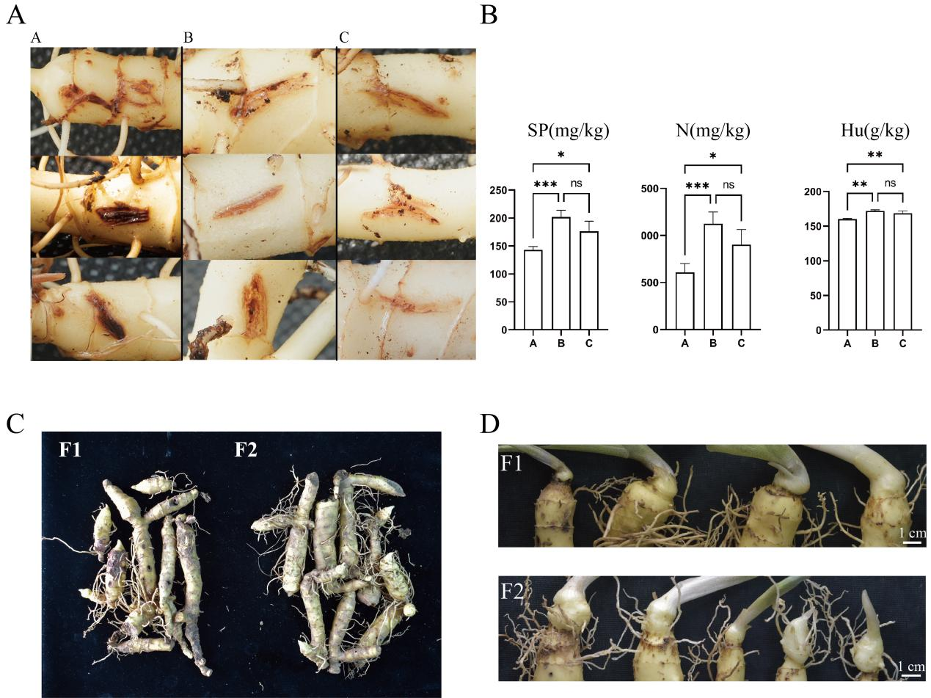

Figure S4: A. Comparison of the degree of wound healing of rhizomes in different treatment groups in the potted experiment. B. Comparison of soil in different treatment groups in the potted experiment. C. Comparison of the condition of rhizomes in different treatment groups in the field experiment. D. Comparison of the difference between newly born rhizomes and roots of rhizomes in different treatment groups in the field experiment.

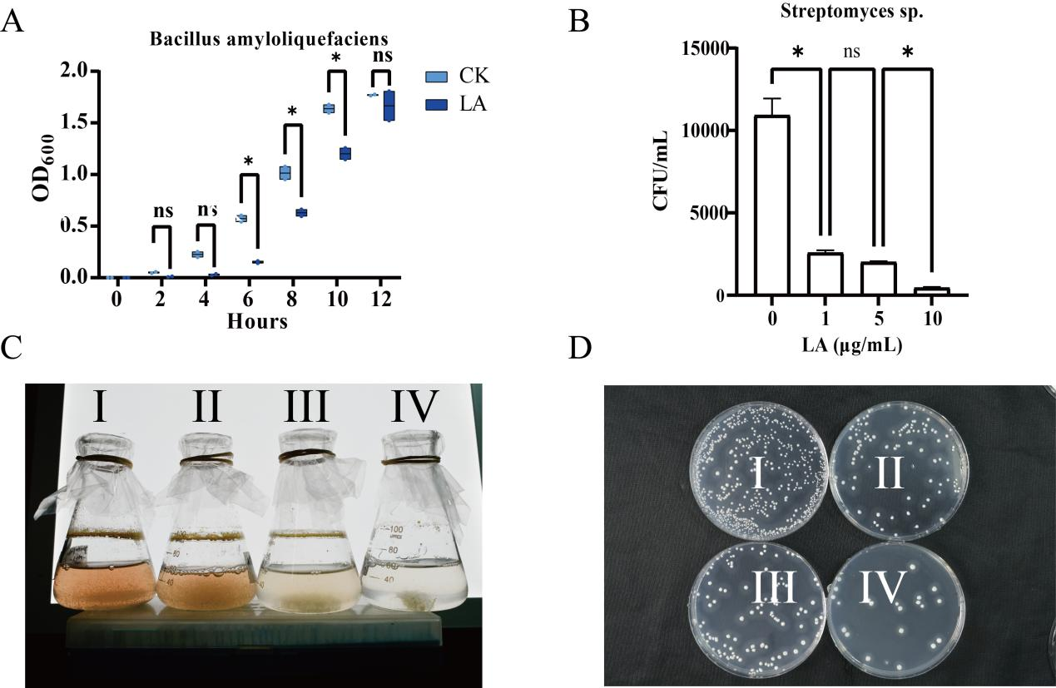

Figure S5: A. Effect of α-linolenyl alcohol on the growth curves of Bacillus amyloliquefaciens. B. Comparison of growth and spore germination rate of streptomyces after adding α-linolenyl alcohol. C, D. Effect of α-linolenyl alcohol on the growth of Streptomyces, from I to IV in order of increasing concentration.

