Cooperative shell softening effect for lithium-metal battery electrolytes
Hyun-Wook Lee,^{1†} Youngoh Kim,^{2,3†} Dong-Ha Kim,¹ Ho-Jeong Ji,¹ Hong-Bin Youn,¹ Hyo-Gyeong Kwon,¹ Seo-Young Park,¹ Hong-Geun Lee,¹ Sun-Phil Han,⁴ Joonmyung Choi⁵* and Won-Jin Kwak¹*

¹School of Energy and Chemical Engineering, UNIST, Ulsan, 44919, Republic of Korea
²Next-Generation Battery Research Center, Battery Research Division, Korea Electrotechnology Research Institute, Republic of Korea
³Electric Energy Materials Engineering, KERI School, University of Science and Technology, Republic of Korea
⁴Office of Research Facilities and Training, UNIST, Ulsan, 44919, Republic of Korea
⁵School of Mechanical Engineering, Sungkyunkwan University, Suwon 16419, Republic of Korea

e-mail: joonchoi@skku.edu; wjkwak@unist.ac.kr

Supplementary Fig. 1 Raman spectra of electrolytes in 680-900 cm⁻¹, and area for corresponding chemicals are assigned as boxes.

Supplementary Fig. 2 (a) ⁷Li, (b) ¹⁹F, and (c) ¹H NMR spectra of electrolytes. ⁷Li, ¹⁹F, and ¹H NMR are referenced to LiCl, hexafluorobenzene, and tetramethylsilane, respectively

Supplementary Fig. 3 Full H-H NOESY NMR spectra of (a) CE, (b) WSE, and (c) CSSE.

Supplementary Fig. 4 Full and enlarged H-H NOESY NMR spectra of electrolytes in different ratio of solvents. (a) DME:THP=2:1 vol % (2D1T) and (b) DME:THP=1:2 vol % (1D2T). 2D1T exhibits NOE shown in DE, which indicates THP does not participate in the solvation shell. In the case of 1D2T, NOE of the mixture is shown, implying that DME cannot participate in the solvation shell.

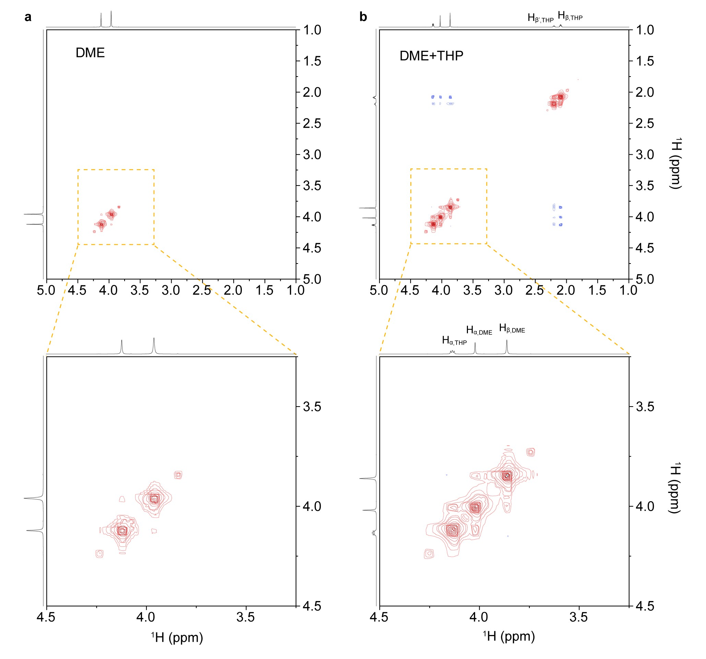
Supplementary Fig. 5 Full and enlarged H-H NOESY NMR spectra of solvents. (a) DME and (b) DME:THP=1:1 vol%. From these spectra, it is predictable that patterns shown in DE or CSSE appear only when DME participates in the solvation shell.

Supplementary Fig. 6 Long-term cyclability test under high-power conditions of electrolytes at different solvent ratios with Li‖NCM coin-cells. 1:1 vol% of CSSE exhibited superior cyclability, indicating participation of both solvents in the solvation shell is crucial for long cycle life.

Supplementary Fig. 7 Radial distribution functions (g(r), RDFs) for anion binding sites around Li.

Supplementary Fig. 8 Coordination number (N_{Li-O}) spectra of CE and WSE for solvent and anion binding sites around Li⁺. The coordination numbers of solvent molecules and anions are plotted along the x and y axes, respectively. Color intensity represents the population density of each coordination configuration, where brighter regions correspond to higher populations.

Supplementary Fig. 9 Representative solvation motifs in CE, WSE, and CSSE electrolytes. In CE, the dominant coordination motif (𝑁_{Li–O}=5) primarily consists of Li⁺DME₁FSI₃, whereas WSE is dominated by the 𝑁_{Li–O}=4 motif Li⁺THP₁FSI₃. In CSSE, both DME and THP participate in the first solvation shell, generating diverse hybrid coordination motifs such as Li⁺DME₁THP₁FSI₂ and Li⁺DME₁THP₂FSI₂.

Supplementary Fig. 10 Electrochemical impedance spectroscopy and chronoamperometry results to measure transference number of electrolytes.

Supplementary Fig. 11 Exchange current density measurement results for electrolytes.

Supplementary Fig. 12 Li symmetric test at 8.0 mA cm⁻² of 4.0 mAh cm⁻². To stabilize Li electrodes before cycling, 10 cycles of pre-cycling at low current is conducted.

Supplementary Fig. 13 Potential energy (E_{p}) distributions of Li⁺ near the Li metal surface under polarized conditions and the corresponding population distributions for different electrolytes.

Supplementary Fig. 14 FFT images of SEI formed during Li deposition at 3.2 mA cm⁻² for 0.5 mAh cm⁻².

Supplementary Fig. 15 (a-c) 10 cycles of cyclic voltammetry of electrolytes in Li‖Cu cell scanned at 10 mV s⁻¹. (d) R2 and (e) O1 current over 10 cycles.

Supplementary Fig. 16 Titration gas chromatography of dead Li formed Cu substrate after modified Aurbach test conducted at Fig. 4c. Gray dots are known concentrations of H₂ gas used for calibration.

Supplementary Fig. 17 Areal ratio of each compound consisting of SEI collected from O 1s XPS spectra in Fig. 4f.

Supplementary Fig. 18 (a-c) Li 1s XPS profiles and (d) corresponding areal ratio of each compound consisting of SEI on Cu collected after Aurbach test according to the etching time.

Supplementary Fig. 19 First shell-softening mechanism by THP penetration. THP directly penetrates the solvation shell to form a hybrid solvation environment composed of DME and THP, thereby facilitating Li adsorption and metallization.

Supplementary Fig. 20 Non-covalent interaction map of the Li⁺DME₁FSI₃/THP complex. Red indicates Coulombic repulsion, blue indicates attractive interactions, and green represents weak van der Waals interactions.

Supplementary Fig. 21 Second shell-softening mechanism by THP interference. THP-induced electronic structure modulation of DME mitigates inter-ligand repulsion, thereby facilitating Li⁺ adsorption and metallization.

Supplementary Fig. 22 Solvation shell softening induced by the synergistic effects of THP insertion into the solvation shell and its external perturbation.

Supplementary Fig. 23 Cell-configuration of pouch-cell for long-term cyclability test in Fig. 5b.

Supplementary Fig. 24 Linear sweep voltammetry measuring oxidation potential of electrolytes scanned at 10 mV s^{–1}.

Supplementary Fig. 25 Bulk electrolyte models of CE, WSE and CSSE. Electrolyte structures in thermodynamic equilibrium state were obtained from an NPT ensemble with room temperature and atmospheric pressure.

Reference number | Reference | Cathode  area capacity  (mAh cm^{–2}) | Charging current density  (mA cm^{–2}) | Discharging current density  (mA cm^{–2}) | Cycle number
This work |  | 4 | 3.2 | 8 | 144
S1 | Energy Environ. Sci., 18, 6224-6236 (2025) | 1.8 | 1.8 | 3.6 | 120
S2 | ACS Nano, 19, 25, 23294–23305 (2025) | 2 | 1 | 2 | 200
S3 | Nat. Chem., 16, 922-929 (2024) | 4 | 1.2 | 1.2 | 150
S4 | Nat Commun. (2026). https://doi.org/10.1038/s41467-025-65697-w | 6.6 | 0.66 | 3.3 | 200
S5 | Chem, 11, 102306 (2025) | 4.2 | 0.42 | 2.1 | 100
S6 | Nat. Commun., 14, 868 (2023) | 3.3 | 0.33 | 0.99 | 150
S7 | Adv. Mater., 35, 2303347 (2023) | 2 | 0.6 | 0.6 | 60
S8 | Angew. Chem., 138, e25130 (2026) | 6.49 | 0.649 | 1.30 | 200
S9 | Nat. Commun., 16, 4229 (2025) | 6 | 0.6 | 1.5 | 120
S10 | Energy Stor. Mater., 75, 104105 (2025) | 0.72 | 0.18 | 0.18 | 65
S11 | Nat. Commun., 16, 10188 (2025) | 5.6 | 0.56 | 1.12 | 100
S12 | Adv. Funct. Mater., 35, 2421802 (2025) | 3.3 | 0.66 | 0.66 | 50
Supplementary Table. 1 Comparison of electrolytes benchmarked in pouch-cell level with electrolytes without excessive F-sources (F-additive or perhalogenated solvents).

Supplementary Note 1: Molecular-level metallization process
Our molecular dynamics simulations provide molecular-scale insights into the metallization process of solvated Li⁺. First, solvated Li⁺ adsorbed in the outer-sphere configuration partially lose their solvation shells through structural deformation of the coordination environment. Such deformation and partial dissociation of the solvation shell during the outer-sphere adsorption stage are well-known initial steps governing ion adsorption and interfacial penetration processes.^{S13} When ions approach the electrode surface and direct contact is made between the ions and the electrode without insulating solvent molecules, redox conversion of Li⁺ occurs. This causes a structural rearrangement of metallized lithium atoms at the interface and is completed in the form of lithium plating. During the process, anions are repelled from the surface due to Coulombic repulsion with accumulated interfacial electrons, consistent with previous reports.^{S4} These results suggest what the structural properties of the solvation shell should be for efficient lithium plating. The shell must be mechanically flexible enough to facilitate ion adsorption, while simultaneously possessing chemically weak ion–solvent interactions that enable facile desolvation.^{S14}

Supplementary note 2: Structural mechanical indices of solvation shell
Following the structural mechanics concept of solvation shell, three energy indices for characterizing inner-sphere adsorption preference were calculated as follows:
$E_{l}=E_{M^{q}\left(X\right)}(i)-(E_{M^{q}}+E_{X}(i))$ Eq. (S1)
$E_{c}=E_{M^{q}{(X)}_{N}}-(E_{M^{q}{\left(X\right)}_{N-1}}(i)+E_{X}(i))$ Eq. (S2)
$E_{r}=E_{c}-E_{l}$ Eq. (S3)
where $E_{M^{q}\left(X\right)}(i)$, $E_{M^{q}}$, and $E_{X}\left(i\right)$, are the potential energy of ion($M^{q}$) – $i^{th}$ligand X dimer (X=DME, THP, FSI), isolated ion ($M^{q}$ = Li⁺ ), and $i^{th}$ligand X, respectively; $E_{M^{q}{(X)}_{N}}$, and $E_{M^{q}{\left(X\right)}_{N-1}}(i)$ are the potential energy of fully solvated ion cluster and incomplete complex structure with $i^{th}$ligand X eliminated, respectively; $E_{l}$ is the intrinsic interaction energy between ion and ligand X (i.e. ligand bond strength); $E_{c}$ is the cluster binding energy of solvation shell for ligand X; $E_{r}$ is the interligand repulsion. The minimum values of the structural mechanics indices are presented in the main text as ligand collapse and cleavage energies, respectively.

References
S1. Ruan et al. Oscillating lithium ion-acceptor fluorine-donor electrolytes for practical fast-charging high-energy lithium metal pouch cells. Energy Environ. Sci., 18, 6224-6236 (2025)
S2. Li et al. Data-Assisted Design of Temperature-Resistant Weakly Solvating Electrolyte for All-Climate 500 Wh/kg Lithium-Metal Batteries. ACS Nano, 19, 25, 23294–23305 (2025)
S3. Li et al. Methylation enables the use of fluorine-free ether electrolytes in high-voltage lithium metal batteries. Nat. Chem., 16, 922-929 (2024)
S4. Wu et al. Cost-effective interfacial high-concentration electrolyte for stable lithium metal batteries. Nat Commun. (2026). https://doi.org/10.1038/s41467-025-65697-w
S5. Qiao et al. Non-fluorinated electrolytes with micelle-like solvation for ultra-high-energy-density lithium metal batteries. Chem, 11, 102306 (2025)
S6. Li et al. Non-polar ether-based electrolyte solutions for stable high-voltage non-aqueous lithium metal batteries. Nat. Commun., 14, 868 (2023)
S7. Wu et al. Unique Tridentate Coordination Tailored Solvation Sheath Toward Highly Stable Lithium Metal Batteries. Adv. Mater., 35, 2303347 (2023)
S8. Li et al. Patching Solid Electrolyte Interphase via Modulating Anion Decomposition Reactions for Stable Lithium Metal Batteries Angew. Chem., 138, e25130 (2026)
S9. Wujie Yang, Aoyuan Che, Ping He & Haoshen Zhou. Advancing lithium metal electrode beyond 99.9% coulombic efficiency via super-saturated electrolyte with compressed solvation structure. Nat. Commun., 16, 4229 (2025)
S10. Wang et al. Weak traction effect modulates anionic solvation transition for stable-cycling and fast-charging lithium metal batteries. Energy Stor. Mater., 75, 104105 (2025)
S11.Wang et al. Flame-retardant electrolytes with electrochemically-inert and weakly coordinating dichloroalkane diluents for practical lithium metal batteries. Nat. Commun., 16, 10188 (2025)
S12. Lian et al. Unique Non-Chelating Multidentate Ligand Tuning Solvation Structure and Interfacial Chemistry for High-Voltage Lithium Metal Batteries. Adv. Funct. Mater., 35, 2421802 (2025)
S13. Lee, H. et al. Diluents Effect on Inhibiting Dissolution of Organic Electrode for Highly Reversible Li‐Ion Batteries. Adv. Energy Mater. 14, (2024).
S14. Lee, J.-H. et al. Control of Electrolyte Desolvation Energy Suppressing the Cointercalation Mechanism and Organic Electrode Dissolution. ACS Nano 19, 1371–1382 (2025).

