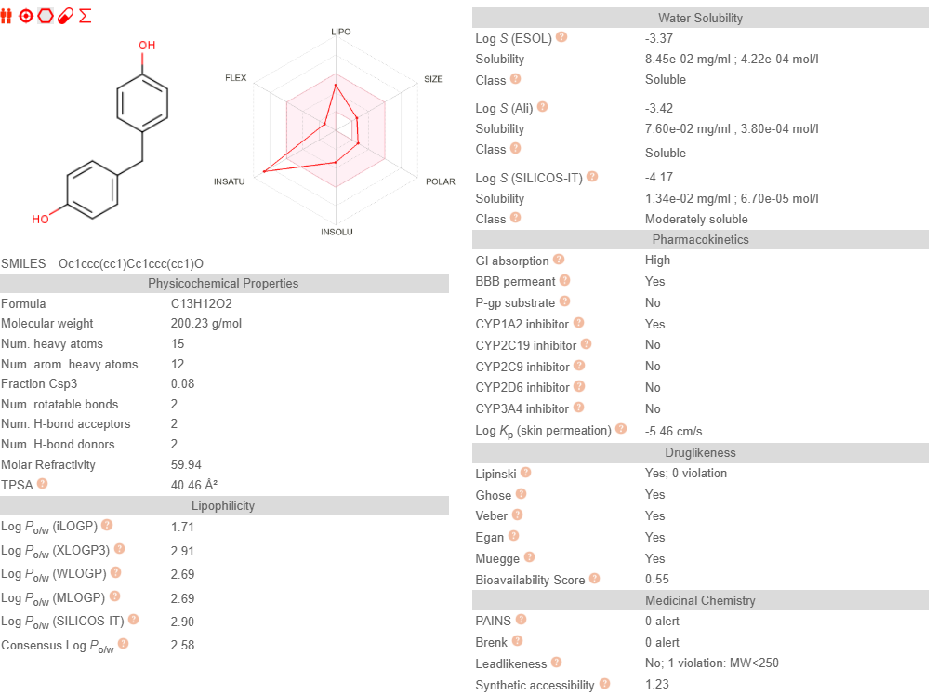
Supplementary Figure 1 BPF ADME Assessment



Supplementary Figure 2 BPF-Target Gene Network

Supplementary Table 1. Binding free energies between key genes and small molecule drugs.
metabolites | targets | Binding Energy (kcal/mol)
BisphenolF | INSR | -6.7
Supplementary Table 2. The predicted binding free energy and the individual energy components (kJ/mol).
Complex | Van der Waals Energy (ΔE_{vdw}) | Electrostatic Energy (ΔE_{elec}) | Polar Solvation Energy (ΔG_{polar}) | SASA Energy (ΔG_{nonpolar}) | Binding Energy (ΔG_{bind})
INSR-BisphenolF | -117.718± 10.838 | -34.536± 9.139 | 102.986± 12.718 | -12.317± 0.635 | -61.585 ± 7.503

