Supplementary Table S1: Inclusion and Exclusion criteria
Inclusion criteria | Exclusion criteria | Removal criteria
①full-time undergraduates aged ≥18  ②voluntary participation with signed informed consent | ①completion of a similar course within the past two years  ②physical or mental disorders precluding course completion/evaluation  ③language barriers hindering scale assessment  ④color vision abnormalities (color blindness or weakness) impairing visual art perception | ①attendance <80% (≥3 absences) or incomplete course content  ②withdraw from the research halfway
Supplementary Table S2: Learning objectives and Detailed requirements
Three-Dimensional Model | Learning Objectives | Detailed Requirements
Aesthetic Perception | Develop sensitivity and interpretive skills for visual and auditory arts | - Master the picturebook creation workflow and the operating principles of AI-assisted drawing tools  - Understand the emotional interplay between music and narrative  - Comprehend narrative structures and visual expression strategies across cultures  - Integrate diverse art forms to represent life-education themes
Emotional Resonance | Cultivate the ability to connect emotionally and reflect through art | - Enhance self-awareness through artistic creation• Improve emotional regulation and access potential therapeutic benefits of art
Creative Practice | Develop integrative artistic creation and expression abilities | - Develop the capacity to create original picturebooks through collaborative artistic practice  - Synthesize aesthetic perception, educational value, and conceptual depth in creative outputs  - Strengthen aesthetic literacy and creative thinking
Supplementary Table S3: Teaching plan for picture book art aesthetic Education Course based on Three-Dimensional Integrated Teaching Model
Course Topics | Course Aesthetic Education Points | Teaching Methods | Course Objectives | Recommended Picture Books
Chapter 1: From Conception to Realization - A Journey of Picture Book Creation  (3 class hours) | 1.Therapeutic Induction: Soothing music and Zentangle practice for relaxation and creative engagement.  2.Artistic Evolution: Analysis of contemporary artists' works to explore styles and historical development. | Theoretical explanation  Appreciation of picture books | 1.Foster aesthetic appreciation and artistic competencies;  2.Promote creative potential, innovative thinking, and self-expression;  3.Develop capabilities for managing emotions | The Duck Riding a Bike  Life Montage
Chapter 2: AI and Picture Book Art - New Dimensions of Innovative Creation  (3 class hours) | 1.Therapeutic Induction: Daily "Three Good Things" journaling to foster positive mood and a relaxed environment.  2.AI & Classic Picture Books: Hands-on experimentation with AI tools for character/scene creation, complemented by case studies and reflective discussion. | Theoretical explanation  Appreciation of picture books  Production experience | 1.Cultivation of innovation and critical thinking.  2.Development of appropriate ethical guidelines for technology use.  3.Enhancement of student well-being and focused attention. | Hello Robot  A Li: Always Standing
Chapter 3: The Dialogue between Notes and Brushes - The Art of Picture Books and Music  (3 class hours) | 1.Therapeutic Induction: Free-form clay modeling accompanied by gentle music for stress relief.  2.Music Integration & Classic Picture Books: Analysis of specific picture books to examine music's role in storytelling and emotional expression. | Theoretical explanation  Music fusion  Appreciation of picture books | 1.Development of perceptual and expressive skills for musical elements and intermedia aesthetics.  2.Cultivation of sensory awareness, internal rhythm, and the pleasure of creation. | The Secret of the Eight Tones  Let's All Come to the Concert  Searching for the Ears of Sound
Chapter 4: The Sound of Healing - Emotional Resonance in Music and Picture Books  (3 class hours) | 1.Therapeutic Induction: Mindful meditation in dim light with music for emotional awareness.  2.Shared Reading & Emotional Resonance: Analyzing music's role in picture books through group discussion.  3.Picture Book Musical: Scene performance integrating ideological elements with evaluative debate. | Reading picture books together  Group discussion  Situational interpretation | 1.Comprehension of the co-construction of emotional expression in picture books and music.  2.Promotion of stress relief, self-awareness, and personal healing.  3.Development of emotional literacy and self-regulatory skills. | The Sound of Silence  The Sky Beneath Our Feet  Best Friend  I Speak Like a River  "Oh, I'm Fine Too  The Boy with Flowers All Over His Head  It's okay. Everything Will be fine.
Chapter 5: Picture Books and the World - An Artistic Bridge for Cross-Cultural Communication  (3 class hours) | 1.Therapeutic Induction: Drawing-based exploration of cultural identity.  2.Shared Reading & Civilizational Exchange: Comparative analysis of Chinese and Western picture books to appreciate cultural distinctiveness and common ground.  3.National Style Practice: Mastering the appropriation of National Style aesthetics into picture books via watercolor techniques, deepening the cognition of cross-cultural carriers. | Theoretical explanation  Reading picture books together  Group discussion | 1.Development of cultural identity, inclusivity, and respect for cultural diversity.  2.Advancement of cross-cultural competencies, aesthetic judgment, and visual storytelling skills. | Reunion  Wing Baby  Little Sun  An's Seed  A Great River  Batik and Parasol  Walking with the Wind  The Last Feather Coat of a Hundred Birds  Grandma Lives in Perfume Village
Chapter 6: The Beauty of Narrative-The Life Journey in Picture Books  (3 class hours) | 1.Therapeutic Induction: Mindfulness meditation in dim light to access profound life experiences.  2.Shared Reading & Life Education: Exploring the "life journey" theme in picture books through group discussion on mortality and meaning.  3.Creative Workshop: Collaborative picture books creation and sharing centered on moral or aesthetic education themes. | Theoretical explanation  Reading picture books together  Group discussion  Co-creation of picture books | 1.Exploration of life-cycle themes to cultivate profound empathy and respect.  2.Development of a constructive outlook on life and its value.  3.Advancement of visual storytelling skills and narrative cognition. | Black Butterfly  Sad Book  The Badger's Gift  Little Lu's Pond  Dad's Scarf  After I Left  The Story of Birth  A Leaf Falls  Grandpa Turned into a Ghost  Grandpa's Meatball Soup  Grandpa Mouse's Confession Letter  Don't Cry Too Hard  The visit of little her  Cry But Don’t Break Your Heart  The First Goodbye  Grandma's Blue Iron Cabinet Wheelchair
Supplementary Table S4: Intervention components, activities and materials
Component | Activities | Materials
Aesthetic perception | - Analyze diverse picturebook styles  - Integrate music to build multisensory experience  - Clay workshops to explore form/space  - AI-assisted drawing tasks to extend to digital art | - Picturebooks (varied styles)  - Audio/music tracks  - Clay and sculpting tools;  - Digital devices
Emotional resonance | - Therapeutic warm-up using themed picturebooks  - Close reading of emotional narratives; guided reflection and personal meaning-making  - Role-playing and scenario simulation  - Structured sharing workshops in a psychologically safe setting | - Themed picturebooks  - Role-play/scenario scripts or prompts;  - facilitation guide  - Optional calming music
Creative practice | - Group-based original picturebook project  - Use traditional or digital production  - Public exhibition and sharing to reinforce confidence and sustained motivation | - No special requirements

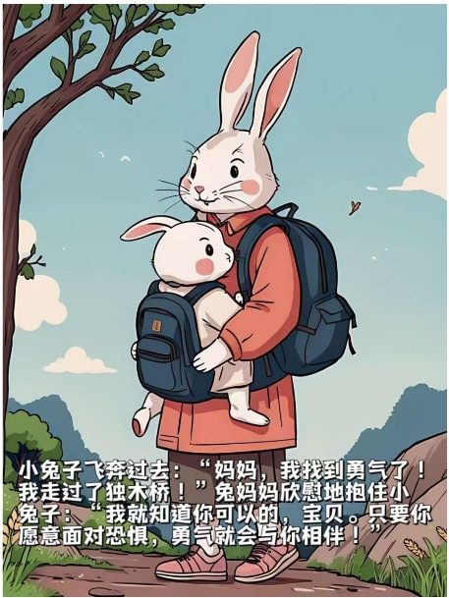 | 
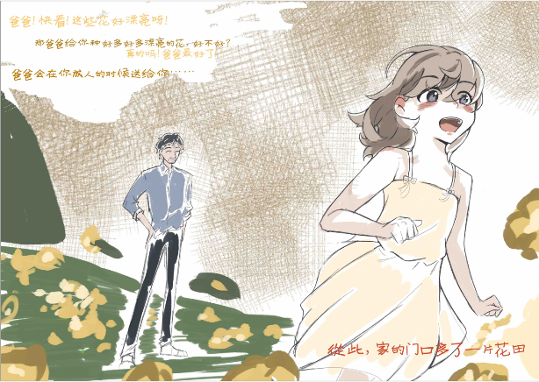 | 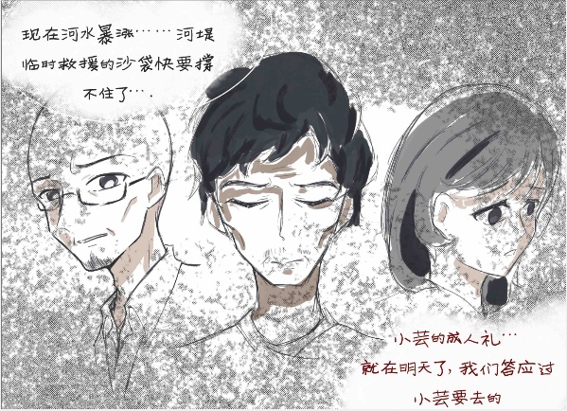
Figure 1: Excerpts from students' picture book works

