Supplementary material

Supplementary methods
The Corogene study includes 5294 Finnish patients who were assigned to coronary angiography in the Helsinki University Central Hospital, Finland, between 2006 and 2008¹⁸. Blood samples were drawn from the arterial line during the coronary angiography into serum, EDTA- and citrate plasma vacuum tubes. The diagnoses were validated by cardiologist from coronary angiogram imaging. The samples were handled according to the laboratory standards of the Helsinki University Central Hospital.
FINRISK is a Finnish national population-based health examination survey that has been conducted in 5-year intervals. The surveys have been performed in 5 geographical areas in Finland, and they included a clinical examination, questionnaire, and laboratory analyses. Blood samples were collected during the health examination. The cases with prevalent cardiovascular diseases at baseline were identified via (1) the questionnaire as a doctor-diagnosed disease, (2) the disease-associated drug reimbursement records from the Social Insurance Institution of Finland, including purchased medications and entitled reimbursements, and (3) the National Hospital Discharge register for hospitalizations. incident CAD events (acute MI, bypass surgery, and angioplasty), cardiovascular events (CAD events and stroke), and all-cause deaths during the follow-up were identified via (1) the National Hospital Discharge register for hospitalizations, and (2) the National Causes-of-Death Register.
The OXI cohort consists of 125 myocardial infarction patients who were randomized in a median of 43 h after hospitalization to receive either HCQ (Orion Pharma, Espoo, Finland) 300 mg once daily (weight <60 kg: received 300 mg for five days per week) or placebo for six months. Clinical data were collected from electronic patient records⁵⁰. DNA samples and PaxGene blood samples are available for this cohort.
Sequencing results were analysed using Genomic DNA reagent kit and HT DNA Extended LabChip (PerkinElmer, MA, USA). Pooled PCR products were processed further to Illumina-compatible libraries using Illumina NexteraRDNA Sample Preparation Kit. Sample preparation was done according to the manufacturer’s instructions. Purification was performed using PerformaR V3 96-Well Short Plate according to the recommended protocol. PCR clean-up was performed the recommended protocol⁵¹. All the processed libraries were analysed on LabChipR GX using HT DNA HiSens Reagent kit and HT DNA Extended LabChip (PerkinElmer). Sample pool was concentrated using DNA Clean & Concentrator™-5 column (Zymo Research Corp. CA, USA). The final sample pool was analysed on Agilent 2100 Bioanalyzer (Agilent Technologies Inc.CA, USA). Sequencing was performed using the Illumina MiSeq instrument with MiSeq Control Software v. 2.2.2 (Illumina, Inc., San Diego, CA, USA). Samples were sequenced as 251 bp paired-end reads and two 8 bp index reads using amplicon workflow. Results were analysed with an in-house variant calling pipeline (VCP), Human genome build hg19 (GRCh37) was used as the reference sequence and a minimum variant frequency of 20 % was required to call a variant.
For capillary sequencing, we used OneTaq Hot Start 2X polymerase and Master Mix with Standard Buffer (LOT: 10165618, New England Biolabs, Ipswich, MA, USA). With a 4 µl volume of template DNA at concentration 20 ng/µl we ran the PCR protocol of initial 94°C hotstart (2’) followed by 30 cycles of 94°C denaturation and 50°C annealing (both 30’’) and 68°C extension stages (60’’) followed by final extension stage at 68°C (5’) run on MiniAmp Plus Thermal Cycler (Applied Biosystems; Waltham, MA, USA). The size of PCR products was verified by electrophoresis on 2% agarose gel (run 12’ at 110V). The PCR products were purified by ExoSAP-It (Applied Biosystems; Waltham, MA, USA) using 23 µl of PCR product and, 4 µl ExoSAP reagent with 8 µl MgCl² run at 37°C (30’) followed by 80°C (15’). The cleaned PCR product was sequenced in sense and antisense directions by ABI3730XL DNA Analyzer (Applied Biosystems; Waltham, MA, USA) at FIMM. Sequences were read by Sequencher v. 4.9.1 (Gene Codes, Ann Arbor, MI, USA) software. A negative control (template omitted) was included in each sequencing run.
To quantify BTNL2 mRNA, we performed mRNA sequencing for patients with verified NSTEMI or STEMI in the Oxi cohort as follows. mRNA was extracted from 1.8 ml sample in PaxGene vials stored at -80°C using GeneJet Stabilizer and Fresh Whole Blood RNA kit (lot: 2651280; Thermo Fisher,Waltham, MA, USA) following the manufacturer’s protocol. The cDNA inversion was performed using reagents and protocol from Promega GoScript, random primers kit (lot: 0000553832; Promega, Madison, WI, USA) in MiniAmp Plus Thermal Cycler (Applied Biosystems; Waltham, MA, USA). Finally, the expression level of BTNL2 mRNA was quantified using in-house RT-PCR protocol with PerfeCta SYBR® Green FastMix (Quantabio, LLC., Beverly, MA, USA) and specific primers (sense 5’-AGTGAATGGACCTTCCCAGCC-3’ and antisense 5’-TCCATGCTCTGTGCATTCG-3’) on RT-PCR Corbett Rotor-Gene 3000 (Corbett Research, Qiagen GmbH, Hilden, Germany). The results were reported in reference to housekeeping gene β-actin, which was detected for each sample using specific primers (sense 5'-GCACTCTTCCAGCCTTCC-3', antisense 5'-GCGCTCAGGAGGAGCAAT-3'). Two negative control (template omitted) was used for each RT-PCR run and an in-house standard control sample was used for positive control.

In silica functional studies
Transcription binding site analysis

We studied the transcription binding sites for 14 BTNL2 SNPs with FeatSNP database (Functional Epigenetic Annotation Tool of SNPs) which currently hosts the brain-specific functional and epigenetic annotations of 81M SNPs in the human genome ⁵². The other databases tested (PROMO 3.0, GeneCards, Bioconductor TFBSTools, CHEA Transcription Factor Targets Dataset, MotifMap Predicted Transcription Factor Targets Dataset, TRANSFAC database of transcription factor binding sites) did not contain the information for these SNPs.
eQTL analysis
To study, whether the BTNL2 SNPs identified by sequencing were associated with gene expression levels, we searched for cis- and trans-expression quantitative trait loci (eQTLs) from Blood eQTL Browser (www.genenetwork.nl/bloodeqtbrowser), seeQTL (www.bios.unc.edu/research/genomic_software/seeQTL/), GTEx2015_v6 and Fairfax2014 ^{53–56}.
Supplementary results
BTNL2 risk SNPs influence expression of MHC genes
The rs4248166 (BTNL2) affects the RNA expression of several nearby genes located in MHC class II (HCG23, BTNL2, HLA-DRA, HLA-DRB5, HLA-DRB1, HLA-DQA2, HLA-DQB1, HLA-DRB6, HLA-DMA, TAP2) and class III (MCCD1, LTB, SKIV2L, AGPAT1, GPSM3) HLA regions according to trans-eQTL meta-analysis in blood monocytes. Overall, the BTNL2 risk SNPs significantly affect the MHC gene expression found in many tissues such as adipose, brain, lung, stomach, nerve, testis and thyroid (p-values from 4.15E-06 to 2.81E-14).
BTNL2 risk variants lie within motifs for cardiac transcription factors
Using FeatSNP in silico analysis, we assessed whether BTNL2 risk SNPs lie within predicted binding sites for the transcription factors with known association with CAD. We found predicted effects in transcription factor binding sites for risk alleles of the 3’UTR SNP rs17202358, for two SNPs in intron 4 (rs113669229 and rs4248166) and for one SNP in intron 3 (rs4935352) (Supplementary table 2). The rs17202358 in 3’UTR sequence lies within the motif for myocyte enhancer factors MEF2A, MEF2B and MEF2D, which are members of MADS-box transcription factors. The rs113669229 in intron 4 lies within the motif for transcription factors EGR-1 and EGR-4 (early growth response proteins) and SP2 and SP3 that belong to the C2H2 zinc finger transcription factor gene group. MEF2 is a critical regulator in heart development and cardiac gene expression. BTNL2 risk SNP rs17202358 in 3’UTR sequence lies within the motif for myocyte enhancer factors MEF2A, MEF2B and MEF2D. PHACTR1 intron has a MEF2 binding site, that reduces PHACTR1 expression levels in MI ⁵⁷. An analogous regulation of BTNL2 expression via MEF2 binding at rs17202358 locus is a possible underlying mechanism behind the observed genetic predisposition to MI. Similar mechanisms may function at the other transcription factor binding sites found at BTNL2 SNPs rs113669229, rs4248166 and rs4935352, included in the risk haplotype.
The rs4248166 SNP lies within the motif for the transcription factor heterodimer ARNT::HIF1A, which belongs to the basic Helix-Loop-Helix transcription factor-group. ARNT (aryl hydrocarbon receptor nuclear translocator) is a subunit of Hypoxia-inducible factor-1 (HIF-1), the main regulator of mammalian oxygen homeostasis. The rs4935352 SNP lies within the motif for transcription factor FOXO6.

Supplementary table 1. Associations of single nucleotide polymorphisms within BTNL2 with myocardial infarction from targeted sequencing of 24 patients from Corogene cohort and 23 FINRISK controls.
Association study
(N_{CAD}=24, N_{cont}=23)
SNP | Position (GRCh38.p12) | Position in BTNL2 gene | MAF  (Finnish) | Risk Allele | p-value | OR | 95 CI lower | 95 CI upper
rs17202358 | 32393446 | 3'-UTR | 0.258 | T | 0.01 | 9.33 | 1.220 | 106.57
rs62402759 | 32397930 | intron 4 | 0.354 | C | 0.02 | 7 | 1.010 | 55.16
rs62404560 | 32398119 | intron 4 | 0.354 | G | 0.02 | 7 | 1.010 | 55.16
rs113669229 | 32398151 | intron 4 | 0.354 | A | 0.02 | 7 | 1.010 | 55.16
rs4248166 | 32398644 | intron 4 | 0.353 | C | 0.02 | 7 | 1.010 | 55.16
rs4959097 | 32398848 | intron 4 | 0.354 | C | 0.02 | 7 | 1.010 | 55.16
rs2294884 | 32399482 | intron 4 | 0.353 | G | 0.02 | 7 | 1.010 | 55.16
rs2294883 | 32399674 | intron 4 | 0.353 | A | 0.02 | 7 | 1.010 | 55.16
rs2294882 | 32399738 | intron 4 | 0.353 | C | 0.02 | 7 | 1.010 | 55.16
rs2294881 | 32399827 | intron 4 | 0.354 | C | 0.02 | 7 | 1.010 | 55.16
rs112748105 | 32400706 | intron 4 | 0.218* | A | 0.01 | 9.33 | 1.220 | 106.57
rs3763304 | 32401578 | intron 4 | 0.354 | T | 0.02 | 7 | 1.010 | 55.16
rs3763306 | 32401866 | intron 3 | 0.353 | G | 0.02 | 7 | 1.010 | 55.16
rs4935352 | 32402109 | intron 3 | 0.354 | G | 0.02 | 7 | 1.010 | 55.16
Probability value was calculated Χ² test for association with Odds Ratio (OR) and 95% Confidence Interval (CI) values. *Minor allele frequency (MAF) from 1000genomes (Europe), Finnish MAF not available.
Supplementary table 2. The alleles (Allele2, bolded) of the BTNL2 SNPs associated with ACS indicate high transcription factor binding site (TFBS) scores (*). The indicated SNP position is in red font in the TFBS motif sequence. MEF2 transcription factor binding motifs have the highest TFBS scores with T allele. The presence of the C allele destroys the TFBS motifs shown by low TFBS scores.

SNP | TFBS score (Allele1) | Pvalue | Qvalue | TFBS motif (Allele1) | TFBS score (Allele2) | Pvalue | Qvalue | TFBS motif (Allele2) | Motif Name | Class |  | DNA sequence with Allele1 |  | DNA sequence with Allele2
rs17202358 | 7.194 | 1.28E-4 | 0.003 | TCTATTAACAGC | 15.807 | 3.79E-6 | 3.79E-5 | TCTATTAATAGC | MEF2A | MADS box factors | ATTCTATTAACAGCCAAACAG |  | ATTCTATTAATAGCCAAACAG
rs17202358 | -0.982 | 4.93E-4 | 0.005 | TCTATTAACAGC | 15.946 | 2.52E-6 | 2.52E-5 | TCTATTAATAGC | MEF2B | MADS box factors | ATTCTATTAACAGCCAAACAG |  | ATTCTATTAATAGCCAAACAG
rs17202358 | -1.873 | 5.14E-4 | 0.005 | TCTATTAACAGC | 15.891 | 3.01E-6 | 3.01E-5 | TCTATTAATAGC | MEF2D | MADS box factors | ATTCTATTAACAGCCAAACAG |  | ATTCTATTAATAGCCAAACAG
rs113669229 | -7.192 | 5.71E-3 | 0.091 | GCCCTGCCCGTGCC | 9.808 | 8.37E-5 | 1.34E-3 | GCCCTGCCCATGCC | EGR1 | C2H2 zinc finger factors | GGCCCTGCCCGTGCCATTTTT |  | GGCCCTGCCCATGCCATTTTT
rs113669229 | -2.655 | 2.48E-3 | 0.017 | GCCCTGCCCGTGCCA | 10.190 | 7.46E-5 | 1.04E-3 | GCCCTGCCCATGCCA | SP2 | C2H2 zinc finger factors | GGCCCTGCCCGTGCCATTTTT |  | GGCCCTGCCCATGCCATTTTT
rs113669229 | 7.509 | 2.67E-4 | 0.003 | CCCTGCCCGTGCCATT | 10.909 | 4.77E-5 | 5.72E-4 | CCCTGCCCATGCCATT | EGR4 | C2H2 zinc finger factors | GGCCCTGCCCGTGCCATTTTT |  | GGCCCTGCCCATGCCATTTTT
rs113669229 | 4.959 | 1.89E-3 | 0.042 | GCCCTGCCCGT | 8.878 | 2.58E-4 | 5.67E-3 | GCCCTGCCCAT | SP3 | C2H2 zinc finger factors | GGCCCTGCCCGTGCCATTTTT |  | GGCCCTGCCCATGCCATTTTT
rs4248166 | 1.842 | 3.03E-3 | 0.032 | GTGTGTGA | 8.776 | 6.75E-4 | 0.015 | GTGCGTGA | ARNT::HIF1A | Basic helix-loop-helix factors | CCTGTCCGTGTGTGACCTGTG |  | CCTGTCCGTGCGTGACCTGTG
rs4935352 | 5.519 | 8.91E-4 | 0.027 | ATACACA | 8.096 | 4.03E-4 | 0.012 | GTACACA | FOXO6 | Fork head / winged helix factors | CCTTTTATAGATACACAGAAA |  | CCTTTTATAGGTACACAGAAA
(*) The TFBS score is an estimation of fitness between TFBS motif position weight matrix (PWM) and target sequence by using log-likelihood calculation method. Higher score indicates a higher similarity of target sequence to TFBS motif PWM
- (B) (C)
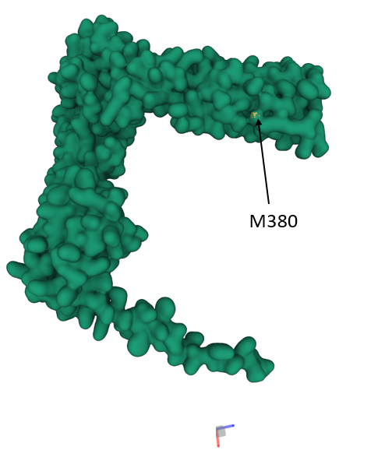
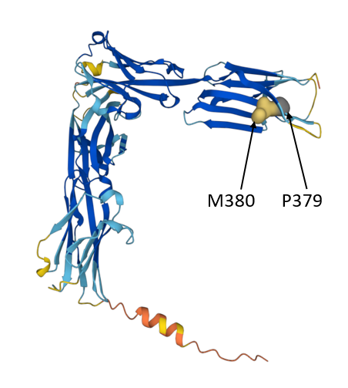
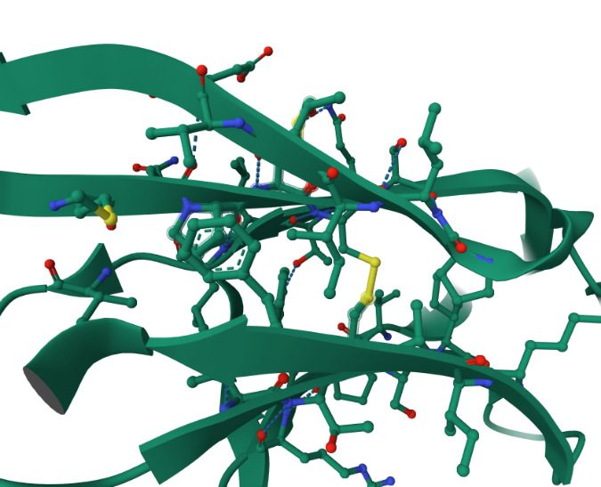
C435
P379 M380
C381
*
Supplementary figure 1. The structure of the BTNL2 molecule with missense mutations in positions 380 and 379 indicated in the apical Ig domain.
(A) The M380 and P379 are indicated by filled in yellow in this cartoon representation of the BTNL2 molecule. The darkness of the colour indicates higher confidence of the predicted structure. (B) The surface prediction model indicates that while residue P379 is thoroughly buried in the functional molecule, the sidechain of the methionine in position 380 is exposed. Being hydrophobic and considering its apical location, it is plausible that the Met380 sidechain may be involved in binding of lipid ligands. With the substitution of methionine by isoleucine, this exposed sidechain is lost. (C) The missense variants in positions 379 and 380 may potentially disrupt the disulphide bridge (yellow, marked with an asterisk) between the cysteins at positions 381 and 435 thereby causing a structural and/or functional disturbance of the apical Ig domain of the BTNL2 protein. The figure is produced at RCSB PDB from structure Q9UIR0.

