Supplementary information of
Distinctive microfabrics and radiometric age of seep carbonates from the Romagna Apennines (San Vernicio, Italy): Insights into seepage dynamics
by Stefano Giunti, Fabian Tramm, Stefano Conti, Catherine Mottram, Glenn Chapman, Magdalena Radzikowska, Daniela Fontana, and Maciej J. Bojanowski
U-PB GEOCHRONOLOGY METHODS
LA-ICP-MS operating conditions
Laboratory & Sample Preparation
Laboratory name | Institute of the Earth and Environment, University of Portsmouth
Analytical sessions | 25/04/25_run2
Sample type/mineral | Carbonate
Sample preparation | In-situ polished 30 µm thin sections
Imaging | Reflected light
Laser ablation system
Make, Model & type | ASI RESOlution SE ArF (Argon-Fluoride)
Ablation cell & volume | Laurin S155 (dual volume design)
Laser wavelength (nm) | 193nm
Pulse width (ns) | 3 ns
Fluence (J cm⁻²) | ≈ 3.5 J cm⁻²
Repetition rate (Hz) | 8 Hz
Spot size (um) | 80 µm following 100 µm pre-ablation of 3 pulses
Sampling mode / pattern | Spot, with pre-ablation cleaning spot
Carrier gas | 100% He (0.30 l min⁻¹), Ar make-up gas (1.05-1.06 l min⁻¹) combined 50% along sample line in mixing bulb
Ablation duration (secs) | 20 secs, 15 s washout, 20 s background between pulses
Cell carrier gas flow (l/min) | 100% He (0.300 l min⁻¹), N2 (0.0032l min⁻¹)
ICP-MS Instrument
Make, Model & type | Agilent 8900 Triple Quad ICP-QQQ-MS
Carrier gas flow rate | 0.30 l min⁻¹ He and 1.05-1.06 l min⁻¹ Ar neb flow
Auxiliary gas flow rate | 0.9 l min⁻¹ Ar
RF power (W) | 1330 W, 15 l min⁻¹ Ar plasma flow
Detection system | 3 MHz quadrupole
Masses measured | The following masses were measured and had integration time of (10 ms ²⁰²Hg, ²⁰⁴Pb), (20 ms ²³²Th, ²³⁵U, ²³⁸U, ²⁰⁸Pb), (50 ms ²⁰⁶Pb), and (70 ms ²⁰⁷Pb).
Integration time per peak (ms) | 10-70 ms
Attenuation | Pulse/analogue factors were calibrated for U and Th using NIST 612 glass.
Mass spectrometer tuning parameters | A 38um, 10 Hz, ~4.5 J cm⁻² line on NIST-612 glass yields a typical sensitivity of ~970 000 cps U²³⁸ and a Hg²⁰² background of 700 cps.
Fractionation and oxide production | U/Th fractionation was typically ~4-6% and Th oxide production is 0.2-0.3%
Data Processing
Gas blank | 20 second on-peak zero subtracted
Calibration strategy | Primary and secondary reference materials were ablated between every 8 unknowns
Reference Material info | SRM-614 glass (NIST-614; 0.82 ppb U and 2.3 ppb Pb; GEOREM; ²³⁸U/²⁰⁶Pb ratio of 0.2236; ²⁰⁷Pb/²⁰⁶Pb 0.8704 and ²⁰⁶Pb/²⁰⁸Pb 2.0995 - GEOREM) and WC-1 carbonate (254.4 ± 6.4 Ma; Roberts et al., 2017), Duff Brown Limestone (64 ± 2 Ma; Hill et al., 2016), and RA138 (321.99 ± 0.65 Ma; Guillong et al., 2024) were used as a secondary reference material to test long-term reproducibility.
Secondary Reference material reproducibility | Analyses of Duff Brown during the analytical period yielded a ²⁰⁶Pb/²³⁸U intercept age of 62 ± 1.1 Ma (MSWD = 0.5; 3% from reported age). Analyses of RA-138 during the analytical period yielded a ²⁰⁶Pb/²³⁸U intercept age of 312.0 ± 6.4 Ma (MSWD = 0.8; 1.0% from reported age).
Data processing package used / Correction for LIEF | Iolite© 3.4 software, using the 'automatic spline' to correct for downhole fractionation (which was minimal) and the 'Automatic spline' to correct for instrumental drift
Common-Pb correction, composition and uncertainty | Propagated analytical uncertainties: analytical uncertainties, reproducibility of the primary reference material in each analytical session and the uncertainty on the primary RM have been added in quadrature to all data presented in data tables and in plots. Final quoted uncertainties include an additional 3% uncertainty added in quadrature to account for typical long-term reproducibility of analytical equipment and for the secondary reference material.

Analytical session | Uncorrected WC-1 age (Ma) | Correction factor
25/04/2025_run2 | 276.2 ± 2.2 | 1.087
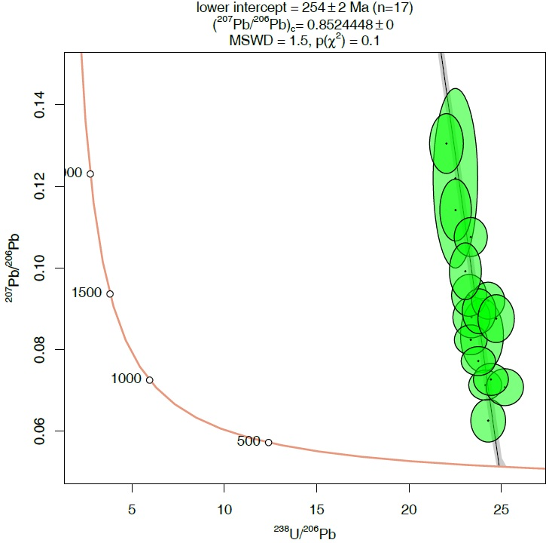
Fig. SI 1. WC-1 primary reference material:

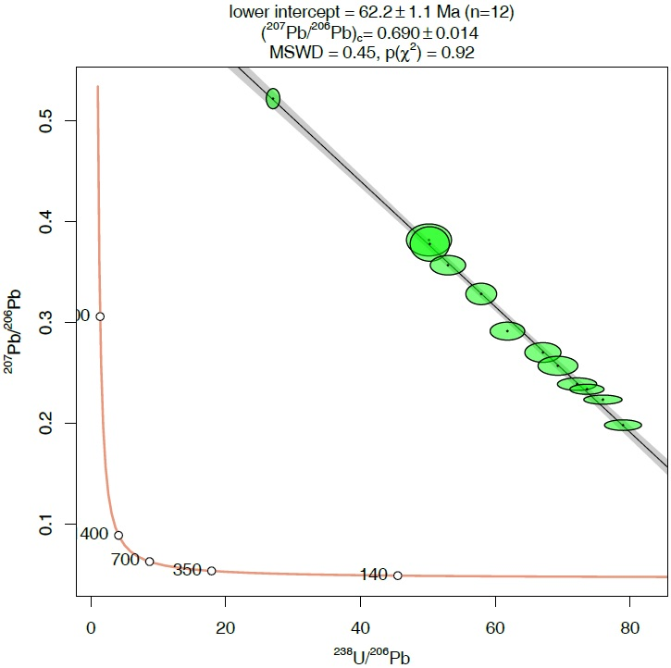
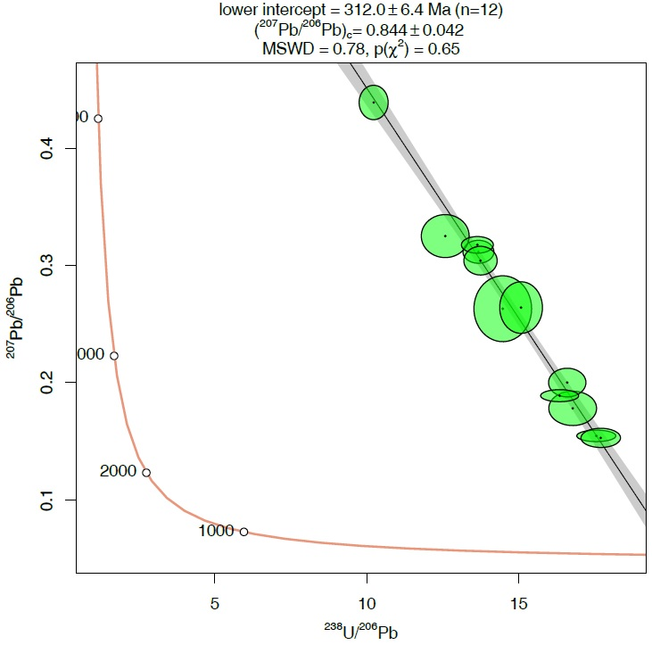
Fig. SI 2. Duff Brown (left) and RA-138 (right) secondary reference material (TW diagrams):
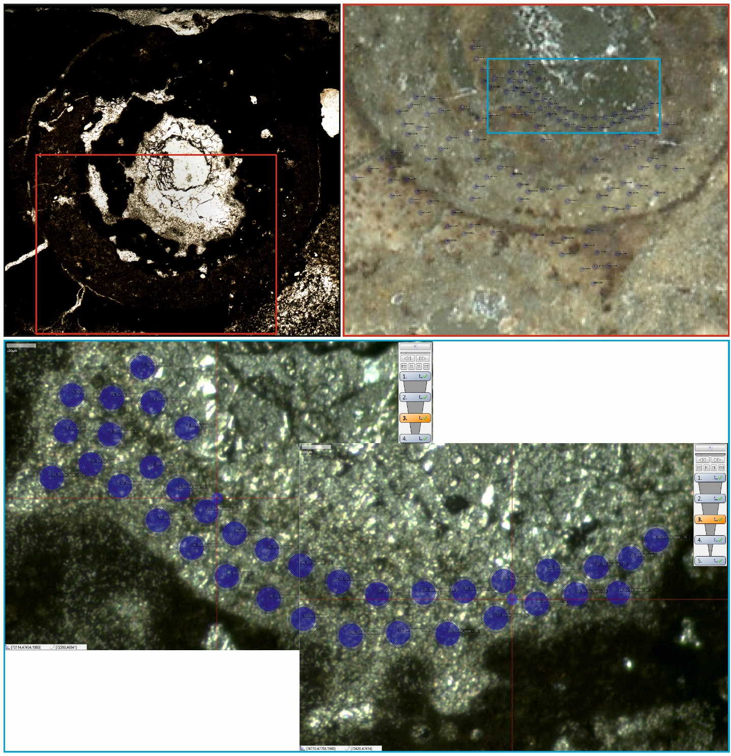
Fig. SI 3. Location of the spots in the spar of the conduit where U-Pb dating resulted in a constrained age.
PPL image of cross section of the conduit analysed with in situ U-Pb
Reflected light image with location of the analysed spots
Reflected light image with location of the analysed spots in the spar where in situ U-Pb dating resulted in a constrained age

Fig. SI 4. Unconstrained ages of the concentric laminae and micrite.
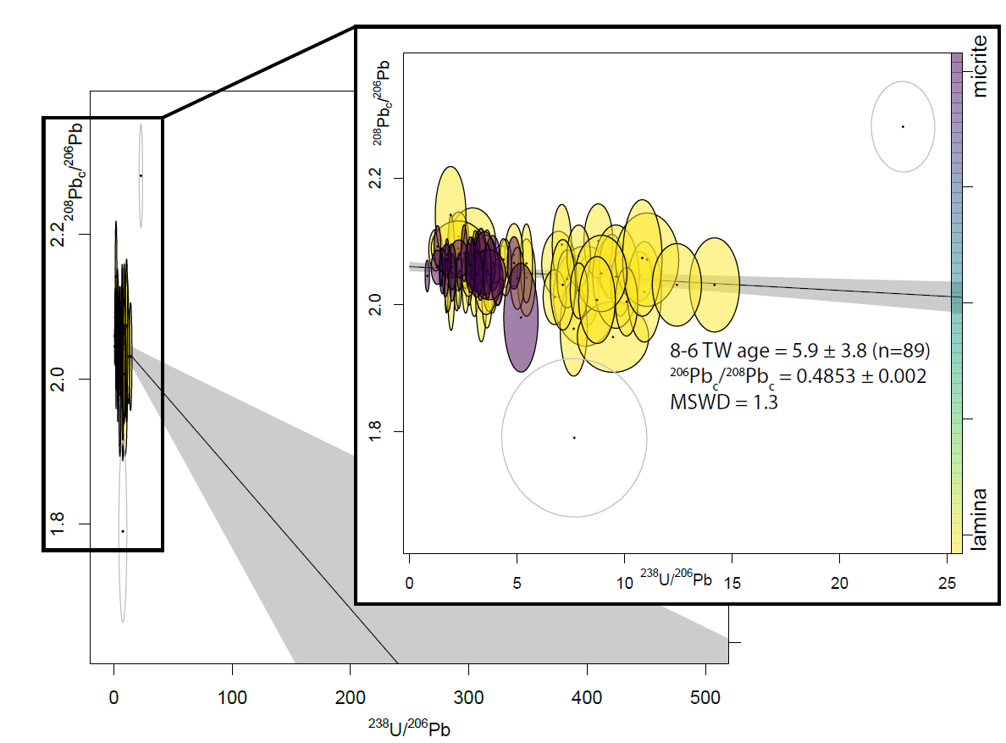

RAMAN MICROSPECTROSCOPY
Structure and symmetry of calcite
The trigonal structure of calcite (CaCO₃) possesses the group symmetry of $R\overline{3}c (D_{3d}^{6})$with a site symmetry 32(D₃) of the isolated CO₃⁻ group (e.g. Wehrmeister et al., 2010). Group theory results in 27 vibrational modes classified according to the irreducible representations of the $\overline{3}m$ point group (De La Pierre et al., 2014):
Г total = 1×A_{1g} ⊕ 2×A_{1u} ⊕ 3×A_{2g} ⊕ 3×A_{2u} ⊕ 4×E_{g} ⊕ 5×E_{u}.
The doubly degenerate A_{1g} and Eg modes are Raman active modes (resulting in 5 fundamental Raman modes); the doubly degenerate A_{2u} and Eu modes are IR (infrared) active modes; the A_{1u} and A_{2g} modes are inactive (silent). The Raman spectrum of calcite can thus be divided into the primary Raman modes (~1085 cm⁻¹ v₁; ~1435 cm⁻¹ v₃; ~712 cm⁻¹ v₄) and lattice modes below 400 cm⁻¹ (Scheetz and White, 1977). Experimental spectra of calcite demonstrate the appearance of additional bands at (~1068 cm⁻¹ and 1749 cm⁻¹), the first A_{1g} band is due to the decoupling of an ¹⁸O isotope substitution from other “common” ¹⁶O atoms (which stretch at ~1087 cm⁻¹) in the carbonate group (De La Pierre et al., 2014). The second additional band (1749 cm⁻¹) is proposed to be an overtone and bending mode of the CO₃^{ˉ} caused by the IR active mode at 874.5 cm⁻¹ (Scheetz and White, 1977; Gillet et al., 1996; De La Pierre et al., 2014).

Additional considerations
The slightly increased FWHM values in the centre of the conduit, particularly starting in the micritic lamina, indicate a lower degree of crystallinity due to more rapid precipitation and formation of smaller crystals. The centre of the conduit consists of spar. Taking into consideration that the spectra were obtained from a cross-section of the conduit, overlapping spar crystals with different orientation may result in broader “gross” Raman signals (Spectra 14–16; Fig. 6C). Micrite is a material consisting of small calcite crystals, thus the increase in FWHM values could be a combination of smaller randomly oriented crystals with overlapping signals which result in broadening of Raman signals, and crypto crystalline cement aggregating the crystals. This is in agreement with observations of other tubular structures, which display fine microcrystalline calcite at the outer centre which then transition into blocky spar (Fig. 4C, E). Furthermore, the high FWHM values of disordered carbonaceous material present as D1, D2, D4, and D5 bands in the spectrum of the central blocky spar (Spectrum 16), may be a result of a combined signal from crystalline calcite and amorphous carbonaceous material cemented into the filling of the conduit (Fig. 6A, B).
The relative intensities of the G, D2 and D1 bands may be used to assess the maturity of carbonaceous materials and involved paleotemperatures during diagenesis, but require careful calibration (Rahl et al., 2005; Allwood et al., 2006). Such calibration was not done in this work, however, comparison of the spectral parameters with literature may provide a tentative temperature range. In disordered organic matter, the G band disappears and the D2 band or a combination band (D2 + G) becomes prominent (Allwood et al., 2006; Kouketsu et al., 2014). Considering the combined G+D2 band as the G band of disordered carbonaceous materials I(D1)/[I(G)+I(D1)] may be a tentative approach of paleothermometry. The I(D1)/[I(G)+I(D1)], calculated for spectra taken in the transect of a conduit (Spectra 8–14, and Spectrum 16), range from 0.33 to 0.44 (except Spectra 14 with 0.15). These values correlate to a low temperature (< 200 °C) estimated by similarly low values (ca. 0.42–0.50) of Raman spectra of stromatolitic carbonates (Allwood et al., 2006). According to Kouketsu et al. (2014) the Raman signals at the range of > 1600 cm⁻¹ solely belong to the D2 band, and the G band is absent. The D2 band would correspond to amorphous carbon such as kerogen (Kouketsu et al., 2014). Deconvoluted spectra without a G band, including only a D2 band of disordered, amorphous OM are corresponding to an estimated temperature of ca. 150–280 °C, whereas in the cases of Raman spectra with a distinct low-intense G band would then correspond to a temperature > 280 °C (cf. Kouketsu et al., 2014). Comparison of data with both approaches fit to relatively low temperature environments < 200 °C after Allwood et al. (2006) or 150–280 °C after Kouketsu et al. (2014). However, correct approaches towards the paleothermometry is still disputed, particularly at relatively low temperature where the thermometer rapidly reaches its limitations (Allwood et al., 2006; Kouketsu et al., 2014; Henry et al., 2019). Such temperature estimations are more or less in line with the ones expected for the generation of hydrocarbons (ca. 70–200 °C), but more precise temperature reconstructions are difficult to obtain from the measured spectra.

REFERENCES
Allwood AC, Walter MR, Marshall CP (2006) Raman spectroscopy reveals thermal palaeoenvironments of c.3.5 billion-year-old organic matter. Vibrational Spectroscopy 41(2): 190–197. https://doi.org/10.1016/j.vibspec.2006.02.006
De La Pierre M, Carteret C, Lorenzo M, André E, Orlando R, Dovesi R (2014) The Raman spectrum of CaCO₃ polymorphs calcite and aragonite: A combined experimental and computational study. J Chem Phys 140: 164509. https://doi.org/10.1063/1.4871900
Gillet P, McMillan P, Schott J, Badro J, Grzechnik A (1996) Thermo-dynamic properties and isotopic fractionation of calcite from vibrational spectroscopy of ¹⁸O-substituted calcite. Geochim Cosmochim Acta 60: 3471–3485. https://doi.org/10.1016/0016-7037(96)00178-0
Guillong M, Samankassou E, Müller IA, Szymanowski D, Looser N, Tavazzani L, Merino-Tomé O, Bahamonde JR, Buret Y, Ovtcharova M (2024) RA138 calcite U–Pb LA-ICP-MS primary reference material. Geochronology 6(3): 465–474. https://doi.org/10.5194/gchron-6-465-2024
Henry GH, Jarvis I, Gillmore G, Stephenson M (2019) Raman spectroscopy as a tool to determine the thermal maturity of organic matter: Application to sedimentary, metamorphic and structural geology. Earth-Sci Rev 198: 102936. https://doi.org/10.1016/j.earscirev.2019.102936
Hill CA, Polyak VJ, Asmerom YP, Provencio P (2016) Constraints on a Late Cretaceous uplift, denudation, and incision of the Grand Canyon region, southwestern Colorado Plateau, USA, from U-Pb dating of lacustrine limestone. Tectonics 35: 896–906. https://doi.org/10.1002/2016TC004166
Kouketsu Y, Mizukami T, Mori H, Endo S, Aoya M, Hara H, Nakamura D, Wallis S (2014) A new approach to develop the Raman carbonaceous material geothermometer for low-grade metamorphism using peak width. Island Arc 23: 33–50. https://doi.org/10.1111/iar.12057
Rahl JM, Anderson KM, Brandon MT, Fassoulas C (2005) Raman spectroscopic carbonaceous material thermometry of low-grade metamorphic rocks: Calibration and application to tectonic exhumation in Crete, Greece: Earth Planet Sci Lett 240: 339–354. https://doi.org/10.1016/j.epsl.2005.09.055
Roberts NMW, Rasbury ET, Parrish RR, Smith CJ, Horstwood MSA, Condon DJ (2017) A calcite reference material for LA-ICP-MS U-Pb geochronology. Geochem Geophys Geosyst 18: 2807–2814. https://doi.org/10.1002/2016GC006784
Scheetz B, White W (1977) Vibrational spectra of the alkaline earth double carbonates. Am Mineral 62: 36–50.
Wehrmeister U, Soldati AL, Jacob DE, Häger T, Hofmeister W (2010) Raman spectroscopy of synthetic, geological and biological vaterite: A Raman spectroscopic study. J Raman Spectr 41: 193–201. https://doi.org/10.1002/jrs.2438

