Intrinsic cortical geometry is associated with individual differences in local functional organization
Francesco Alberti^{1,2*}, Pierre-Louis Bazin³, R. Austin Benn^{1,2}, Robert Scholz^{1,2,4,5}, Wei Wei^{1,2}, Alexander Holmes^{1,2}, Victoria Shevchenko^{1,2}, Ulysse Klatzmann^{1,2}, Carla Pallavicini^{1,2,6,7}, Robert Leech⁸, Daniel S. Margulies^{1,2*}

Affiliations:
- Université Paris Cité, INCC UMR 8002, CNRS, Paris, France
- Centre for Integrative Neuroimaging (OxCIN), FMRIB, Nuffield Department of Clinical Neurosciences, University of Oxford
- Full Brain Picture Analytics, Leiden, Netherlands
- Wilhelm Wundt Institute for Psychology, Leipzig University, Leipzig, Germany
- Max Planck School of Cognition, Leipzig, Germany
- National Scientific and Technical Research Council (CONICET), Argentina
- Cognitive Neuroscience Center, University of San Andres, Buenos Aires, Argentina
- Department of Neuroimaging, King’s College London, UK

Corresponding Authors (*):
francesco.alberti@etu.u-paris.fr (F.A.)
daniel.margulies@ndcn.ox.ac.uk (D.S.M.)

Supplementary Methods
For spatial modeling we used the lattice Kriging approach relying on the publicly available LatticeKrig package for R. Lattice Kriging models spatial processes based on irregularly spaced observations (centered and uncentered gradients in our case). Spatial data is modeled as:
$y_{i}=d(x_{i})+g(x_{i})+ϵ_{i}$
Where $x_{i}$ are the spatial coordinates of an observation in the geometry embedding, $d$ are fixed coefficients, $g{(x}_{i})$ is a smooth Gaussian process, and $ϵ_{i}$ is measurement error. This process is approximated as:
$g(x)=\sum_{j=1}^{m}{}c_{j}ϕ_{j}(x)$
Where $ϕ_{j}$, $1≤j≤m$, are a series of radial basis functions—namely Wendland functions—, and $C_{j}$ is a coefficient fitted on the observed data. The basis functions are centered on the nodes of a three dimensional lattice covering the full spatial domain of each searchlight, and its coefficient is fitted following a Gaussian Markov random field. This enforces spatial autocorrelation between coefficients by coupling adjacent nodes. We used a 30x30x30 lattice with a buffer of two extra nodes on each side to mitigate boundary effects. The basis functions were assigned an overlap factor of 1.5 and an alpha weight of 6.019—this parameter controls the spatial dependence between coefficients.

Supplementary Tables

Supplementary Table 1 | Whole cortex error comparisons for centered gradients
Hemisphere | Gradient | Comparison | Statistic | p | Error difference | CI | p_adj
L | Gradient 1 | baselines + model vs baselines | -20.941 | 9E-81 | -0.019 | (-0.020, -0.017) | 1E-80
L | Gradient 1 | baselines + model vs baselines + mean geom. | -31.207 | 6E-149 | -0.037 | (-0.039, -0.035) | 1E-148
L | Gradient 1 | baselines + model vs baselines + null geom. | -31.181 | 9E-149 | -0.053 | (-0.056, -0.050) | 1E-148
L | Gradient 1 | baselines + mean geom. vs baselines | 18.595 | 2E-66 | 0.018 | (0.016, 0.019) | 2E-66
L | Gradient 1 | baselines + null geom. vs baselines | 36.883 | 2E-187 | 0.034 | (0.033, 0.036) | 1E-186
L | Gradient 2 | baselines + model vs baselines | -14.138 | 2E-41 | -0.007 | (-0.008, -0.007) | 2E-41
L | Gradient 2 | baselines + model vs baselines + mean geom. | -23.352 | 4E-96 | -0.021 | (-0.023, -0.020) | 7E-96
L | Gradient 2 | baselines + model vs baselines + null geom. | -23.782 | 6E-99 | -0.028 | (-0.030, -0.026) | 1E-98
L | Gradient 2 | baselines + mean geom. vs baselines | 18.464 | 2E-65 | 0.014 | (0.013, 0.015) | 2E-65
L | Gradient 2 | baselines + null geom. vs baselines | 27.39 | 6E-123 | 0.021 | (0.020, 0.022) | 3E-122
L | Gradient 3 | baselines + model vs baselines | -21.37 | 2E-83 | -0.023 | (-0.024, -0.021) | 2E-83
L | Gradient 3 | baselines + model vs baselines + mean geom. | -33.464 | 3E-164 | -0.042 | (-0.044, -0.040) | 7E-164
L | Gradient 3 | baselines + model vs baselines + null geom. | -32.432 | 3E-157 | -0.065 | (-0.068, -0.062) | 5E-157
L | Gradient 3 | baselines + mean geom. vs baselines | 17.613 | 2E-60 | 0.019 | (0.018, 0.021) | 2E-60
L | Gradient 3 | baselines + null geom. vs baselines | 39.516 | 6E-205 | 0.042 | (0.041, 0.044) | 3E-204
R | Gradient 1 | baselines + model vs baselines | -20.528 | 3E-78 | -0.018 | (-0.020, -0.017) | 3E-78
R | Gradient 1 | baselines + model vs baselines + mean geom. | -30.403 | 6E-144 | -0.04 | (-0.042, -0.038) | 1E-143
R | Gradient 1 | baselines + model vs baselines + null geom. | -30.428 | 4E-144 | -0.051 | (-0.054, -0.048) | 1E-143
R | Gradient 1 | baselines + mean geom. vs baselines | 21.247 | 8E-83 | 0.022 | (0.020, 0.024) | 1E-82
R | Gradient 1 | baselines + null geom. vs baselines | 37.275 | 1E-190 | 0.032 | (0.031, 0.034) | 5E-190
R | Gradient 2 | baselines + model vs baselines | -13.933 | 2E-40 | -0.008 | (-0.009, -0.007) | 2E-40
R | Gradient 2 | baselines + model vs baselines + mean geom. | -24.034 | 1E-100 | -0.026 | (-0.027, -0.024) | 3E-100
R | Gradient 2 | baselines + model vs baselines + null geom. | -23.84 | 2E-99 | -0.031 | (-0.033, -0.029) | 3E-99
R | Gradient 2 | baselines + mean geom. vs baselines | 19.515 | 6E-72 | 0.017 | (0.016, 0.019) | 8E-72
R | Gradient 2 | baselines + null geom. vs baselines | 28.459 | 2E-130 | 0.023 | (0.021, 0.024) | 1E-129
R | Gradient 3 | baselines + model vs baselines | -23.326 | 4E-96 | -0.02 | (-0.022, -0.019) | 5E-96
R | Gradient 3 | baselines + model vs baselines + mean geom. | -32.302 | 1E-156 | -0.044 | (-0.046, -0.042) | 2E-156
R | Gradient 3 | baselines + model vs baselines + null geom. | -35.23 | 2E-176 | -0.059 | (-0.061, -0.056) | 5E-176
R | Gradient 3 | baselines + mean geom. vs baselines | 19.783 | 1E-73 | 0.024 | (0.022, 0.026) | 1E-73
R | Gradient 3 | baselines + null geom. vs baselines | 42.128 | 2E-222 | 0.038 | (0.037, 0.040) | 1E-221

Supplementary Table 2 | Whole cortex error comparisons for uncentered gradients
Hemisphere | Gradient | Comparison | Statistic | p | Error difference | CI | p_adj
L | Gradient 1 | model vs average | 28.024 | 2E-127 | 0.04 | (0.038, 0.042) | 6E-127
L | Gradient 1 | model vs mean geom. | 23.775 | 5E-99 | 0.025 | (0.023, 0.026) | 5E-99
L | Gradient 1 | model vs null geom. | -27.772 | 1E-125 | -0.036 | (-0.038, -0.034) | 2E-125
L | Gradient 2 | model vs average | 19.159 | 1E-69 | 0.02 | (0.018, 0.022) | 1E-69
L | Gradient 2 | model vs mean geom. | 15.856 | 2E-50 | 0.01 | (0.009, 0.011) | 2E-50
L | Gradient 2 | model vs null geom. | -20.194 | 5E-76 | -0.017 | (-0.018, -0.015) | 1E-75
L | Gradient 3 | model vs average | 29.587 | 6E-138 | 0.05 | (0.047, 0.052) | 2E-137
L | Gradient 3 | model vs mean geom. | 22.561 | 4E-91 | 0.027 | (0.025, 0.029) | 4E-91
L | Gradient 3 | model vs null geom. | -28.377 | 1E-129 | -0.041 | (-0.044, -0.039) | 1E-129
R | Gradient 1 | model vs average | 29.341 | 1E-136 | 0.042 | (0.039, 0.044) | 3E-136
R | Gradient 1 | model vs mean geom. | 23.369 | 2E-96 | 0.027 | (0.025, 0.028) | 2E-96
R | Gradient 1 | model vs null geom. | -26.938 | 2E-120 | -0.033 | (-0.035, -0.031) | 3E-120
R | Gradient 2 | model vs average | 20.906 | 1E-80 | 0.024 | (0.022, 0.026) | 3E-80
R | Gradient 2 | model vs mean geom. | 15.688 | 1E-49 | 0.012 | (0.011, 0.014) | 1E-49
R | Gradient 2 | model vs null geom. | -19.565 | 3E-72 | -0.019 | (-0.020, -0.017) | 5E-72
R | Gradient 3 | model vs average | 34.077 | 1E-168 | 0.045 | (0.042, 0.047) | 3E-168
R | Gradient 3 | model vs mean geom. | 25.853 | 7E-113 | 0.026 | (0.025, 0.028) | 7E-113
R | Gradient 3 | model vs null geom. | -29.483 | 2E-137 | -0.037 | (-0.039, -0.035) | 3E-137

Supplementary Figures
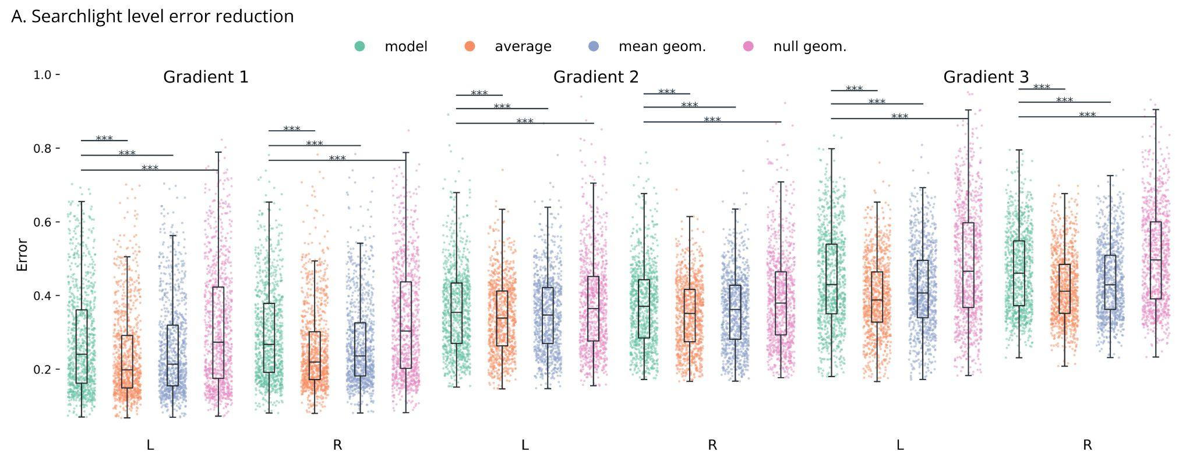

Figure 2 | Error-reduction tests
A. Box plots of searchlight-wise errors (mean absolute error) from the different iterations of the uncentered models of gradients one to three in the left (L) and right (R) hemisphere. Predictions based on true individual geometry have significantly lower error than those based on cross-subject permutations. However, they are still less accurate than the group average gradient and the predictions based on the group average geometry. ***: p<0.001.

