SUPPLEMENTARY MATERIALS
Title: Development of a multidomain neuromuscular aging clock integrating neurosensory dysfunction with molecular biomarkers
Authors: Apurba Kumar Ganguly, Ph.D.*, Sudip Kumar Banerjee, Ph.D. Vidya Sagar GV, MD, Ph.D. Dinesh Kumar Singal, MD. and Anondeep Ganguly, PGDH.
* Corresponding Author: Apurba Kumar Ganguly, Ph.D.; Address: 7, Panditya Place, Kolkata-700029, India; Tel: +919830389616; Email: apurbaganguly15@gmail.com.
Journal: Aging Clinical and Experimental Research

Supplementary Figure S5. Neuromuscular biological age estimation

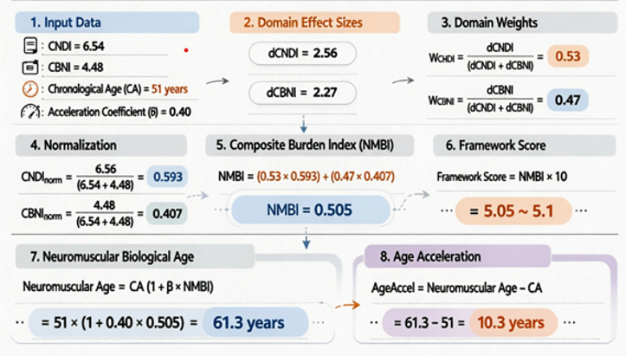
Schematic illustrating calculation of neuromuscular biological age using the Neuromuscular Aging Clock (NAC):
Neuromuscular Age = CA × (1 + β × NMBI)
where CA = chronological age, β = acceleration coefficient (0.40), NMBI = Neuromuscular Biological Age Index (weighted sum of normalized CNDI and CBNI). Age acceleration = Neuromuscular Age − CA.

