SUPPLEMENTARY MATERIALS
Title: Development of a multidomain neuromuscular aging clock integrating neurosensory dysfunction with molecular biomarkers
Authors: Apurba Kumar Ganguly, Ph.D.*, Sudip Kumar Banerjee, Ph.D. Vidya Sagar GV, MD, Ph.D. Dinesh Kumar Singal, MD. and Anondeep Ganguly, PGDH.
* Corresponding Author: Apurba Kumar Ganguly, Ph.D.; Address: 7, Panditya Place, Kolkata-700029, India; Tel: +919830389616; Email: apurbaganguly15@gmail.com.

Journal: Aging Clinical and Experimental Research

Supplementary Figure S4. Domain-level contributions to CNDI and CBNI
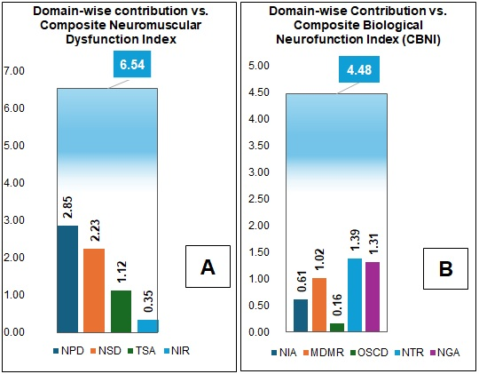
Proportional contributions of clinical neurosensory domains to the Composite Neuromuscular Dysfunction Index (CNDI). (B) Proportional contributions of molecular biomarker domains to the Composite Biological Neurofunctional Index (CBNI). Values represent weighted contributions (∑d × W<sub>d</sub>) normalized to total index score.

