SUPPLEMENTARY MATERIALS
Title: Development of a multidomain neuromuscular aging clock integrating neurosensory dysfunction with molecular biomarkers
Authors: Apurba Kumar Ganguly, Ph.D.*, Sudip Kumar Banerjee, Ph.D. Vidya Sagar GV, MD, Ph.D. Dinesh Kumar Singal, MD. and Anondeep Ganguly, PGDH.
* Corresponding Author: Apurba Kumar Ganguly, Ph.D.; Address: 7, Panditya Place, Kolkata-700029, India; Tel: +919830389616; Email: apurbaganguly15@gmail.com.

Journal: Aging Clinical and Experimental Research

Supplementary Figure S3. Forest plots of standardized mean differences

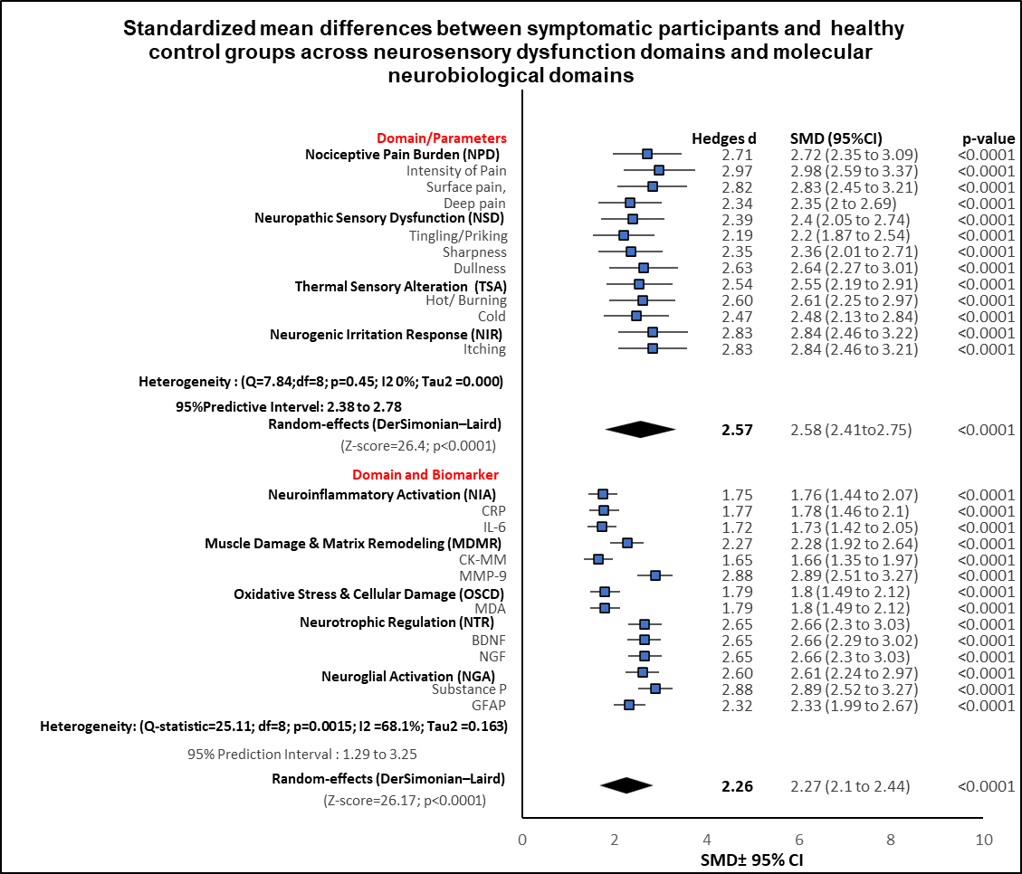
(A) Clinical neurosensory dysfunction domains. (B) Molecular neurobiological biomarker domains. Standardized mean differences (Hedges' g) with 95% confidence intervals comparing symptomatic participants (n = 108) and healthy controls (n = 108). Pooled estimates derived using random-effects (DerSimonian–Laird) meta-analysis. Heterogeneity assessed using I² statistic.

