SUPPLEMENTARY MATERIALS
Title: Development of a multidomain neuromuscular aging clock integrating neurosensory dysfunction with molecular biomarkers
Authors: Apurba Kumar Ganguly, Ph.D.*, Sudip Kumar Banerjee, Ph.D. Vidya Sagar GV, MD, Ph.D. Dinesh Kumar Singal, MD. and Anondeep Ganguly, PGDH.
* Corresponding Author: Apurba Kumar Ganguly, Ph.D.; Address: 7, Panditya Place, Kolkata-700029, India; Tel: +919830389616; Email: apurbaganguly15@gmail.com.

Journal: Aging Clinical and Experimental Research

Supplementary Figure S6. Conceptual framework of the Neuromuscular Aging Clock (NAC)

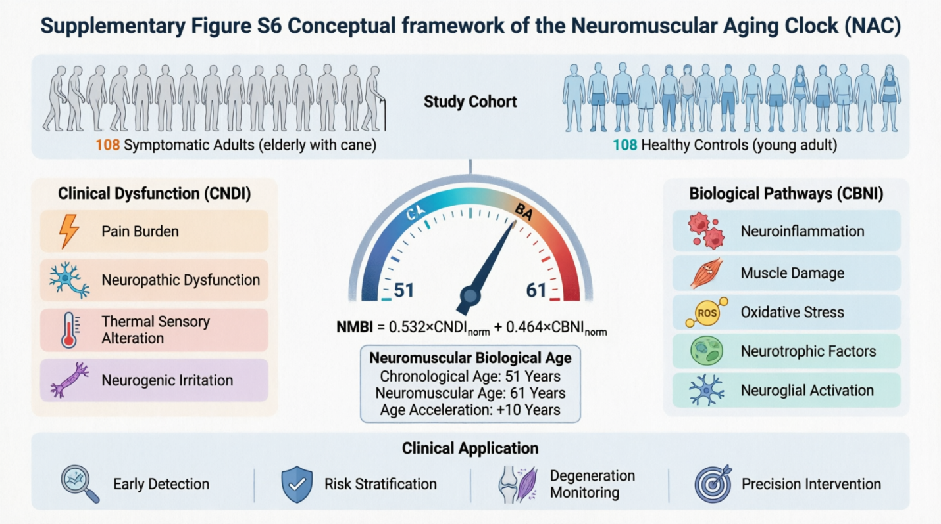
Integrated model showing: (1) clinical neurosensory domains → Composite Neuromuscular Dysfunction Index (CNDI); (2) molecular biomarker domains → Composite Biological Neurofunctional Index (CBNI); (3) effect-size weighting → Neuromuscular Biological Age Index (NMBI); (4) biological age estimation and risk stratification. The framework enables quantification of neuromuscular aging trajectories and identification of accelerated aging.

