Supplementary Information
Supp. Table 1. Parasite clearance following artesunate treatment at enrollment and upon recurrences. Participants with detectable parasitemia by microscopy are indicated. Parasite clearance at inclusion (D0) is shown for patients who did not develop relapses during the 90-day follow-up (No relapse) versus those who did (Relapse). D0 denotes the day of enrollment, and R1, R2, and R3 denote the 1st, 2nd, and 3rd relapse, respectively.

Time since 1st dose | D0  (No relapse)  n = 11 | D0 (Relapse)  n = 48 | R1  n = 47 | R2  n = 32 | R3  n = 18 | R4  n = 1
24h | 27% (3) | 29% (14) | 15% (7) | 16% (5) | 6% (1) | 100% (1)
48h | 0 | 6% (3) | 4% (2) | 3% (1) | 0 | 0
72h | 0 | 0 | 0 | 0 | 0 | 0

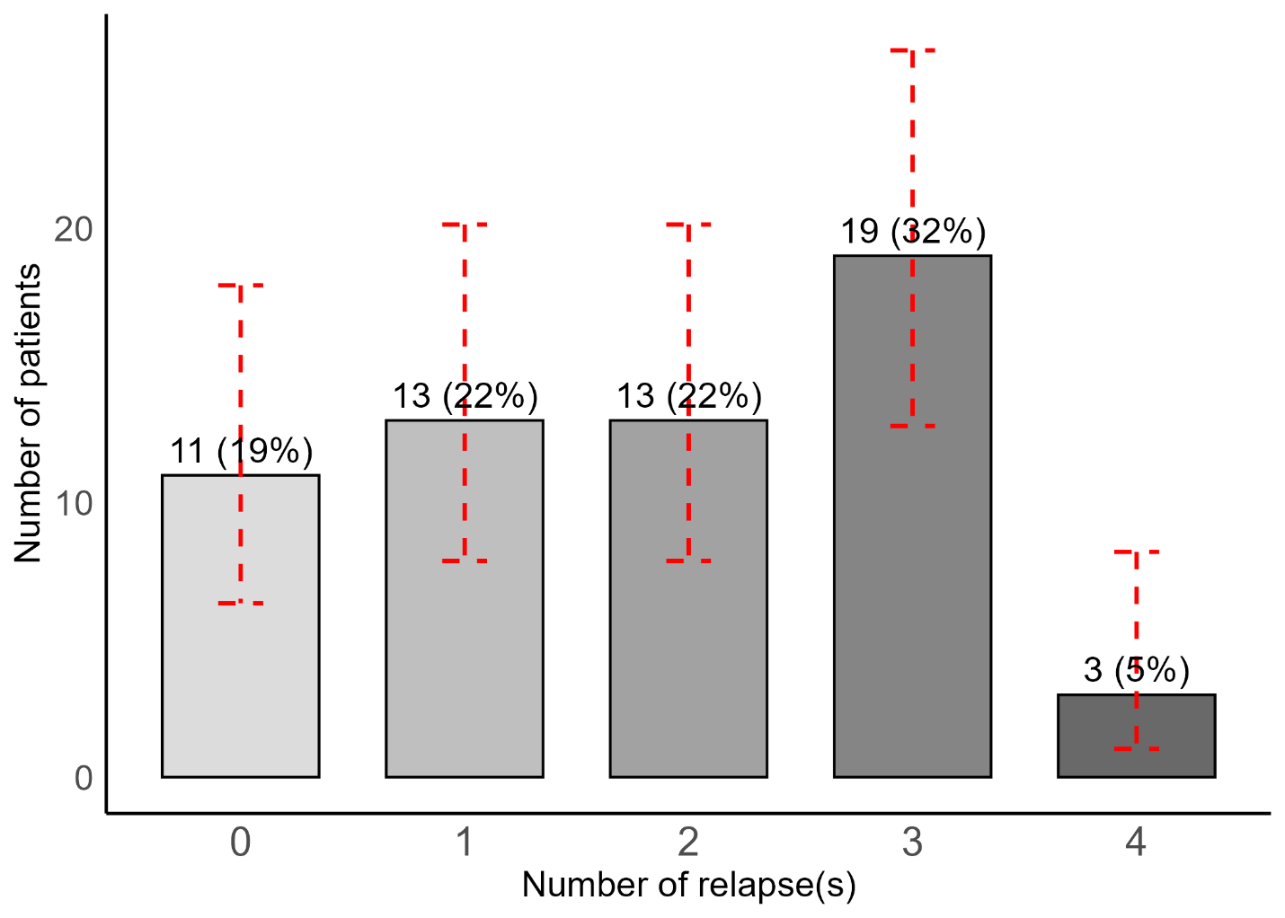Supp. Fig.1. Distribution of P. vivax-infected patients by number of relapses detected over the 90-day follow-up. The x-axis shows the total number of relapses per patient over 90 days, and the y-axis shows the number of patients (n, %). The red dashed error bars represent the 95% confidence interval.

Supp. Table 2. Poisson regression model to predict whether clinical parameters at enrollment are associated with the total number of relapses per patient.
Predictors | IRR | CI | χ2 | p value
log(Parasitemia) | 1.02 | 0.89–1.15 | 0.06 | 0.81
Hemoglobin | 1.00 | 0.89–1.12 | 0.00 | 0.97
log(Neutrophils) | 1.39 | 0.99–1.96 | 3.82 | 0.05
log(Eosinophils) | 1.02 | 0.86–1.22 | 0.07 | 0.80
log(Basophils) | 0.90 | 0.71–1.13 | 0.82 | 0.37
Lymphocytes | 0.88 | 0.67–1.16 | 0.84 | 0.36
log(Monocytes) | 0.96 | 0.67–1.37 | 0.06 | 0.81
Platelets | 1.00 | 0.99–1.00 | 0.28 | 0.59

Supp. Table 3. Logistic regression model to predict whether clinical parameters at enrollment could impact the risk of having relapses or not.
Predictors | OR | CI | χ2 | p value
log(Parasitemia) | 0.73 | 0.36–1.48 | 1.06 | 0.30
Hemoglobin | 1.04 | 0.67–1.61 | 0.03 | 0.85
log(Neutrophils) | 2.04 | 0.61–6.82 | 1.43 | 0.23
log(Eosinophils) | 0.88 | 0.43–1.80 | 0.13 | 0.72
log(Basophils) | 0.87 | 0.38–2.01 | 0.10 | 0.75
Lymphocytes | 0.53 | 0.20–1.38 | 1.80 | 0.18
log(Monocytes) | 0.67 | 0.14–3.33 | 0.25 | 0.62
Platelets | 1.01 | 0.99–1.04 | 1.52 | 0.22

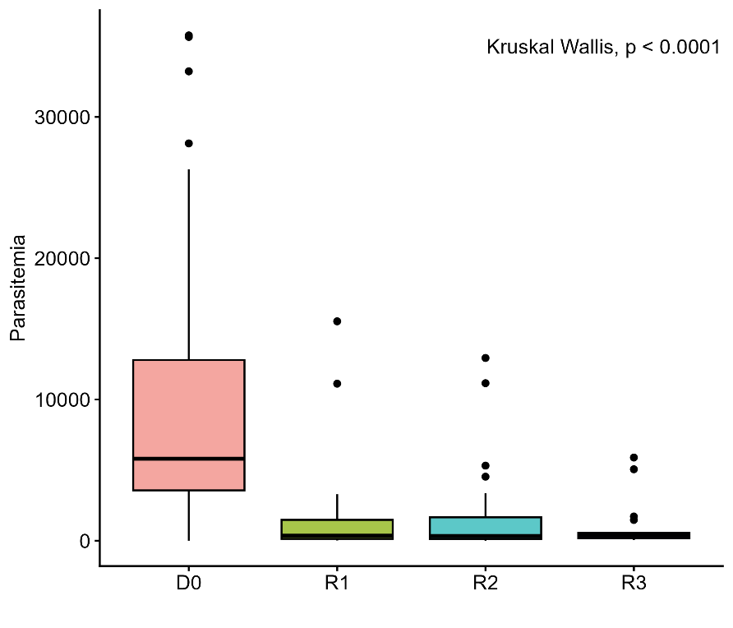
Supp. Fig. 2. Parasitemia comparison between infection episodes (including D0, R1, R2, and R3). There is a significant difference between Parasitemia at enrollment and relapse episodes (Kruskal-Wallis, p < 0.0001), whereas there is no significant difference among relapse episodes (R1, R2, and R3; Kruskal-Wallis, p = 0.98; Supp. Table 5). D0 denotes the day of enrollment, and R1, R2, and R3 denote the 1st, 2nd, and 3rd relapse, respectively.

Supp. Table 4. Proportion of patients with abnormal clinical parameters on the day of enrollment and at each relapse.
 | Enrollment  (n =59) | First relapse  (n=48) | Second relapse  (n = 35) | Third relapse (n=22)
Age (years) | 20 (18-28) | 20 (17-27) | 20 (17-24) | 19 (17-23)
Sex
Male | 54 (92%) | 44(92%) | 32 (91%) | 21(96%)
Female | 5 (8%) | 4 (8%) | 3 (9%) | 1 (5%)
Parasitemia (p/ul) | 5,805 (3,566- 12,787) | 350 (124- 1,577) | 334 (119-1,657) | 380 (167-553)
Symptoms reported
Asymptomatic patients | 0 | 40 | 27 | 14
Symptomatic patients | 59 | 7 | 6 | 4
Fever and/or Frisson | 59 | 6 | 4 | 4
Influenza-like symptoms | 0 | 0 | 1 | 0
Headache | 48 | 1 | 0 | 2
Abdominal pain | 1 | 0 | 1 | 0
Vomiting | 4 | 0 | 0 | 0
Diarrhoea | 1 | 0 | 0 | 0
Hematological parameters
Platelets < 200 x 10⁹ cells/L | 57/59 (97%) | 35/47 (74%) | 23/33 (70%) | 12/18 (67%)
Leukocytes < 4 x10⁹ cells/L | 7/59 (12%) | 2/45 (4%) | 2/33 (6%) | 1/18 (6%)
Lymphocytes < 10⁹ cells/L | 8/59 (14%) | 1/45 (2%) | 0/33 (0%) | 0/18 (0%)
Monocytes > 10⁹ cells/L | 8/59 (14%) | 2/45 (4%) | 3/33 (9%) | 1/18 (6%)
Basophils > 0.11 x10⁹ cells/L | 5/59 (8%) | 6/45 (13%) | 3/33 (9%) | 1/18 (6%)
Eosinophils > 0.50 x 10⁹ cells/L | 8/59 (14%) | 21/45 (47%) | 16/33 (49%) | 11/18 (61%)
Neutrophils > 7.5 x10⁹ cells/L | 2/59 (3%) | 1/45 (2%) | 1/33 (3%) | 2/18 (11%)
RBC ≤ 4.5 x10¹² cells/L | 10/59 (17%) | 1/44 (2%) | 3/33 (9%) | 1/18 (6%)
Hemoglobin < 13 g/dL | 24/59 (41%) | 21/44 (48%) | 7/33 (21%) | 7/18 (39%)
Hematocrit % < 40% | 25/59 (42%) | 15/44 (34%) | 6/33 (18%) | 5/18 (28%)
M.C.V < 80fL | 34/59 (58%) | 24/45 (53%) | 21/33 (64%) | 13/18 (72%)
M.C.H < 27 pg | 39/59 (66%) | 33/45 (73%) | 25/33 (76%) | 15/18 (83%)
M.C.H.C < 32 % | 19/59 (32%) | 20/45 (44%) | 11/33 (33%) | 8/18 (44%)
SpCO > 10% | 7/59 (12%) | 1/45 (2%) | 0/33 (0%) | 0/18 (0%)
SpMet ≥ 3% | 2/59 (3%) | 1/45 (2%) | 0/33 (0%) | 0/18 (0%)
SpO2 < 95% | 0/59 (0%) | 0/45 (0%) | 0/33 (0%) | 0/18 (0%)
Perfusion index < 0.5% | 5/59 (8%) | 1/47 (2%) | 1/33 (3%) | 0/18 (0%)
Pulse rate > 100 BPM | 10/59 (17%) | 5/47 (11%) | 5/33 (15%) | 2/18 (11%)
median (IQR), n (%)

Supp. Table 5. Characteristics of clinical parameters of patients at enrollment and at each relapse.
 | Enrollment | First relapse | Second relapse | Third relapse
Parasitemia (p/µL) | 5,805 (3,566-12,787) | 350 (124-1,577) | 334 (119-1,657) | 380 (167-553)
RBC, 10¹² cells/L | 5.2 (4.7-5.8) | 5.4 (5.1-6.2) | 5.7 (5.2-6.2) | 5.9 (5.2-6.3)
Hemoglobin, g/dL | 13.2 (12.0-14.3) | 13.1 (12.4-14.7) | 13.8 (13.0-14.9) | 14.1 (12.6-15.1)
Hematocrit, % | 41.1 (37.1-43.9) | 40.8 (38.7-44.9) | 43.0 (40.5-44.8) | 43.7 (39.8-46.3)
M.C.V, fL | 79.0 (73.0-85.0) | 79.0 (69.0-84.0) | 77.0 (72.0-81.0) | 76.0 (73.0-80.0)
M.C.H, pg | 25.6 (23.3-28.5) | 25.7 (21.7-27.0) | 25.5 (22.9-26.5) | 24.6 (21.9-25.9)
M.C.H.C, % | 32.5 (31.6-33.2) | 32.0 (31.5-32.9) | 32.5 (31.8-33.2) | 32.4 (31.3-32.9)
Leukocytes, 10⁹ cells/L | 6.5 (4.9-7.5) | 6.5 (5.5-8.0) | 7.8 (5.9-8.9) | 7.8 (5.8-10.3)
Neutrophils, 10⁹ cells/L | 3.4 (2.4-4.2) | 3.1 (1.9-3.9) | 3.9 (3.1-4.9) | 3.8 (2.6-6.1)
Eosinophils, 10⁹ cells/L | 0.1 (0.1-0.3) | 0.5 (0.3-0.8) | 0.5 (0.2-0.7) | 0.6 (0.3-0.8)
Basophils,10⁹ cells/L | 0.1 (0.0-0.1) | 0.1 (0.0-0.1) | 0.1 (0.0-0.1) | 0.1 (0.1-0.1)
Lymphocytes, 10⁹ cells/L | 1.9 (1.3-2.6) | 2.2 (1.7-2.8) | 2.2 (1.7-2.5) | 2.4 (1.8-3.0)
Monocytes, 10⁹ cells/L | 0.6 (0.3-0.9) | 0.6 (0.5-0.7) | 0.6 (0.5-0.8) | 0.6 (0.5-0.7)
Platelets, 10⁹ cells/L | 91.0 (64.0-128.0) | 172.0 (149.0-192.0) | 173.0 (139.0-210.0) | 190.5 (138.0-212.0)
SpO2, % | 99.0 (98.0-100.0) | 99.0 (99.0-100.0) | 99.0 (99.0-100.0) | 99.0 (99.0-100.0)
SpMet, % | 0.8 (0.5-1.2) | 0.8 (0.4-1.2) | 0.9 (0.5-1.1) | 0.8 (0.1-0.9)
SpCO, % | 6.0 (4.0-8.0) | 3.0 (2.0-6.0) | 4.0 (2.0-7.0) | 4.5 (1.0-7.0)
Pulse rate, BPM | 85.0 (76.0-97.0) | 83.0 (76.0-93.0) | 94.0 (86.0- 99.0) | 89.0 (82.0-94.0)
Perfusion index, % | 4.6 (1.6-7.3) | 4.2 (2.1-6.0) | 5.4 (2.1-6.9) | 4.5 (2.3-6.8)
Temperature, °C | 37.3 (36.9-38.0) | 36.8 (36.6-37.0) | 36.9 (36.5-37.5) | 36.8 (36.6-37.1)
median (IQR)

Supp. Table 6: Overall effect of relapse rank on the clinical parameters.
Outcome | F (NumDF, DenDF) | p value | Significance
RBC | F(2, 52.04) = 4.16 | 0.02 | *
Hemoglobin | F(2, 47.67) = 5.62 | 0.006 | **
Hematocrit | F(2, 47.36) = 4.63 | 0.02 | *
M.C.V | F(2, 51.50) = 0.45 | 0.64 | ns
M.C.H | F(2, 51.36) = 1.15 | 0.32 | ns
M.C.H.C | F(2, 52.86) = 2.19 | 0.12 | ns
Leukocytes | F(2, 55.32) = 2.49 | 0.09 | ns
Neutrophils | F(2, 55.57) = 3.40 | 0.04 | *
Log(Eosinophils) | F(2, 62.30) = 4.08 | 0.02 | *
Log(Basophils) | F(2, 69.74) = 0.95 | 0.39 | ns
Lymphocytes | F(2, 58.02) = 1.00 | 0.37 | ns
Monocytes | F(2, 70.81) = 0.61 | 0.55 | ns
Platelets | F(2, 54.88) = 0.17 | 0.85 | ns
Log(SpO2) | F(2, 52.79) = 1.18 | 0.32 | ns
Log(SpMet) | F(2, 54.47) = 5.52 | 0.01 | **
Log(SpCO) | F(2, 48.92) = 2.41 | 0.100 | ns
Log(Pulse_rate) | F(2, 59.37) = 3.60 | 0.03 | *
Perfusion_index | F(2, 61.24) = 1.43 | 0.25 | ns
Temperature | F(2, 62.84) = 2.06 | 0.14 | ns
*: p<0.05, **: p<0.01, ns: non-significant

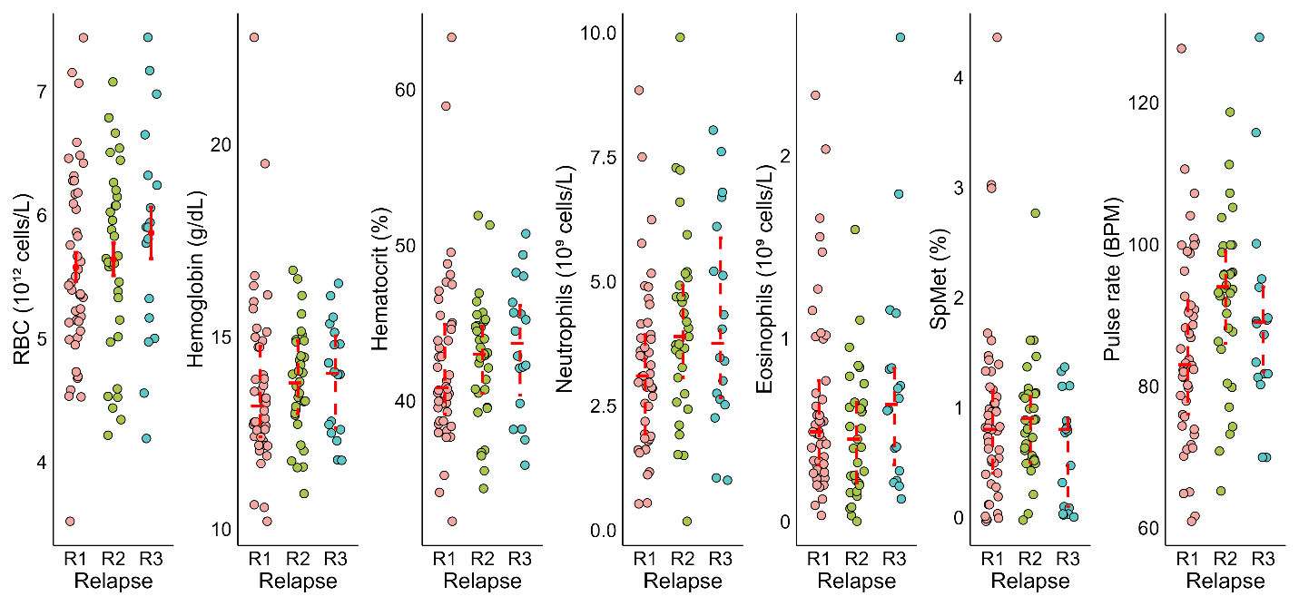
Supp. Fig. 3. Significant overall effect of the relapse ranks on six parameters, including red blood cell counts, hemoglobin, neutrophil counts, eosinophil counts, SpMet, and pulse rate. For RBC counts, the red dot represents the mean, and the error bars represent the standard deviation. For the other panels, median and IQR are represented. R1, R2 and R3 denote as 1st, 2nd, and 3rd relapse, respectively.

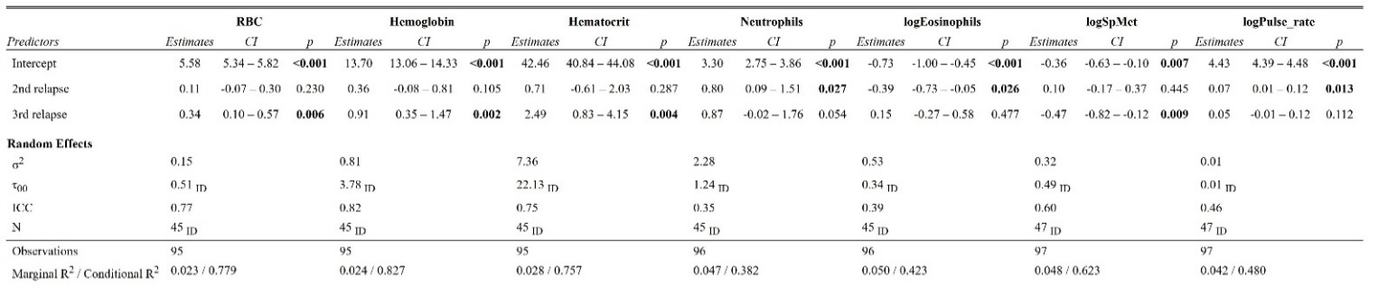
Supp. Table 7. Impact of the relapse rank on clinical parameters at the individual level. The first relapse is the baseline in the conditional model.

Supp. Table 8. Likelihood ratio test of the random effect of patient ID on clinical and hematological parameters.
Outcome | χ2 | p value | Significance
RBC | 45.68 | <0.001 | ***
Hemoglobin | 34.32 | <0.001 | ***
Hematocrit | 25.93 | <0.001 | ***
M.C.V | 127.19 | <0.001 | ***
M.C.H | 137.00 | <0.001 | ***
M.C.H.C | 39.53 | <0.001 | ***
Leukocytes | 19.45 | <0.001 | ***
Neutrophils | 5.90 | 0.02 | *
logEosinophils | 11.26 | <0.001 | ***
logBasophils | 0.32 | 0.57 | ns
Lymphocytes | 14.77 | <0.001 | ***
Monocytes | 4.87 | 0.03 | *
Platelets | 2.49 | 0.11 | ns
logSpO2 | 2.95 | 0.09 | ns
logSpMet | 24.90 | <0.001 | ***
logSpCO | 10.72 | 0.001 | **
logPulse_rate | 14.48 | <0.001 | ***
Perfusion_index | 12.02 | <0.001 | ***
Temperature | 3.88 | 0.05 | *
*: p<0.05, **: p<0.01, ***: p<0.001, ns: non-significant

Supp. Table 9. Linear mixed-effects regression model with random intercept of patient ID, to examine whether the relapse ranks and clinal parameters could influence the growth rate of parasites (slope).
Predictor | F (NumDF, DenDF) | p value
Relapse | F(2, 55.14) = 1.52 | 0.23
Hemoglobin | F(1, 75.94) = 0.47 | 0.50
Neutrophils | F(1, 80.48) = 1.53 | 0.22
logEosinophils | F(1, 77.85) = 1.54 | 0.22
logBasophils | F(1, 71.44) = 1.79 | 0.19
Lymphocytes | F(1, 84.05) = 1.56 | 0.21
logMonocytes | F(1, 78.99) = 0.01 | 0.93
Platelets | F(1, 73.93) = 0.41 | 0.53

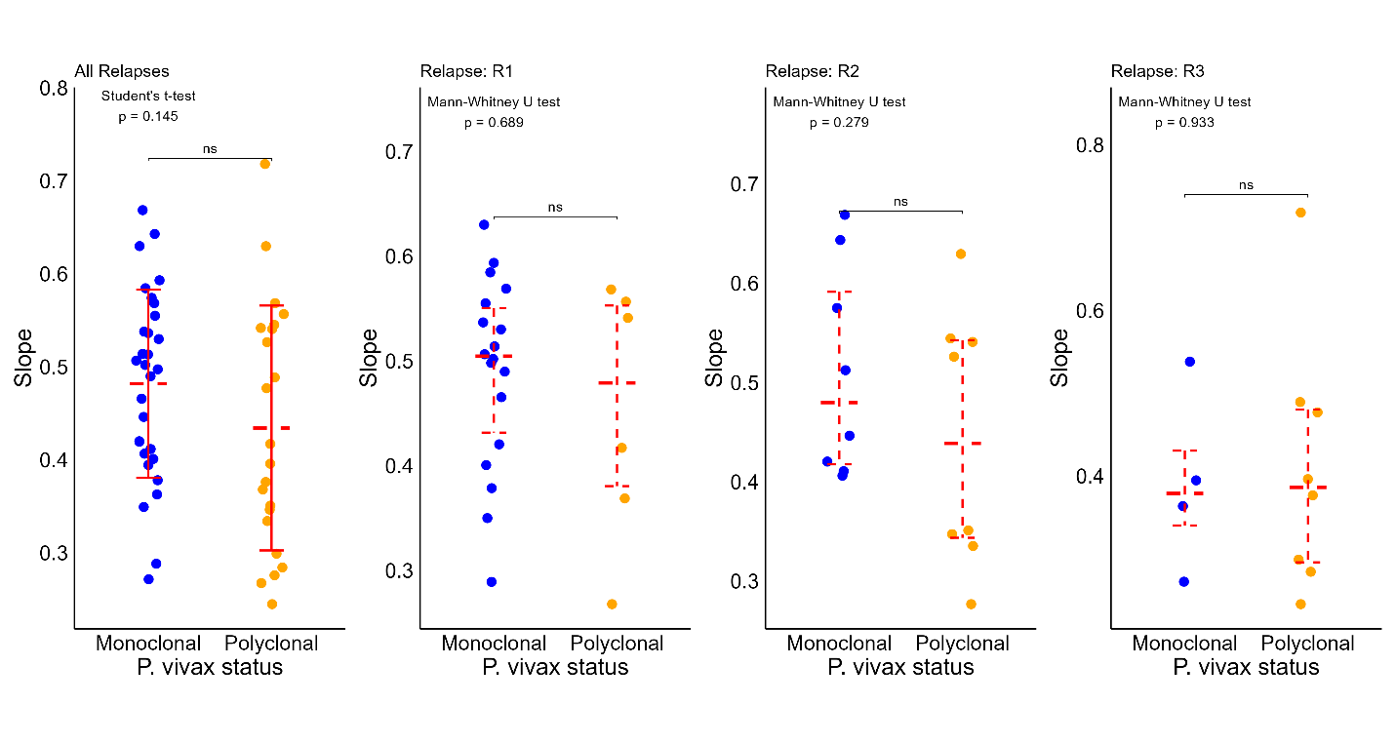
Supp. Fig. 4. Comparison of the growth rate (slope) of P. vivax between monoclonal and polyclonal samples in all of relapse ranks (R1, R2, and R3). There is no significant difference between the two groups for all relapses (t-test, p = 0.145), as well as R1 (Mann-Whitney, p = 0.689), R2 (Mann-Whitney, p = 0.279), and R3 (Mann-Whitney, p = 0.933). R1, R2, and R3 denote as 1st 2nd, and 3rd relapse, respectively.

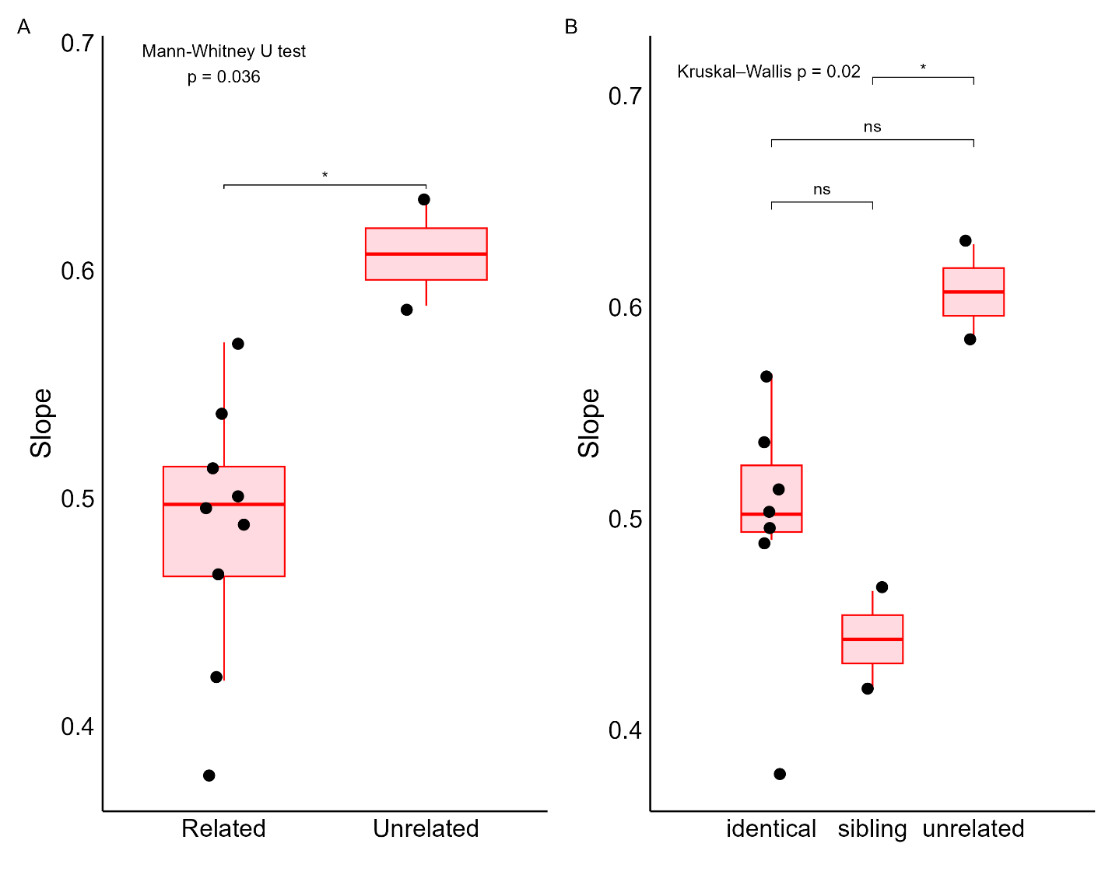
Supp. Fig. 5. Comparison of growth rates of parasites upon first relapse in monoclonal infections. A. Comparison of the slope between genetically related and unrelated clones compared to the initial infection (Mann-Whitney, p=0.036). B. Comparison of the slope of identical, sibling, and unrelated clones of P. vivax parasites compared to the initial infection (Kruskal-Wallis, p=0.02). In both panels, box plots represent median (and IQR) slopes.

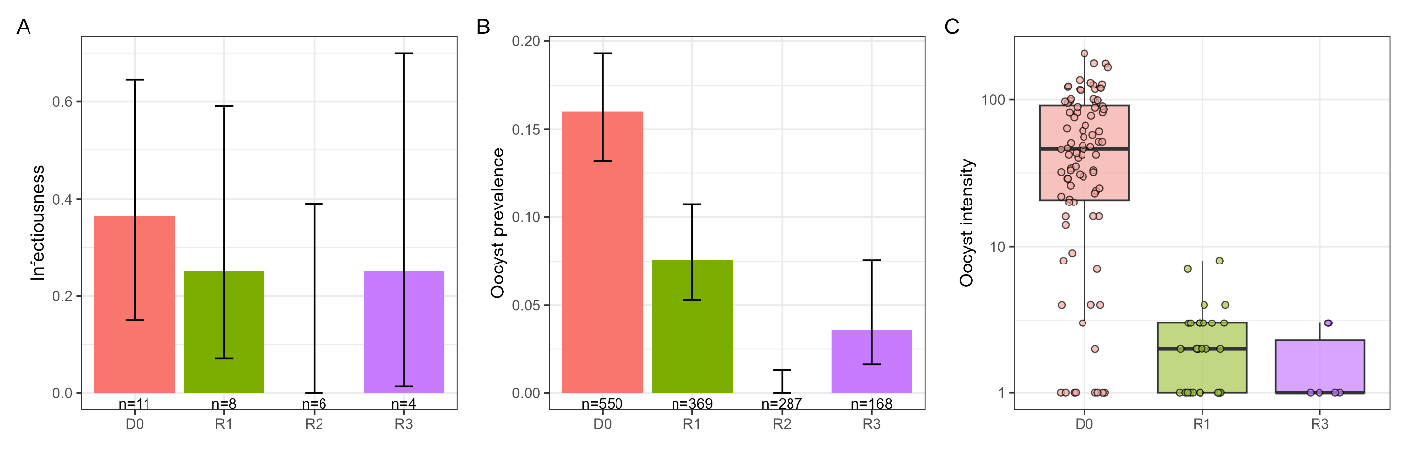
Supp. Fig. 6. Effect of the infection episodes (D0, R1, R2, R3) on P. vivax transmission to Anopheles dirus in membrane-feeding assays without serum replacement. A. Infectiousness B. Oocyst prevalence C. Oocyst intensity measured at 6 days post-blood meal (dpbm) as a function of infection episodes. Due to the small sample size, the oocyst prevalence is low overall, and there is no significant effect of infection episodes when focusing on this natural serum alone (LRT $χ_{3}^{2}$= 4.2, p = 0.24). D0 denotes the day of enrollment, and R1, R2, and R3 denote the 1st, 2nd, and 3rd relapse, respectively.

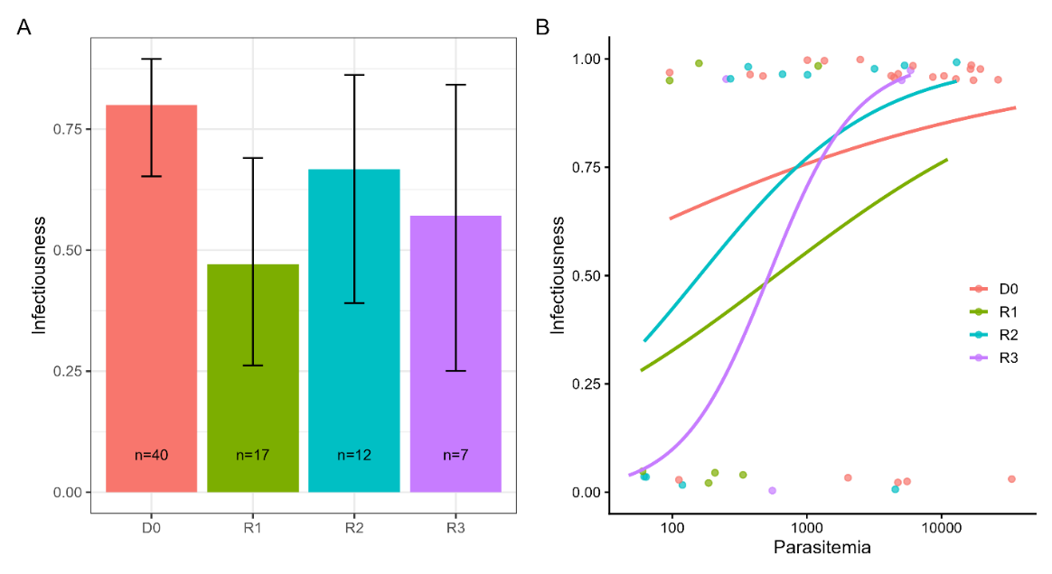
Supp. Fig. 7. Infectiousness (proportion of MFA resulting in at least one infected mosquito) as a function of infection episodes with serum replacement. A. Infectiousness as a function of infection episodes. Error bars represent 95% confidence intervals. The number of MFA contributing to infection episodes (D0, R1, R2, R3) is indicated within the bars. B. Relationship between parasitemia and infectiousness stratified by infection episodes. The solid lines represent predicted infectious probability from a binomial glm. D0 denotes the day of enrollment, and R1, R2, and R3 denote the 1st, 2nd, and 3rd relapse, respectively.

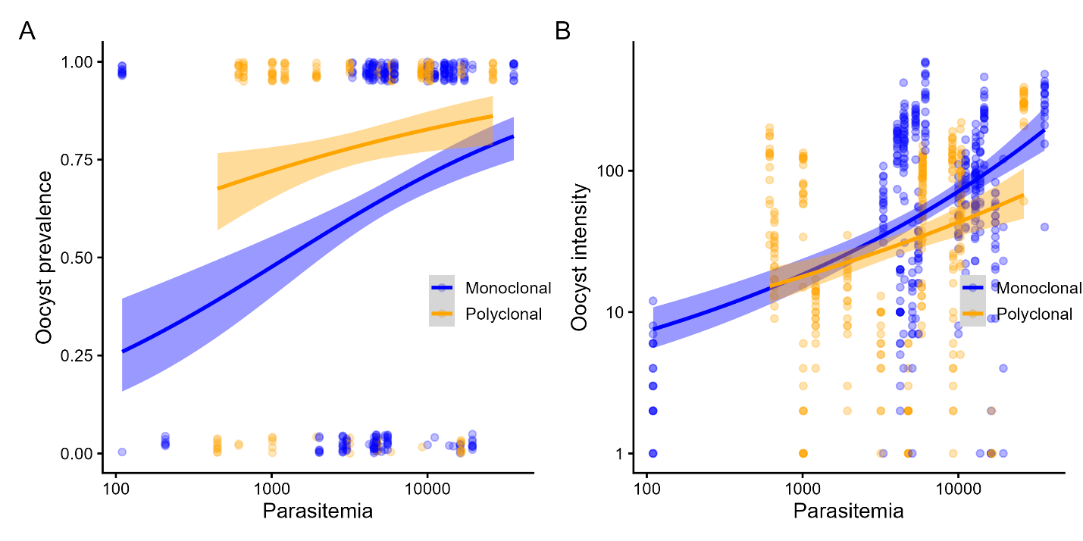
Supp. Fig. 8. Effect of parasitemia and complexity of infection (monoclonal vs. polyclonal) on mosquito infection. A. oocyst prevalence and B. oocyst intensity at 6 dpbm stratified by complexity of infection and parasitemia. Each point denotes an individual mosquito. The solid lines represent best-fit estimates for the complexity of infection (logistic regression for prevalence; quasi-Poisson for intensity) with shaded areas indicating the 95% confidence intervals.

Supp. Table 10. Summarized results of the membrane feeding assays to evaluate transmission to A. dirus mosquitoes upon infection episodes (D0, R1, R2, R3).
ID | Episode | Parasitemia /µl | Average oocyst count (serum replacement) | % Infection rate (serum replacement) | Average oocyst count (no serum replacement) | % Infection rate (no serum) | Complexity of infection
31 | D0 | 4762 | 1.8 | 75 | - | - | P
51 | D0 | 378 | 0.3 | 15 | - | - | -
32 | D0 | 9147 | 134.4 | 100 | - | - | P
2 | D0 | 16221 | 0.75 | 30 | - | - | M
3 | D0 | 16640 | 136.2 | 100 | - | - | -
4 | D0 | 10000 | 45.75 | 90 | - | - | M
21 | D0 | 2491 | 43.85 | 100 | - | - | -
33 | D0 | 4740 | 0 | 0 | - | - | P
33 | R1 | 614 | 95.6 | 80 | - | - | -
33 | R2 | 156 | 0.7 | 35 | - | - | P
52 | D0 | 4444 | 140.25 | 90 | - | - | M
5 | D0 | 17254 | 42.2 | 100 | - | - | M
5 | R1 | 335 | 0 | 0 | - | - | -
5 | R2 | 367 | 0.2 | 5 | - | - | -
6 | D0 | 5531 | 30.95 | 100 | - | - | M
6 | R1 | 3026 | 0 | 0 | - | - | M
6 | R2 | 12937 | 109.7 | 100 | - | - | M
22 | D0 | 1349 | 26.15 | 100 | - | - | -
34 | D0 | 1938 | 14 | 95 | - | - | P
34 | R2 | 64 | 0 | 0 | - | - | -
53 | D0 | 13785 | 79.2 | 95 | - | - | M
8 | D0 | 35769 | 281.85 | 90 | - | - | M
59 | D0 | 33226 | 0 | 0 | - | - | -
36 | D0 | 5893 | 80 | 100 | - | - | P
23 | D0 | 8618 | 0.2 | 5 | - | - | -
23 | R3 | 5890 | 102 | 100 | - | - | P
37 | D0 | 10430 | 90.3 | 100 | - | - | P
37 | R1 | 110 | 3.65 | 90 | - | - | M
37 | R3 | 251 | 1.6 | 60 | - | - | -
38 | D0 | 9246 | 13.7 | 90 | - | - | P
38 | R2 | 1010 | 1.05 | 55 | - | - | P
39 | D0 | 5805 | 26.25 | 95 | - | - | P
39 | R1 | 58 | 0 | 0 | - | - | -
40 | D0 | 1008 | 83.35 | 100 | - | - | P
41 | D0 | 16406 | 0.4 | 15 | - | - | P
41 | R1 | 3295 | 55.8 | 95 | - | - | M
10 | D0 | 2020 | 0 | 0 | - | - | M
42 | R1 | 96 | 0.1 | 5 | - | - | -
11 | D0 | 4508 | 162.05 | 95 | - | - | M
11 | R2 | 5313 | 182.9 | 85 | - | - | M
12 | D0 | 4032 | 0 | 0 | - | - | N
12 | R1 | 11117 | 80.85 | 95 | - | - | M
12 | R2 | 4533 | 0 | 0 | 0 | 0 | -
13 | D0 | 19420 | 9.45 | 25 | - | - | M
14 | D0 | 6130 | 342.2 | 100 | 0 | 0 | M
15 | R2 | 3175 | 5.15 | 80 | 0 | 0 | M
15 | R3 | 5058 | 10.15 | 75 | 0.28 | 17 | P
43 | R1 | 189 | 0 | 0 | 0 | 0 | -
43 | R3 | 448 | 0 | 0 | 0 | 0 | P
44 | D0 | 26295 | 297.25 | 100 | - | - | P
44 | R1 | 1213 | 11.15 | 100 | 1.06 | 36 | -
44 | R3 | 47 | 0 | 0 | 0 | 0 | P
45 | R1 | 1578 | 2.2 | 60 | 0.36 | 20 | P
24 | D0 | 0 | 0 | 0 | 0 | 0 | -
46 | D0 | 10284 | 60.15 | 100 | 0.02 | 2 | P
46 | R2 | 119 | 0 | 0 | 0 | 0 | -
46 | R3 | 1470 | 10.1 | 85 | 0 | 0 | -
55 | D0 | 14635 | 243.5 | 95 | 35.12 | 74 | M
56 | D0 | 4048 | 157.55 | 100 | 76.04 | 98 | M
25 | D0 | 96 | 5 | 100 | 0 | 0 | -
25 | R1 | 186 | 0 | 0 | 0 | 0 | -
47 | R1 | 158 | 1.6 | 40 | - | - | -
26 | D0 | 471 | 4.55 | 80 | 0.13 | 14 | -
26 | R2 | 271 | 4 | 95 | 0 | 0 | -
17 | R1 | 2857 | 0 | 0 | 0 | 0 | M
17 | R2 | 62 | 0 | 0 | 0 | 0 | -
17 | R3 | 554 | 0 | 0 | - | - | -
27 | D0 | 112 | 0 | 0 | 0 | 0 | -
27 | R1 | 60 | 0 | 0 | 0 | 0 | -
57 | D0 | 4683 | 0 | 0 | 0 | 0 | M
18 | D0 | 12788 | 63 | 100 | - | - | M
18 | R1 | 158 | 0 | 0 | 0 | 0 | -
19 | D0 | 4227 | 11.7 | 95 | 0 | 0 | M
48 | R1 | 208 | 0 | 0 | 0 | 0 | M
48 | R2 | 659 | 27.55 | 100 | 0 | 0 | P
58 | D0 | 5546 | 0 | 0 | 0 | 0 | M
P: Polyclonal, M: Monoclonal, D0: enrolment, R1, R2, R3: 1st, 2nd, 3rd relapse, respectively

