Supplementary Information

Comparative genomics of the Nap2-2B clade reveals substrate partitioning, niche diversification, and reciprocal cofactor auxotrophies among uncultured hydrocarbon-degrading Peptococcaceae

Fig. S1. Pairwise average nucleotide identity (ANI) heatmap for 34 Nap2-2B genomes.

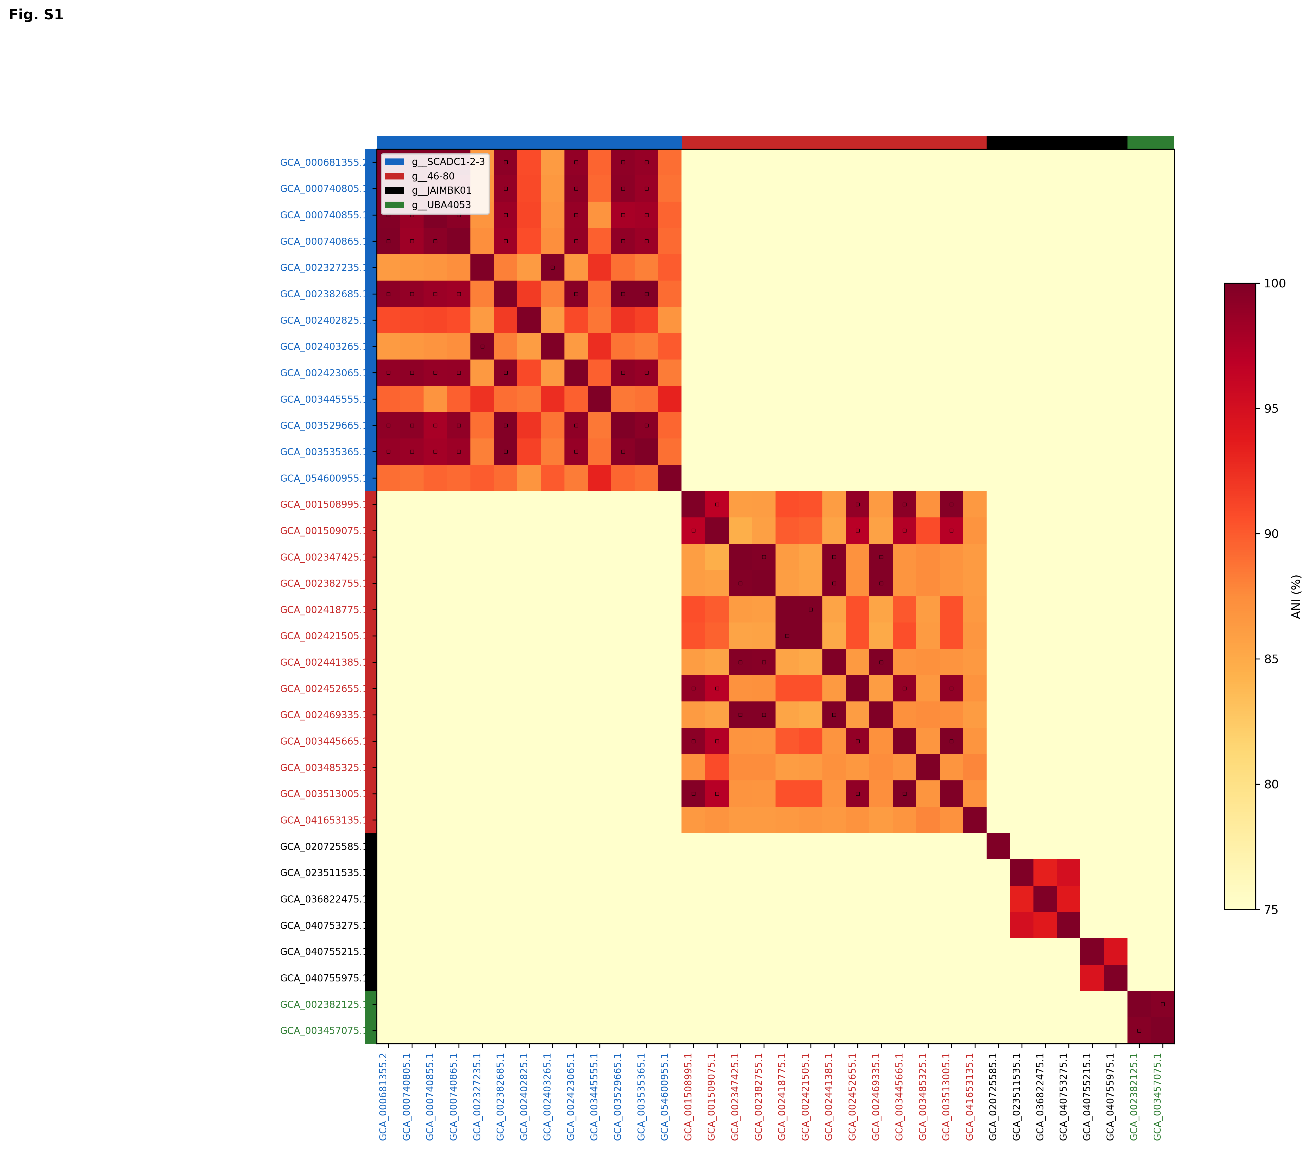

Pairwise ANI values were computed using skani v0.3.1 (1) for all 34 Nap2-2B genomes. The heatmap is colored using a YlOrRd gradient (75-100% ANI). Genomes are ordered by GTDB (2) genus assignment and colored accordingly: blue = SCADC1-2-3 (n=13), red = 46-80 (n=13), black = JAIMBK01 (n=6), green = UBA4053 (n=2). Colored bars along the top and left margins indicate genus membership. No inter-genus genome pair exceeded the 95% ANI species boundary threshold, confirming genus-level divergence. Within genera, multiple species-level clusters (>=95% ANI) were identified, particularly within SCADC1-2-3 and 46-80. Intra-genus ANI values range from ~78-89%, while inter-genus values are generally lower (75-82%).
Fig. S2. Genome assembly and quality statistics for 34 Nap2-2B genomes by genus.
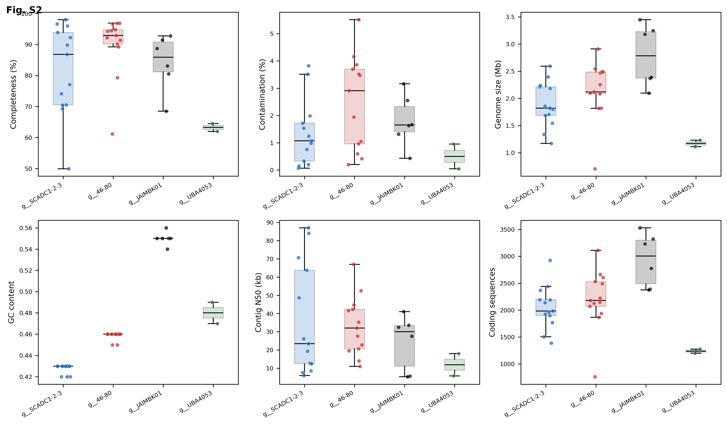

Box-and-strip plots of six genome quality and assembly metrics, grouped by GTDB genus: completeness (%, CheckM2 (3)), contamination (%, CheckM2), genome size (Mb), GC content, contig N50 (kb), and number of coding sequences. Individual genomes are shown as jittered points. Box plots show median (black line), interquartile range (shaded box), and whiskers. Colors as in Fig. S1.

Fig. S3. Pangenome analysis of 34 Nap2-2B genomes.
Pangenome analysis was performed using Panaroo v1.3 (4) with moderate clean mode and a core threshold of 0.95. (A) Pangenome composition showing the proportion of core (present in >=95% of genomes), soft-core (85-95%), shell (15-85%), and cloud (<15%) gene clusters. (B) Gene accumulation curve showing the total number of gene clusters as a function of the number of genomes sampled (mean +/- SD of 50 random permutations). The open pangenome indicates substantial gene content diversity across the Nap2-2B family.

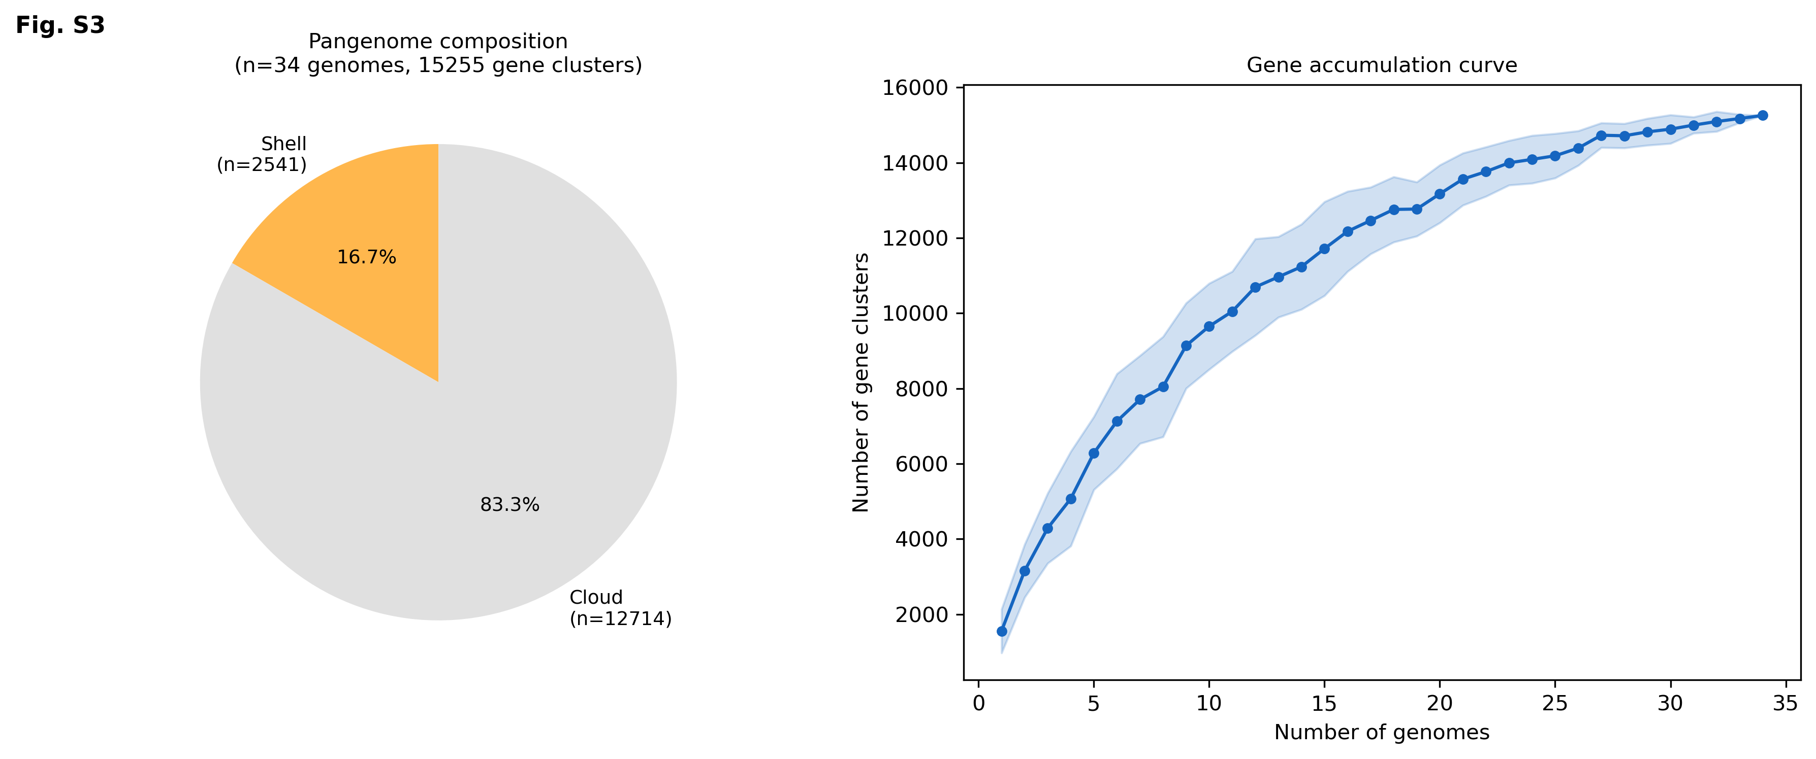

Supplementary Tables
- S1a: Subunit Summary. Summary of assD/bssD, bssB, bssC, and radical SAM subunit detection per assA/bssA operon across 18 Nap2-2B operons.
- S1b: DIAMOND Annotations. Full DIAMOND blastp annotations of all flanking genes (±7 positions) around assA/bssA anchor genes, including percent identity, alignment length, e-value, bitscore, and functional description.
- S2a: Genome Stats. Genome quality and assembly statistics for all 34 Nap2-2B metagenome-assembled genomes, including completeness, contamination, genome size, GC content, N50, coding sequence count, and coding density.
- S2b: Genus Summary. Summary statistics (mean ± SD) of genome quality metrics by GTDB genus.
- S3: ANI Matrix. Pairwise average nucleotide identity (ANI) matrix for all 34 Nap2-2B genomes computed using skani v0.3.1, with genus assignments.
- S3b: ANI Summary. Mean, minimum, and maximum ANI values summarized by genus pair.
- S4a: Indicator KOs. Genus-specific KEGG ortholog (KO) indicators identified by prevalence filtering (>=80% in target genus, <=20% in all others). Reports per-genus prevalence for all 34 genomes.
- S4b: Unique KOs. KOs unique to each genus (>=50% prevalence in target genus, 0% in all others), with per-genus prevalence values.
- S4c: Core KOs. Core KOs shared by all four genera (>=50% prevalence in each), with per-genus prevalence values. 666 KOs total.

Reference

1. Shaw J, Yu YW. Fast and robust metagenomic sequence comparison through sparse chaining with skani. Nature Methods. 2023 Sep;20(11):1661–5. doi:10.1038/s41592-023-02018-3
2. Chaumeil PA, Mussig AJ, Hugenholtz P, Parks DH. GTDB-Tk v2: memory friendly classification with the genome taxonomy database. Borgwardt K, editor. Bioinformatics. 2022 Oct;38(23):5315–6. doi:10.1093/bioinformatics/btac672
3. Chklovski A, Parks DH, Woodcroft BJ, Tyson GW. CheckM2: a rapid, scalable and accurate tool for assessing microbial genome quality using machine learning. Nature Methods. 2023 Jul;20(8):1203–12. doi:10.1038/s41592-023-01940-w
4. Tonkin-Hill G, MacAlasdair N, Ruis C, Weimann A, Horesh G, Lees JA, et al. Producing polished prokaryotic pangenomes with the Panaroo pipeline. Genome Biol. 2020 Jul 22;21:180. doi:10.1186/s13059-020-02090-4 PubMed PMID: 32698896; PubMed Central PMCID: PMC7376924.

