Table S1 Airport emission factors (kg/LTO)
Airport | HC | CO | NO_{X} | SO₂ | PM_{2.5}
First level | 1.11 | 10.22 | 20.19 | 1.20 | 0.18
Second level | 1.15 | 8.63 | 12.96 | 0.95 | 0.19
Third level | 1.09 | 8.31 | 13.37 | 0.98 | 0.27
Fourth level | 0.96 | 8.25 | 12.55 | 0.97 | 0.13
Table S2 Proportion of HC, CO, NO_{X} and PM emissions from civil aircraft in vehicle emissions
Year | HC | CO | NO_{X} | PM
2010 | 0.063% | 0.065% | 0.821% | 0.089%
2011 | 0.072% | 0.080% | 0.810% | 0.089%
2012 | 0.080% | 0.088% | 0.886% | 0.098%
2013 | 0.093% | 0.101% | 1.001% | 0.119%
2014 | 0.102% | 0.110% | 1.107% | 0.131%
2015 | 0.109% | 0.118% | 1.276% | 0.145%
2016 | 0.120% | 0.128% | 1.390% | 0.165%
2017 | 0.137% | 0.144% | 1.524% | 0.192%
2018 | 0.162% | 0.167% | 1.658% | 0.238%
2019 | 0.330% | 0.695% | 1.527% | 1.490%

Table S3 Comparison of emissions with previous studies (tons)
Airport | Year | Sources | HC | CO | NO_{X} | SO₂ | PM
ZGGG | 2012 | Huang et al.,2014 | 166.6 | 1477.0 | 1936.8 | 188.2 | 18.1
ZGGG | 2012 | This study | 206.7 | 1907.7 | 3768.3 | 224.5 | 33.3
ZGGG | 2016 | Yu et al., 2019 | 256.0 | 2060.0 | 3389.0 | 190.0 | 25.0
ZGGG | 2016 | This study | 241.0 | 2224.1 | 4393.2 | 261.8 | 38.8
ZSPD | 2016 | Yu et al., 2019 | 293.0 | 2280.0 | 4140.0 | 223.0 | 27.0
ZSPD | 2016 | This study | 265.7 | 2452.4 | 4844.2 | 288.7 | 42.7
ZUUU | 2016 | Yu et al., 2019 | 206.0 | 1439.0 | 2246.0 | 130.0 | 28.0
ZUUU | 2016 | This study | 176.8 | 1632.1 | 3223.9 | 192.1 | 28.4
ZPPP | 2016 | Yu et al., 2019 | 185.0 | 1394.0 | 1921.0 | 121.0 | 16.0
ZPPP | 2016 | This study | 180.4 | 1665.6 | 3290.0 | 196.0 | 29.0
ZSHC | 2016 | Yu et al., 2019 | 136.0 | 950.0 | 1485.0 | 88.0 | 16.0
ZSHC | 2016 | This study | 139.0 | 1282.9 | 2534.1 | 151.0 | 22.4
ZBTJ | 2016 | Yuan et al., 2018 | 133.1 | 1160.1 | 1515.6 | - | 38.1
ZBTJ | 2016 | This study | 79.6 | 735.0 | 1451.7 | 86.5 | 12.8
ZBAA | 2016 | Yu et al., 2019 | 333.0 | 3194.0 | 6181.0 | 327.0 | 38.0
ZBAA | 2016 | Li et al., 2018 | 410.6 | 3847.7 | 5332.9 | 369.0 | 38.3
ZBAA | 2016 | This study | 335.5 | 3097.2 | 6117.8 | 364.6 | 54.0
ZGGG: Guangzhou Baiyun International Airport
ZSPD: Shanghai Pudong International Airport
ZUUU: Chengdu Shuangliu International Airport
ZPPP: Kunming Changshui International Airport
SZHC: Hangzhou International Airport.
ZBTJ: Tianjin Binhai International Airport

Fig.S1 shows the proportion of the seven typical airport models. There are thirty-one types of aircraft in ZBAA, of which Boeing and Airbus series are 49.29% and 50.43%, respectively; the Tupolev series and McDonnell series only account for 0.28%. There are twenty-three types of aircraft in ZSP, with A320-100 accounting for 56.22% and A321-100 and B738-800 accounting for 13.33% and 10.79%, respectively. ZHHH had the largest proportion of A320 (35.97%), B737 (30.72%), and B738 (28.03%). There are 11 types of aircraft in ZLLL, with the Airbus and Boeing series accounting for 90.50% and NYS111, ERJ145, ERJ190, and ERJ 195, accounting for 9.50%. ZUMY has six types of aircraft with A320 accounting for 35.04%, A319 accounting for 20.51%, and B738 accounting for 19.09%. The largest proportion at ZYJZ was A320, which accounted for 60.38%, and the B737 series for 39.62%. ZGFS has a series of operating models for the B737. The aircraft types of the seven airports are mainly the Boeing and Airbus series.

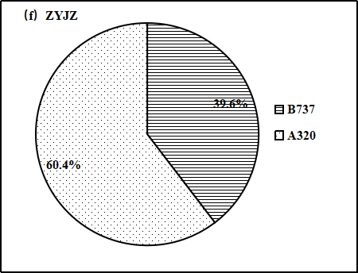
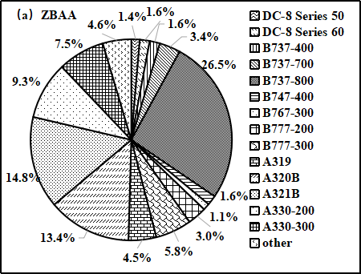
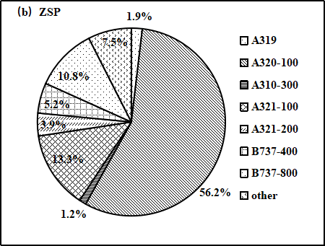
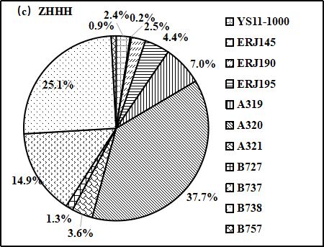
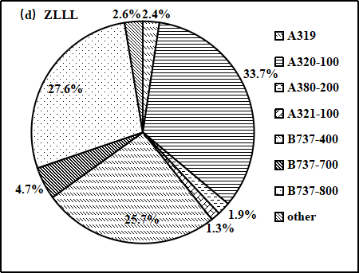
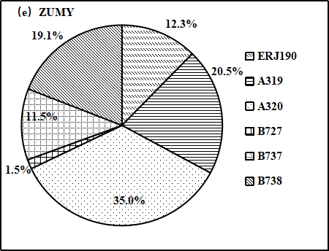
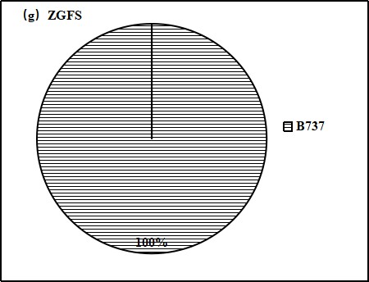

Fig.S1 The aircraft type composition of typical airport

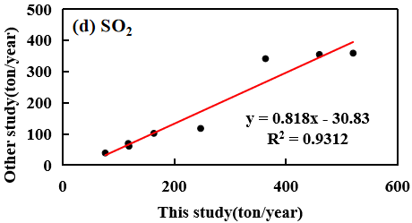
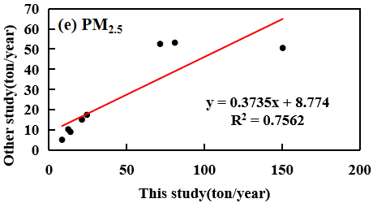
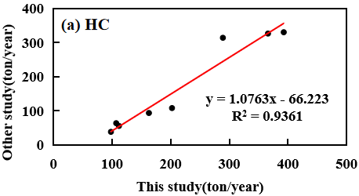
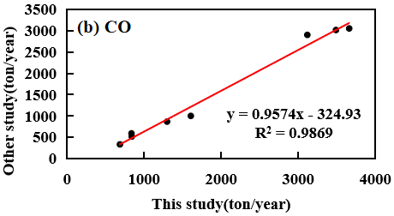
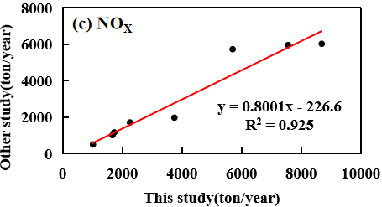

Fig. S2 The results were compared with those of the same method

