Extended Data Fig. 1
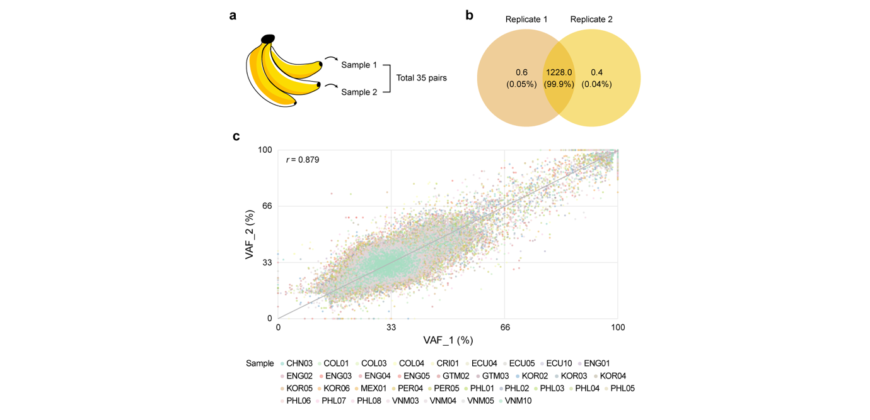
Extended Data Fig. 1 | Concordance of somatic variant calls from replicate whole-genome sequencing of the same banana plants. a, Schematic of biological replicates sampled from the same banana plants. b, Venn diagram showing the average number of shared and unique somatic variants across all replicate pairs (n = 35). Replicates with higher sequencing depth were designated as Replicate 1. c, The scatter plot comparing variant allele frequencies (VAFs) between paired replicates for each union set of variants across all pairs. Data points are color-coded by the source sample for each replicate pair. Shared variants are represented by points distributed across the plot according to their VAFs in both replicates, whereas variants unique to one replicate appear along the axes. The gray line represents the diagonal line y=x and the Pearson correlation coefficient (r) are indicated (P < 2.2 × 10⁻¹⁶). Two-sided Pearson’s correlation.

Extended Data Fig. 2
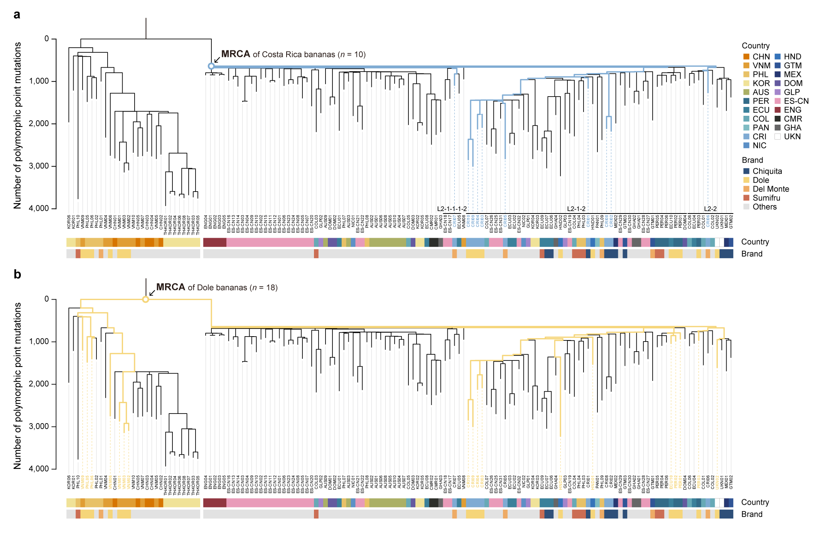
Extended Data Fig. 2 | Location of the common ancestors of Costa Rica and Dole Cavendish bananas in the phylogeny. a, Phylogenetic tree highlighting the inferred MRCA of ten Cavendish bananas from Costa Rica, located near the node of lineage L2. The bananas and their ancestral branches leading to MRCA are highlighted in color. b, Phylogenetic tree highlighting the MRCA of 18 Dole bananas, located at the root of the Cavendish phylogeny, with the corresponding samples and ancestral branches highlighted in color.

Extended Data Fig. 3
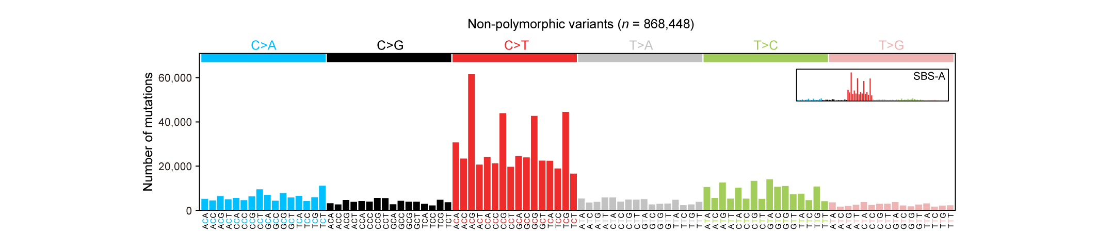
Extended Data Fig. 3 | Mutational spectrum of non-polymorphic genomic variants in Cavendish bananas. Mutational spectrum of 868,448 non-polymorphic base substitutions inferred to have accumulated in Cavendish bananas after divergence from Gros Michel. The spectrum closely resembles the SBS-A signature with high cosine similarity (0.954).

