Meat | Fat
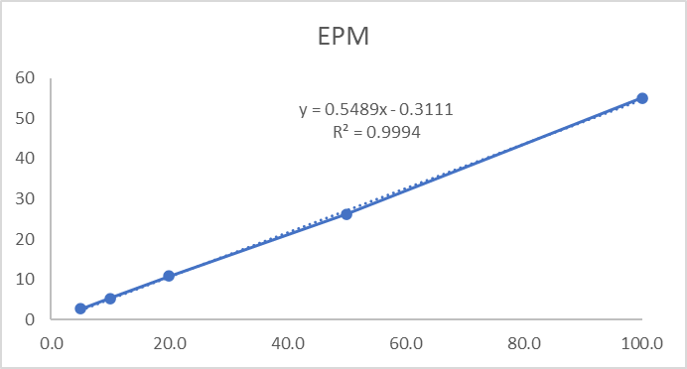 | 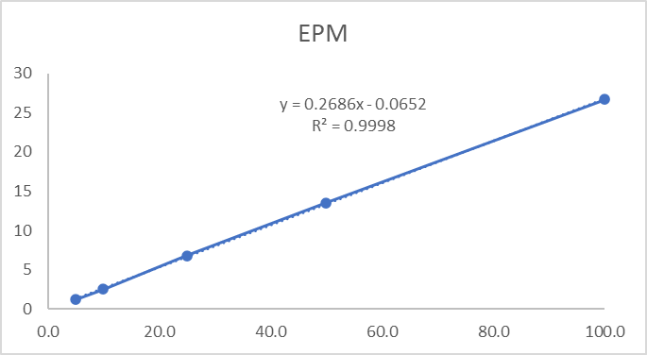
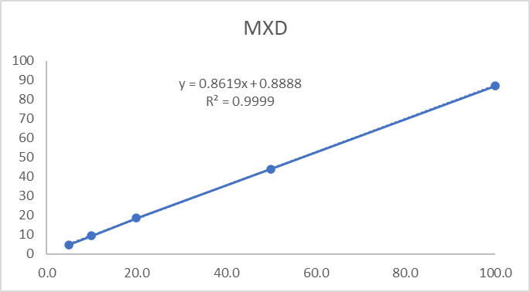 | 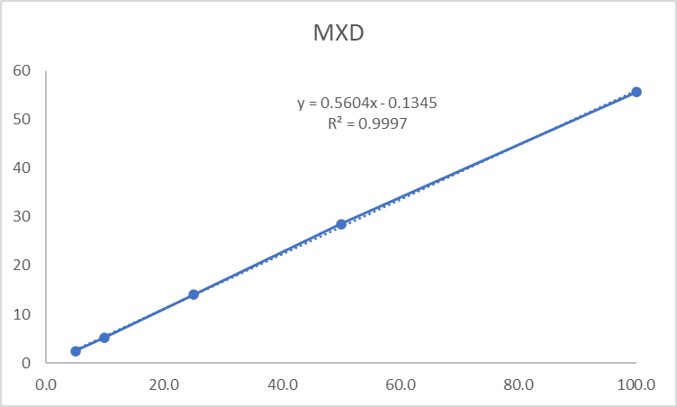
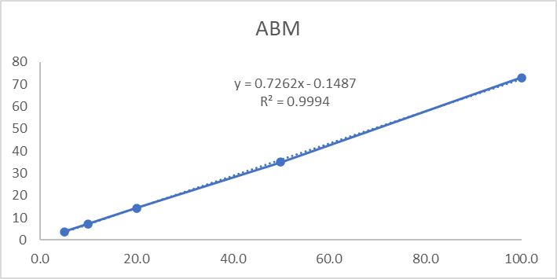 | 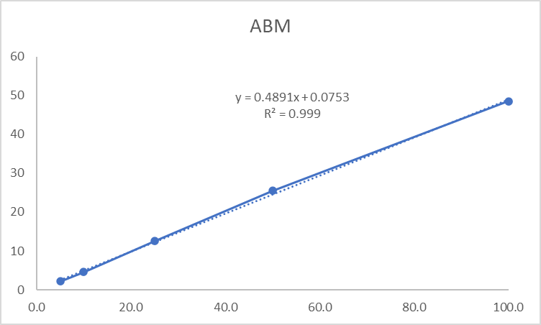
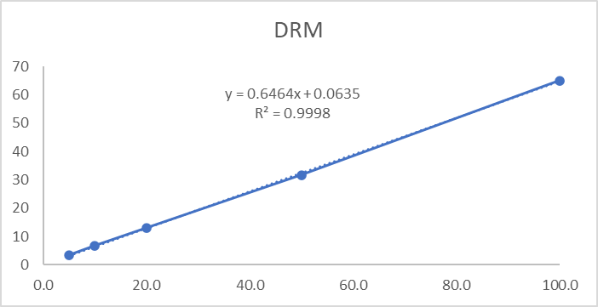 | 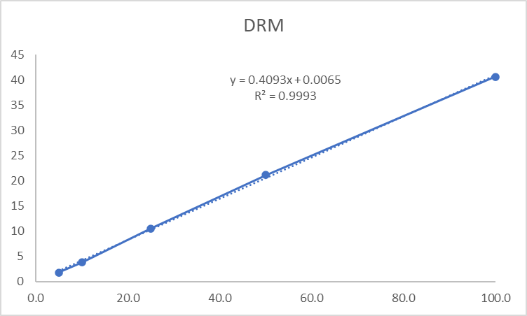
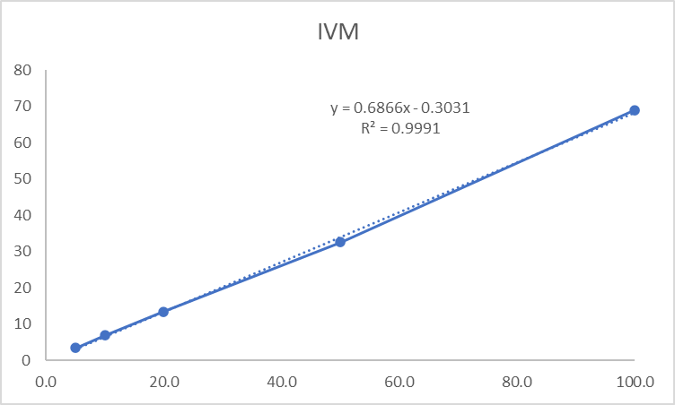 | 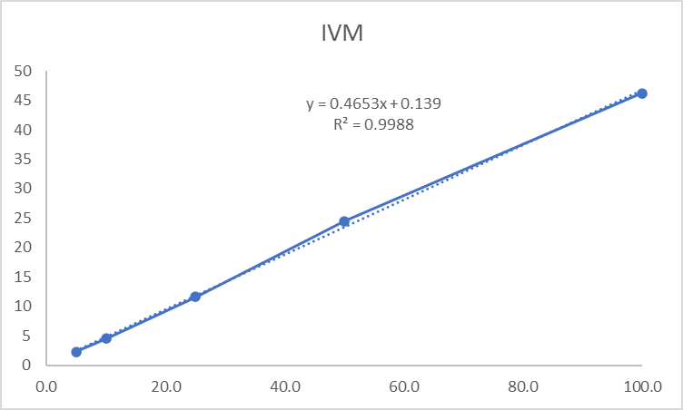
Fig. S1 Calibration curves of MLs [(eprinomectin (EPM), moxidectin (MXD), abamectin (ABM), doramectin (DRM), and ivermectin (IVM)] for meat and fat tissue samples by HPLC-FLD method.

Meat | Fat
M1 | F1
M2 | F2
M3 | F3
M4 | F4
M5 | F5
M6 | F6
M7 | F7

Fig. S2 HPLC-FLD chromatograms [analytic standard mixture (M1 or F1, 25 ng/ml), blank meat (M2) or fat (F2) tissue samples, fortified meat (M3: 5 ng/g, M4: 10 ng/g, M5: 20 ng/g, M6: 50 ng/g and M7: 100 ng/g) and fat (F3: 5 ng/g, F4: 10 ng/g, F5: 20 ng/g, F6: 50 ng/g and F7: 100 ng/g) tissue samples for calibration curves of MLs [(eprinomectin, moxidectin, abamectin, doramectin, and ivermectin, respectively)].

Liver | Kidney
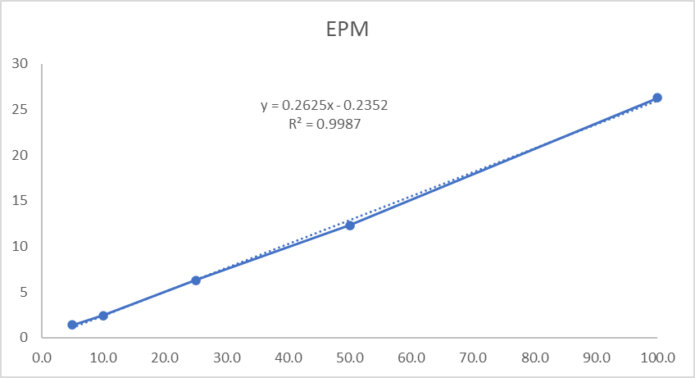 | 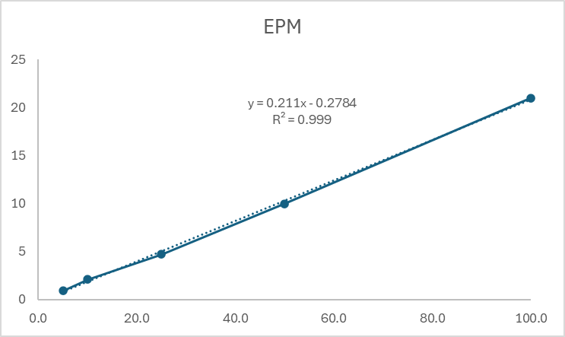
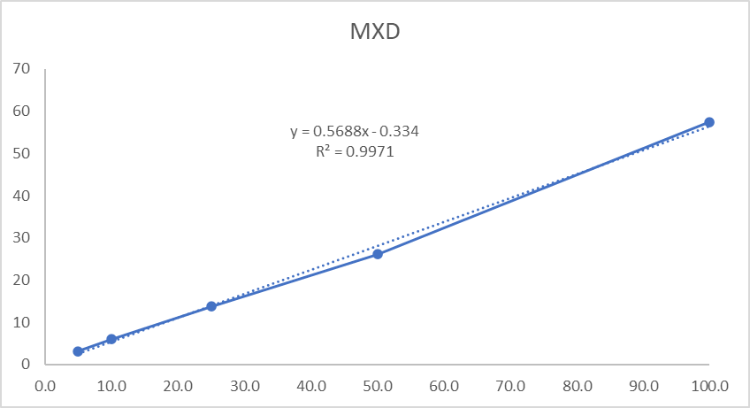 | 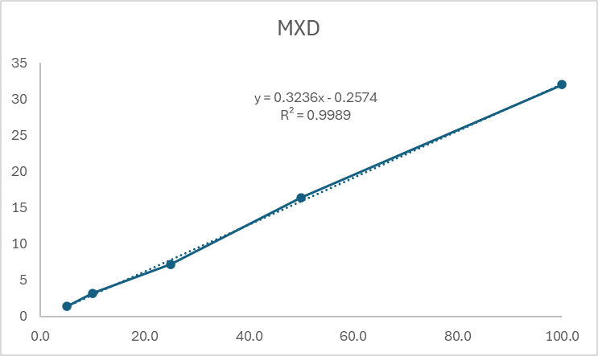
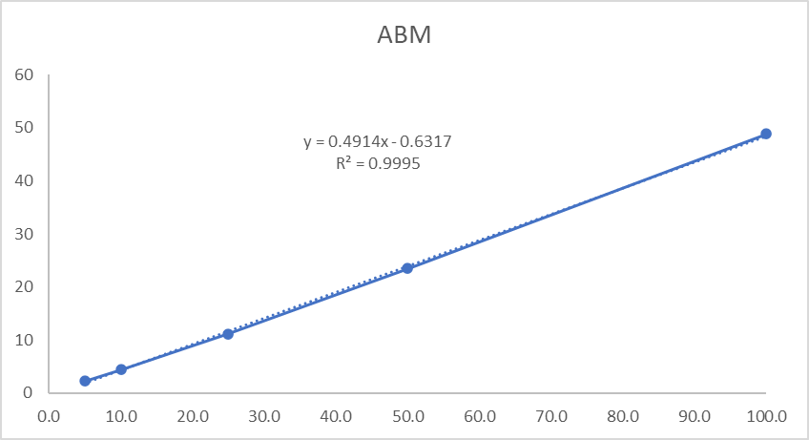 | 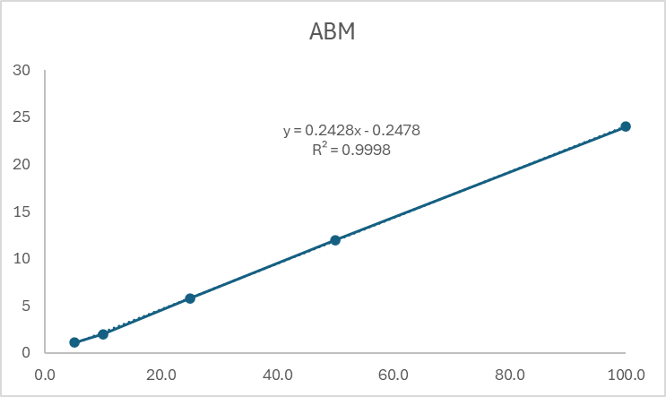
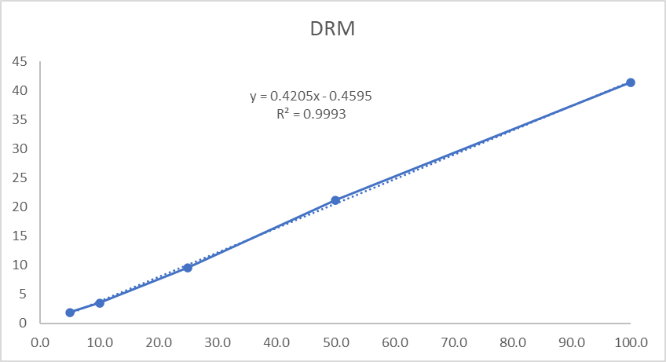 | 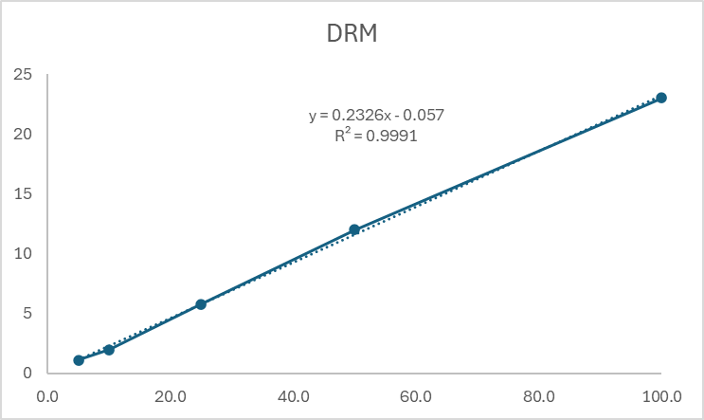
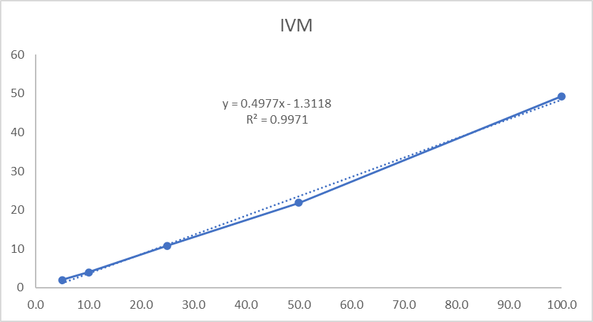 | 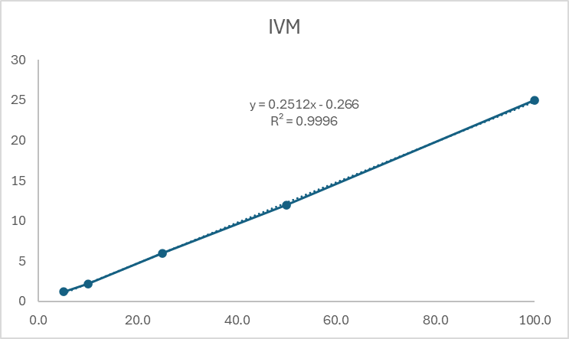

Fig. S3 Calibration curves of MLs [(eprinomectin (EPM), moxidectin (MXD), abamectin (ABM), doramectin (DRM), and ivermectin (IVM)] for liver and kidney tissue samples by HPLC-FLD method.
Liver | Kidney
L1 | K1
L2 | K2
L3 | K3
L4 | K4
L5 | K5
L6 | K6
L7 | K7

Fig. S4 HPLC-FLD chromatograms [analytic standard mixture (L1 or K1, 25 ng/ml), blank liver (L2) or kidney (K2) tissue samples, fortified meat (L3: 5 ng/g, L4: 10 ng/g, L5: 20 ng/g, L6: 50 ng/g, and L7: 100 ng/g) and fat (K3: 5 ng/g, K4: 10 ng/g, K5: 20 ng/g, K6: 50 ng/g, and K7: 100 ng/g) tissue samples for calibration curves of MLs (eprinomectin, moxidectin, abamectin, doramectin, and ivermectin, respectively)].

