Table 1. The summary of physico-chemical properties of investigated cyclopropylindole-based synthetic cannabinoid: UR-144, 5F-UR-144 (XLR-11) and XLR-12 based on PubChem.
Property | Cyclopropoylindole-based synthetic cannabinoids
Forensic acronym | UR-144 | 5F-UR-144, XLR-11 | XLR-12
IUPAC Name | (1-pentylindol-3-yl)-(2,2,3,3-tetramethylcyclopropyl)methanone | [1-(5-fluoropentyl)indol-3-yl]-(2,2,3,3-tetramethylcyclopropyl)methanone | (2,2,3,3-tetramethylcyclopropyl)-[1-(4,4,4-trifluorobutyl)indol-3-yl]methanone
Synonyms | (1-pentyl-1H-indol-3-yl)(2,2,3,3-tetramethylcyclopropyl)-methanone;  KM-X1;  1199943-44-6 | (1-(5-fluoropentyl)indol-3-yl)-(2,2,3,3-tetramethylcyclopropyl)methanone;  XLR11; 1364933-54-9 | (2,2,3,3-tetramethylcyclopropyl)-[1-(4,4,4-trifluorobutyl)indol-3-yl]methanone;  XLR12;  895155-78-9
CAS number | 1199943-44-6 | 1364933-54-9 | 895155-78-9
SMILES (canonical) | CCCCCN1C2=CC=CC=C2C (C(C3C(C)(C)C3(C)C)=O)=C1 | CC1(C(C1(C)C)C(=O)C2=CN (C3=CC=CC=C32)CCCCCF)C | CC1(C(C1(C)C)C(=O)C2=CN (C3=CC=CC=C32)CCCC(F)(F)F)C
Molecular formula | C₂₁H₂₉NO | C₂₁H₂₈FNO | C₂₀H₂₄F₃NO
Chemical structure | 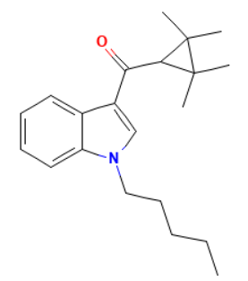 | 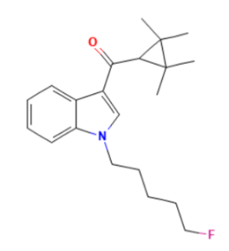 | 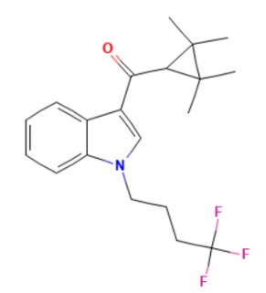
Molar mass, g/mol | 311.5 g/mol | 329.5 g/mol | 351.4 g/mol

Table 2. Qualitative prediction of acute toxicity for UR-144, 5F-UR-144 (XLR-11) and XLR-12 using in silico software: StopTox and admetSAR.

Type of toxicity | UR-144
Type of toxicity | STopTox |  |  |  | admetSAR3.0 | Admetlab 3.0  3.0
Type of toxicity | Prediction | Confidence (%) | Applicability domain | Predicted toxicophore(s) | Probability (%) | Probability (%)
Acute  oral toxicity | Toxic (+) | 75 | 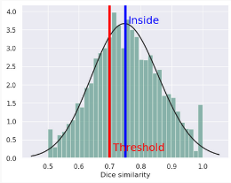 | 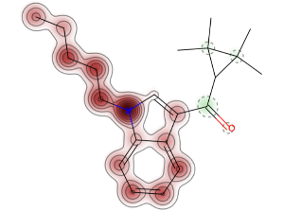 | 17.6 | 34.3
Acute dermal toxicity | Non-Toxic  (-) | 72 | 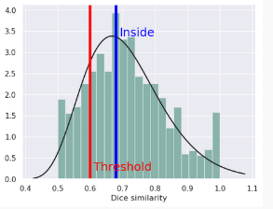 | 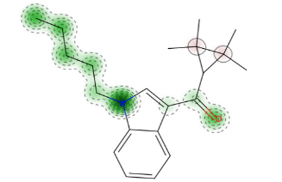 | 48.8 | NA
Acute inhalation toxicity | Toxic (+) | 71 | 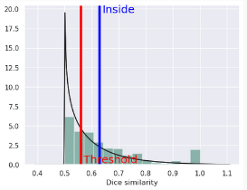 | 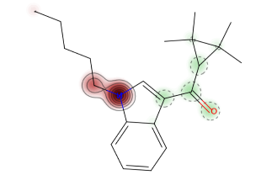 | NA | NA
Type of toxicity | 5F-UR-144 (XLR-11)
Type of toxicity | STopTox |  |  |  | admetSAR 3.0 | Admetlab 3.0 3.0
Type of toxicity | Prediction | Confidence (%) | Applicability domain | Predicted toxicophore(s) | Probability (%) | Probability (%)
Acute  oral toxicity | Toxic (+) | 72 % | 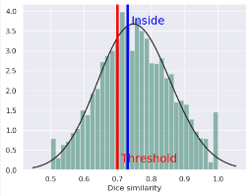 | 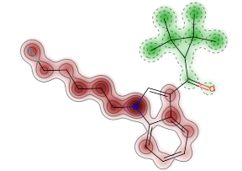 | 78.3 | 79.5
Acute dermal toxicity | Non-Toxic (-) | 66 % | 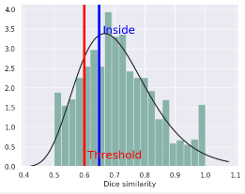 | 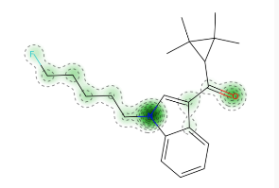 | 80 | NA
Acute inhalation toxicity | Toxic (+) | 66 % | 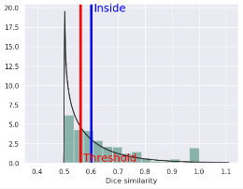 | 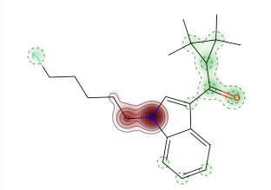 | NA | NA
Type of toxicity | XLR-12
Type of toxicity | STopTox |  |  |  | admetSAR | Admetlab 3.0
Type of toxicity | Prediction | Confidence (%) | Applicability domain | Predicted toxicophore(s) | Probability (%) | Probability (%)
Acute  oral toxicity | Toxic (+) | 69 % | 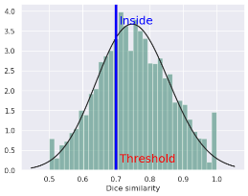 | 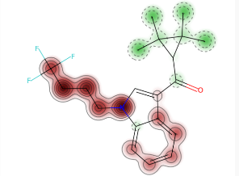 | 75.3 | 24.5 %
Acute dermal toxicity | Non-Toxic (-) | 56 % | 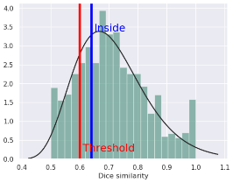 | 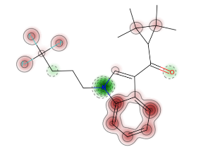 | 74.3 | NA
Acute inhalation toxicity | Toxic (+) | 65 % | 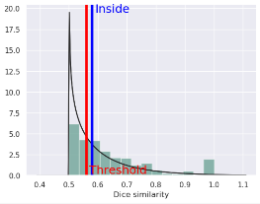 | 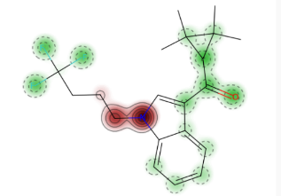 | NA | NA
NA – Not applicable

Table 4. Predicted health effects for investigated cyclopropylindole-based synthetic cannabinoids: UR-144, 5F-UR-144 (XLR-11) and XLR-12 using Percepta software.
UR-144 |  |  | 5F-UR-144 (XLR-11) |  | XLR-12
Health effect | Probability od health effect [%] | Toxicophore(s) | Probability od health effect [%] | Toxicophore(s) | Probability od health effect [%] | Toxicophore(s)
Lungs | 89 | 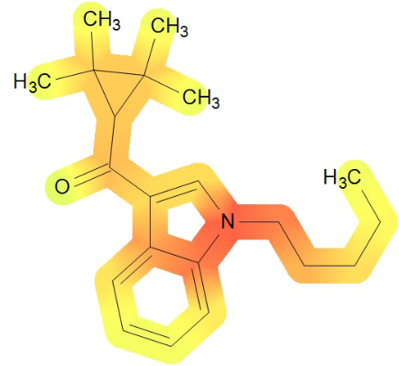 | 89 | 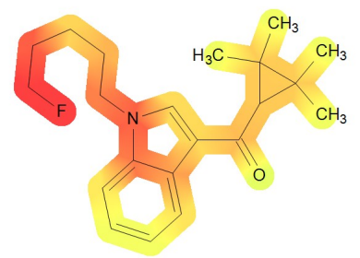 | 80 | 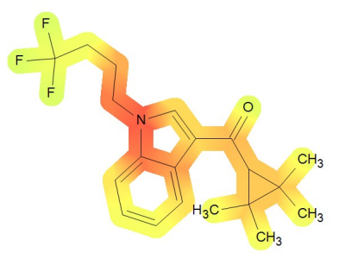
Blood | 82 | 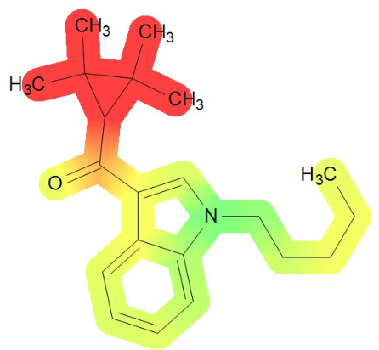 | 84 | 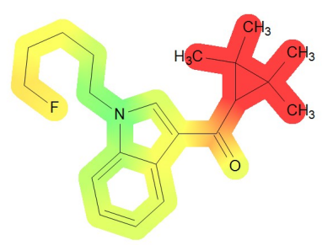 | 86 | 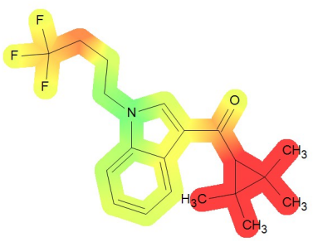
Kidney | 70 | 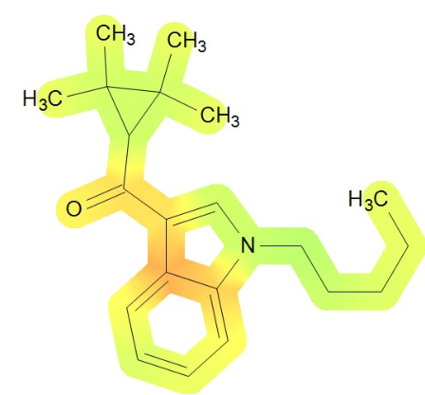 | 73 | 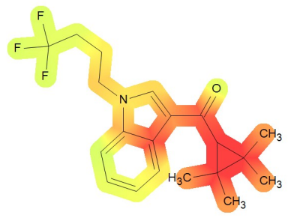 | 76 | 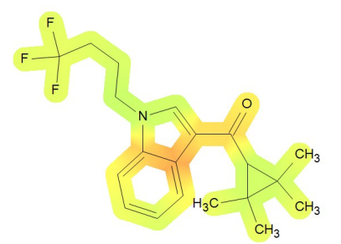
Cardiovascular system | 59 | 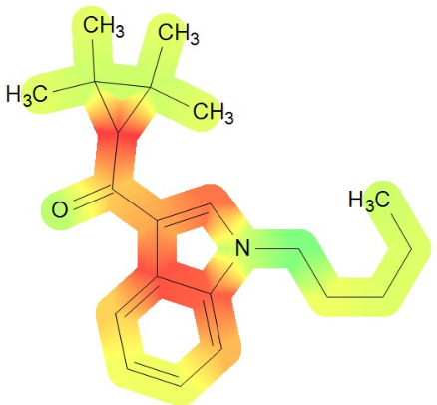 | 70 | 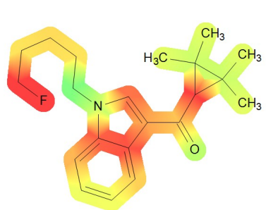 | 72 | 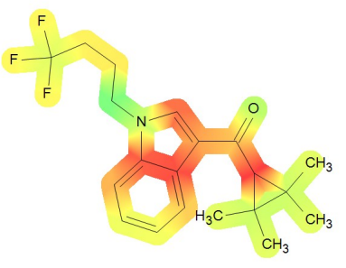
Gastrointestinal system | 27 | 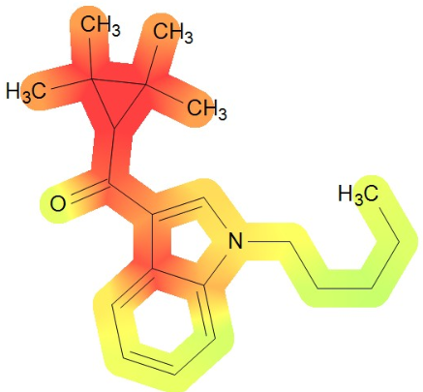 | 19 | 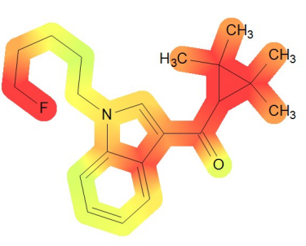 | 14
Liver | 24 | 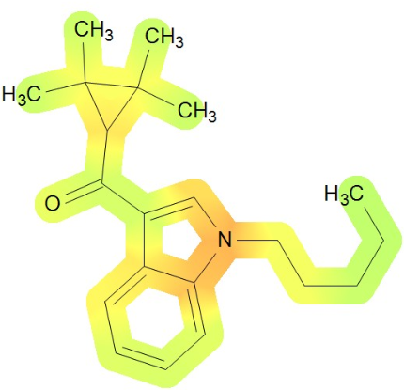 | 25 | 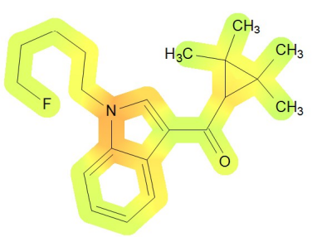 | 32 | 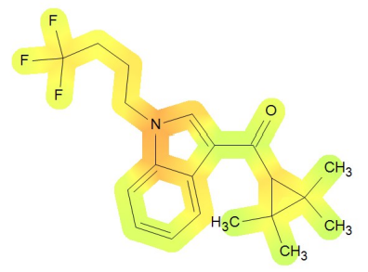

Table 6. Results of eye irritation prediction for investigated cyclopropylindole-based synthetic cannabinoids: UR-144, 5F-UR-144 (XLR-11) and XLR-12 received with various in silico methods.
In silico method | UR-144 | 5F-UR-144 (XLR-11) | XLR-12
StopTox | Non-toxic (-) | Non-toxic (-) | Non-toxic (-)
StopTox | Probability 58% | Probability 59% | Probability 50%
StopTox | 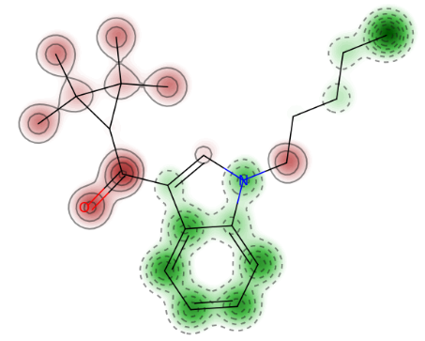 | 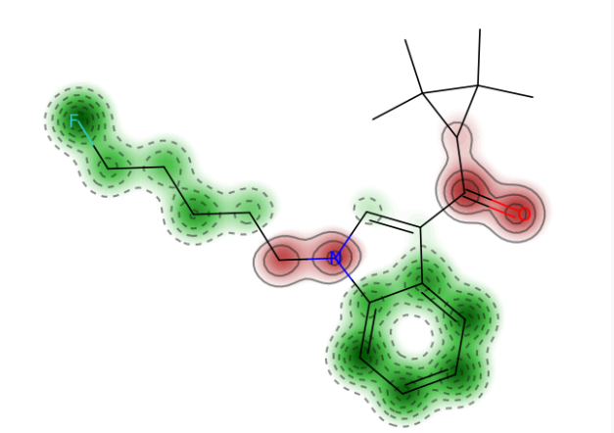 | 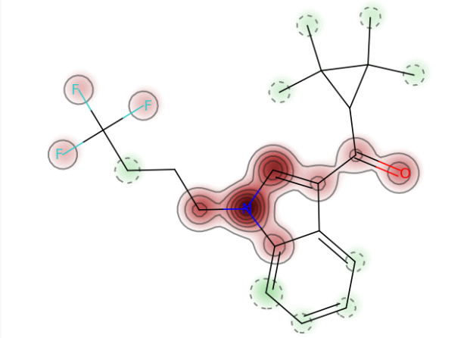
StopTox | 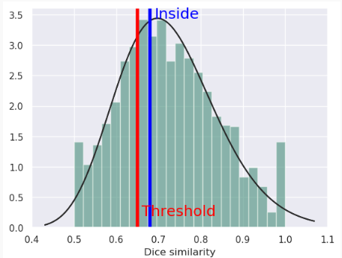 | 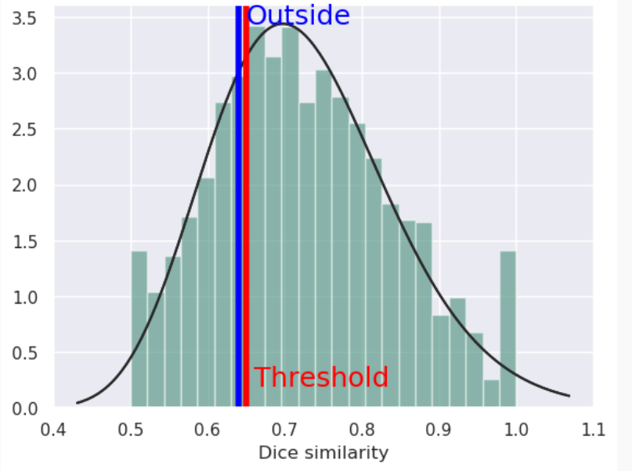 | 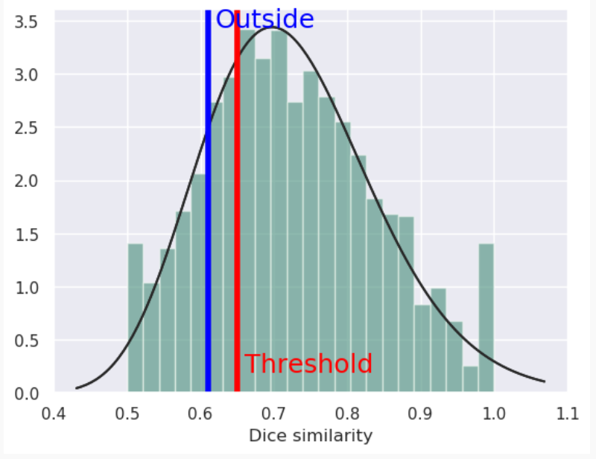
Admetlab 3.0 3.0 | 78.2% (probability of being irritation) | 58% ((probability of being irritation) | 44.1% (probability of being irritation)
admetSAR 3.0 | 88.3% (probability of being irritation) | 42.1% (probability of being irritation) | 49.9% (probability of being irritation)
Percepta 2023.1.2 | Probability – 19% | Probability – 19% | Probability – 20%
Vega QSAR 1.2.3  (Eye irritation (CONCERT/Kode) 1.0.0) | Not-irritation, but the predicted compound is outside the AD of the model | Irritation, but the predicted compound is outside the AD of the model | Not irritation, but the predicted compound could be out of the AD of the model
AD – applicability domain

Table 7. Results of skin irritation prediction for investigated cyclopropylindole-based synthetic cannabinoids: UR-144, 5F-UR-144 (XLR-11) and XLR-12 received with various in silico methods.

In silico method | UR-144 | 5F-UR-144 (XLR-11) | XLR-12
StopTox | Negative (-) | Negative (-) | Negative (-)
StopTox | Probability 60% | Probability 60% | Probability 70%
StopTox | 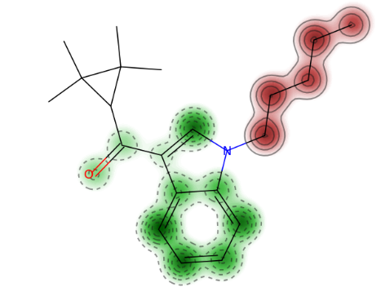 | 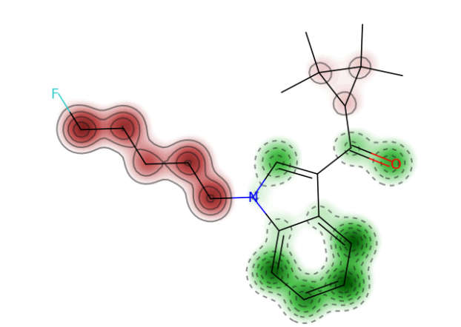 | 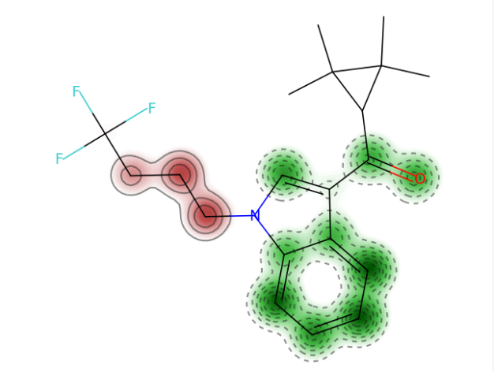
StopTox | 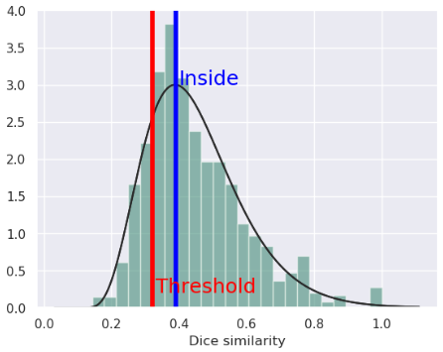 | 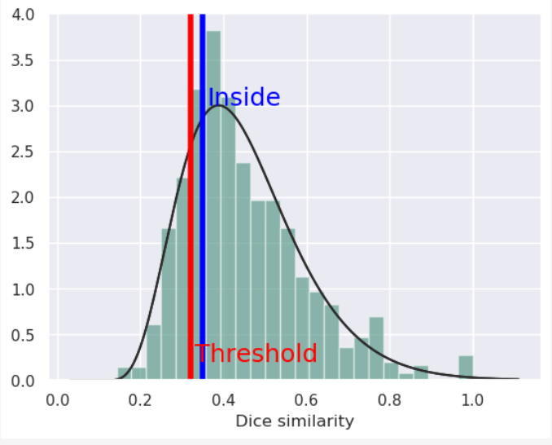 | 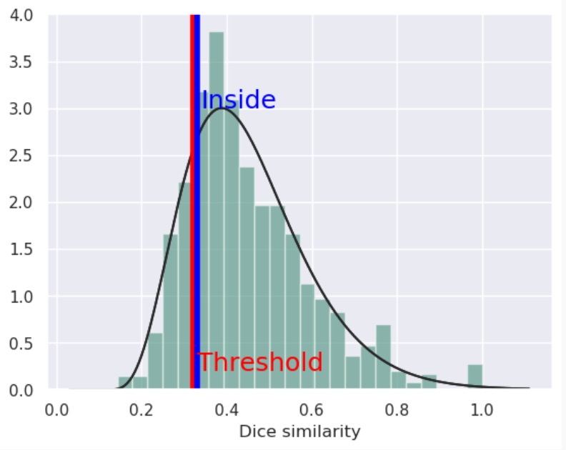
Admetlab 3.0 3.0 | NA | NA | NA
admetSAR 3.0 | 34.1% (probability of being irritation) | 15.7% (probability of being irritation) | 12.9% (probability of being irritation)
Percepta 2023.1.2 | Probability – 28 % | Probability – 28 % | Probability – 29 %
Vega QSAR 1.2.3  Skin irritation (CONCERT/Kode) 1.0.0 | Not-Sensitizer, but the predicted compound is outside the AD of the model | Active, but the predicted compound is outside the AD of the model | Active, but the predicted compound is outside the AD of the model
NA – Not applicable

