Supplementary Information

Supplementary Tables
Supplementary Table S1 | Nuisance model comparison for CausalForestDML
Nuisance Model | DR Estimate | 95% CI | CI Width
Random Forest | 0.280 | 0.244–0.316 | 0.072
CatBoost | 0.272 | 0.217–0.325 | 0.108
Logistic Regression | 0.618 | −0.248 to 1.959 | 2.207
HistGradientBoosting | 1.620 | −0.790 to 4.329 | 5.119
LightGBM | 1.102 | −1.230 to 3.603 | 4.833
Random Forest was selected based on (1) algorithmic consistency with CausalForestDML's internal Generalised Random Forest, and (2) the narrowest CI width indicating stable estimation.

Supplementary Table S2 | Category-specific Q4–Q1 difference tests
Category | Q4–Q1 Difference | Z-statistic | P value (one-tailed)
JAKi | −0.118 | −2.59 | 0.005
CTLA4-Ig | −0.184 | −3.63 | < 0.001
IL-6i | −0.020 | −0.47 | 0.321

Supplementary Table S3 | BLP coefficients for statistically significant effect modifiers
The BLP analysis evaluated 222 candidate features. Twenty-two covariates reached nominal significance (P < 0.05); of these, twelve were independently confirmed by Lasso regression (marked with †).
Feature | Coefficient | SE | t-statistic | P value
Smoking† | −0.0127 | 0.0012 | −10.40 | < 0.001
ESR (1 hour)† | 0.0005 | < 0.001 | 13.89 | < 0.001
Age† | 0.0008 | < 0.001 | 8.20 | < 0.001
DAS28-CRP† | 0.0166 | 0.0022 | 7.58 | < 0.001
CRP† | 0.0025 | 0.0004 | 6.04 | < 0.001
Albumin† | −0.0110 | 0.0020 | −5.51 | < 0.001
Steinbrocker class† | 0.0040 | 0.0012 | 3.27 | 0.001
WBC† | 0.0010 | 0.0003 | 3.21 | 0.001
MMP-3† | < 0.001 | < 0.001 | 3.20 | 0.001
Tender right index finger DIP (a31) | 0.0221 | 0.0082 | 2.71 | 0.007
ACPA† | < 0.001 | < 0.001 | −2.71 | 0.007
SDAI | −0.0009 | 0.0003 | −2.71 | 0.007
DAS28-ESR | −0.0038 | 0.0014 | −2.69 | 0.007
Haemoglobin† | −0.0013 | 0.0005 | −2.58 | 0.010
Past sarilumab use | 0.0128 | 0.0053 | 2.40 | 0.016
Creatinine | −0.0054 | 0.0023 | −2.37 | 0.018
Past ozoralizumab use | 0.0195 | 0.0086 | 2.28 | 0.023
Doctor VAS | 0.0001 | < 0.001 | 2.13 | 0.033
Past TNFi use† | −0.0044 | 0.0022 | −1.99 | 0.047
† Independently confirmed by Lasso regression.

Supplementary Figures
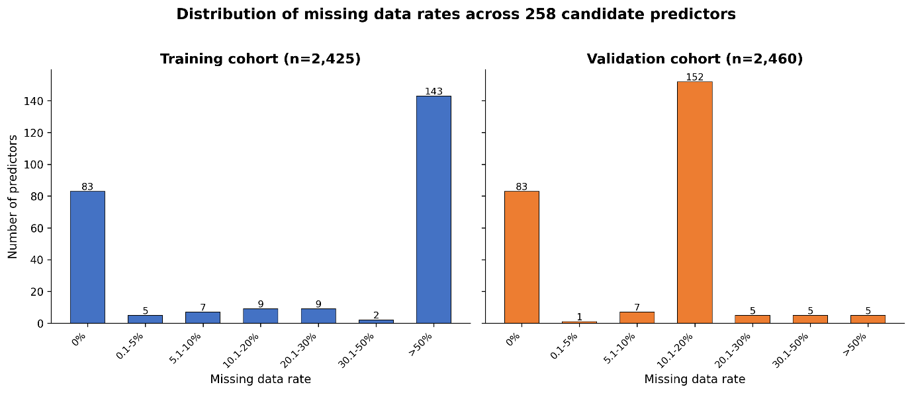
Supplementary Fig. S1 | Distribution of missing data rates across 258 candidate predictors.
Of 258 candidate predictors, 83 (32.2%) had no missing values. The remaining 175 predictors had missing data rates ranging from 0.1% to 78.8% in the training cohort and 0.1% to 82.9% in the validation cohort. In the training cohort, 143 predictors had >50% missing data, primarily reflecting individual joint assessments (swollen and tender joint counts for 70 joints each) that were not systematically recorded at all facilities.

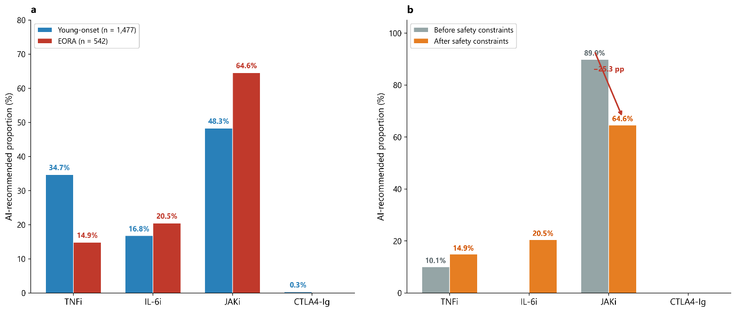
Supplementary Fig. S2 | Elderly-onset RA (EORA) subgroup analysis of AI treatment recommendations.
(a) AI-recommended drug category distribution in the external validation cohort stratified by age of onset (EORA, onset age ≥ 60 years, n = 542; young-onset RA, onset age < 60 years, n = 1,477). EORA patients received significantly more JAKi recommendations (64.6% vs 48.3%) and fewer TNFi recommendations (14.9% vs 34.7%) compared with young-onset patients (chi-square P < 0.001). JAKi safety exclusion rates were higher in EORA (22.5%) than in young-onset RA (7.4%).
(b) Effect of clinician-guided safety constraints on EORA recommendation distribution (EORA patients only, n = 542). Before applying safety constraints, 89.9% of EORA patients were recommended JAKi; after exclusion of 122 patients (22.5%) meeting predefined risk criteria (age ≥ 65, smoking history, or elevated cardiovascular/malignancy risk), JAKi recommendations decreased by 25.3 percentage points to 64.6%, with redistributions primarily to IL-6i (0% → 20.5%) and TNFi (10.1% → 14.9%).
EORA, elderly-onset rheumatoid arthritis; RA, rheumatoid arthritis; TNFi, tumour necrosis factor inhibitor; IL-6i, interleukin-6 inhibitor; JAKi, Janus kinase inhibitor; CTLA4-Ig, cytotoxic T-lymphocyte-associated antigen 4-immunoglobulin; pp, percentage points.

