Supplementary Figures：
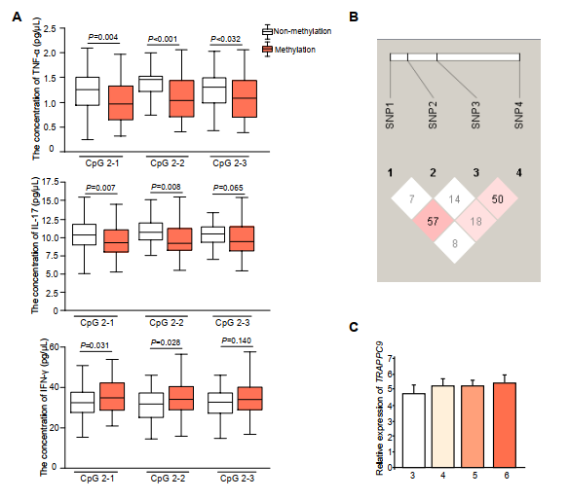

S1 Figure. (related to Figure 1): Relationship between methylation level, SNP and CNV of the TRAPPC9 gene and bovine mastitis.
(A) Relationship between the methylation status at the CpG sites in R2 and the concentration of TNF-α, IL-17 and IFN-γ in serum.
(B) Haplotype blocks and pairwise linkage disequilibrium values for the four SNPs in bovine TRAPPC9.
(C) Relative mRNA expression of TRAPPC9 with different copy number variants in Holsteins (n = 7/group). Gene expression profiling was measured by RT-qPCR assay.
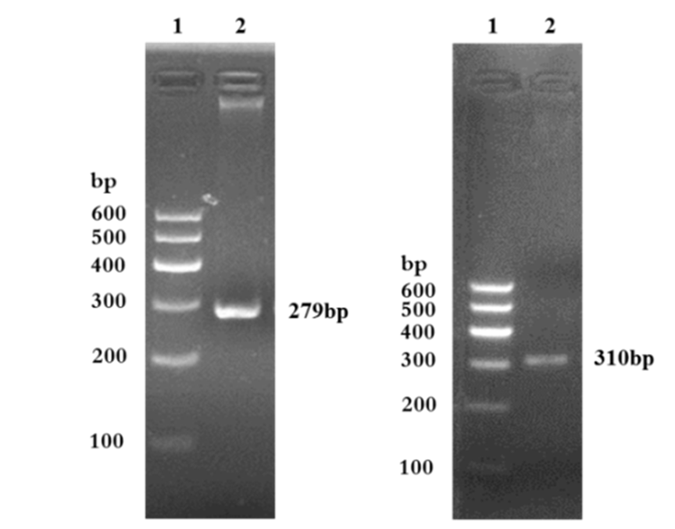

S2 Figure. (related to Figure 3): Bacteria-specific PCR assay for the detection of Staphylococcus aureus (S. aureus) and methicillin-resistant S. aureus (MRSA).
The Nuc and MecA genes were used for the detection of S. aureus and MRSA, respectively. Results of PCR confirmed that these two strains chosen in this study were S. aureus (Nuc, left panel) and MRSA (MecA, right panel) respectively.

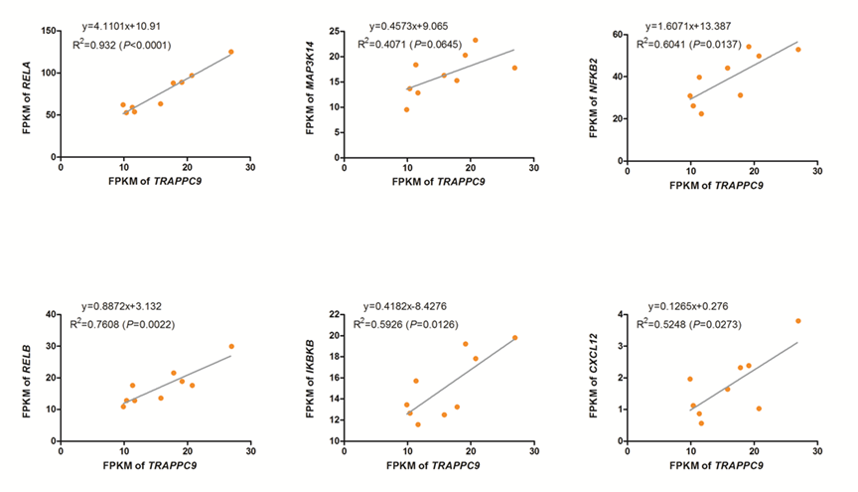
S3 Figure. Regression analysis between the expression levels of TRAPPC9 and genes in the NF-κB pathway.

