Supporting information for

Trace hydroxypropyl methylcellulose induced physical crosslinking enables direct 3D printing of aqueous PEDOT:PSS
Hengyi Ma,^{a†} Mingyuan He,^{b†} Teng Zhan,ª Kaiming Yang,ª Ruizhe Wang,^{d} Zhenhu Liang,^{b,c,}* Yingdan Liu,^{e,}* Hengda Sun,^{d} Kai Xu ^{a,}*

ª Center for Extreme Deformation Research, State Key Laboratory of Metastable Materials Science and Technology, Yanshan University, Qinhuangdao, 066004 P. R. China.
^{b}School of electrical engineering, Yanshan University, Qinhuangdao, 066004, China
^{c}Key Laboratory of Intelligent Rehabilitation and Neuromodulation of Hebei Province, Yanshan University,Qinhuangdao 066004, China
^{d} State Key Laboratory of Advanced Fiber Materials, College of Materials Science and Engineering, Donghua University, Shanghai, 201620 China.
^{e} Center for Extreme Deformation Research, State Key Laboratory of Metastable Materials Science and Technology, Yanshan University, Qinhuangdao, 066004 P. R. China.

* E-mail: zhl@ysu.edu.cn (Z.H. Liang), ydliu@ysu.edu.cn (Y.D Liu), xukai@ysu.edu.cn (K. Xu)
† These authors contributed equally to this work.

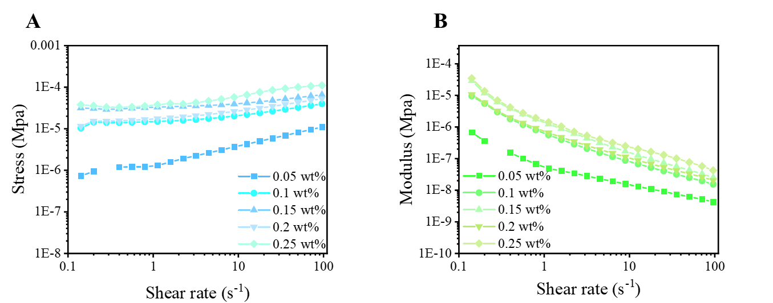
Figure S1. Stress and modulus responses of PEDOT:PSS/HPMC inks with varying HPMC contents. Stress-dependent rheological responses of aqueous PEDOT:PSS inks containing different HPMC loadings, showing the evolution of shear stress (A) and viscoelastic modulus (B). Across the investigated HPMC concentration range, the inks operate within a low-stress regime (below ~100 Pa) while maintaining finite modulus, indicating a weakly percolated, physically crosslinked network.
Figure S2. Temperature-dependent rheological behavior of aqueous HPMC solution (0.1 wt%). Shear-rate-dependent viscosity of an aqueous HPMC solution (0.1 wt%) measured at temperatures ranging from 25 to 85 °C.

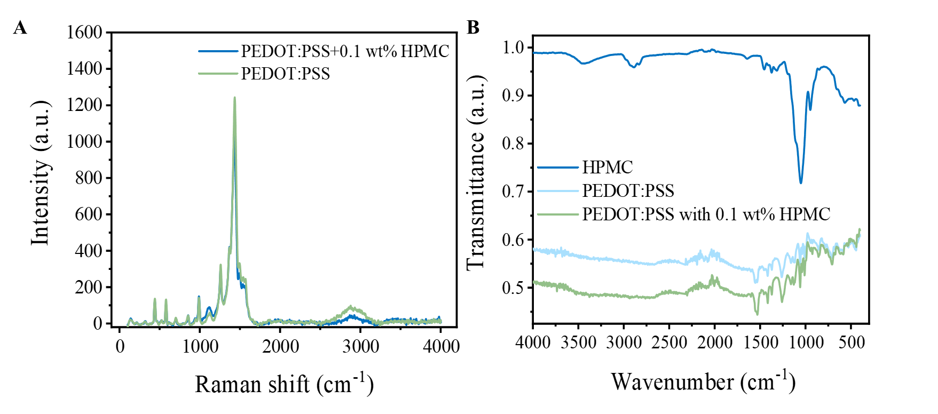
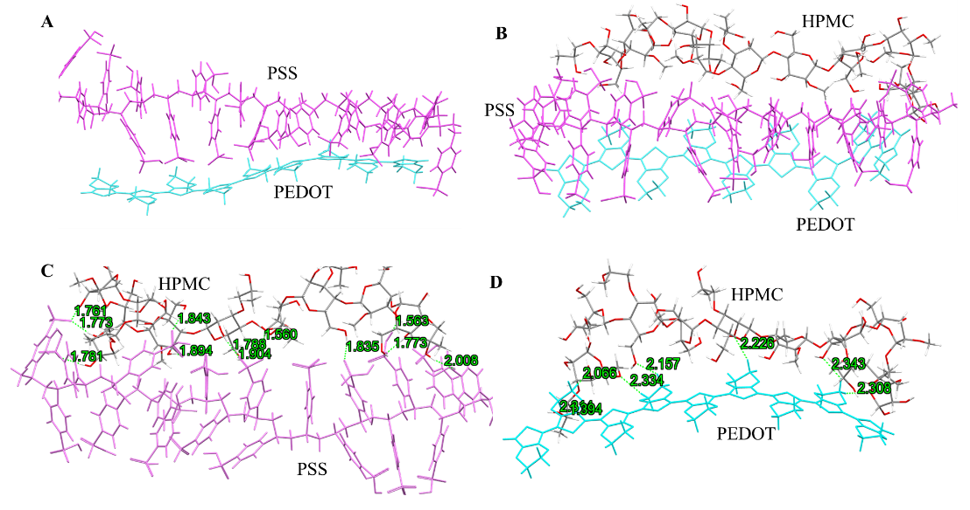
Figure S3. Full-range Raman and ATR-FTIR spectra of PEDOT:PSS and PEDOT:PSS/HPMC systems. (A) Full-range Raman spectra of pristine PEDOT:PSS and PEDOT:PSS containing 1 wt% HPMC. (B) Full-range ATR-FTIR spectra of pristine HPMC, pristine PEDOT:PSS, and PEDOT:PSS containing 1 wt% HPMC.
Figure S4. Representative equilibrium conformations and intermolecular contacts obtained from xTB-based conformational sampling. (A) Representative equilibrium conformation of the PEDOT/PSS system extracted after 150 ps of finite-temperature xTB-based dynamical sampling. (B) Representative equilibrium conformation of the PEDOT/PSS/HPMC system obtained after 150 ps of xTB-based dynamical sampling. (C) The HPMC–PSS interface extracted from panel (B), with selected short intermolecular contacts highlighted. The annotated distances indicate hydrogen-bonding and other noncovalent interactions between HPMC and the sulfonate-rich PSS chains. (D) The HPMC–PEDOT interface extracted from panel (B), with selected short intermolecular contacts highlighted for comparison. The generally longer interaction distances reflect weaker and predominantly dispersive interactions between HPMC and the PEDOT backbone.

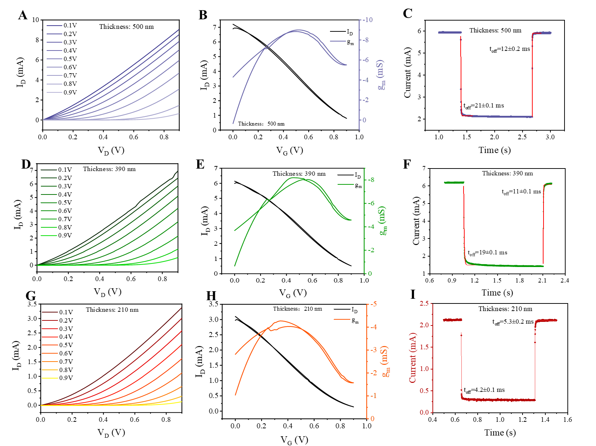
Figure S5. Thickness-dependent electrical characteristics and dynamic response of fully printed OECTs. (A–C) Output characteristics, transfer curves, and transient response of fully printed OECTs with a channel thickness of approximately 500 nm. (D–F) Output characteristics, transfer curves, and transient response of OECTs with a channel thickness of approximately 390 nm. (G–I) Output characteristics, transfer curves, and transient response of OECTs with a channel thickness of approximately 210 nm. For the transient measurements shown in panels C, F, and I, a pulsed gate voltage of V_{G} = 0.6 V was applied at a constant V_{SD} = 0.6 V, and the corresponding drain current responses were recorded. The turn-on (τ_{on}) and turn-off (τ_{off}) time constants were extracted by fitting the transient current profiles with a single exponential decay function. With increasing channel thickness, devices exhibit larger response time and incomplete current suppression, indicating hindered ion de-doping in thicker channels.

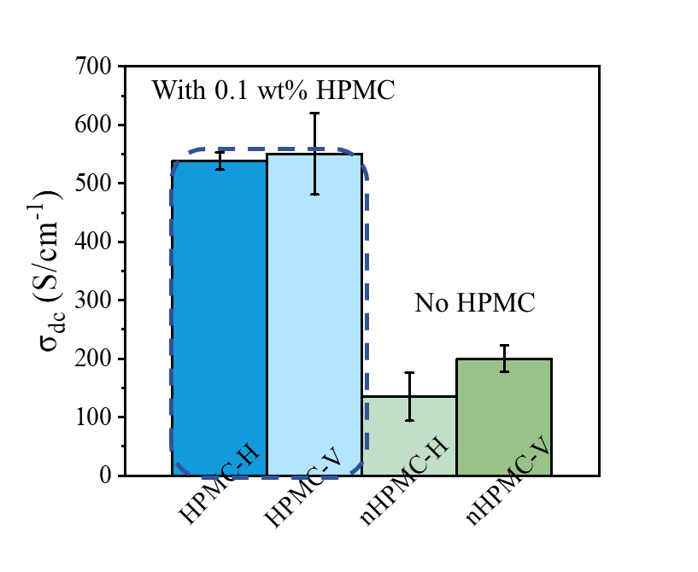
Figure S6. Long-term operational stability of fully printed OECTs under pulsed biasing conditions. Current evolution of a DIW printed OECT measured under a constant drain bias of V_{SD} = 0.4 V and a pulsed gate voltage of V_{G} = 0.65 V with a period of 20 s. The device was continuously operated for more than 10,000 switching cycles.
Figure S7. Effect of printing direction on the electrical conductivity of DIW-printed PEDOT films. Electrical conductivity of DIW-printed PEDOT films measured along the printing direction (H) and perpendicular to the printing direction (V), for samples prepared with and without HPMC using a 60 μm nozzle. Comparable conductivities are observed in the H and V directions for both compositions, indicating no anisotropy induced by the printing process under the present conditions.

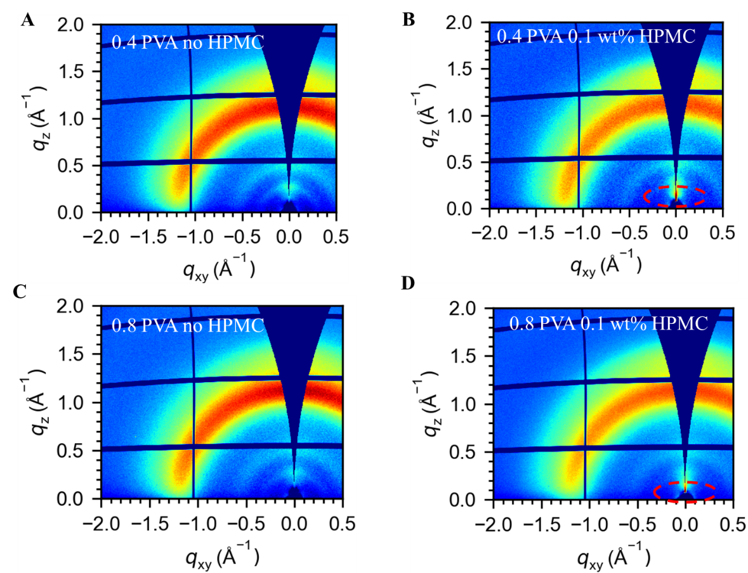
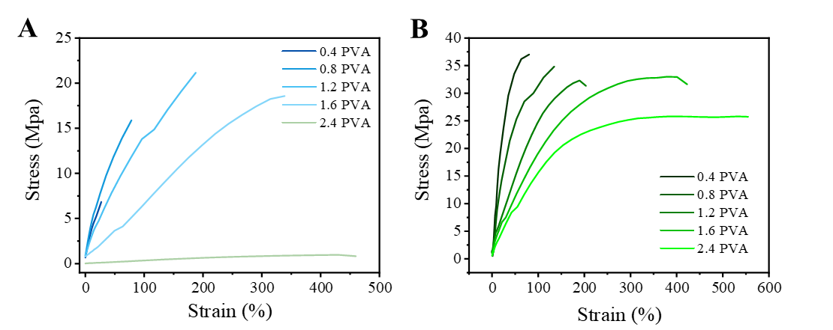
Figure S8. Tensile properties of PEDOT-based composite films with varying PVA contents, with and without HPMC. (A) Stress–strain curves of PEDOT-based films containing different PVA contents without HPMC, (B) Stress–strain curves of PEDOT-based films containing different PVA contents with 0.1 wt% HPMC.
Figure S9. Two-dimensional GIWAXS patterns of PEDOT-based composite films with different PVA contents, with and without HPMC. Two-dimensional GIWAXS patterns of PEDOT-based films containing 0.4 PVA ((A) no HPMC, (B) with 0.1 wt% HPMC) and 0.8 PVA ((C) no HPMC, (D) with 0.1 wt% HPMC). Notably, films containing HPMC display enhanced scattering intensity in the ultra-low-q region (highlighted by red dashed circles), indicating the emergence of mesoscale structural correlations.

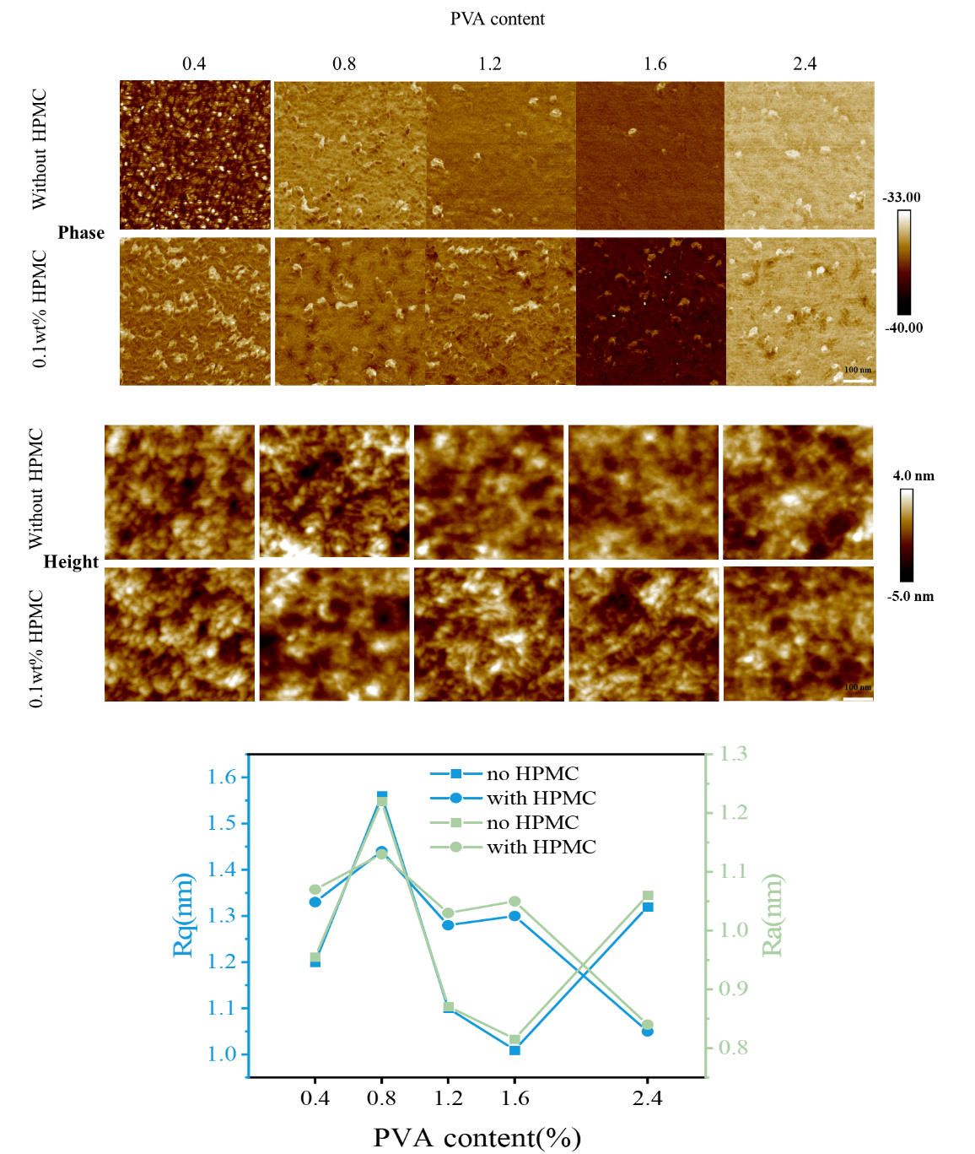
Figure S10. AFM phase and topography analysis of PEDOT-based composite films with varying PVA contents, with and without HPMC. AFM images of PEDOT-based composite films with different PVA contents (from left to right). Top two rows: Phase images of films without HPMC (top row) and with 0.1 wt% HPMC (second row), revealing pronounced differences in phase contrast upon HPMC incorporation, indicative of modified nanoscale mechanical heterogeneity. Bottom two rows: Corresponding height images of films without HPMC (third row) and with 0.1 wt% HPMC (fourth row), showing comparable surface morphologies across different PVA contents. The quantitative surface roughness parameters (R_{q} and R_{a}), summarized in the bottom panel, exhibit no substantial variation upon HPMC addition.

Sample | Carrier type | Film thickness (nm) | Sample area (mm²) | Charge carrier surface density  (cm⁻²) | Charge carrier bulk density (cm⁻³) | Resistivity  (Ω*cm) | Hall coefficient  (cm³/C) | Hall mobility  (cm²/Vs)
0.4 PVA+0.1 wt% HPMC | p | 231 | 64 | 5.47E16 | 2.37E21 | 0.01371 | 0.00264 | 0.19236
0.8 PVA+0.1 wt% HPMC | p | 297 | 64 | 4.50E16 | 1.52E21 | 0.02375 | 0.00412 | 0.17329
0.4 PVA | p | 350 | 64 | 5.21E16 | 1.49E21 | 0.03006 | 0.00419 | 0.13953
0.8 PVA | p | 212 | 64 | 3.02E16 | 1.43E21 | 0.08513 | 0.00438 | 0.05139
Table S1. Hall-effect parameters of PEDOT-based films with different PVA contents, with and without HPMC.
Notably, at higher PVA content (0.8 PVA), the incorporation of HPMC leads to a pronounced increase in Hall mobility.

