Supplementary Information
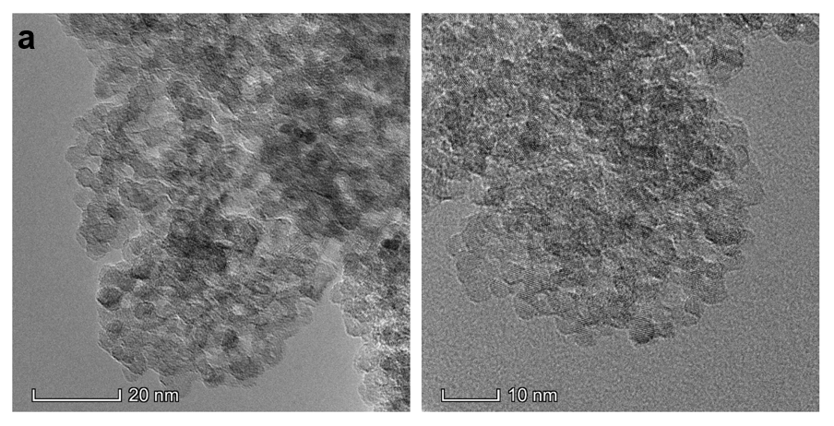
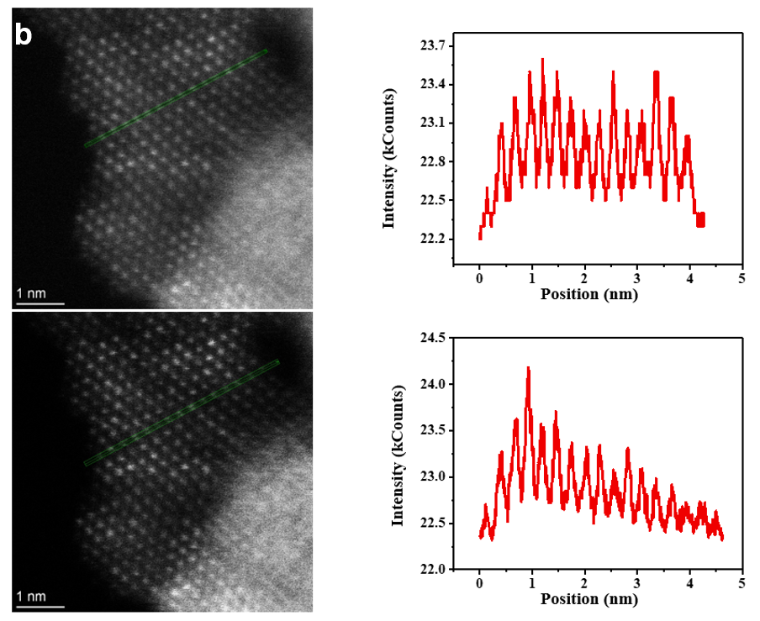
Supplementary Figure 1. a, TEM images of aggregated TiO₂ nanoparticles with 5-10 nm size. b, Ti column intensity variation in the HAADF images of the 5-10 nm TiO₂ nanoparticles.

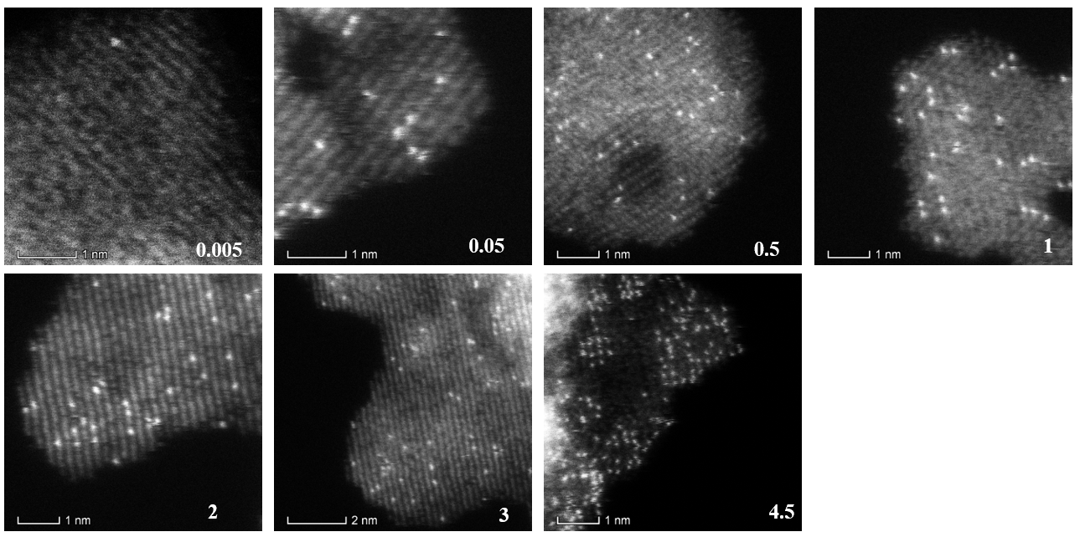
Supplementary Figure 2. HAADF images of STAO at TiO₂ step with various density (from 0.005 to 4.5 wt%).

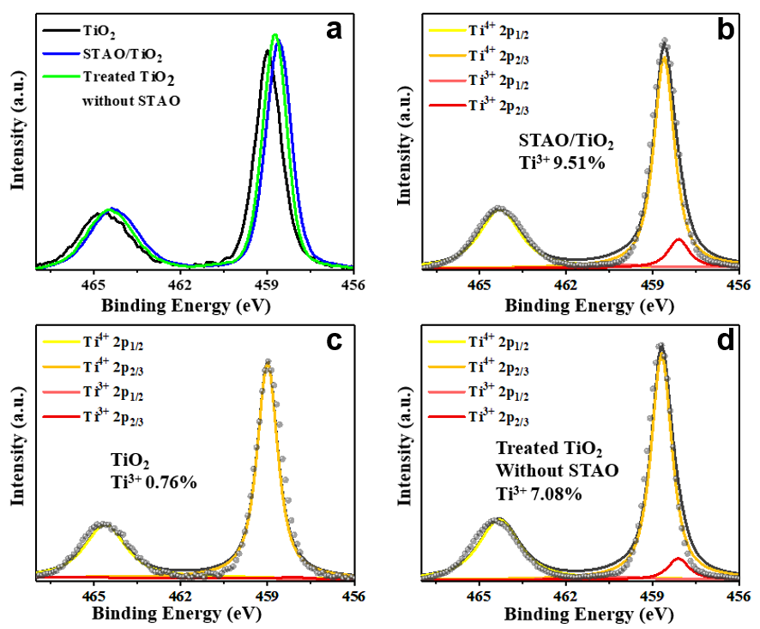
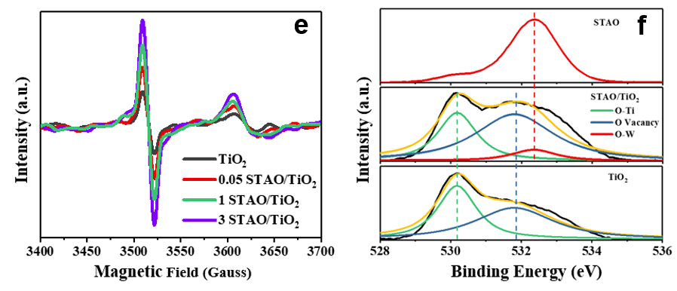
Supplementary Figure 3. a, b, XPS spectra of processing technique and STAO anchoring both induce Ti³⁺ formation. Reference sample is pristine TiO₂ and treated TiO₂ without STAO.
c, EPR signals change of photocatalyst with various STAO anchoring density. d, XPS of O_{1s} in pristine TiO₂, STAO/TiO₂ and pristine STAO.

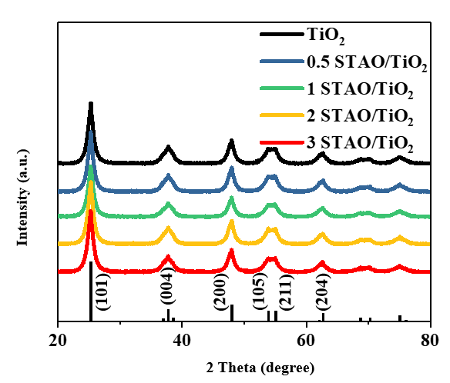
Supplementary Figure 4. X-ray diffraction patterns of pristine TiO₂ substrate and photocatalysts with various STAO anchoring density.

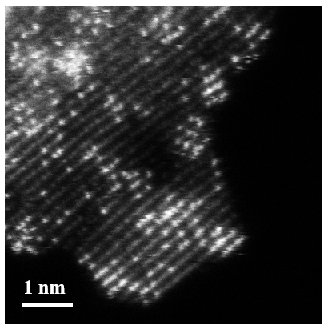
Supplementary Figure 5. The HAADF image of 4.5 wt% STAO anchored on TiO₂, the cluster (yellow circle) and the string of pearls (cyan circle) are shown.

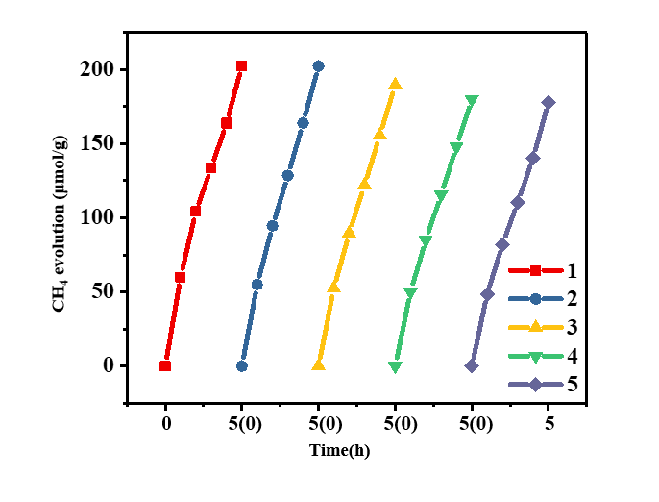
Supplementary Figure 6. Stability of CH₄-max STAO/TiO₂ is investigated by 5 times cycling test.

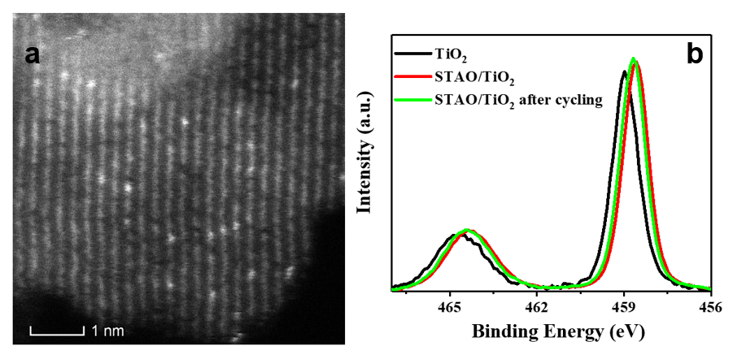
Supplementary Figure 7. HAADF image and XPS spectra of STAO/TiO₂ after 5 times cycling to exhibit the single site is not obviously changed in the CO₂ reduction reaction.

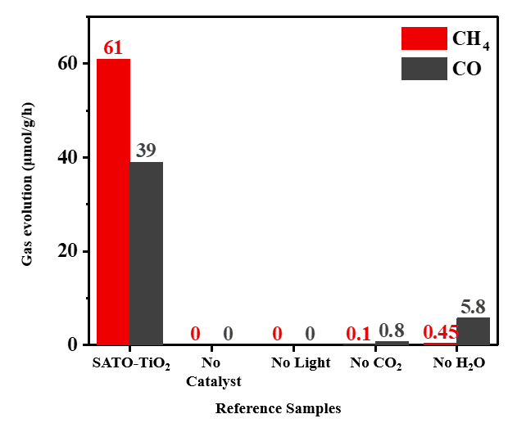
Supplementary Figure 8. Blank test in photocatalytic CO₂ reduction in the conditions of with no catalyst, no light, no CO₂ or no added H₂O (absorbed H₂O molecule may be involved in the slight conversion of CO₂).

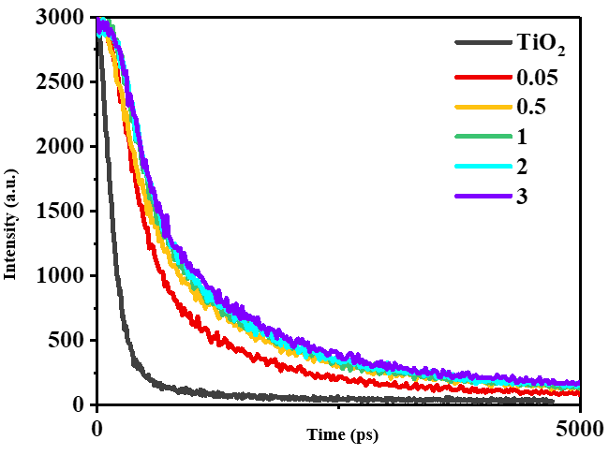
Supplementary Figure 9. Time-resolved PL of catalysts with various STAO at step sites.

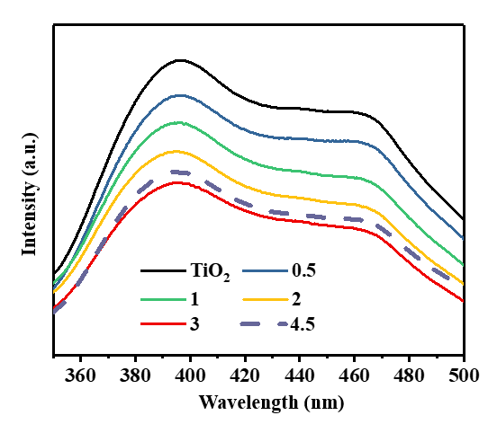
Supplementary Figure 10. PL suppression limit is achieved by STAO/TiO₂. The PL signal of clustered tungsten oxide (4.5 wt%) is seen to increase.

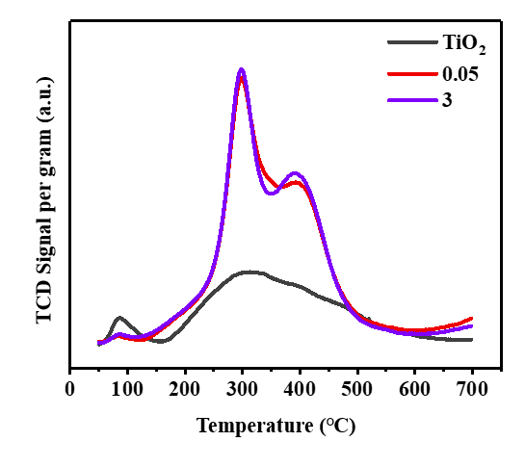
Supplementary Figure 11. Temperature-programmed desorption of CO₂ on pristine TiO₂, CO-max catalyst and CH₄-max catalyst with STAO at step sites.

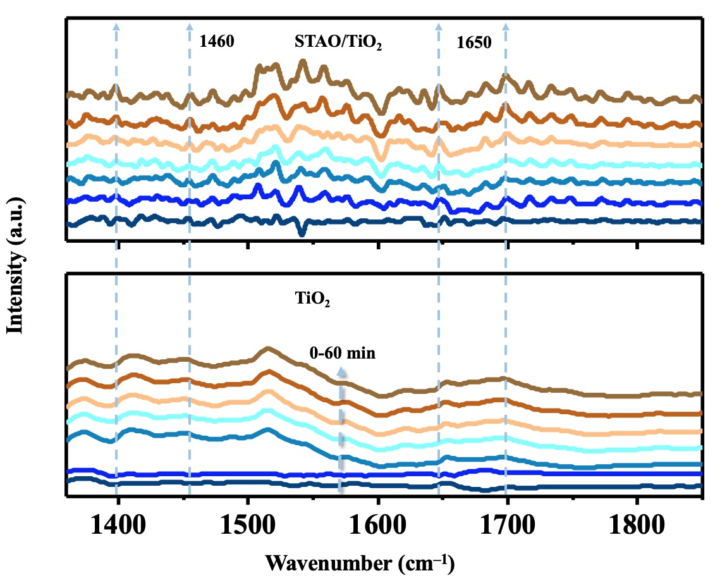
Supplementary Figure 12. Amplified wavenumber 1350-1850 cm⁻¹ DRIFTS signal of STAO/TiO₂ and TiO₂ during photocatalytic CO₂ reduction in 60 mins.

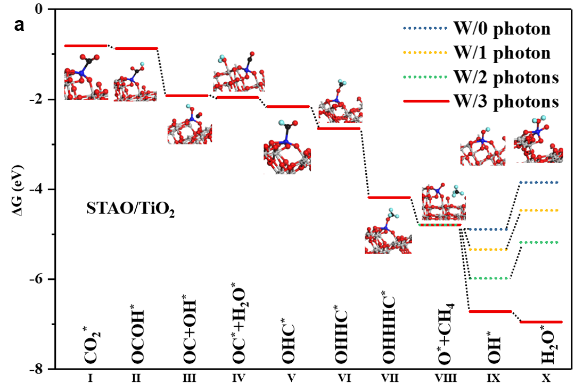
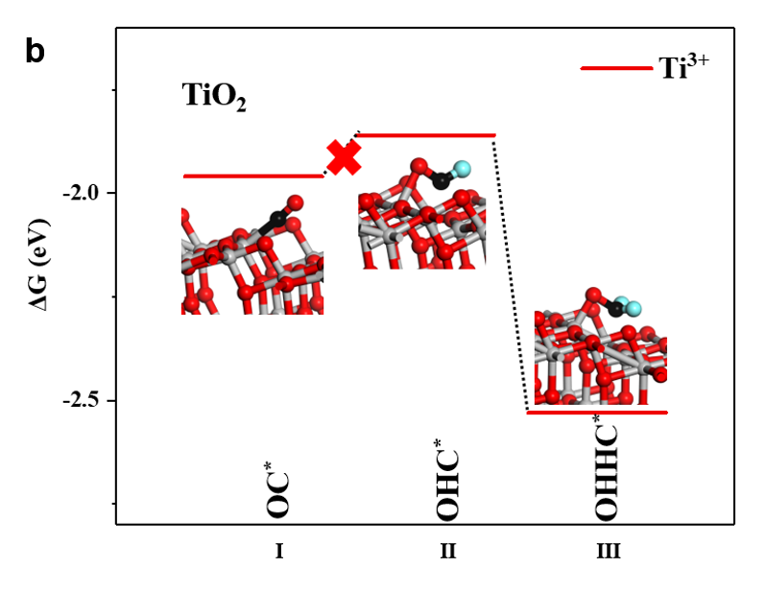
Supplementary Figure 13. a, Possible pathways of intermediate on W⁵⁺ site, especially on CO and CH₄ formation steps. b, CO formation on Ti³⁺ site. The CHO formation is thermodynamically difficult.

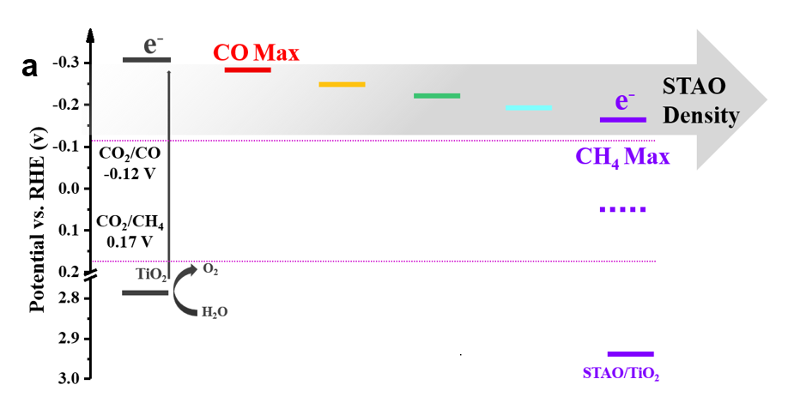
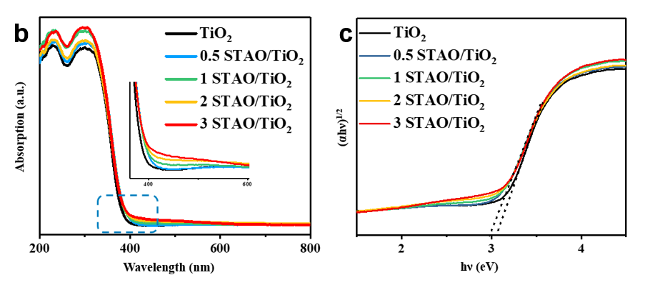
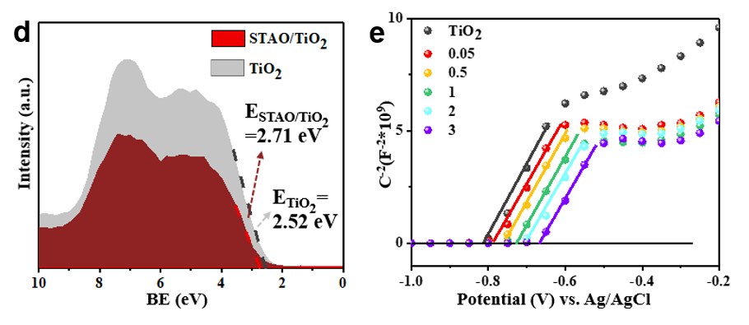
Supplementary Figure 14. a, Band diagram of catalysts with various STAO at step sites. b, c, UV-Vis and (αhν)²=A(hν-Eg) relations of various samples. d, UV-light photoelectronic spectra of pristine TiO₂ and STAO/TiO₂. e, Mott–Schottky plots of TiO₂ and STAO/TiO₂ samples obtained from semiconductor-electrolyte interface capacity values acquired by EIS at 400 Hz at different bias potentials.
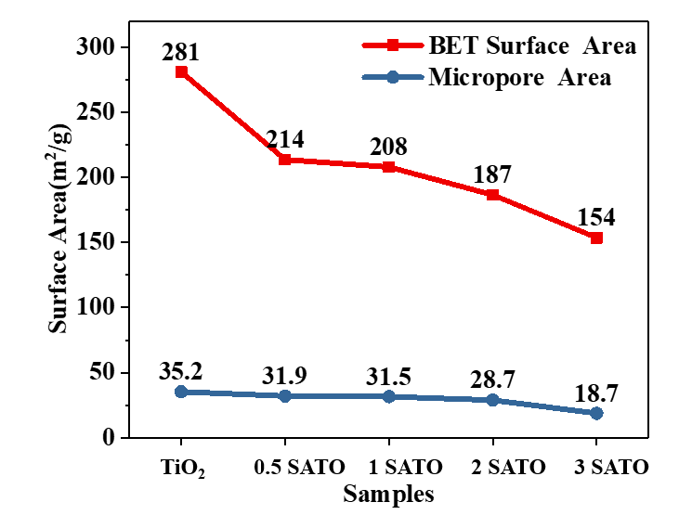
Supplementary Figure 15. BET of catalysts with various STAO at step sites.

Supplementary Table 1. ICP-OES result of catalysts with various STAO at step sites.

Samples | Tungsten Content（mg/kg）
TiO₂ | 0
0.005 STAO/TiO₂ | 67.8
0.05 STAO/TiO₂ | 543.6
0.5 STAO/TiO₂ | 4988.8
1 STAO/TiO₂ | 9587.9
2 STAO/TiO₂ | 21130.9
3 STAO/TiO₂ | 29674.2
4.5 STAO/TiO₂ | 43862.5

Supplementary Table 2. Time-resolved PL corresponding fitting results
Samples | a₁ | τ₁ | a₂ | τ₂ | τ_{av}
TiO₂ | 3774.70516 | 155.48648 | -831.31995 | 31.52561 | 161.2805
0.005 STAO/TiO₂ | 3091.27964 | 534.33924 | 245.33996 | 4937.78716 | 2397.445
0.05 STAO/TiO₂ | 2998.28915 | 551.92851 | 263.17384 | 4947.08337 | 2487.22048
0.5 STAO/TiO₂ | 2837.41045 | 646.94305 | 351.63647 | 5382.21475 | 3050.73907
1 STAO/TiO₂ | 3020.57315 | 751.29246 | 280.46687 | 7515.04542 | 4008.30104
2 STAO/TiO₂ | 3050.65721 | 726.28435 | 269.76462 | 7868.43307 | 4220.78892
3 STAO/TiO₂ | 2985.75371 | 784.38295 | 295.56222 | 8576.4513 | 4834.52229

Supplementary Table 3 Photocatalysts without sacrificial reagent or noble metal co-catalyst

Photocatalysts Light Source Products (µmol g⁻¹ h⁻¹) Reference

STAO/TiO₂ 300W Xe Lamp 59.3 (CH₄), 181.4 (CO) This work
AM 1.5 Solar Simulator

CuIn₅S₈ 300W Xe Lamp 8.7 (CH₄) Nat. Energy
λ＞420nm 4, 690-699 (2019)

HCP-TiO₂-FG 300W Xe Lamp 27.62 (CH₄), 21.63 (CO) Nat. Commun
λ＞420nm 10, 676 (2019)

HCP-TiO₂-FG 300W Xe Lamp 51.23 (CH₄), 39.51 (CO) Nat. Commun
UV 10, 676 (2019)

InVO₄ 300W Xe Lamp 18.28 (CO) J. Am. Chem. Soc.
Solar Simulator 141, 4209-4213 (2019)

Ti₃C₂ Xe Lamp 1.78 (CH₄) 0.58 (CH₃OH) Adv. Funct. Mater.
/Bi₂WO₆ 28, 1800136 (2018)

α‑Fe₂O₃ 300W Xe Lamp 27.2 (CO) Adv. Mater.
/g‑C₃N₄ λ＞420nm 30, 1706108 (2018)

TiO₂/Ni(OH)₂ 350W Xe Lamp 2.2 (CH₄) 0.71(CO) J. Mater. Chem. A
Simulated Sunlight 0.11 (CH₃OH) 6,4729-4736 (2018)
0.15 (C₂H₅OH)

H-TiO_{2-x} 300W Xe Lamp 16.2 (CH₄) 4.2(CO) ACS Catal.
AM 1.5 6.5(H₂) 8, 1009−1017 (2018)

BiOIO₃ 300W Xe Lamp 5.42 (CO) Adv. Funct. Mater.
28, 1804284 (2018)

carbon@TiO₂ 4.22 (CH₄) J. Mater. Chem. A
9.11 (CH₃OH) 5,5020-5029 (2017)

ZnIn₂S₄ 300W Xe Lamp 33.2 (CO) J. Am. Chem. Soc.
139, 7586-7594 (2017)

BiVO₄ 300W Xe Lamp 398.3 (CH₃OH) J. Am. Chem. Soc.
AM 1.5 139, 3438−3445 (2017)

TiO₂/g-C₃N₄ 300W Xe Lamp 5.21 (CH₄) 0.84(CO) Appl. Catal. B: Environ.
λ＞400nm 203,910-916 (2017)

TiO₂/RGO 300W Xe Lamp 44.56 (CO) Chem. Eng. J.
λ＞400nm 316, 449-460 (2017)

m-CeO₂/g-C₃N₄ 300W Xe Lamp 0.69 (CH₄) 0.51(CO) Nano Energy
19,145-155 (2016)

N-GQDs/Vo-NaTaON 300W Xe Lamp 10 (CH₄) 43(CO) Nano Energy
λ＞400nm 30,59-68 (2016)

CdS 300W Xe Lamp 1.02 (CH₄) Small
AM 1.5 39, 5262-5271 (2015)

Bi₂WO₆ 300W Xe Lamp 75 (CH₃OH) Angew.Chem.
AM 1.5 54,13971-13974 (2015)

Cu₃(BTC)₂@TiO₂ 300W Xe Lamp 2.4 (CH₄) Adv. Mater.
λ＜400nm 26, 4783-4788 (2014)

TiO₂ 300W Xe Lamp 1.35 (CH₄) J. Am. Chem. Soc.
136, 8839−8842 (2014)

Go/TiO₂ 300W Xe Lamp 10.1 (CH₄) 16.8 (C₂H₄) Adv. Funct. Mater.
23, 1743-1749 (2014)

Cu/TiO₂ 300W Xe Lamp 0.68 (CH₄) 3.85 (CO) Appl. Catal. B: Environ.
134-135, 349-358 (2014)

