Supporting Information
Synergistic Photophysical Modulation via Molecular Engineering: Carbazole-Based Copolymers Enabling High-Efficiency Ultralong Room-Temperature Phosphorescence
Jian Chenª, Haochen Guoª, Lin Zhangª, Wenqian Liuª, Chuanyong Zong^{a,b,}*, Shichun Jiang^{b}, Xiangkui Ren^{c,}*
ªSchool of Chemistry and Chemical Engineering, Shandong Provincial Key Laboratory of Extreme Environment-tolerant Specialty Chemicals, University of Jinan, Jinan 250022, P. R. China
^{b}School of Materials Science and Engineering, Tianjin University, Tianjin 300072, P. R. China
^{c}School of Chemical Engineering and Technology, Tianjin University, Tianjin 300072, P. R. China
*Corresponding author. E-mail address: chm_zongcy@ujn.edu.cn (Chuanyong Zong); renxiangkui@tju.edu.cn (Xiangkui Ren).

Afterglow lifetime decay curve fitting. The fitting of the phosphorescence lifetime decay curve of the P(KLNVC-co-AM) is described by the following expression:
$I\left(t\right)=\sum_{i}{B_{i}e^{−\frac{t}{τ_{i}}}}$ (1)
Here, B_{i} and τ_{i}denote the amplitude and lifetime of each component in the multi-exponential decay profile, respectively.
The average lifetime is calculated from the function:
$τ_{ave}=\sum_{i}{φ_{i}τ_{i}}$ (2)
Where φ_{i} is the amplitude fraction.
To obtain the intensity-averaged lifetime (τ_{int}), 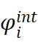is defined by the following function:
$φ_{i}^{int}=\frac{B_{i}τ_{i}}{\sum_{i}{B_{i}τ_{i}}}×100\%$ (3)
τ_{int} is obtained from the following expression:
$τ_{int}=\sum_{i}{φ_{i}^{int}τ_{i}}$ (4)

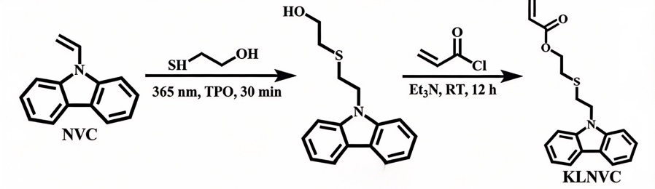
Figure S1. Schematic illustration of the synthesis of the KLNVC monomer.

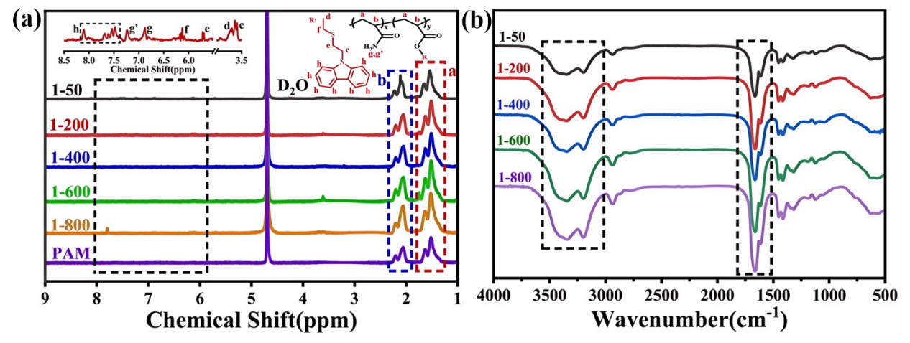Figure S2. ¹H NMR (a) and FT-IR (b) analysis of the as-synthesized copolymers with different monomer molar ratios.
As shown in Fig. S2a, the characteristic absorption peaks at 7.47 ~ 8.11 ppm were assigned to -CH- in the carbazole ring¹. The feature peaks at 6.88 and 7.24 ppm belonged to -NH₂ of the acrylamide moieties². The characteristic peaks at 3.63, 3.69, 5.72 and 6.13 ppm correspond to the carbazole-linked -CH₂-, carbonyl-adjacent -CH₂-, S-carbazole-bridged -CH₂-, and S-bound -CH₂-, respectively. Meanwhile, the feature stretching vibration peaks of -NH₂ groups in the copolymers were observed at 3345 cm⁻¹ (Fig. S2b). The stretching vibration absorption peaks of -CH3 and -CH₂- moieties were observed at around 2939 cm⁻¹. The characteristic stretching vibration peak of C = O group was appeared at 1763 cm⁻¹. Notably, the feature peak of C = C bonds at 1629 cm⁻¹ disappeared, indicating the successful synthesis of the carbazole-containing copolymers.

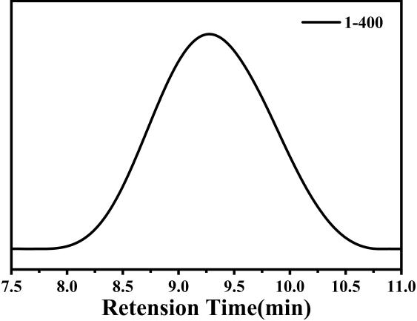
Figure S3. GPC curve of the as-synthesized P(KLNVC-co-AM).

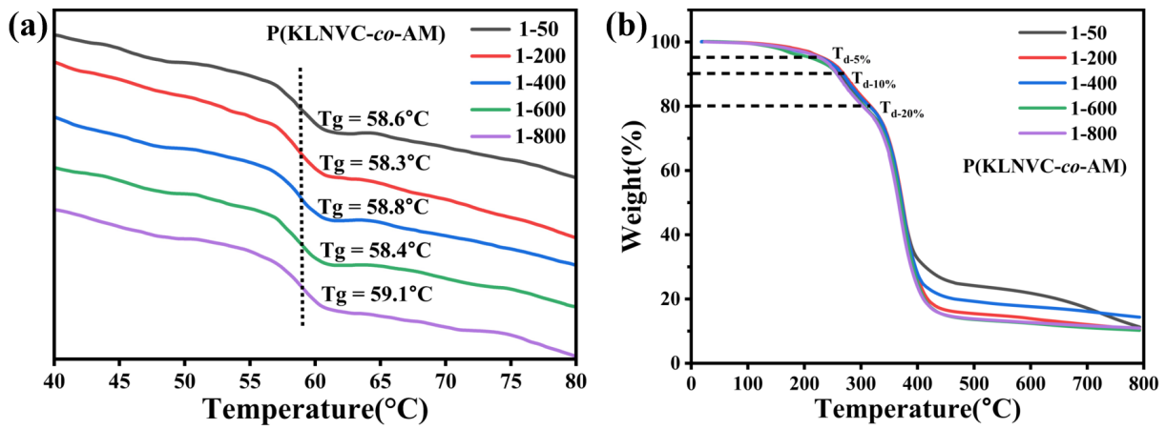
Figure S4. DSC (a) and TGA (b) curves of the as-synthesized P(KLNVC-co-AM).

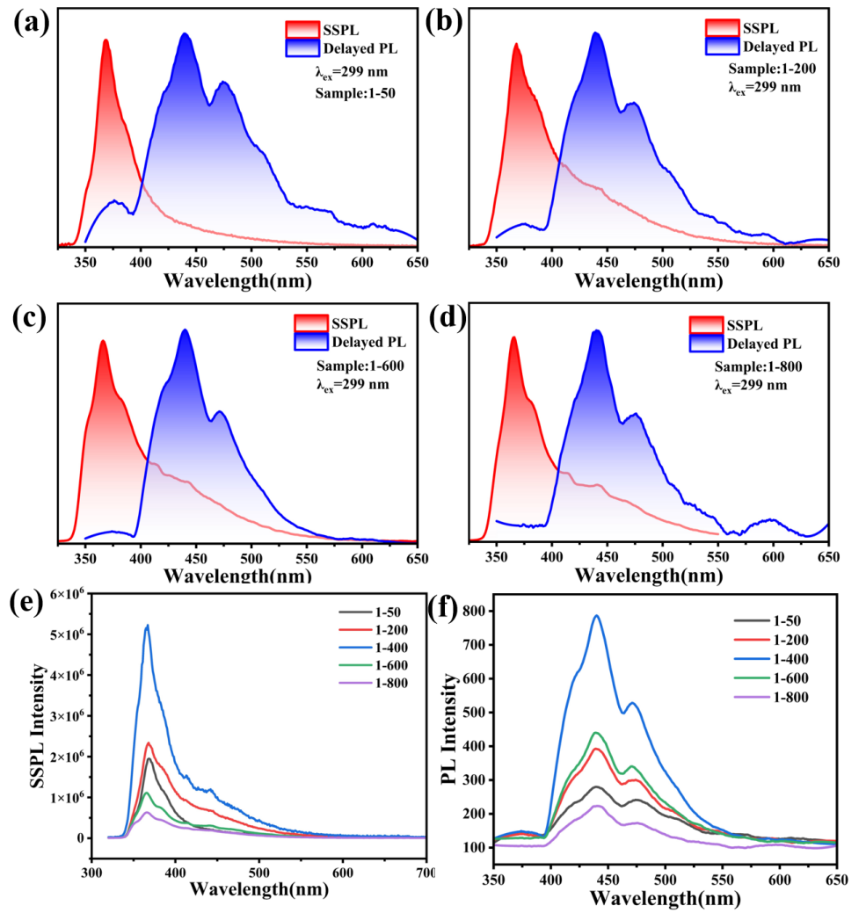
Figure S5. Steady-state (SSPL) and delayed PL spectra of P(KLNVC-co-AM).

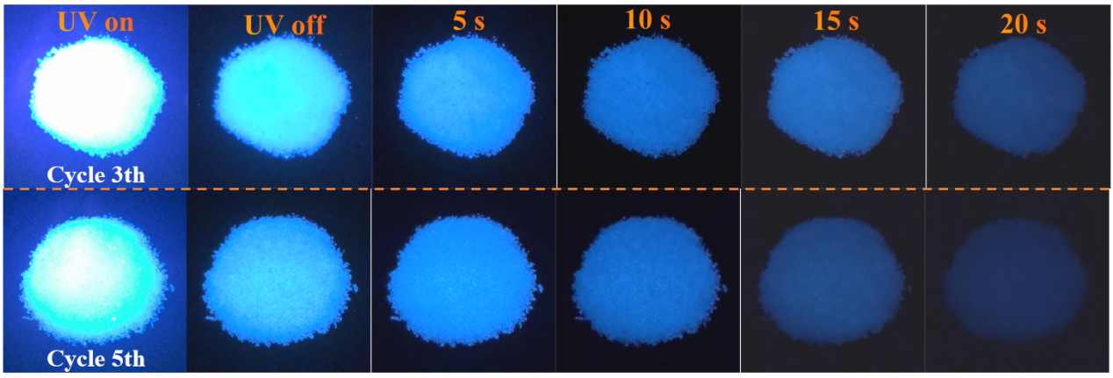
Figure S6. RTP photographs of the carbazole-copolymers (1-400) with UV light (365 nm, 56 mW/cm², 10 s) excitation for 3 and 5 cycles.

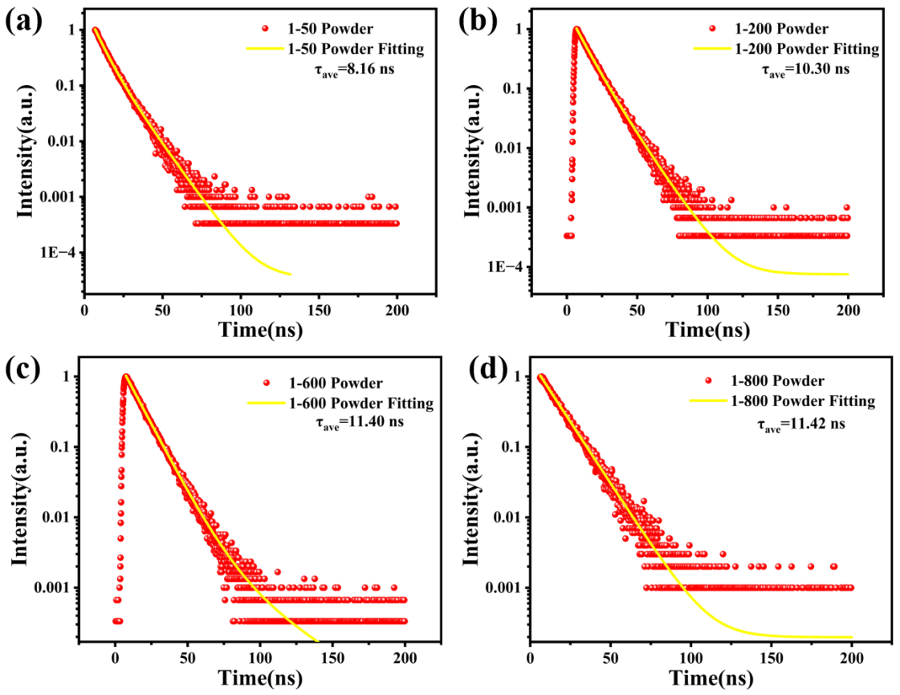
Figure S7. Fluorescence lifetime decay curves of the P(KLNVC-co-AM) copolymers.

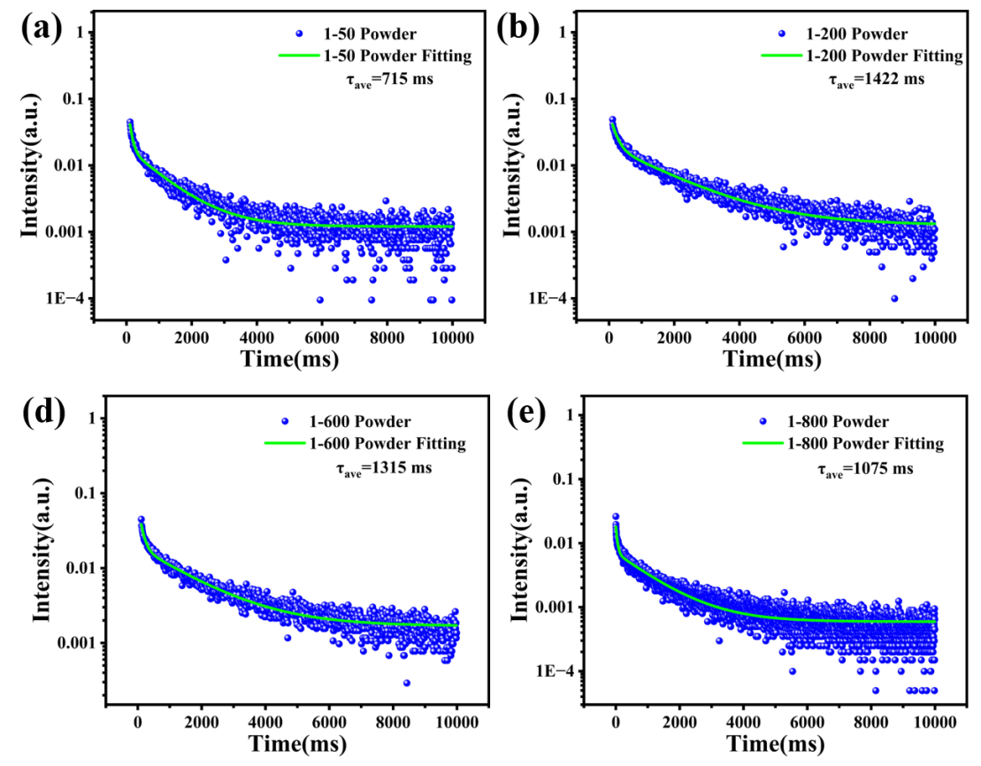
Figure S8. Phosphorescence lifetime decay curves of the P(KLNVC-co-AM) copolymers.

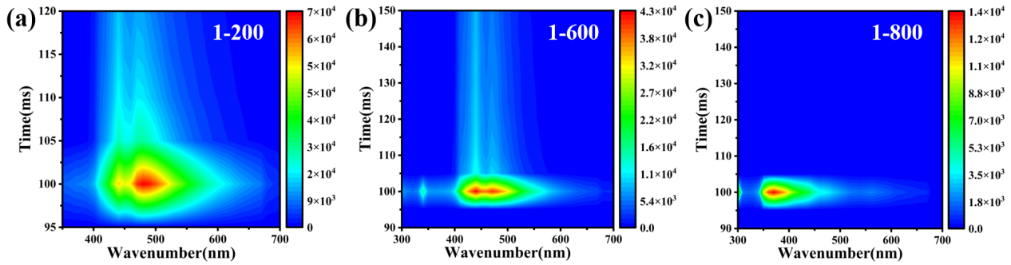
Figure S9. Time-resolved emission fluorescence spectra of the P(KLNVC-co-AM) copolymers.

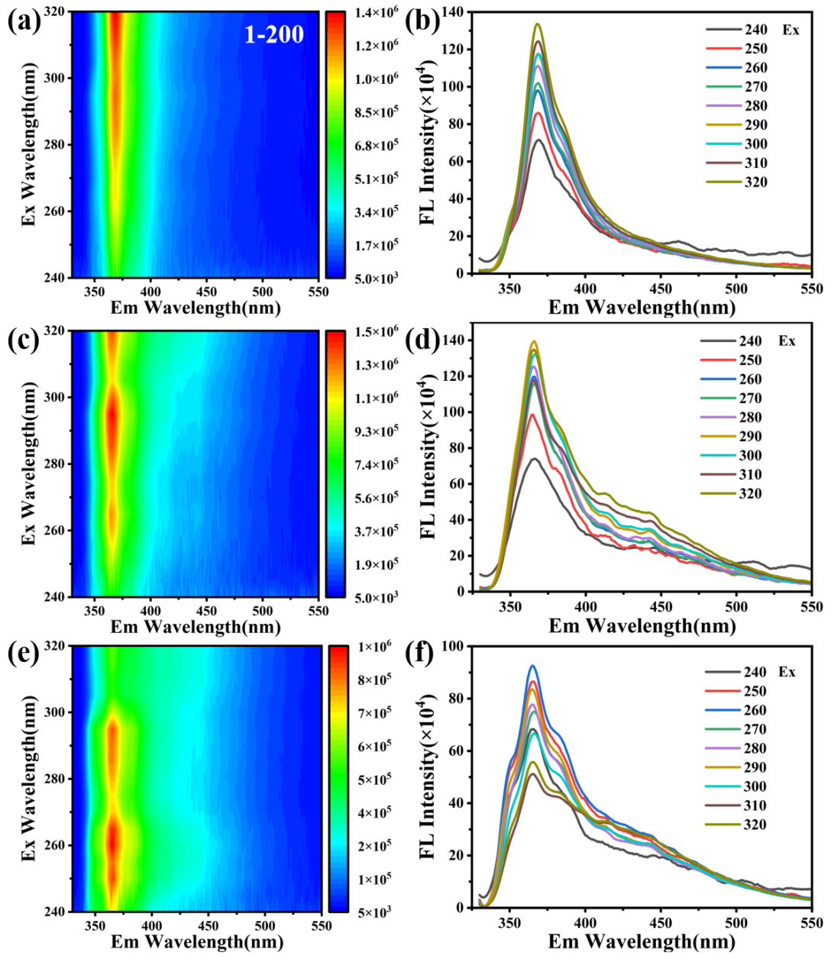
Figure S10. Three-dimensional fluorescence spectra of the P(KLNVC-co-AM) copolymers.

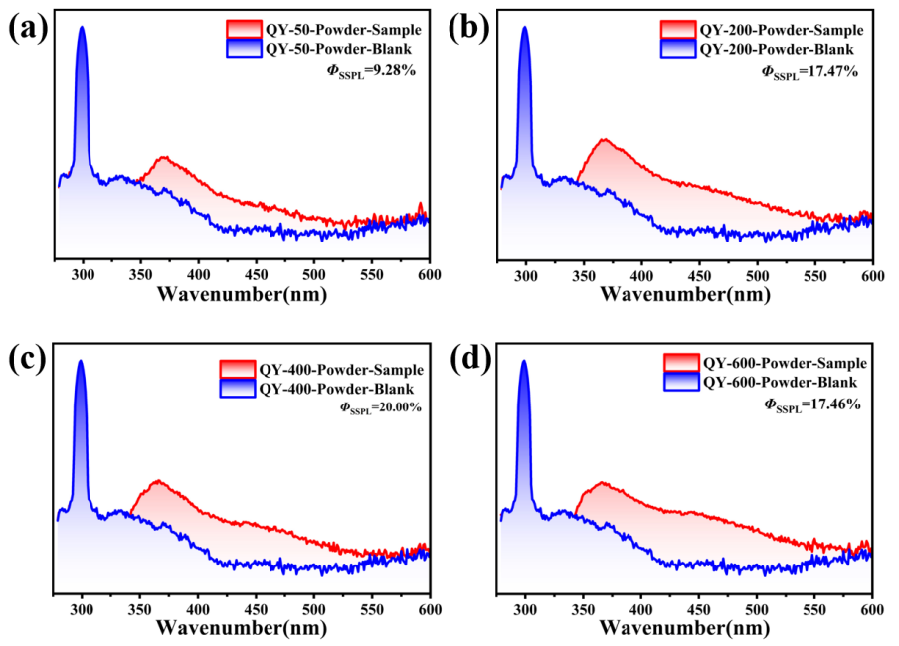
Figure S11. Fluorescence quantum yield of the P(KLNVC-co-AM) copolymers at room temperature: 1-50 (a), 1-200(b), 1-400 (c) and 1-600 (d).

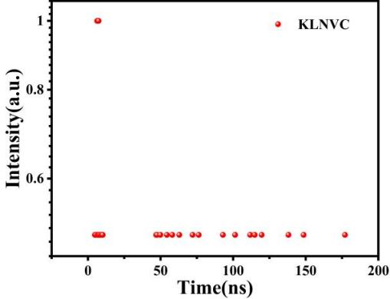
Figure S12. Fluorescence lifetime decay curve of theKLNVC monomer.

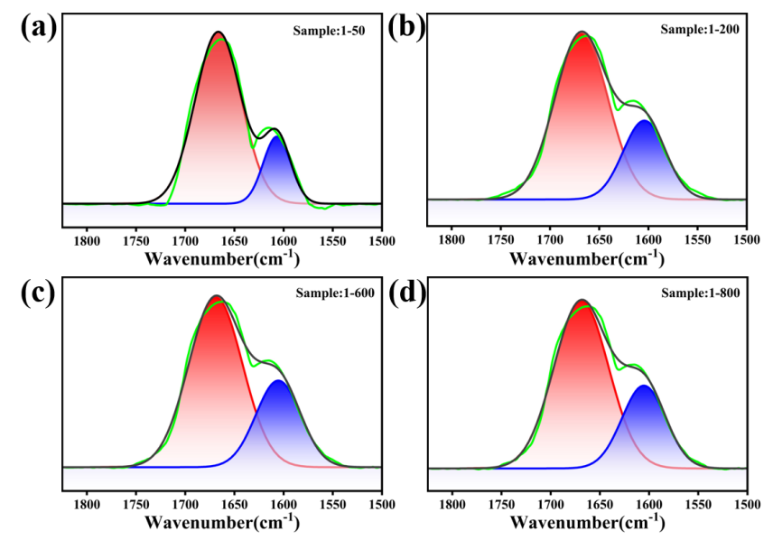
Figure S13. Analysis of hydrogen-bonding interactions of the P(KLNVC-co-AM) copolymers.
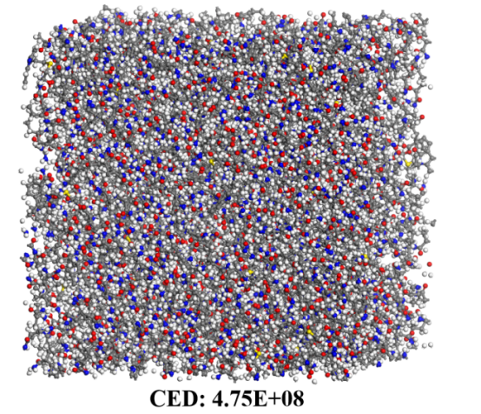
Figure S14. Cohesive energy simulation analysis of the P(KLNVC-co-AM) (1-50) copolymer.

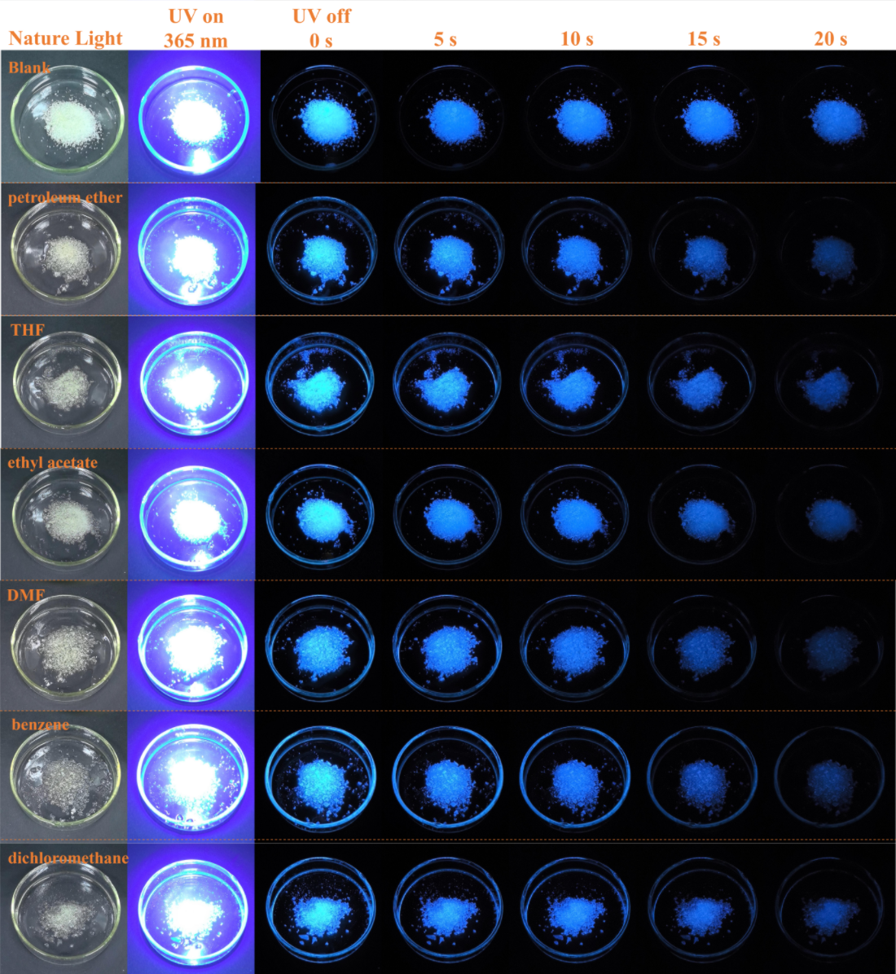
Figure S15. Effect of solvent-immersion treatments on the RTP properties of the P(KLNVC-co-AM) copolymers.
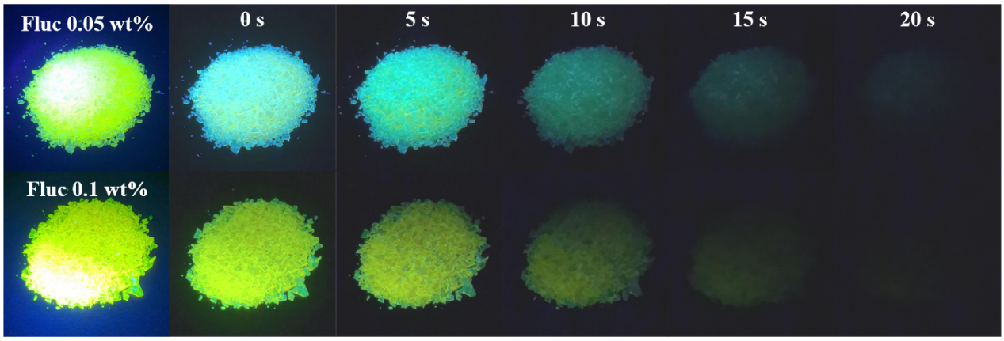
Figure S16. RTP photographs of the P(KLNVC-co-AM)@Fluc with UV light (365 nm, 56 mW/cm²) excitation for 10 s.

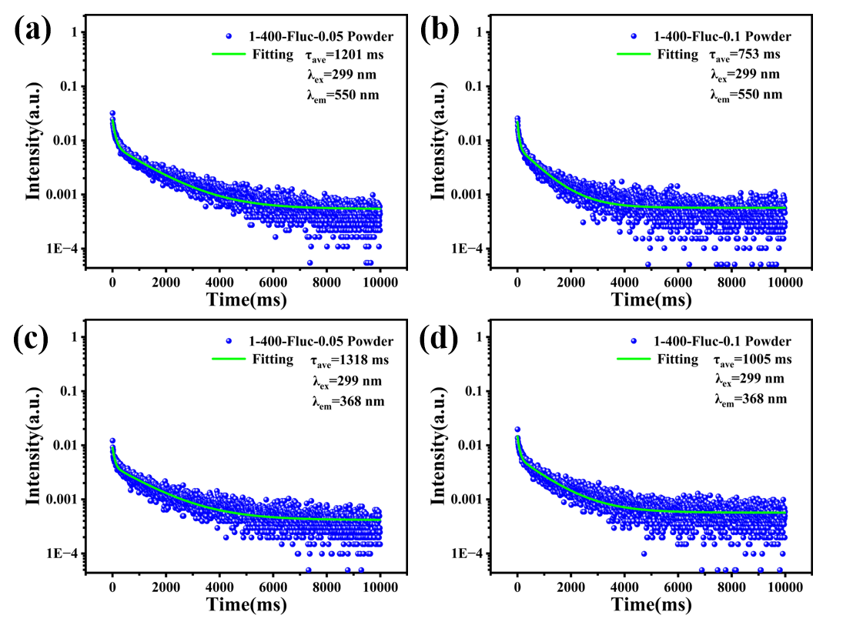
Figure S17. Fluorescence lifetime decay curves of the P(KLNVC-co-AM)@Fluc with with different Fluc loadings.

Table S1 The molecular weight and dispersity of the P(KLNVC-co-AM).
Sample | ªM_{n} | ^{b}M_{w} | ^{c}Đ
1-400 | 17100 | 30100 | 1.76
ªM_{n} number-average molar mass; ^{b}M_{w} weight-average molecular weight; ^{c} dispersity (Đ) = M_{w}/M_{n}

Table S2 The thermal performance analysis of the P(KLNVC-co-AM).
Sample | Td-5%(℃) | Td-10%(℃) | Tg(℃)
1-50 | 229.9 | 264.7 | 58.6
1-200 | 233.6 | 269.9 | 58.3
1-400 | 229.9 | 267.5 | 58.8
1-600 | 212.7 | 257.5 | 58.4
1-800 | 228.4 | 257.9 | 59.1

Table S3 The CIE diagrams of the P(KLNVC-co-AM).
Sample | SSPL | Delayed PL
1-50 | (0.19, 0.14) | (0.27, 0.27)
1-200 | (0.17, 0.12) | (0.25, 0.24)
1-400 | (0.17, 0.12) | (0.24, 0.23)
1-600 | (0.19, 0.14) | (0.21, 0.18)
1-800 | (0.15, 0.11) | (0.28, 0.27)

Table S4 Interaction energy between the cazole and acrylamide group.
Sample | acrylamide | cazole
Geometry | 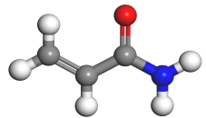 | 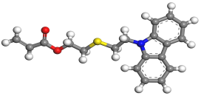
IAE (kcal/mol) | -72.50 | -50.14

References
1. Lim, H. S., Han, J. T., Kwak, D., Jin, M. & Cho, K. Photoreversibly switchable superhydrophobic surface with erasable and rewritable pattern. J. Am. Chem. Soc. 128, 14458-14459 (2026).
2. Zhang, Z. Y., Xu, W. W., Xu, W. S., Niu, J., Sun, X. H. & Liu, Y. A synergistic enhancement strategy for realizing ultralong and efficient room-temperature phosphorescence. Angew. Chem. Int. Ed. 59, 18748-18754 (2020).

